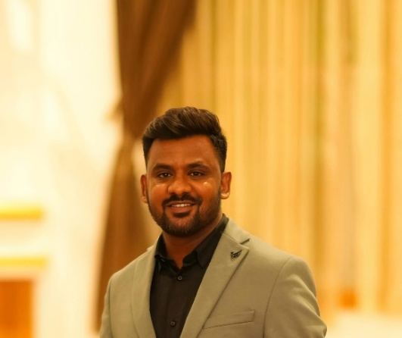 | RAKESHA THIMMAPPA THORENUR  📧 Rakeshyasht92@gmail.com | 📞 +46 761 509 115  🔗 LinkedIn: https://in.linkedin.com/in/rakesh-tt  📍 Myntgatan 10A, Gothenburg, Sweden  🛂 Work Authorization: Sweden (Dependent visa – full work rights)  🗣 English: Fluent | Swedish: Learning

SENIOR FRONTEND DEVELOPER
Senior Frontend Developer with 7+ years of experience in Angular and React, building and modernizing enterprise web applications. Skilled in Typescript, RxJS, and modern frontend architecture. Hands-on experience with AWS and automation, Docker, and CI/CD pipelines using GitHub Actions. Currently based in Sweden and available to start immediately.

TECHNICAL SKILLS
Frontend & UI: Angular (2–20), React, TypeScript, JavaScript (ES6+), HTML5, CSS3, Angular Material, Kendo UI, Shadcn, Tailwind CSS, Bootstrap, JSON
State Management & Reactive Programming: RxJS, NgRx (State Management), Redux, WebSockets
Testing: Jasmine, Karma, Angular Testing Utilities, Jest, React Testing Library
API & Integration: REST APIs, JSON, AJAX
CI/CD & Tools: Git, GitHub, Docker, Bitbucket, AWS, Azure, Jenkins, SonarQube, Jira, Confluence, Postman, Swagger, VS Code
Backend (Working Knowledge): Node.js, Express.js, MongoDB, SQL, .NET, C#

PROFESSIONAL EXPERIENCE

Lead Digital Engineer (Senior Angular Developer)

Sonata Software - Bengaluru, India

Jan 2025 - Jun 2025

Client: Epicor | Project: Bistrack
- Played a key role in modernizing a legacy desktop application into an Angular 19 web application, enabling browser-based access and improved usability.
- Implemented real-time data updates using WebSockets, supporting time-sensitive inventory and order workflows.
- Designed and developed reusable Angular components and shared modules, improving UI consistency and reducing development time.
- Built custom Kendo UI Angular wrappers to support complex enterprise UI requirements.
- Applied modular architecture, lazy loading, and performance optimizations to improve application scalability and responsiveness.
- Collaborated closely with .NET backend teams on API integration, data models, and end-to-end feature delivery.
- Participated in code reviews and followed Angular best practices to maintain high code quality

Associate Consultant (Angular Developer)

Capgemini Pvt Ltd - Bengaluru, India

Jul 2021 - Dec 2024

Clients: Honeywell, GE Vernova, GE Renewables, GE Healthcare

Projects: Myfleet, AMP, VERT, CAPE, Industrial Platforms
- Developed and maintained enterprise-scale Angular applications for industrial and energy platforms used by global clients.
- Led migration of legacy UI modules to modern Angular architecture, improving maintainability and reducing technical debt.
- Implemented RxJS-based data handling, lazy loading, and optimized change detection, improving performance in large applications.
- Designed and implemented reusable Angular components, services, and shared libraries, accelerating feature delivery.
- Integrated REST APIs and WebSocket-based real-time data streams in collaboration with backend (.NET) teams.
- Wrote and maintained unit tests using Jasmine and Karma, improving code stability and release confidence.
- Supported CI/CD pipelines using Jenkins and SonarQube, ensuring automated builds and quality checks
- Worked in Agile/Scrum teams with product owners and cross-functional teams using Jira and Confluence.

Associate Consultant (React Developer)

Mobijini (Bizmobile IT Solutions Pvt Ltd) - Bengaluru, India

Sep 2021 - Mar 2024

Projects: Orderjini, One2One
- Developed interactive single-page applications (SPAs) using React, Node.js, Express.js, and Mongo DB.
- Integrated REST APIs and created reusable React components to enhance maintainability.
- Collaborated with backend teams to deliver high-performing, responsive web applications.
- Conducted unit testing using Jest to ensure code quality.
- Participated in Agile development cycles, using Git and SVN for version control.

Software Engineer (Frontend)

DigitalIT360 - Bengaluru, India

Oct 2017 - Jul 2018
- Developed responsive web interfaces using Javascript, HTML, CSS, and Bootstrap.
- Converted design mockups into user-friendly web pages following UI/UX best practices.
- Integrated frontend components with application business logic layers.

EDUCATION
Bachelor of Engineering in Computer Science | Visvesvaraya Technology University | Bengaluru

