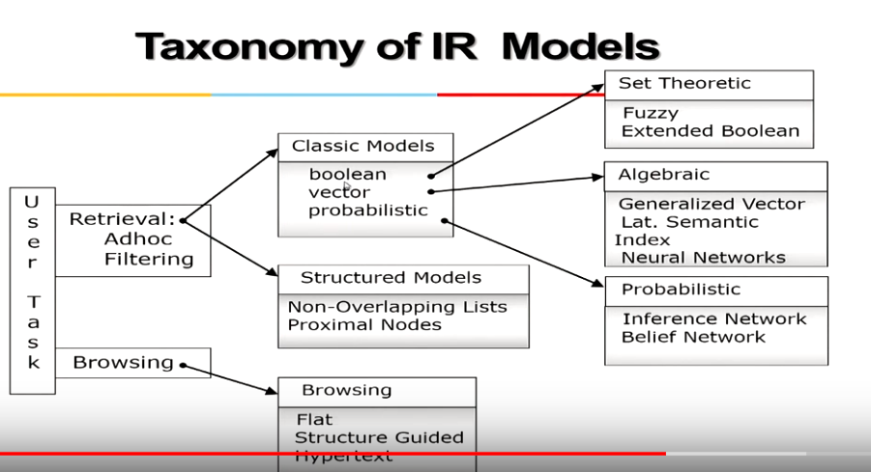

Two types of Information Retrieval User Tasks:

1. Retrieval
   1. Ad-hoc
      1. Document (/Data) set doesn’t change or is static but the queries (by users) keeps changing. Example: A client searches for books in a (closed)library.
   2. Filtering
      1. Document (/Data) set keeps changing, which means that the documents keep adding, but the queries are fixed (every client can have a query/ filter of its own, but none of the clients change their query). Example: A query run by client for latest news. Now, query is fixed, which says latest news, but the news documents/records are updated every second.
   3. Both the retrieval models can be further divided into:
      1. Classical Models
      2. Structured Models
2. Browsing
   * 1. Definition to come later, types are listed in screenshot.

