New One Check this test

Steps to convert a document to a group of indices to be used for searching. Steps are optional and can be chosen on the use case basis.

Each index has the reference(pointer) to the actual document(s) stored, which are filtered based on user query or relevance is calculated.

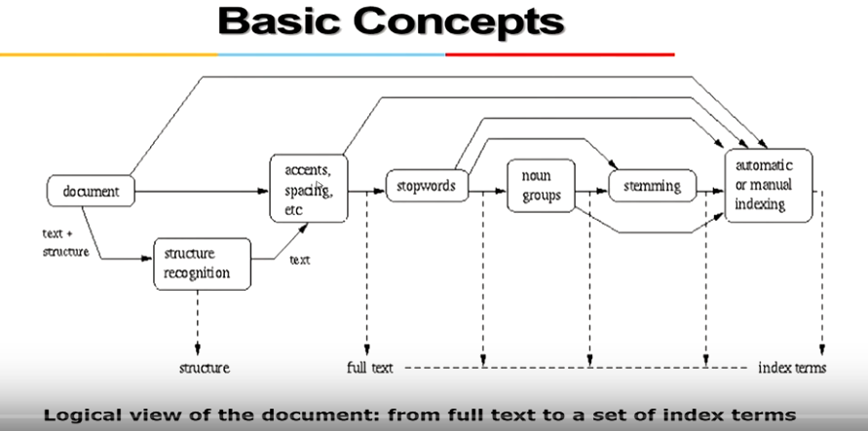

**The Retrieval Process**

