## 

## horizontal line



Admin Portal

28.10.2023

Rakesh Venkitasubban

Code saved in git

https://github.com/rakeshvenki2021/Full_Stack_Project_1_Simplilearn

# Overview

Learner’s Academy is a school that has an online management system. The system keeps track of its classes, subjects, students, and teachers. It has a back-office application with a single administrator login goals

Goal is to develop a prototype of the application

# Specifications

Following specification needs to be followed to achieve the objectives of the project.

● Set up a master list of all the subjects for all the classes  
● Set up a master list of all the teachers  
● Set up a master list of all the classes  
● Assign classes for subjects from the master list  
● Assign teachers to a class for a subject (A teacher can be assigned to different classes for different subjects)  
● Get a master list of students (Each student must be assigned to a single class)

There will be an option to view a Class Report which will show all the information about the class, such as the list of students, subjects, and teachers  
       
The goal of the company is to deliver a high-end quality product as early as possible.

.

**The flow and features of the application:**

* Plan more than two sprints to complete the application  
  ● Document the flow of the application and prepare a flow chart   
  ● List the core concepts and algorithms being used to complete this application  
  ● Implement the appropriate concepts, such as exceptions, collections, and sorting techniques for source code optimization and increased performance

***Product Backlog***

1. Create database and tables.
2. Connect the database to the project.
3. Create models classes.
4. Create a database utility class to retrieve data.
5. Create login page.
6. Create JSP files for all pages of the project.
7. Create a servlet to get requests and send responses to the JSP files.
8. Debug and Test the project.

***Technologies and tools Used***

Servlet: to do the business logic and works a controller for the project.

• JSP: to handle the presentation view.

• SQL: to create and manage the database.

• JDBC: to make operations on the database for the project.

• CSS: to format the contents.

• phpMyAdmin: to administrate and manage the database manually.

• Eclipse: to write and run the code.

• Tomcat: to run and deploy servlet application.

***Flowcharts of the Application***

Database

Servlet

controller

Web Browser

v

JSP Pages(View)

NO

Logined before?

Correct data?

Login Page

NO

YES YES

Students Data

Teachers Data

Subjects Data

Classes Data

**Core Concepts used in the project: -**

* Inheritance.
* Exception handling.
* Modularization.
* Sorting.
* Sanity checking.
* Instantiation.
* Loops
* Interaction with users through terminal.
* IF clauses.
* Data type conversions.
* Case considerations.
* Operators for comparisons, assignments etc.

**Screenshots of various elements:-**

**Welcome Screen:-**

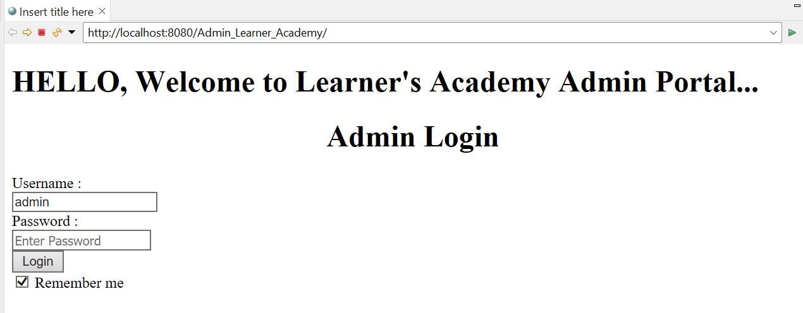

**Selection Screen to add or view**

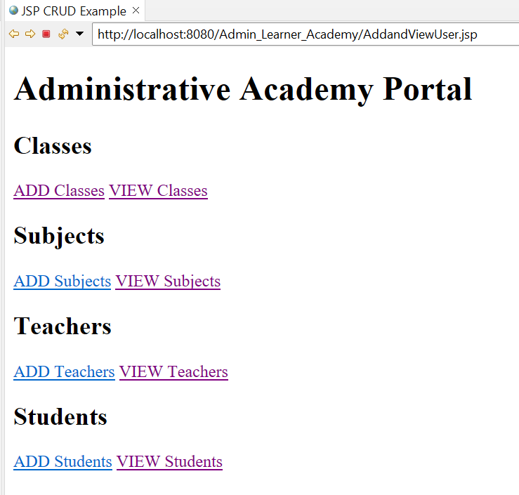

**ADD Classes**

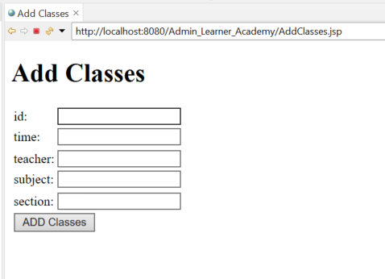

**VIEW Classes**

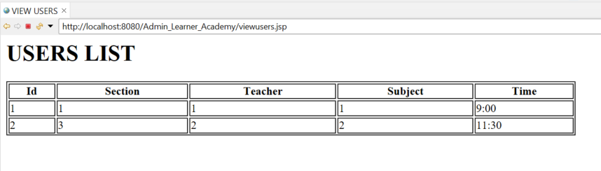

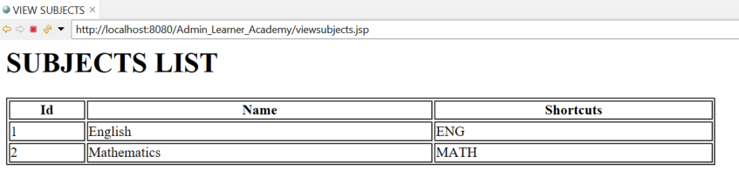

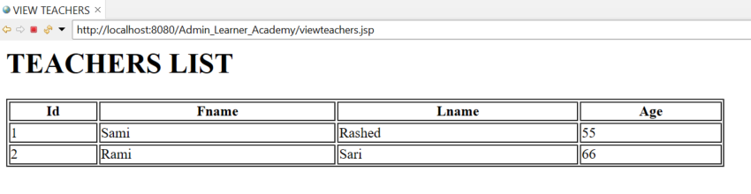

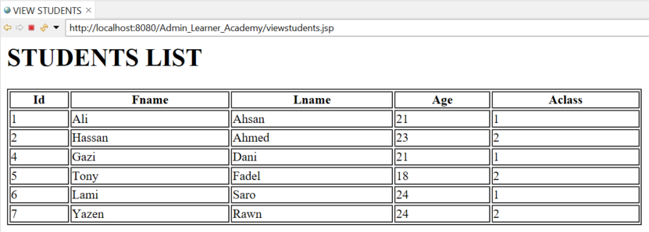

**Git Commit from PC:-**

