BY JEEVANA T

GOUTHAM MARIKANTI

RAKESH V

SAI TEJA SREE

[Pick the date]

CS 551 ADVANCE SOFTWARE ENGINEERING

*INTRODUCTION*

PROJECT PLAN

**INTRODUCTION**

In the food supply chain, food is supplied and consumed in many ways - hotels, restaurants, canteens, house hold etc. To satisfy the hunger of people, millions of tons of food products are supplied and consumed, but at the same time vast portion of the food is getting wasted in the form of leftover food in the above mentioned supply chain. With huge quantity of food is getting wasted, there are so many people who finds it difficult to have at least one meal a day. Our project goal is to provide a platform, using which unutilized food will be distributed to the needy.

***Project Goal and Objectives***

* **Overall goal**

Our main goal is to use the leftover food of restaurant/hotel chains and use to satisfy the hunger of the homeless and poor people.

* **Specific objectives**

We are designing a web application/mobile application to show how much food is utilized and how much food is wasted in hotels, this data we are diverting to NGOs so that we can effectively use the unutilized food. We are going to show statistics for quantity of food conserved using our application. We are also categorizing food based on type (i.e veg/non-veg), expiration date, frozen or normal, liquid or solid etc. So that we are making sure that whatever we are supplying will not harm needy people and also to make it easy for the distributors to carry the food.

* **Significance**

We will work towards diverting this excess food to the hunger struck areas and use it in an eventful and kind gesture towards humanity. Based on the type of NGO involved, food can be distributed to the different categories of the society.

**III. Project Background and Related Work**

**Existing work**

<http://www.statisticbrain.com/world-hunger-statistics/>

<http://www.fao.org/save-food/key-findings/en/>

<http://developer.android.com/training/index.html>

**Comparison**

We are filtering the gathered food based on type, expiration date and time. We are also getting approval from food department before sending our food to NGO’s. We are also providing routing services to NGO’s, thereby facilitating them to receive food by shortest way.

**IV. Proposed System**

1. **Requirement Specification**

* **Functional :** Our application will keep track of all the suppliers of hotel chains / food serving departments and the gathered data is filtered based on categories of types of food , food expiration get it approval from food health department and redirect this data to nearby NGO’s , our application also provides delivery details and routing information through google maps web service.
* **Non-functional:**

**System:**

Operating System: windows/linux

Ram: 2GB

Firewall: required

**Mobile**:

OS: Android, IOS

Ram: 4 GB internal storage

Android version: 4.0.3

* **Business Process/Workflow analysis**
* **Technical/business Requirements**

Front end: Java, C#, HTML5, CSS3, JavaScript, jQuery, Android framework

Back end: sql server

1. **Framework Specification:**

* **Assumptions and Principles**

We are assuming that hotel chains / restaurants will keep track of records i.e how much food is wasted in a day. Our system will retrieve those data and redirect those information to NGO’s.

* **System Architecture Diagram**

**Food Details in website/App**

**Food Provider**

**Food required areas**

**Food Distributor**

**Deliver the food**

1. **System Specification**

**i) Existing Services:**

Google map service

[https://maps.google.com/?q=Pizza&center=37.759748,-122.427135](https://maps.google.com/?q=Pizza&center=37.759748,-122.427135%20)

**ii) New Services to be built**

* **Class diagram**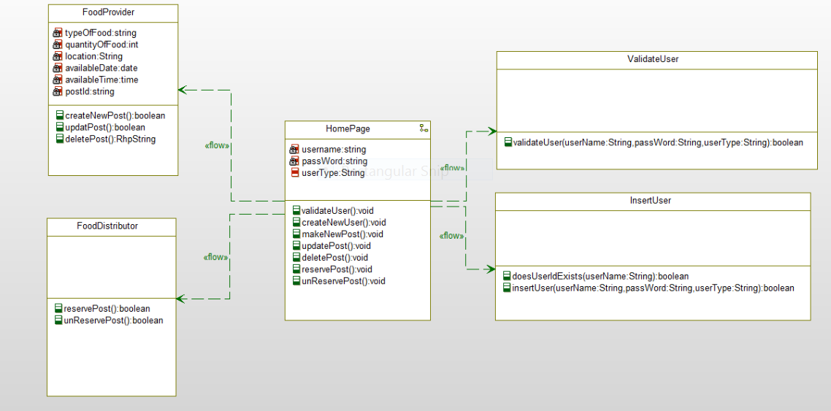
* **Sequence diagram**

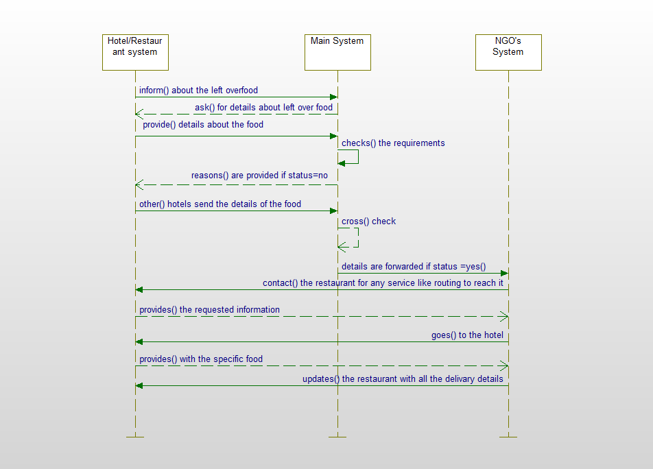

* **Service Specification** 
  + The system is informed about the left-over food by hotels/restaurants.
  + The system checks if the food meets all the requirements.
  + If the food doesn’t meet the requirements then the reasons are provides and if not, the details of the hotel/restaurant is sent to NGO’s
  + The NGO’s contact the hotel for any of the necessary services and then collects food.
  + Provide the delivery details of the food to the needy people.
* **Operational description:**
  + Firstly, the hotels/restaurants informs the system about the left-over food.
  + The system then checks if the food meets all the requirements before forwarding the details of the hotel to the NGOs system.
  + If the food doesn’t meet the requirements then the reasons are provides and if it does then the details of the hotel/restaurant is sent to NGO’s System.
  + The NGO’s System then contact the hotel for any of the necessary services like how to reach the hotel/restaurant and then collects food.
  + Finally, the NGO’s system provides all the delivery details of the food to the needy people.
* **Input/output for services**
* **Constraints/exceptions**
  + Gathering the original data from the hotel management is one of the primary constraint
  + Identifying and authorizing the genuine NGO’s, who could serve as authentic distributors is the primary challenge for this project, because, unless we provide the access to the authentic NGO’s, food provide will not have any trust in this service
* **Service flow/alternative flow**
* **Priorities (degree of importance, difficulty, etc.)**
  + Developing the application with very attractive and easy to navigate user interface is of highest priority
  + Gather the information regarding the NGO’s and hotel managements is the next step
  + Deploying the website/mobile app and marketing for the product is the further step.

**V. Plan by Services (using ScrumDo)**

<http://www.scrumdo.com/projects/project/ase-fall-2014-umkc-project1/iteration/111373>

**VI. Risk management**

* **Technical/business Requirements**

Front end: Java, C#, HTML5, CSS3, JavaScript, jQuery, Android framework

Back end: sql server.

**VIII. Bibliography**

<http://en.wikipedia.org/wiki/Java_Speech_API>

<https://www.google.com/search?biw=1366&bih=624&q=jquery+tutorial+for+beginners&oq=jquer&gs_l=serp.1.0.35i39l2j0i20j0j0i20j0l5.1739.4495.0.6386.20.11.1.0.0.3.140.833.7j2.9.0....0...1c.1.53.serp..14.6.469.0.owzG9sRTMKQ>

<http://www.w3schools.com/html/html5_intro.asp>

<http://www.edureka.in/>

<http://developer.android.com/training/basics/actionbar/index.html>

<http://efytimes.com/e1/fullnews.asp?edid=134678>