BIG DATA ANALYTICS

Lab-3 Assignment

By Rakesh Vistarakula (16167395)

**Task-1:**

**1.a** Sensor Data Collection

>> Data is collected from the different sensors like gyroscope, Accelerometer and temperature

>> A text file is generated with the entire sensor data in it

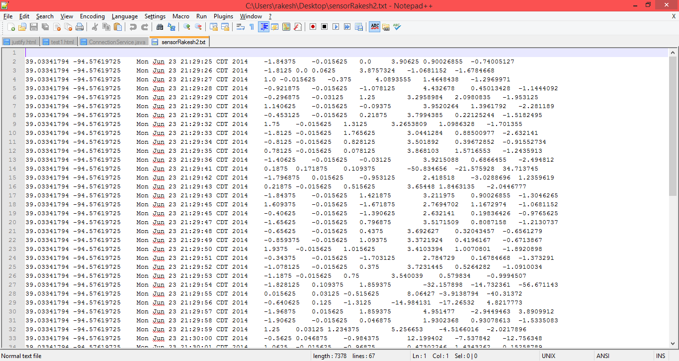

**1.b** File Transfer (using Web Service)

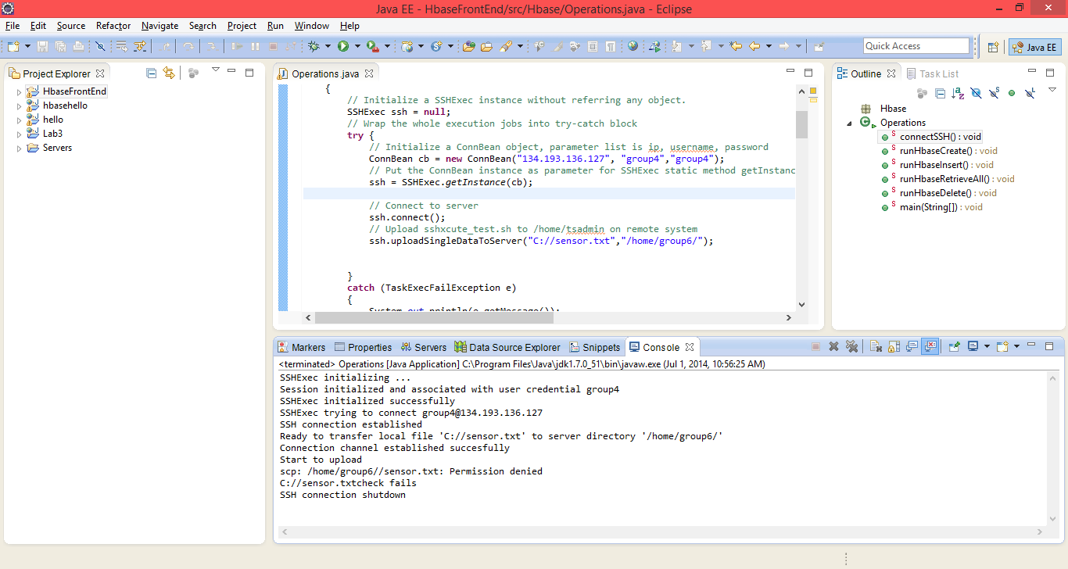

**1.c** HBase CRUD operations (Create, Retrieve, Update, Delete) (Using Web Services)

**i) User Interface screen in Android APP**

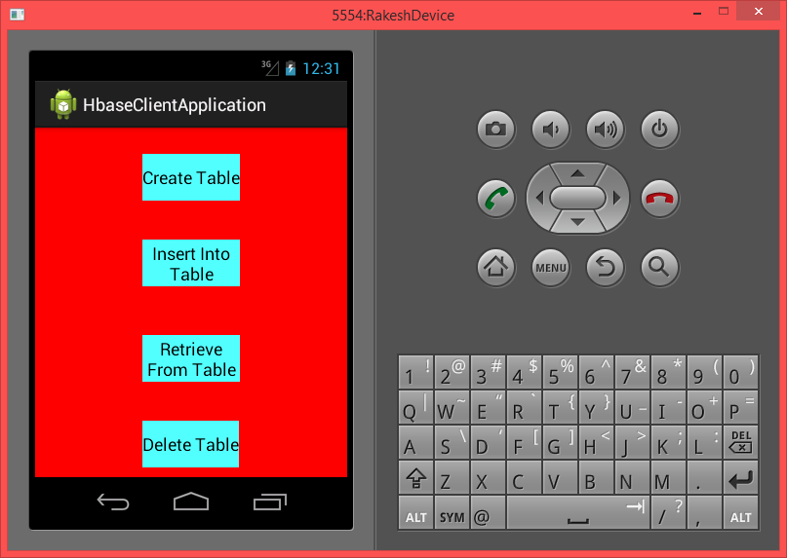

**ii) Create table using android web service**

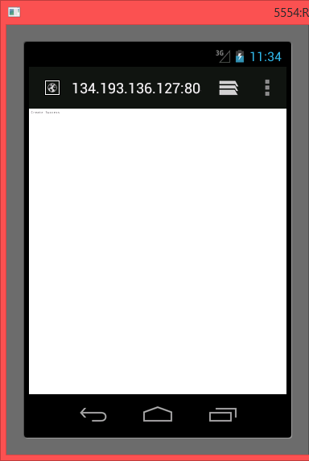

**iii) Insert table using android web service**

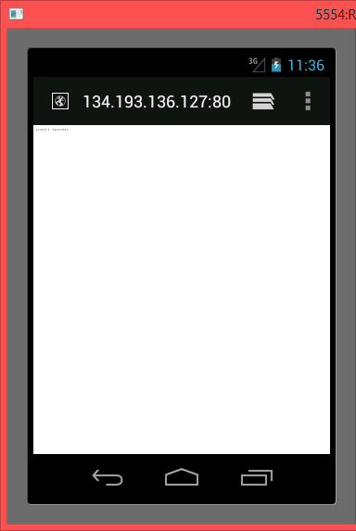

**iv) Retrieve table using android web service**

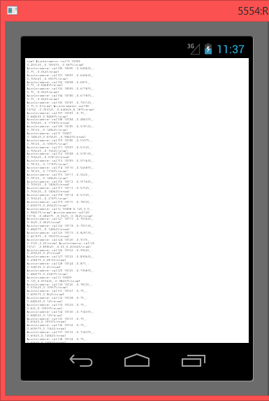

**v) Delete table using android web service**

