Funnyboat is a touch based mobile game. In this there will be a floating and forwaard moving boat.

>> There will be few coming along the ship. If we touch lower half of screen, the ship will jump and we should get over the abstacles.

>> There will be sharks and huge ships coming along the path of ship. If we touch the upper half of the screen, the ship will fire the bullets and we should attack the sharks and other ships.

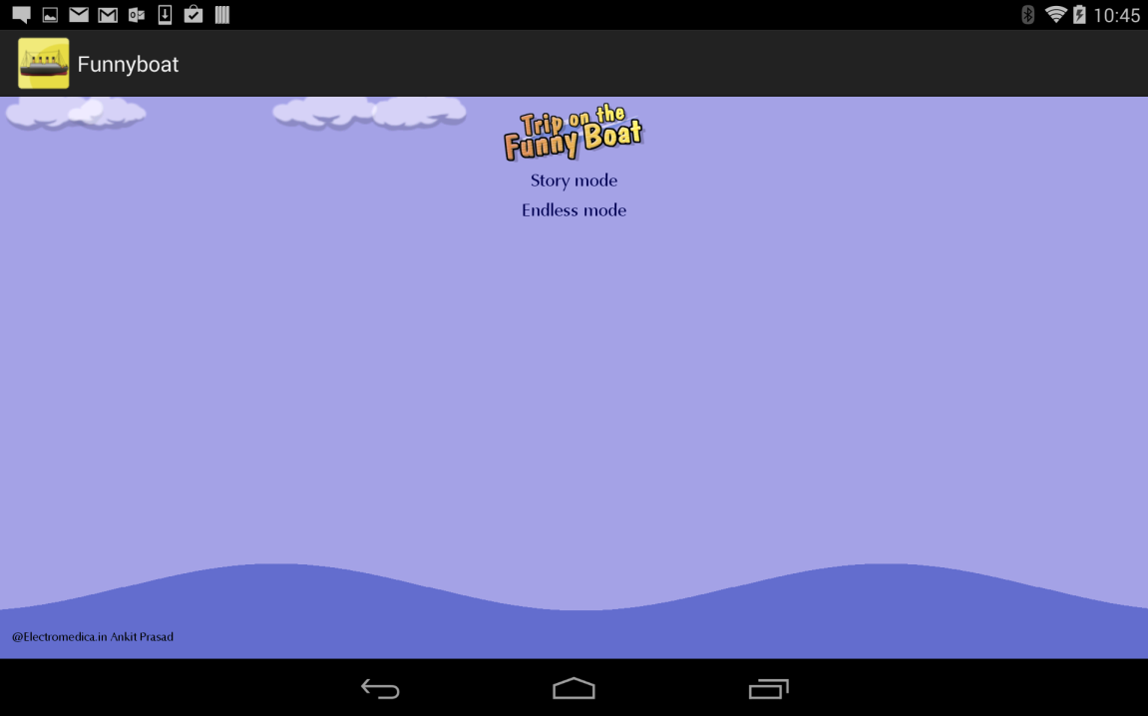

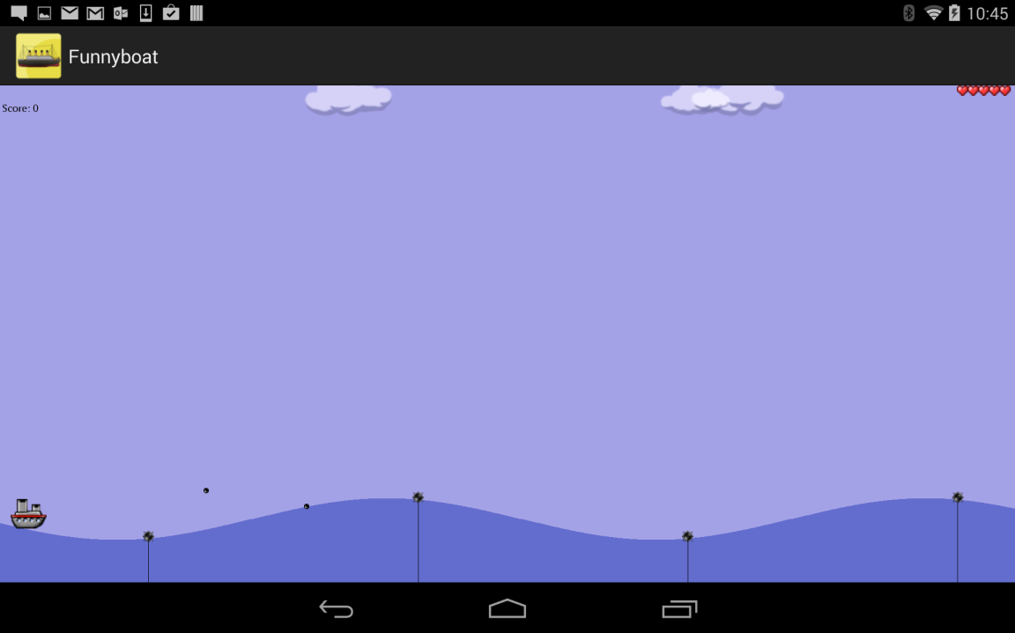

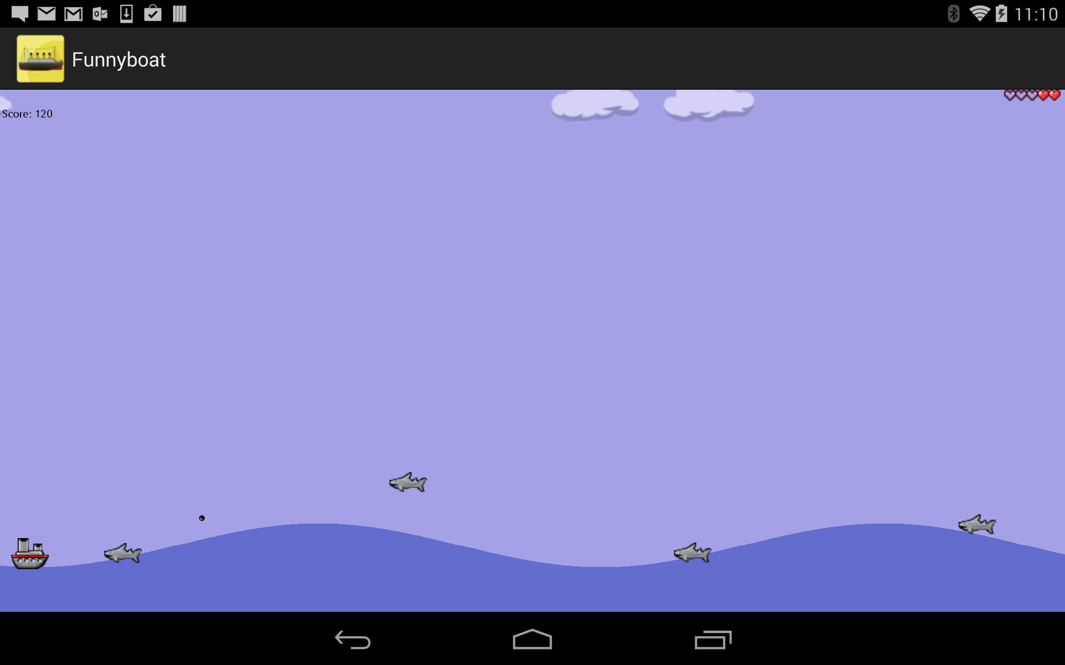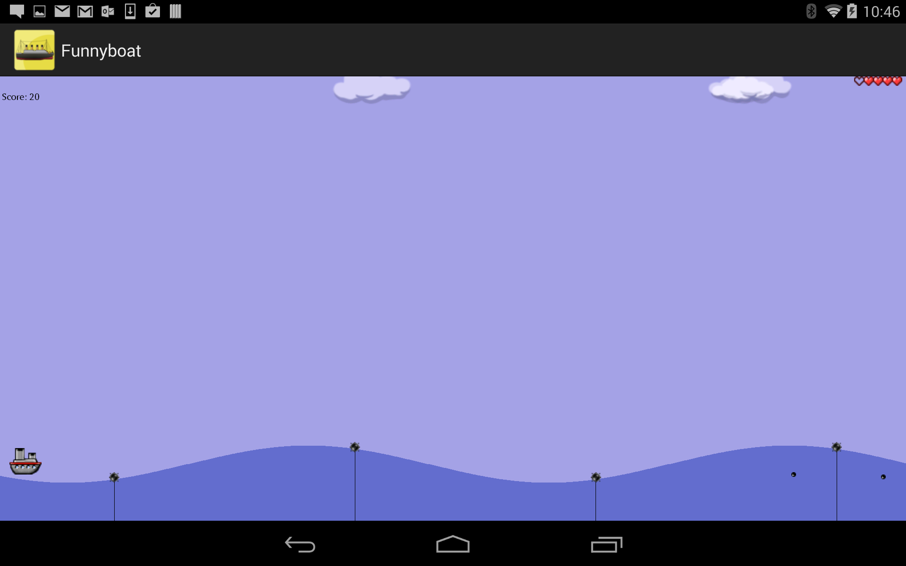

This is the open source game. We downloaded the game source code and using the motion sensor classes, which are provided in the FlappyCow game, we implemented the ship jumping part of the game by using the sensor tag. Code changes and the updated code are available in the github in the following location.