Funny boat is a mobile based game, which can be operated by the touch. The changes have been made in the code to respond to the gestures made by the sensor device. All the events that could be handled by the touch action, now, can also be handled by the motion activities.

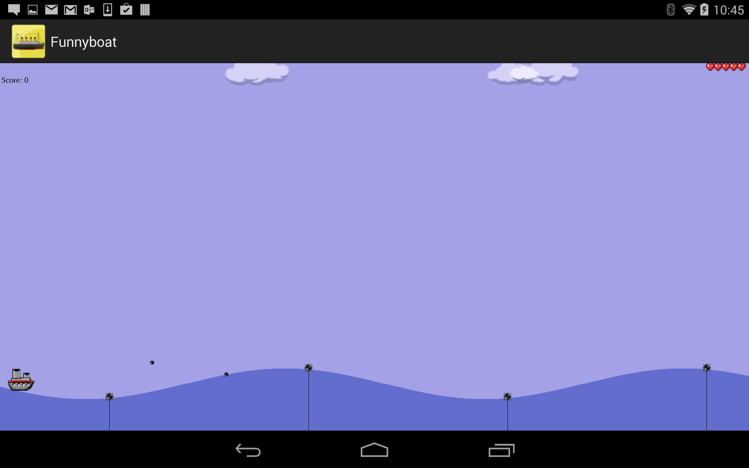

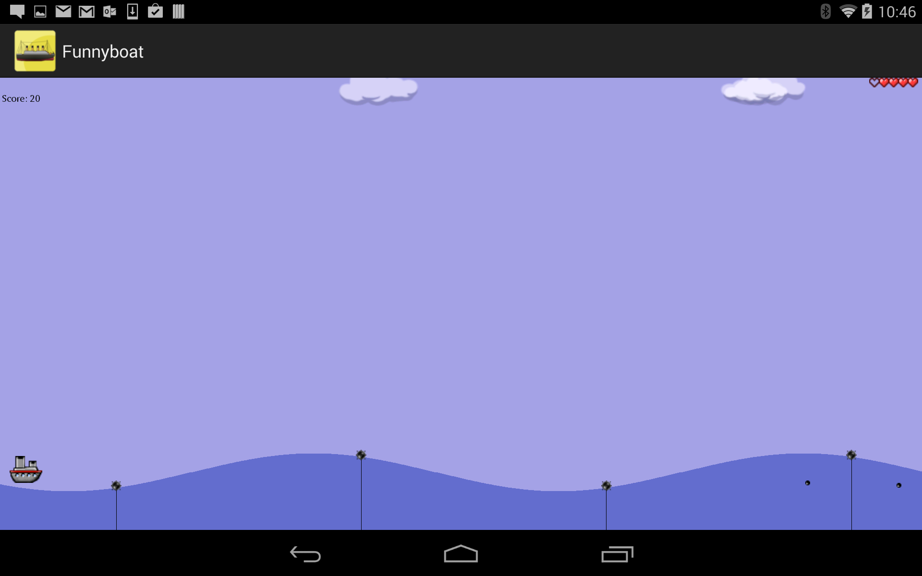

The six different gestures will be identified in the game. The pie chart has been prepared for 6 different gestures and the number of gestures made in each game. The application looks as follows.

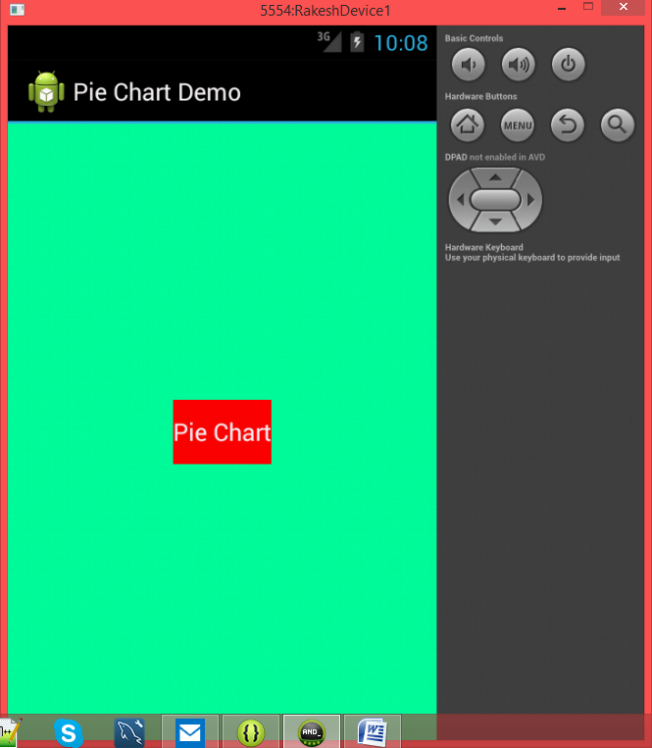

If we press the "Pie Chart" button in the above screen, this will show the following pie chart

