|  |  |
| --- | --- |
| Sentiment ANALYSIS | CS590RA  Real Time big data analytics |

By

L V Sandeep Bathina Class-ID: 3

Rakesh Vistarakula Class-ID: 16

Table of Contents

|  |  |  |
| --- | --- | --- |
| S.No | Description | Page No |
| 1. | Design   1. Data model (features) 2. Sentiment analysis model and algorithm 3. Selection of datasets 4. Mobile App/web design | 3 |
| 2. | Features Implemented   1. Sentiment analysis algorithms 2. Predictive algorithms 3. Mobile User Interface | 9 |
| 3. | Outputs: | 13 |
| 4. | Website URL’s: | 17 |
| 5. | Github URL | 20 |
| 6. | Limitations | 24 |
| 7. | References | 25 |

1. Design
2. Data Model (features):

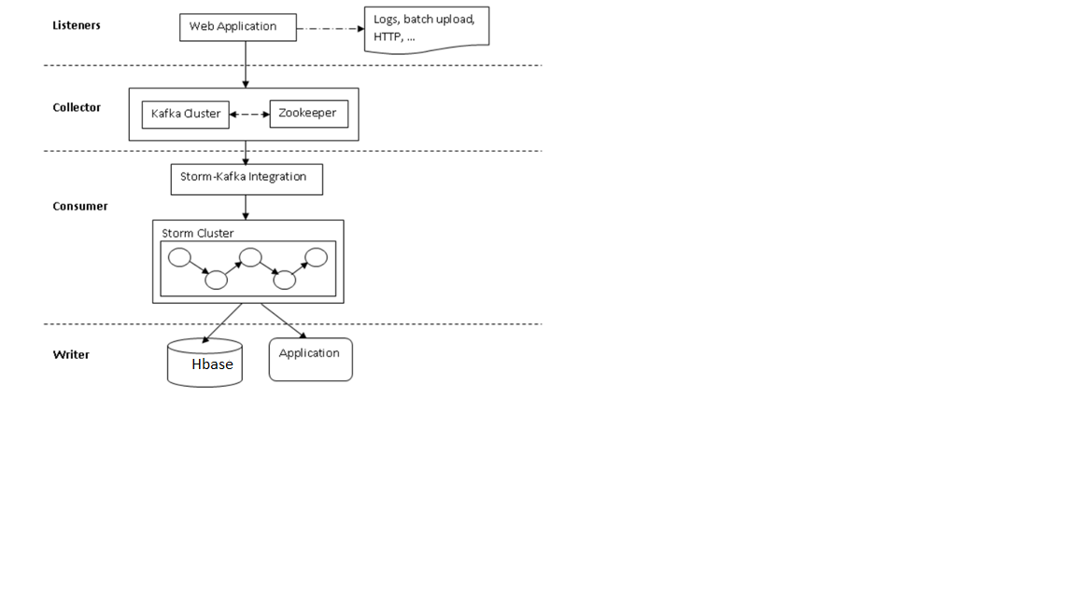

1. Listener:

The raw activity data has to be processed as a stream which is consumed by the storm.

1. Collector:

Kafka here is a messaging system which acts as pipeline between storm and data processing.

1. Consumer:

All data processed by collector consists of stream of data and some associated metadata.

1. Writer:

The standard data writer writes to applications and databases like hbase and file systems.

1. Sentiment Analysis model and algorithm:

The algorithm we used here is naïve bayes classification algorithm. The approach followed here is by using weka tool.

1. Recommendation model and algorithm:

Will use this feature in future.

1. Selection of datasets:

Here we are using twitter dataset by using twitter4j jar file where we get the tweets in a real time basis. We capture this data and store them in text file format.

1. Mobile App/Web design:

The mobile app we are using here is ANDROID.

1. Features Implemented:
2. Sentiment analysis and algorithms:

Naive bayes analysis algorithm: The system is mainly based on naïve-bayes classifier for detecting polarity of the tweets. The best performance here is calculated based on the polarity categories positive and negative. Evaluation results shows good performance when it is used to detect four sentiment categories.

1. Predictive algorithms:

Not yet used.

1. Mobile user interface:

The interface we developed here is by using Android application.

1. Initially a button is created and when the button gets clicked, all the tweets get displayed over here with their tweet ids.
2. The analysis button is created and when the user clicks on the button the sentiment analysis part of each tweet is calculated and displayed over there.
3. The next button created over here is the visualization button which displays the piechart of analysis part and no.of tweets of those are displayed here.
4. Outputs:

Strom Local:

1. Initially install storm , Kafka, zookeeper and hbase
2. Run the below command in storm
3. Before this, modify the habakkuk.properties file and provide your twitter id and keys. This is required to generate the live streaming twitter tweets.
4. The tweets gets displayed on the console.

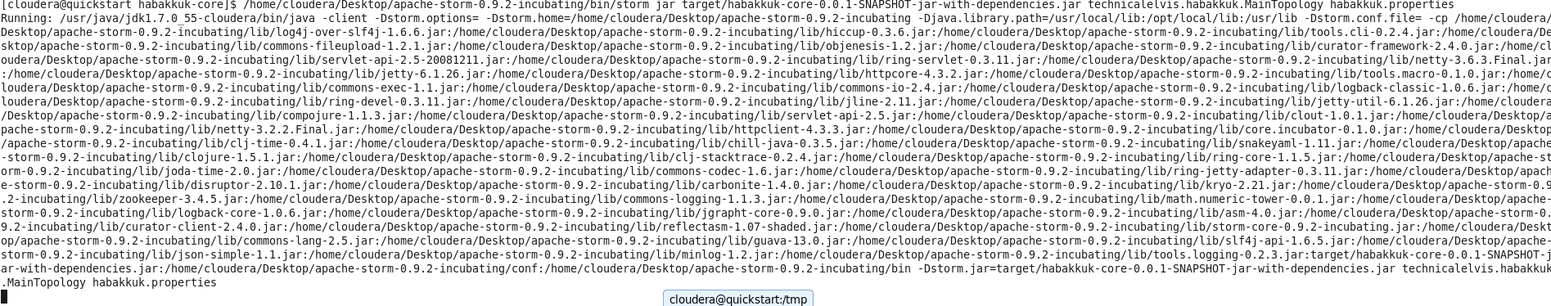

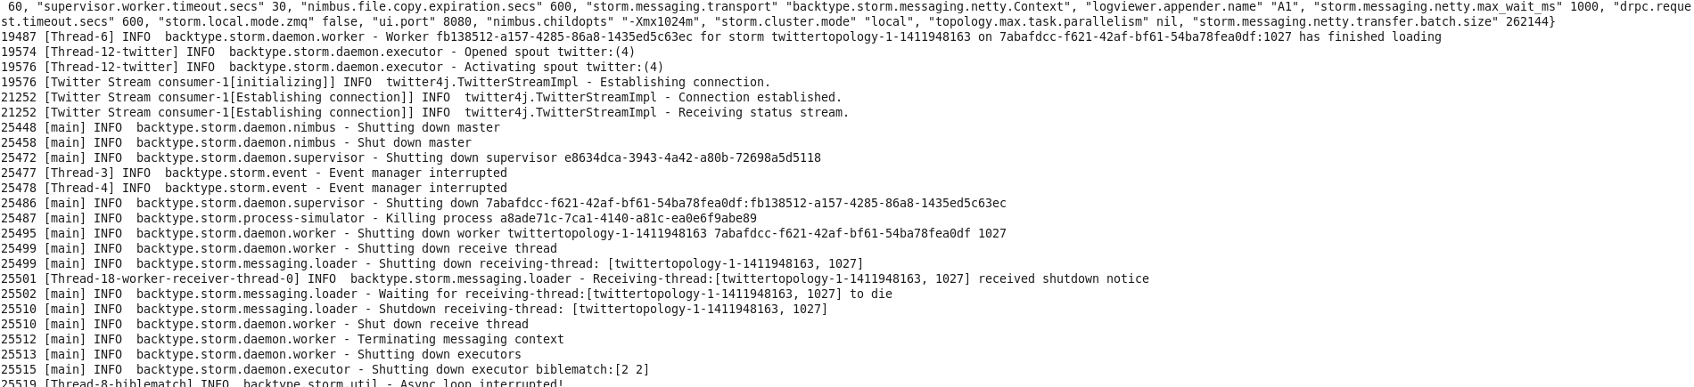

Generated real time streaming output is sent to a file

1. Modify the file printerbolt.java
2. Write the file writer code to extract the tuples of tweets to a file.
3. Provide the exact path in the code so that this can be used to analyze the tweets

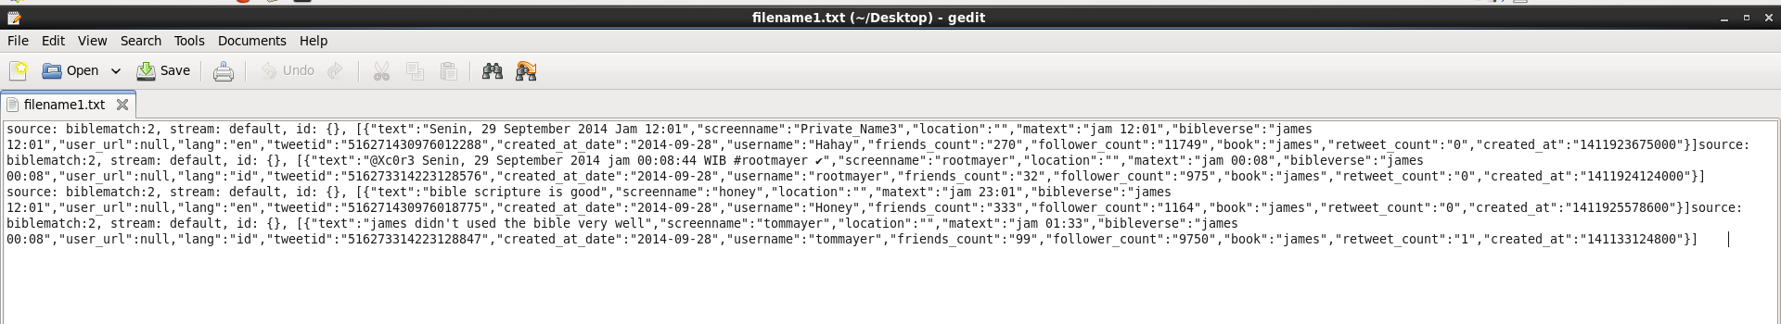

Now the tweet text messages are collected and sent to the csv file

1. In order to analyze the tweets, we need to convert text file of tweets to csv format.
2. We need to append any special character at the end of each tweet.
3. This format must be followed in order to analyze data with training data.

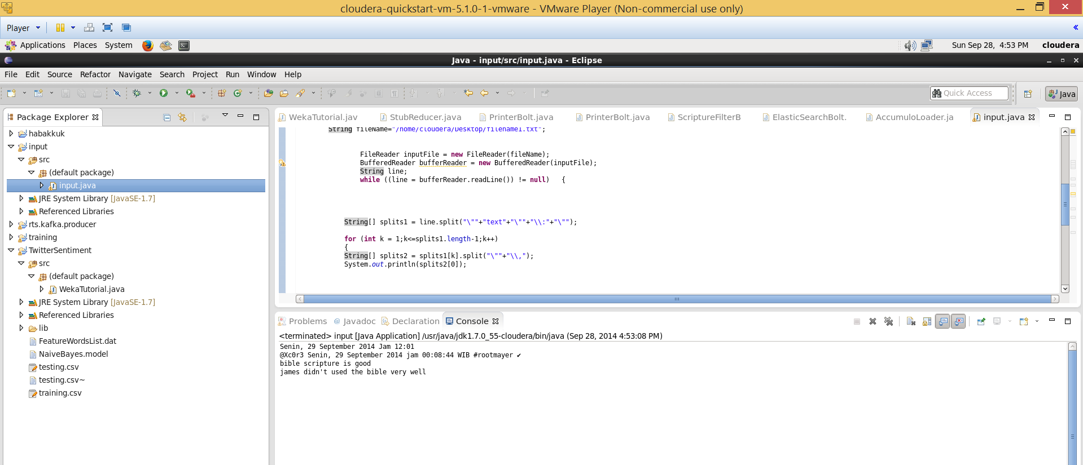

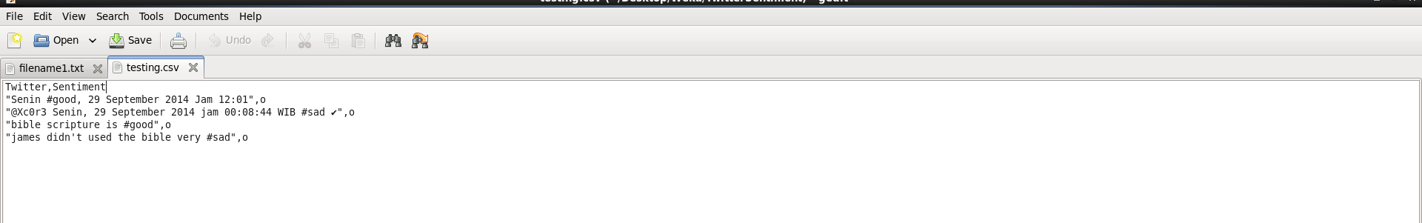

Now run the Analysis algorithm over this generated data

1. The generated csv file is fed to the twitter sentiment code
2. Here we uses weka jar to use the naïve bayes algorithm so that positive negative tweets can be identified over this.
3. Each tweet is analyzed and displayed on the console.

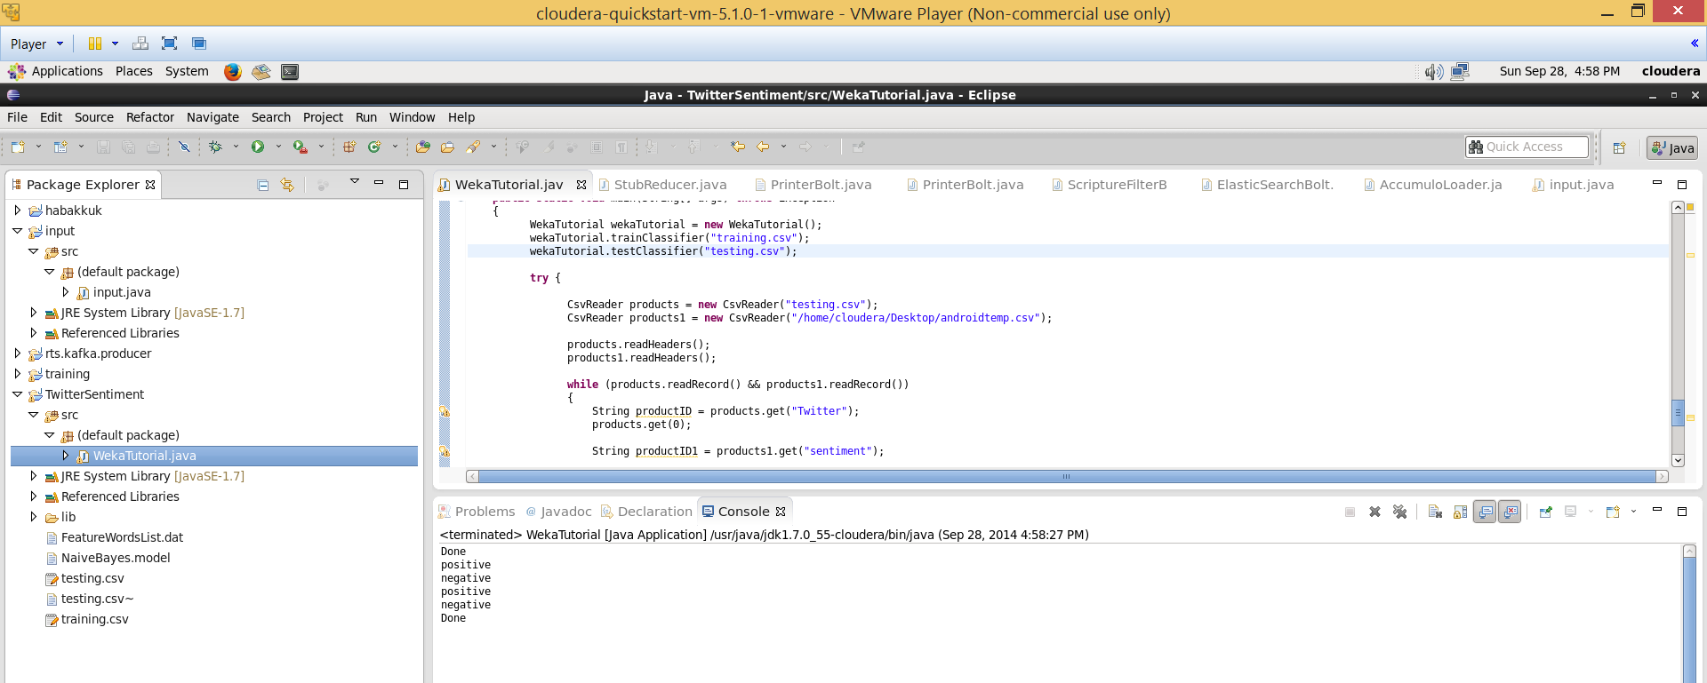

The tweets analysis is displayed here on the console and saved on to a file

1. Apart from his, he analyzed part is stored in to a file along with their corresponding tweets.
2. This file can be used for showing analysis and visualization to the user by using android application .

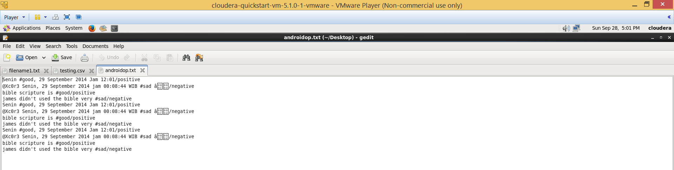

Android:

Now run the android app on the generated tweets

1. Initially create two buttons
2. First button dispalys tweet messages
3. Second button displays no.of positive and negative tweet analysis report.
4. Along with this the visualization part of pie chart is shown displaying percentage of positive and negative tweets.

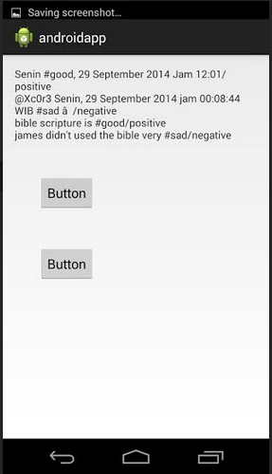

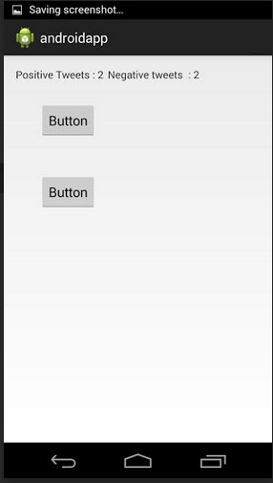

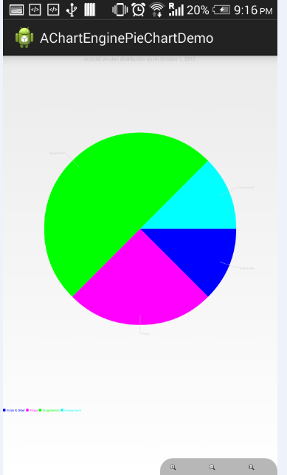

1. Website URL’s:

<http://blog.csdn.net/hljlzc2007/article/details/13275441>

<http://gramatica.usc.es/~gamallo/artigos-web/TASS2013.pdf>

<https://www.google.com/search?hl=en&site=imghp&tbm=isch&source=hp&biw=1536&bih=755&q=twitter+logo&oq=twitter+l&gs_l=img.3.0.0l10.1103.3765.0.4721.9.8.0.1.1.0.253.934.5j2j1.8.0....0...1ac.1.54.img..0.9.933.IpKE-td4Uzc#facrc=_&imgdii=_&imgrc=Z60PgD9iMKtm5M%253A%3BuY8NrGIitp5hnM%3Bhttp%253A%252F%252Floopele.com%252Fwp-content%252Fuploads%252F2014%252F07%252Ftwitter-logo.jpg%3Bhttp%253A%252F%252Floopele.com%252Ftwitter-logo%252F%3B1024%3B831>

<http://www.csvreader.com/java_csv_samples.php>

<http://stackoverflow.com/questions/2346713/csv-row-reader-question>

<https://blackboard.umkc.edu/webapps/blackboard/content/listContent.jsp?course_id=_114034_1&content_id=_1371866_1&mode=reset>

<http://www.java2s.com/Code/Jar/j/Downloadjavacsvjar.htm>

1. GitHub URL:

http://github.com/rakeshvista1/RTA-Challenge1

1. Limitations:

We are getting the real time tweet messages, but we can’t able to pass that to the application as a continuous stream to be analyzed. We are just analyzing only the specific tweets which we got.

In the next challenge, we are going to pass he real time tweets dynamically.

1. References:

<http://blog.csdn.net/hljlzc2007/article/details/13275441>

<http://gramatica.usc.es/~gamallo/artigos-web/TASS2013.pdf>

<https://www.google.com/search?hl=en&site=imghp&tbm=isch&source=hp&biw=1536&bih=755&q=twitter+logo&oq=twitter+l&gs_l=img.3.0.0l10.1103.3765.0.4721.9.8.0.1.1.0.253.934.5j2j1.8.0....0...1ac.1.54.img..0.9.933.IpKE-td4Uzc#facrc=_&imgdii=_&imgrc=Z60PgD9iMKtm5M%253A%3BuY8NrGIitp5hnM%3Bhttp%253A%252F%252Floopele.com%252Fwp-content%252Fuploads%252F2014%252F07%252Ftwitter-logo.jpg%3Bhttp%253A%252F%252Floopele.com%252Ftwitter-logo%252F%3B1024%3B831>

<http://www.csvreader.com/java_csv_samples.php>

<http://stackoverflow.com/questions/2346713/csv-row-reader-question>

<https://blackboard.umkc.edu/webapps/blackboard/content/listContent.jsp?course_id=_114034_1&content_id=_1371866_1&mode=reset>

<http://www.java2s.com/Code/Jar/j/Downloadjavacsvjar.htm>