**FlyAway-Ticket Booking Portal**

This document contains sections for:

* Sprint planning and Task completion
* Core concepts used in project
* Flow of the Application.
* Demonstrating the product capabilities, appearance, and user interactions.
* Unique Selling Points of the Application
* Conclusions

The project is developed by Rakesh Roshan.

## **Sprints planning and Task completion**

The project is planned to be completed in 1 sprint. Tasks assumed to be completed in the sprint are:

* Creating the flow of the application
* Initializing git repository to track changes as development progresses.
* Writing the Java program to fulfill the requirements of the project.
* Testing the Java program with different kinds of User input
* Pushing code to GitHub.
* Creating this specification document highlighting application capabilities, appearance, and user interactions.

## **Core concepts used in project**

JDBC database, File Handling, Sorting, Flow Control, Recursion, Exception Handling, Streams API.

## **Flow of the Application**

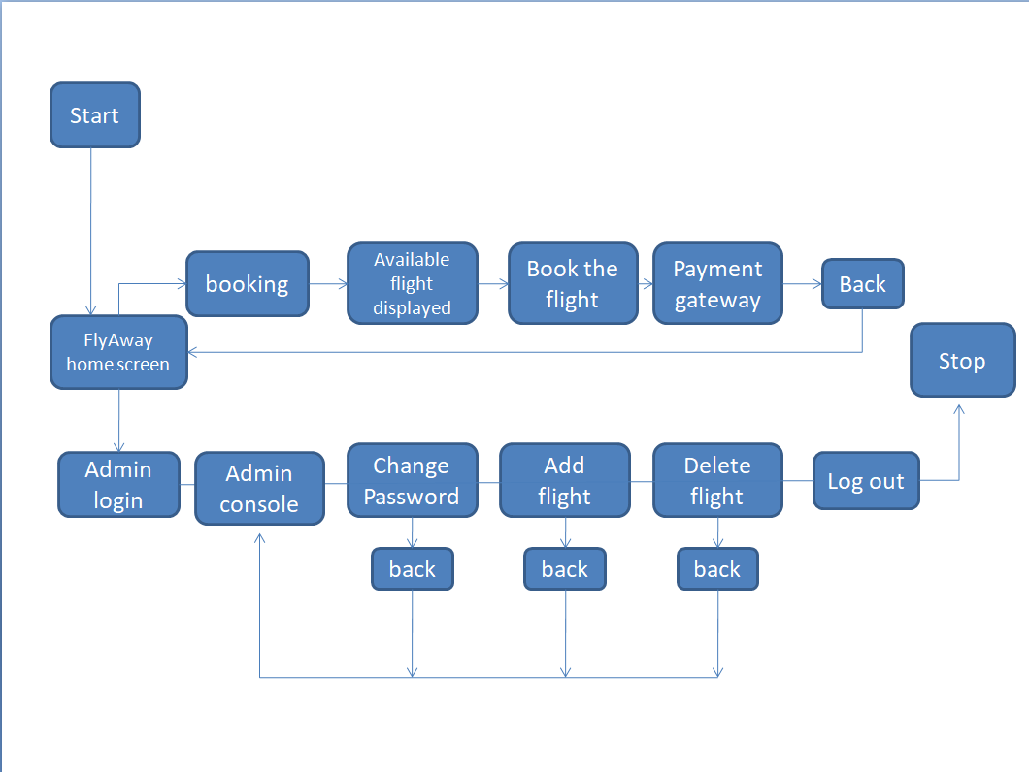



**Demonstrating the product capabilities, appearance, and user interactions**

To demonstrate the product capabilities, beloware the sub-sections configured to highlight appearance and user interactions for the project:

* Create table admin with username and password in Sql workbench.
* Creating the dynaminc web page project in Eclipse with com.admin as package.
* Writing a body frame in html for the entry point of the application (index.html).
* Writing a java servlet code for the login of the application (Admin.java).
* Writing a body frame in html for welcome page of the application (1.html).
* Writing a body frame in html for password change page of the application (cp.html).
* Writing a java servlet code for the changing login password of the application(Change.java).
* Create table flight with flightnumber,source,destination,time,duration and price in Sql workbench.
* Writing a body frame in html for flight addition page of the application (add.html).
* Writing a java servlet code for flight addition of the application (AddFlight.java) with sql.
* Writing a java servlet code for flight deletion of the application (Delete.java) with sql.
* Writing a java class code for checking error flight deletion in the application (Flights.java) with sql(FlightsDB.java).
* Write a java code for CSS design in jsp format (show-flights.jsp).
* Writing a java servlet code for book flight of the application (Book.java) with sql.
* Write a java code for CSS design in jsp format (booking.jsp).
* Writing a java filter code for payment gateway of the application (Payment.java) .
* Writing a java servlet code for Customer detail of the application (Customer.java) .
* Writing a body frame in html for payment page of the application (payment.html).
* Writing a java servlet code for checking validation of the application (Validation.java) .
* Writing a XML Code for payment gateway of the application(web.xml) .
* Writing a java servlet code for payment success of the application(PaySuccess.java)
* Pushing the code to GitHub repository

## **Unique Selling Points of the Application**

1. The application is designed to keep on running and taking user inputs even after exceptions occur. To terminate the application, appropriate option needs to be selected.
2. The application is designed to carry out work with authentication with exception handling.
3. User is also provided with separate display file for each process for better clean business.
4. The application also allows user to delete and also add fights with details
5. The application also provide password change facility for security.
6. The portal also serve complete book of flight with payment gateway linked with better response.

## 

## **Conclusions**

Further enhancements to the application can be made which may include:

* Conditions to check if user login is allowed valid or not.
* Asking user to verify if they really want to change password or not
* Retrieving data,booking and complete payment gateway linked.
* Allowing user to append data to the file.