NOKIA SOLUTIONS AND NETWORKS

-RAKHA CHANDRE.KANUMURI

I joined Nokia Solutions and Networks as an intern on 24th July,2019. Then I was introduced to my mentor Mr.Velumurgan sir . Myself and Raju Katkam are under the guidance of Mr. Velumurgan sir. Then our mentor explained us about the functioning of the factory and gave a brief explanation about Surface Mounting Technology (SMT) .We have seen the various machines that are used in the manufacturing process and got to know the role of each and every machine that are present in the factory.

TASK:

WEB SCRAPPING USING PYTHON.

Then Sir assigned us two tasks, One we have to calculate the time taken and distance travelled by one worker in the process of manufacturing PCB’s. Then we have to generate a report. Second, is to write a code, that is when a work is done a report is being generated on the website of Nokia, from that they are copying the required information and pasting it on Excel and selecting the required rows and coloumns from it and then printing the sheet, But what we have to do is to write a code so that it automatically selects the required information from either Excel or Website and then we have to get a print of that sheet. We both have started carrying out our first task. We went to the shop floor for calculating the amount of work done ,time taken for completing that particular task ,total steps taken and plotting the layout. We have noted down the number of trips that take place in each day with each line and have submitted the entire information in tabular coloumn . I completed plotting the pictorial view (Layout) of Day1 and Day2 which consisted of 7 SMT Lines, Material Control Area(MCA) and I have plotted the routes that are used by the workers in each trip using paint.

* LAYOUT

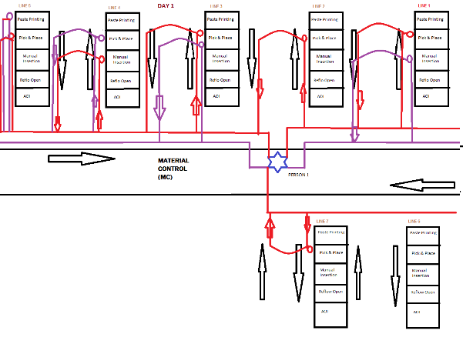 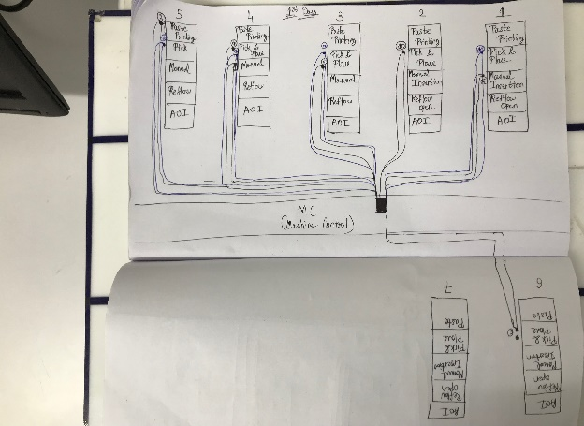

After that I started working on importing live data from a website into excel using python. Then we have to filter the data from the web according to the user and then print that python output to a excel file and then directly print it using printer.

* IMPORTING LIVE DATA FROM WEBSITE:

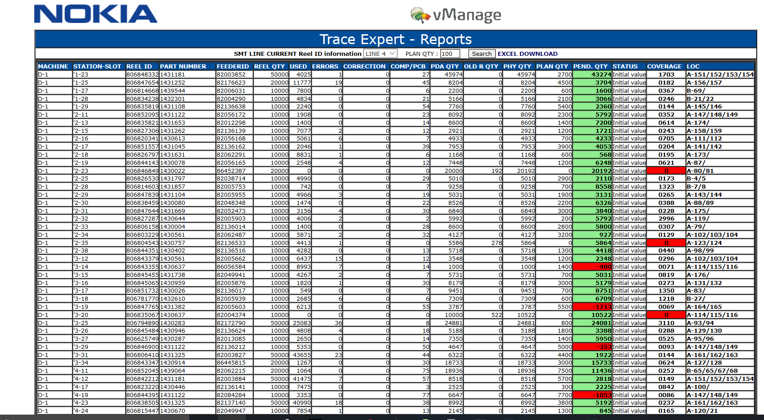

* python code for importing required data only.(DYNAMIC WEB SCRAPPING)

(I used pandas and data frame for importing live data)

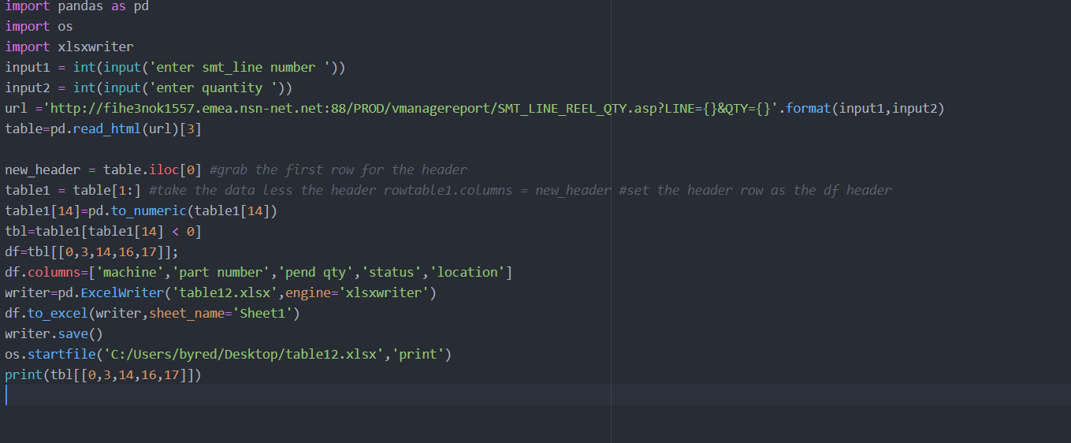

* EXECUTED OUTPUT:

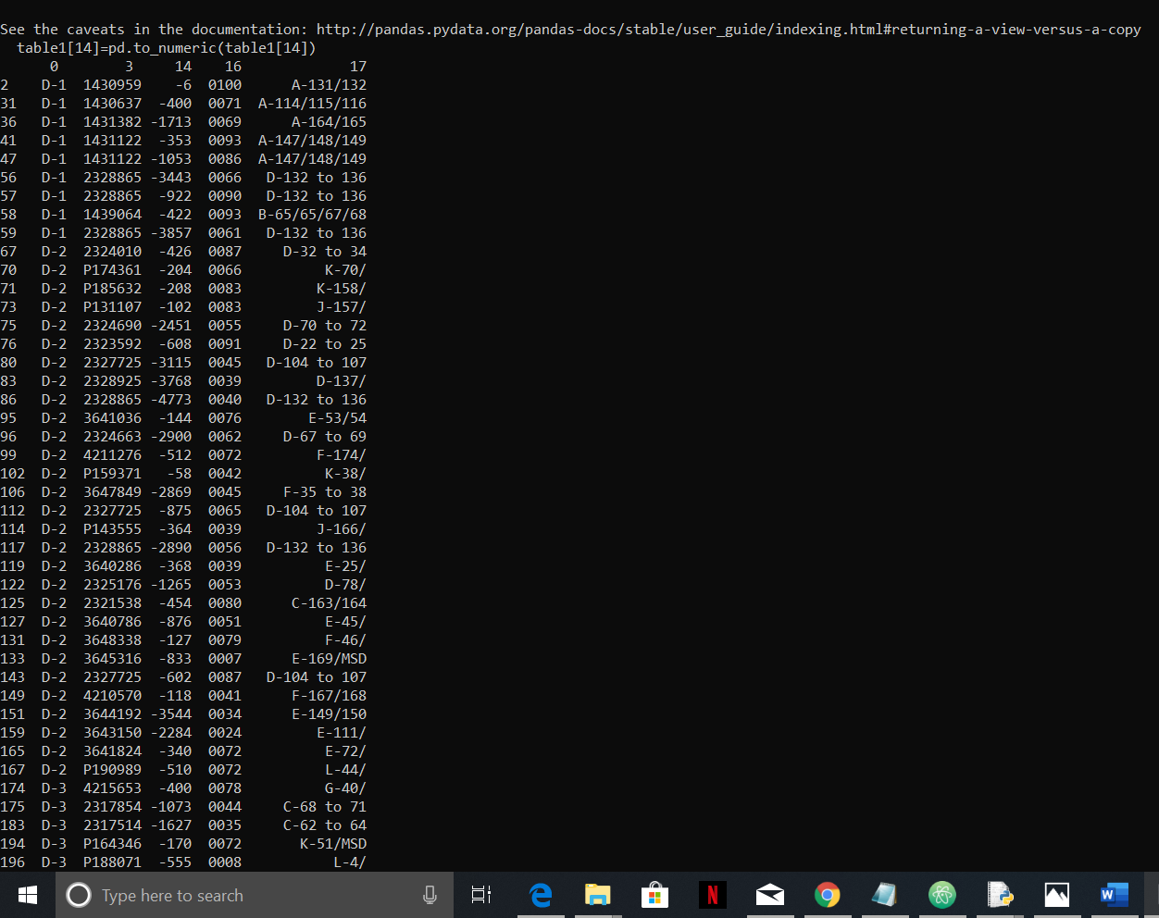

* OUTPUT PRINTS TO EXCEL AND THEN TO PRINTER:

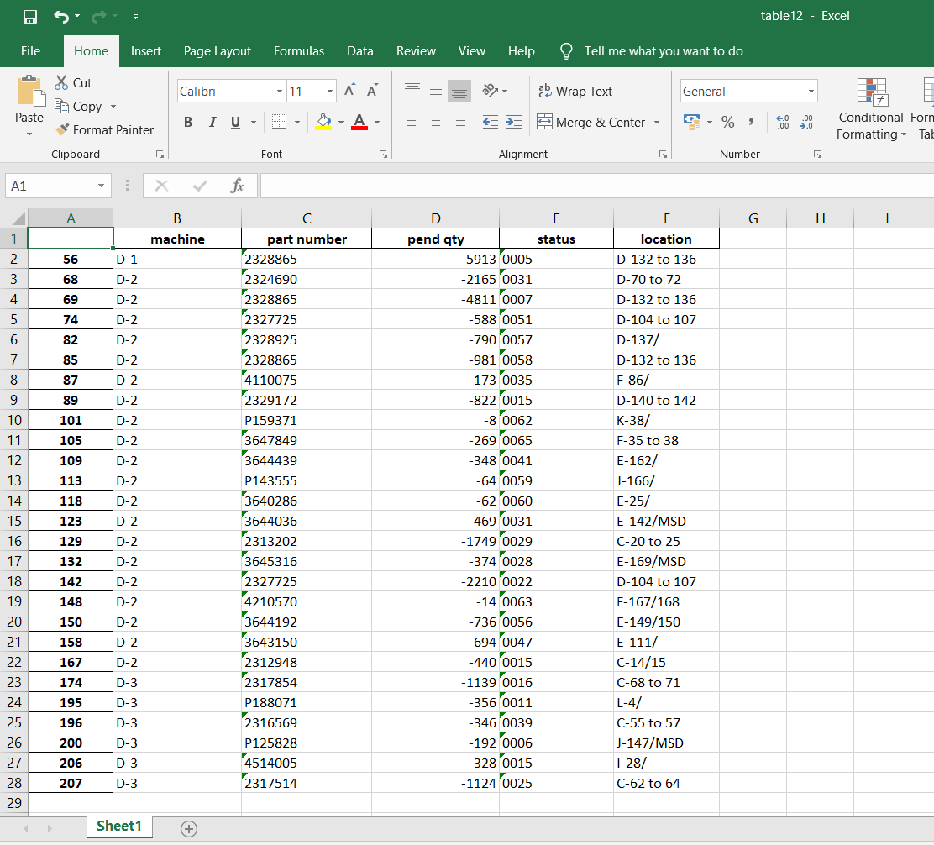

Then Sir gave me a task to build a webpage in which we have to give input quantity i.e to select the line and to enter the quantity required by the user, then after selecting the submit button this website output should get linked with the code that I wrote. I completed creating a website using html. Then I have linked this website output to the python code that I wrote using flask.

* CREATED A WEBPAGE USING HTML:

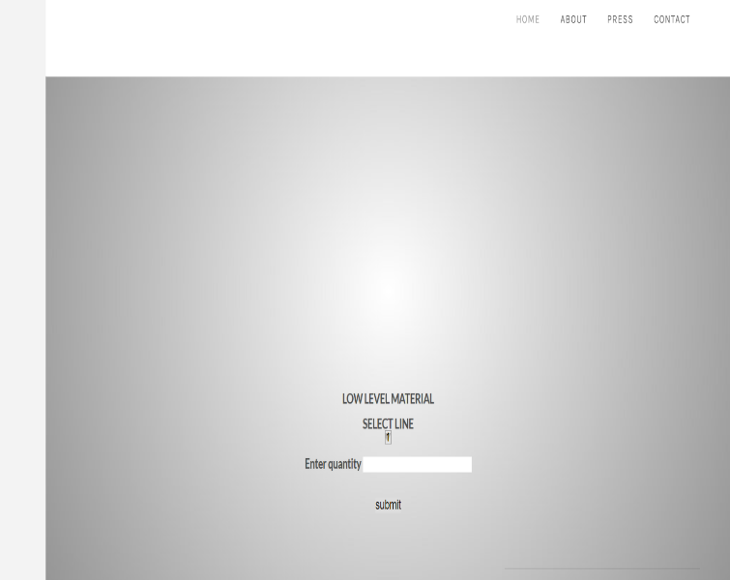

* WRITTEN A CODE USING FLASK:

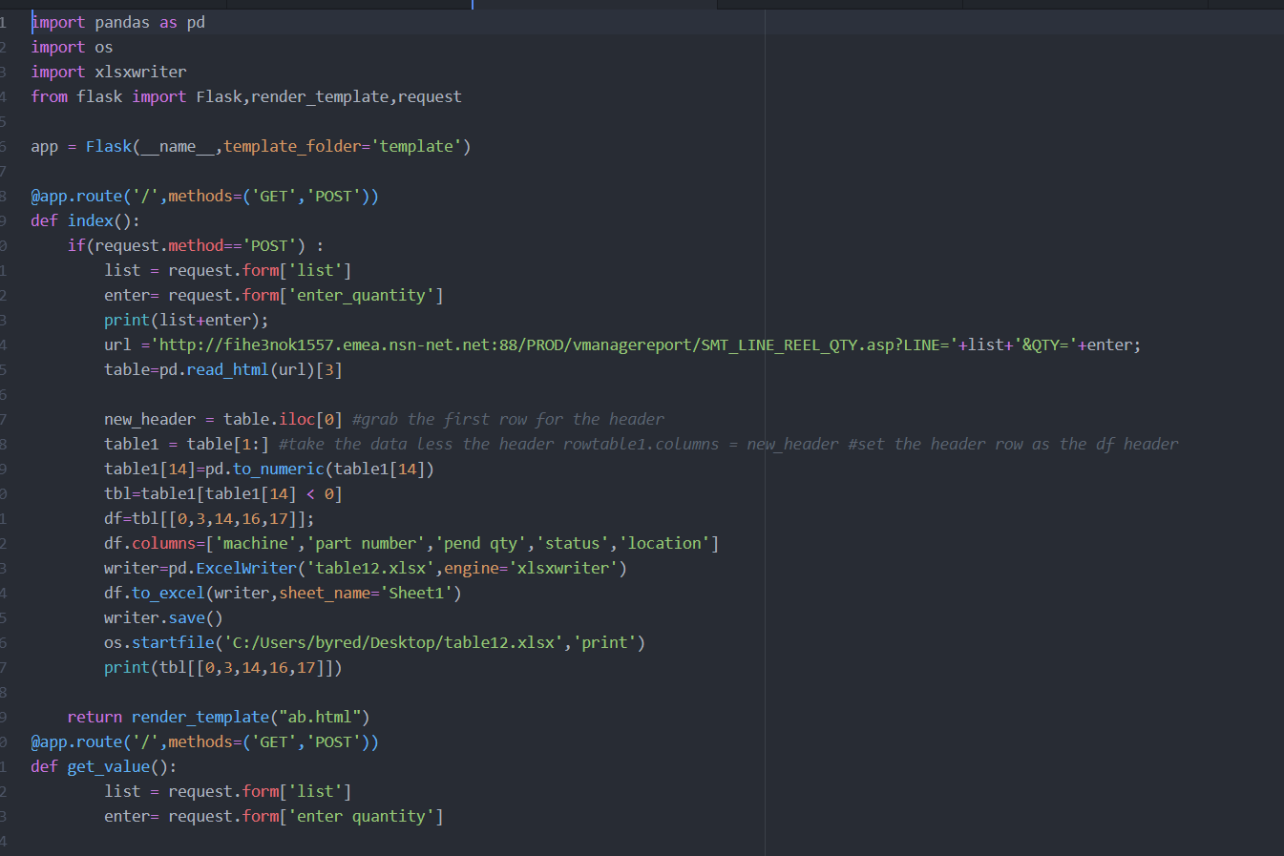

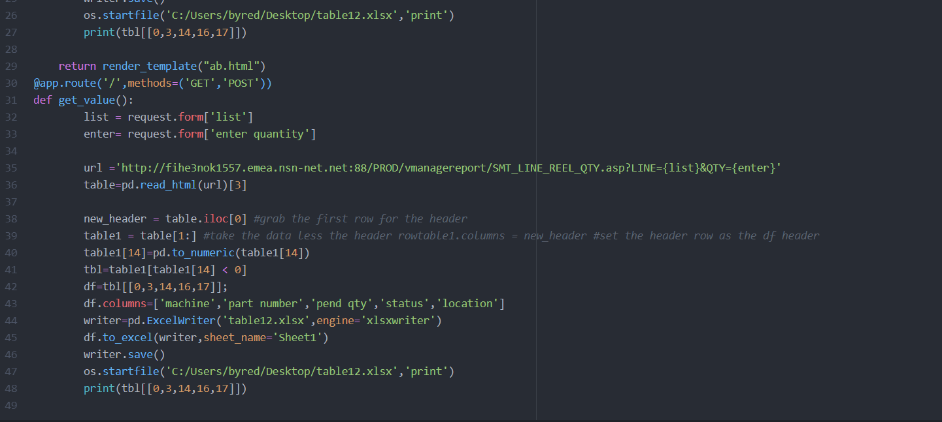

* EXECUTED OUTPUT:

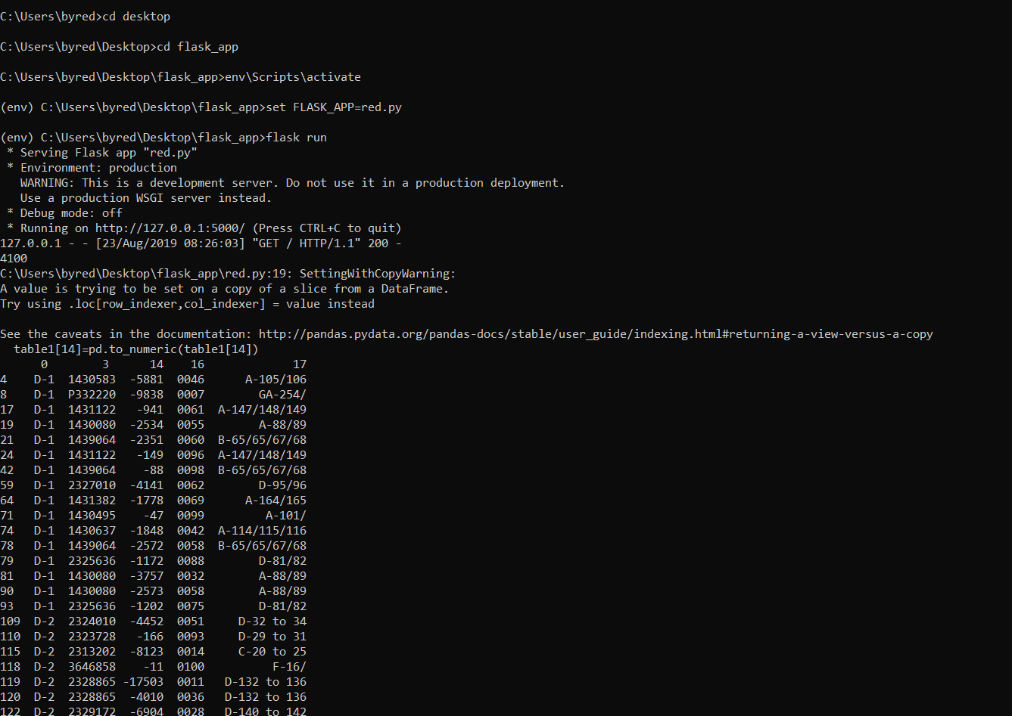

* OUTPUT GETTING SAVED IN EXCEL:

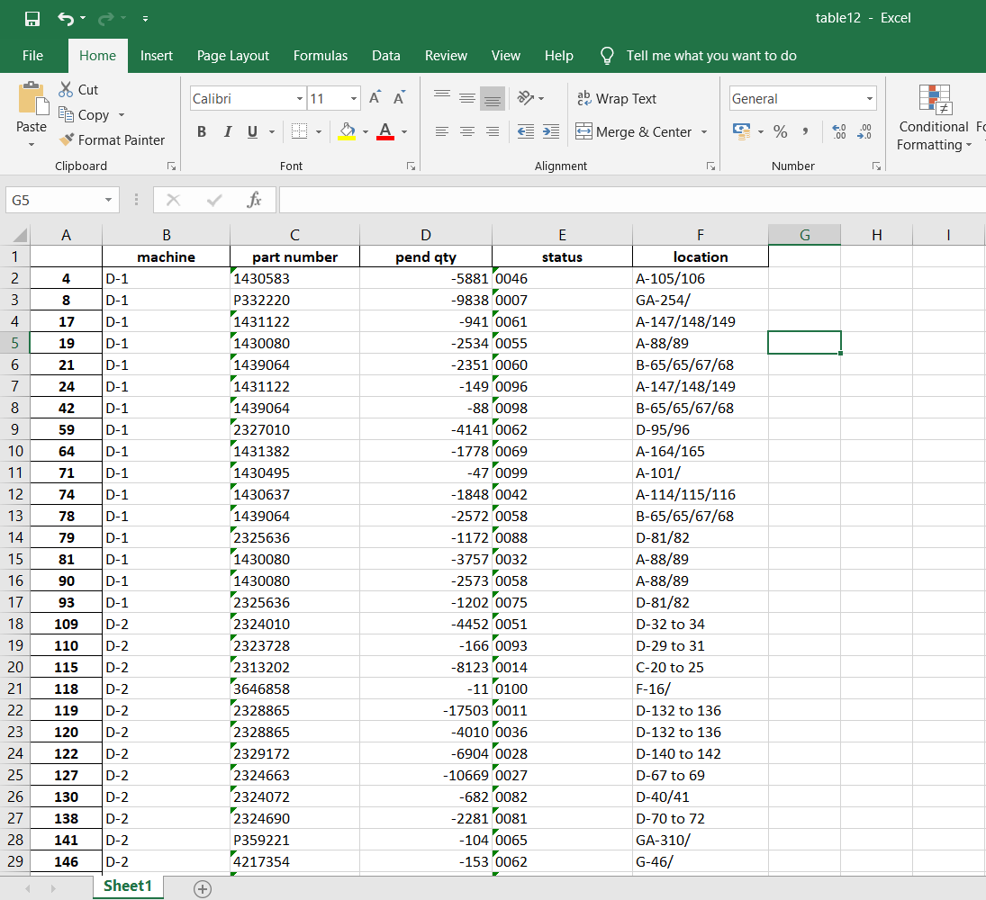

* EXCEL FILE GETTING PRINTED:

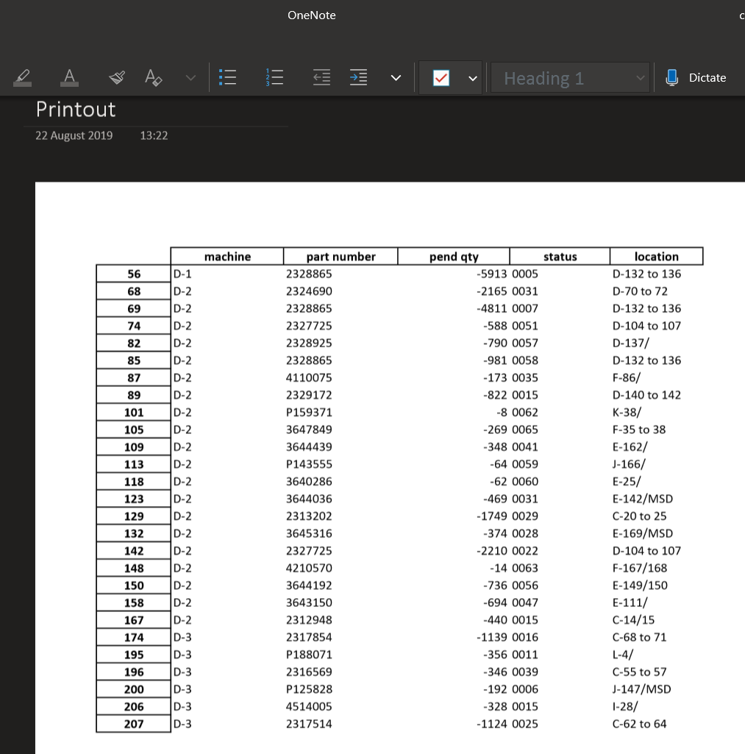

Therefore, I successfully completed the task that was given by my mentor. Then Mr Agni sir gave me a task to prepare a power point presentation on image processing applications used at Airports. I have prepared a ppt which consisted of different image processing applications like X-ray baggage inspection, Body Scanner , Facial Recognition that are used at airport and has submitted it.

I SUCCESSFULLY COMPLETED ALL THE TASKS THAT ARE GIVEN TO ME.