PROJECT SYNOPSIS
AI-Powered Legal Document Summarizer & Risk Analyzer
Category: AI/ML Integrated Web Application
Academic Year 2025–26

Contents
1. Introduction 2
2. Objectives 3
3. System Design — Data Flow Diagrams (DFD) 4
3.1 DFD Level 0 — Context Diagram 4
3.2 DFD Level 1 — Main Process Decomposition 4
3.3 DFD Level 2 — Explosion of Process 3.0: AI NLP Pipeline 6
4. Entity-Relationship (ER) Diagram 7
4.1 Entity Descriptions 7
4.2 Relationship Summary 7
5. System Architecture Diagram 9
5.1 Layer-by-Layer Description 9
Layer 1: Presentation Layer (React.js SPA) 9
Layer 2: Application / API Layer (FastAPI) 9
Layer 3: AI Engine Layer (NLP Pipeline) — Core Detail 10
Layer 4: Data Layer 11
Layer 5: Infrastructure & Security 12
6. Database Design — Table Schemas 13
6.1 Table: USERS 13
6.2 Table: DOCUMENTS 13
6.3 Table: ANALYSIS_REPORTS 13
6.4 Table: RISK_CLAUSES 14
7. Tools and Technologies 15
8. Testing and Validation Strategy 16
9. Module Description 17
9.1 User Authentication Module 17
9.2 Document Management Module 17
9.3 AI NLP Processing Module 17
9.4 Report Generation Module 18
9.5 Admin Panel Module 18
9.6 User Dashboard Module 19
10. Limitations 20
11. Future Scope 22
11.1 Short-Term Enhancements (v1.1 — v1.5) 22
11.2 Medium-Term Enhancements (v2.0) 22
11.3 Long-Term Vision (v3.0+) 23
12. Bibliography 24

1. Introduction
The legal domain involves documents of enormous complexity — contracts, agreements, terms of service, employment letters, and more. Reading and interpreting such documents requires significant legal expertise and time. For individuals and small businesses without dedicated legal counsel, this presents a major challenge: critical clauses, risky obligations, and ambiguous language can be easily overlooked.

This project addresses that challenge by delivering an intelligent, web-based platform that leverages state-of-the-art Natural Language Processing (NLP) to automate two key tasks: (1) generating concise, plain-English summaries of complex legal documents, and (2) identifying and flagging potentially high-risk clauses such as Indemnity, Termination, Liability Limitation, and Non-Compete clauses.

The system is built as a full-stack web application with a React.js front end, a FastAPI (Python) backend serving AI models, and a PostgreSQL database for secure data persistence. The AI engine is powered by the Hugging Face Transformers library, utilizing the BART and T5 model families for summarization and zero-shot classification for clause detection via Natural Language Inference (NLI).

2. Objectives
The primary objective is to create a secure, web-enabled application that automates the legal document review process. The specific objectives are:

- Automated Summarization: Convert lengthy, complex legal language into concise, plain-English summaries that any non-expert can understand.
- Risk Highlighting: Automatically detect, classify, and highlight high-risk clauses including Indemnity, Termination, Liability, Non-Compete, and Confidentiality clauses.
- Secure Document Management: Provide an authenticated dashboard for users to securely upload, store, and retrieve their legal documents and analyses.
- Report Generation: Enable users to download complete analysis reports as PDF files for offline review and record-keeping.
- Scalable Design: Architect the system in a modular fashion that allows new legal domains and model types to be incorporated in future iterations.
- Admin Controls: Provide an administrative interface for managing risk definitions, clause rules, and user accounts.

3. System Design — Data Flow Diagrams (DFD)
Data Flow Diagrams (DFDs) model the flow of data through the system at different levels of abstraction. They show the inputs, outputs, processes, and data stores that make up the system without prescribing implementation details.

3.1 DFD Level 0 — Context Diagram
What is a Context Diagram?
A Level 0 DFD (Context Diagram) provides the highest-level view of the entire system. It shows the system as a single process bubble and identifies all external entities that interact with it, along with the data flows between them.

At the context level, the system is represented as a single process: "AI-Powered Legal Document Summarizer & Risk Analyzer." Two external entities interact with it: the User (who uploads documents and receives analysis reports) and the Admin (who manages risk rules and users). A PostgreSQL data store persists all application data.
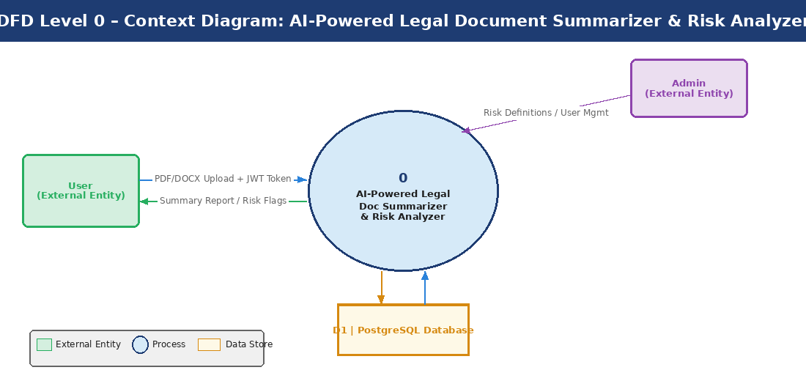
Figure 3.1 — DFD Level 0: Context Diagram showing the system boundary and all external entities

Entity / Component | Type | Interaction Description
User | External Entity | Uploads PDF/DOCX files; receives summaries and risk reports; authenticates via JWT.
Admin | External Entity | Manages risk clause definitions, user accounts, and system configuration via Admin Panel.
PostgreSQL Database | Data Store (D1) | Persists user records, document metadata, analysis reports, and session data.
AI Legal Analyzer System | Process (0) | Core system that accepts documents, processes them through AI, and returns structured analysis reports.

3.2 DFD Level 1 — Main Process Decomposition
What is a Level 1 DFD?
A Level 1 DFD expands the single process from Level 0 into its major sub-processes. Each sub-process handles a distinct functional area of the system, and data flows connect them along with external entities and data stores.

The Level 1 diagram decomposes the main system into six major processes: User Authentication, Document Upload & Parsing, AI NLP Pipeline (the core processing engine), Report Generation, Database & Storage management, and the Admin Panel.
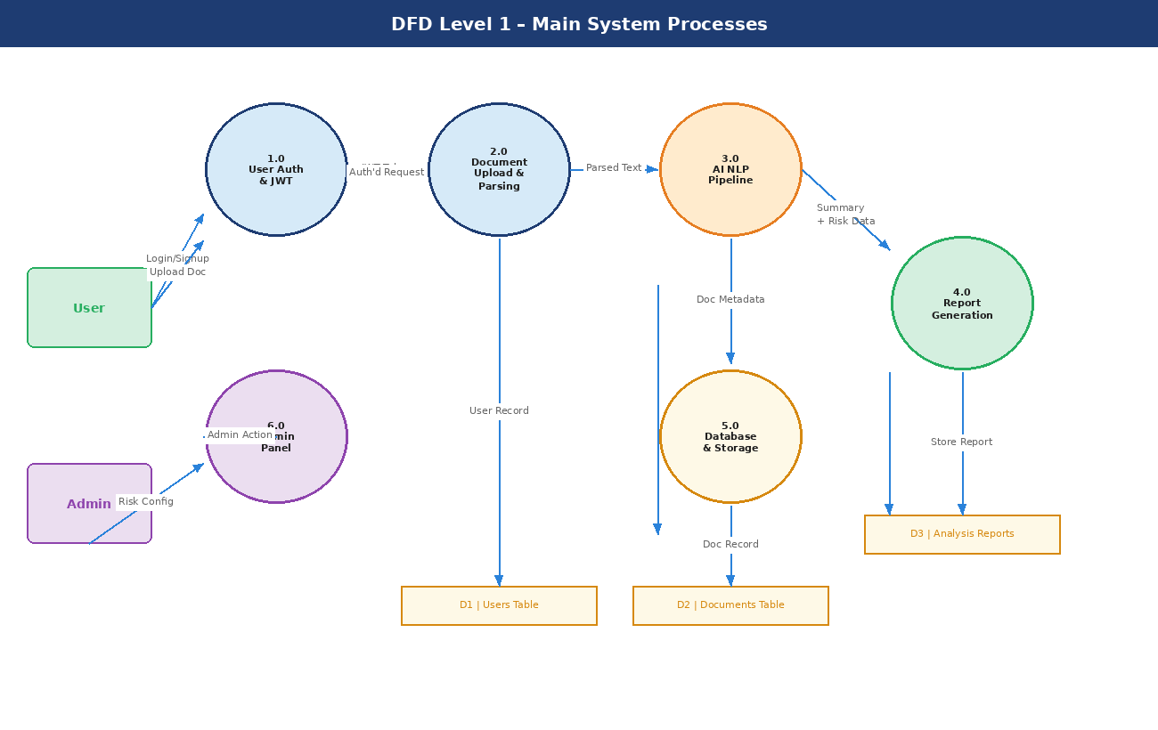
Figure 3.2 — DFD Level 1: Decomposition into six major functional processes

Process ID | Process Name | Inputs | Outputs | Description
1.0 | User Auth & JWT | Email, Password | JWT Token | Validates credentials against D1; issues signed JWT tokens for authorized sessions.
2.0 | Document Upload & Parsing | PDF/DOCX File + JWT | Parsed Text + Metadata | Validates file type, extracts raw text using PyMuPDF/python-docx, stores metadata in D2.
3.0 | AI NLP Pipeline | Parsed Text | Summary + Risk Data JSON | Core AI engine: summarizes text and classifies risk clauses. Expanded in Level 2.
4.0 | Report Generation | Summary + Risk Data | Formatted Report | Assembles AI output into a structured report; supports PDF export via jsPDF.
5.0 | Database & Storage | All system data | Persisted Records | Manages all CRUD operations across Users, Documents, and Analysis_Reports tables.
6.0 | Admin Panel | Admin Credentials + Config | Updated Rules / User Data | Allows administrators to update risk clause rules and manage user accounts.

3.3 DFD Level 2 — Explosion of Process 3.0: AI NLP Pipeline
What is a Level 2 DFD?
A Level 2 DFD further decomposes one specific Level 1 process into its internal sub-processes. Here, Process 3.0 (AI NLP Pipeline) is expanded to reveal the step-by-step sequence of AI operations performed on each document.

This is the most technically detailed DFD. It breaks the AI Pipeline into seven sequential sub-processes: Text Extraction, Text Pre-processing, Abstractive Summarization (using BART), Clause Classification (using Zero-Shot NLI), Summary Post-Processing, Risk Score Calculation, and final Report Assembly. Two model data stores support the AI processes: the Hugging Face Model Cache and the Risk Rules Configuration.
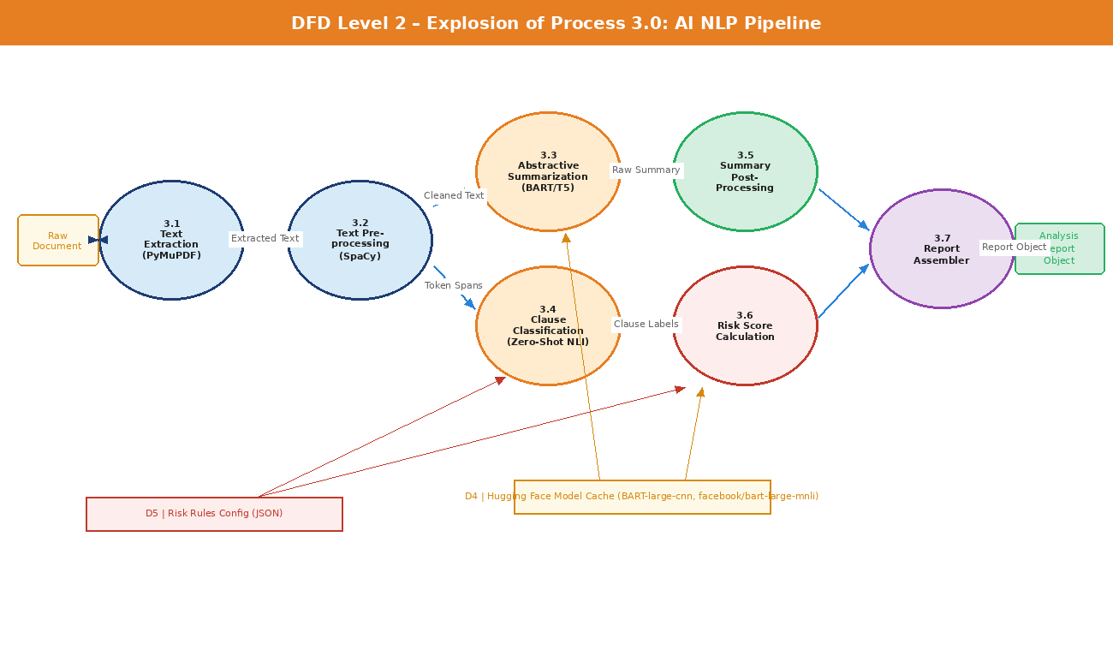
Figure 3.3 — DFD Level 2: Internal decomposition of the AI NLP Pipeline (Process 3.0)

Sub-Process | ID | Technology | Input | Output
Text Extraction | 3.1 | PyMuPDF, python-docx | Raw PDF/DOCX binary | Plain text string
Text Pre-processing | 3.2 | SpaCy NLP | Raw text string | Tokenized sentences & cleaned spans
Abstractive Summarization | 3.3 | BART-large-cnn (HF) | Cleaned full text | Abstractive summary paragraphs
Clause Classification | 3.4 | bart-large-mnli (Zero-Shot) | Sentence spans | Clause labels + confidence scores
Summary Post-Processing | 3.5 | Python string processing | Raw summary text | Formatted, readable summary
Risk Score Calculation | 3.6 | Rule engine + NLI scores | Clause labels + confidence | Risk level: Low / Medium / High
Report Assembler | 3.7 | Pydantic model serializer | Summary + Risk data | Structured JSON report object

4. Entity-Relationship (ER) Diagram
The ER Diagram models the relational database structure of the application. It defines the entities (tables), their attributes (columns), data types, constraints, and the relationships between them (Primary Keys, Foreign Keys, cardinalities).

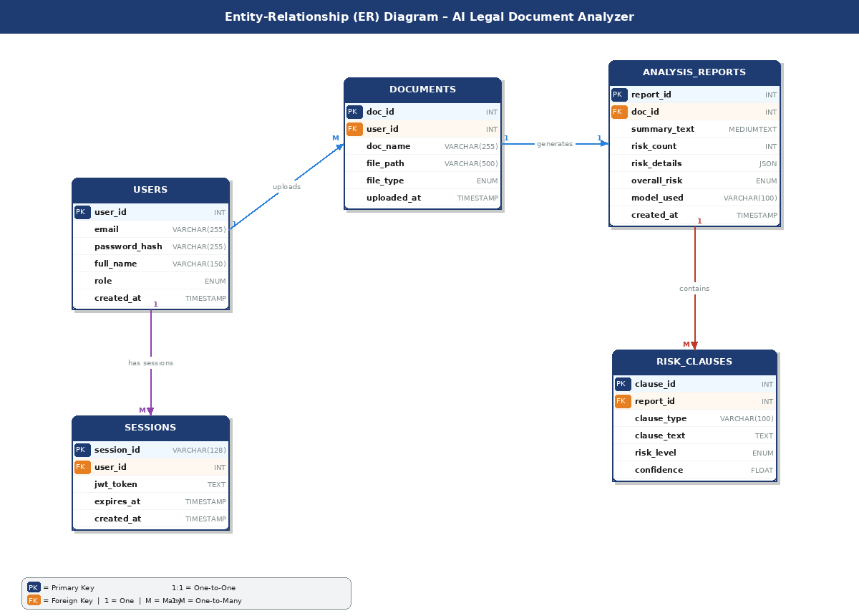
Figure 4.1 — Complete ER Diagram showing all five entities and their relationships

4.1 Entity Descriptions
Entity Name | Description
USERS | Stores registered user accounts. Each user has a unique email, a bcrypt-hashed password, a role (user or admin), and a creation timestamp. One user can own many documents (1:M).
DOCUMENTS | Records each uploaded legal document. Stores the original filename, encrypted storage path, file type (PDF or DOCX), and a foreign key reference to the owning user. Each document produces one analysis report (1:1).
ANALYSIS_REPORTS | Holds the AI-generated output for each document. Stores the full summary text, total risk count, detailed risk clause data as a JSON blob, and the model version used for auditability.
RISK_CLAUSES | A child table of ANALYSIS_REPORTS that stores individual detected clauses. Each record holds the clause type (e.g., Indemnity), the extracted text span, the classified risk level (Low/Medium/High), and the NLI confidence score.
SESSIONS | Manages active JWT authentication sessions. Stores the signed token, the user it belongs to, and an expiry timestamp. Expired sessions are periodically purged.

4.2 Relationship Summary
Relationship | Cardinality | FK Column | Description
USERS → DOCUMENTS | 1 : Many | documents.user_id | A user can upload multiple documents.
DOCUMENTS → ANALYSIS_REPORTS | 1 : 1 | analysis_reports.doc_id | Each document has exactly one analysis report.
ANALYSIS_REPORTS → RISK_CLAUSES | 1 : Many | risk_clauses.report_id | A report can contain multiple individual risk clauses.
USERS → SESSIONS | 1 : Many | sessions.user_id | A user can have multiple active sessions across devices.

5. System Architecture Diagram
The System Architecture Diagram provides a comprehensive view of all technical components organized into five distinct layers: Presentation, Application/API, AI Engine, Data, and Infrastructure & Security. This layered (N-tier) architecture ensures clear separation of concerns, making the system maintainable, scalable, and secure.
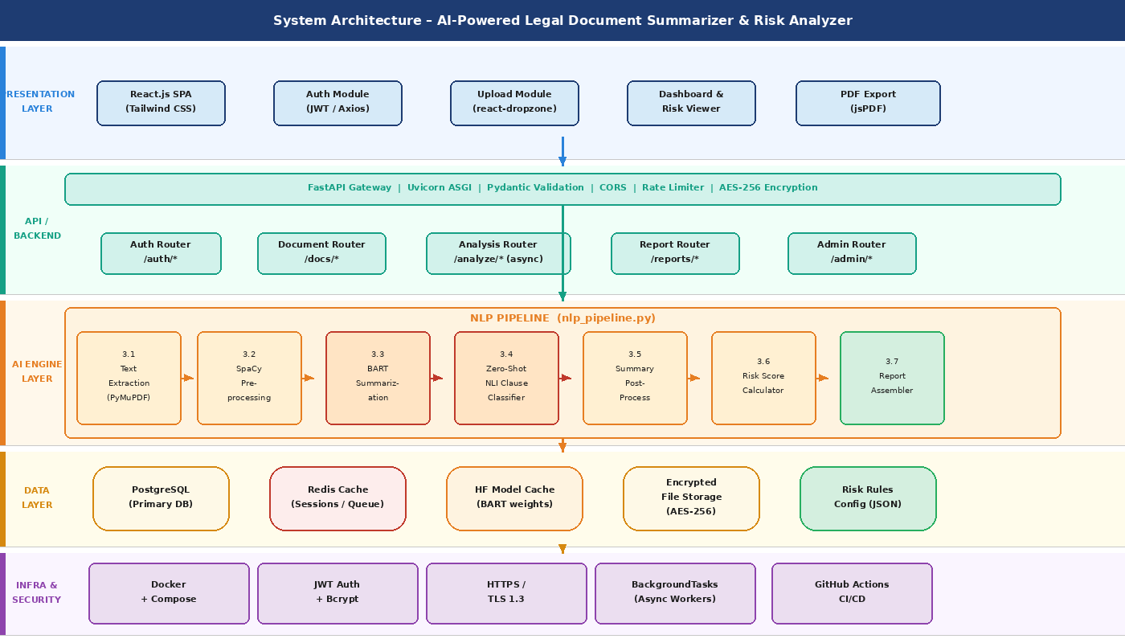
Figure 5.1 — Complete N-Tier System Architecture Diagram showing all components and layers

5.1 Layer-by-Layer Description

Layer 1: Presentation Layer (React.js SPA)
The frontend is a Single Page Application built with React.js and styled using Tailwind CSS. It is structured into four primary functional modules:
- Authentication Module: Manages login, signup, and JWT token storage in memory; uses Axios interceptors to automatically attach Bearer tokens to every API request.
- Upload Module: Integrates react-dropzone for drag-and-drop file uploads with real-time progress indicators. Validates file type (PDF/DOCX) and size before transmission.
- Dashboard: The main user interface displaying a history of uploaded documents, analysis status badges, and links to full reports. Includes an interactive risk clause visualizer.
- PDF Export Module: Leverages jsPDF and React-PDF to render the analysis report into a downloadable, formatted PDF document.

Layer 2: Application / API Layer (FastAPI)
The backend is built with FastAPI, a modern high-performance Python web framework. It serves as the central orchestrator between the frontend and all downstream services.
- FastAPI Gateway: Handles HTTP request routing, input validation via Pydantic models, CORS middleware configuration, and rate limiting to prevent abuse.
- Auth Router (/auth/*): Implements bcrypt password hashing for storage and JWT issuance on login. Token validation middleware protects all sensitive routes.
- Document Router (/docs/*): Handles file reception, applies AES-256 encryption before saving documents to disk, and stores file metadata to the database.
- Analysis Router (/analyze/*): Accepts an analysis request for a given document_id. Dispatches the AI task to a BackgroundTasks worker to prevent blocking the API thread. Returns a task ID for polling.
- Report Router (/reports/*): Retrieves formatted analysis results from the database and supports PDF export triggers.
- Admin Router (/admin/*): Protected by a role guard that checks the user's role claim in the JWT. Allows modifying the risk_rules_config.json and managing user accounts.

Layer 3: AI Engine Layer (NLP Pipeline) — Core Detail
Technical Deep Dive: AI Engine
The AI Engine is the intellectual core of the system. It is implemented as a Python module (nlp_pipeline.py) invoked by the FastAPI background worker. It executes a strict 7-stage sequential pipeline for each document.

Stage 3.1 — Text Extraction:
The pipeline begins by determining the file type. For PDF files, PyMuPDF (fitz) is used to extract text page by page, handling multi-column layouts. For DOCX files, python-docx iterates over document paragraphs and tables. The output is a single concatenated plain text string.

Stage 3.2 — Text Pre-processing (SpaCy):
The raw text is processed through a SpaCy NLP pipeline (en_core_web_sm model). This stage performs: sentence boundary detection (producing a list of sentence objects), tokenization, stop-word identification, and Named Entity Recognition (NER) to identify parties, dates, and monetary values for the summary. The output is a list of clean sentence spans used by both downstream AI models.

Stage 3.3 — Abstractive Summarization (BART-large-cnn):
The full cleaned text is fed into the facebook/bart-large-cnn model loaded via the Hugging Face pipeline("summarization") API. BART (Bidirectional and Auto-Regressive Transformers) is a sequence-to-sequence model pre-trained on CNN/DailyMail news data, making it exceptionally capable of abstractive summarization — generating new sentences that capture the key meaning rather than extracting existing ones verbatim. Due to the model's 1024-token input limit, long documents are processed in chunks using a sliding-window approach, and the per-chunk summaries are merged and re-summarized to produce a final coherent output.

Stage 3.4 — Clause Classification (Zero-Shot NLI with facebook/bart-large-mnli):
Each sentence span from Stage 3.2 is evaluated against a predefined set of clause labels using the facebook/bart-large-mnli model in zero-shot classification mode. This technique uses Natural Language Inference (NLI): the sentence is treated as a "premise" and each potential clause label (e.g., "This clause is about indemnity obligations", "This clause is about termination conditions") is treated as a "hypothesis." The model outputs a probability score for each hypothesis being entailed by the premise. Sentences with an entailment score exceeding a configurable threshold (default: 0.75) are flagged as instances of that clause type. This approach requires no task-specific fine-tuning.

Clause Label | Risk Level | Description
Indemnity / Hold Harmless | High | Clauses requiring one party to compensate the other for losses or damages.
Unilateral Termination | High | Allows one party to end the contract without cause or with minimal notice.
Liability Cap / Exclusion | High | Limits or eliminates one party's financial responsibility for damages.
Non-Compete / Non-Solicitation | Medium | Restricts future employment or business activities of the signing party.
Automatic Renewal | Medium | Contract auto-renews unless explicitly cancelled within a notice window.
Governing Law / Jurisdiction | Medium | Specifies which state/country's laws govern disputes — may be inconvenient for one party.
Confidentiality / NDA | Medium | Restricts the disclosure of information; breach can have serious consequences.
Arbitration Clause | Low | Waives the right to a jury trial in favor of private arbitration.
Force Majeure | Low | Excuses performance under extraordinary circumstances.

Stage 3.5 — Summary Post-Processing:
The raw BART output undergoes formatting: sentence capitalization is normalized, redundant whitespace is removed, and key named entities (parties, dates, amounts) identified by SpaCy NER are injected as a structured "Key Details" section at the top of the summary.

Stage 3.6 — Risk Score Calculation:
The list of detected clauses is passed through the risk scoring engine. Each clause has a base risk weight defined in the risk_rules_config.json file. This weight is multiplied by the NLI confidence score to produce a final clause risk score. The total number of High, Medium, and Low risk clauses is tallied. An overall document risk level is determined by a rule: if any High-risk clause is present with confidence > 0.85, the document is flagged as "High Risk"; otherwise, thresholds on the count of Medium and Low clauses determine the final rating.

Stage 3.7 — Report Assembler:
All processed data (summary text, key entities, clause records with risk levels and scores, overall risk rating) are assembled into a Pydantic AnalysisReportSchema object and serialized to JSON. This object is returned to the FastAPI background worker, which writes it to the Analysis_Reports and Risk_Clauses database tables and marks the task as complete.

Layer 4: Data Layer
- PostgreSQL: The primary relational database stores all user, document, and report records as defined in the ER Diagram (Section 4). It uses ACID-compliant transactions for data integrity.
- Hugging Face Model Cache: Pre-downloaded model weights (several GB in size) are stored on disk and loaded into RAM/VRAM at server startup to avoid repeated downloads and minimize inference latency.
- Redis Cache: Used as a fast in-memory session store (replacing database lookups for active JWT validation), a task queue for managing background AI jobs, and a result cache to serve recent analyses instantly.
- Encrypted File Storage: Uploaded documents are stored as AES-256 encrypted blobs in a structured directory. Only the server's file service can decrypt them for processing.
- Risk Rules Config (JSON): A version-controlled JSON file that maps clause labels to base risk weights and threshold scores. Modifiable by admins without requiring code changes.

Layer 5: Infrastructure & Security
- Docker Containers: Each service (React SPA, FastAPI, PostgreSQL, Redis) runs in its own Docker container, orchestrated via Docker Compose. This guarantees consistent environments from development to production.
- JWT + Bcrypt: User passwords are hashed with bcrypt (cost factor 12). Authentication uses RS256-signed JWTs with configurable expiry (default: 1 hour access token, 7-day refresh token).
- HTTPS / TLS 1.3: All client-server communication is encrypted in transit using TLS 1.3. In production, an Nginx reverse proxy handles SSL termination.
- Async Background Workers: FastAPI's BackgroundTasks mechanism runs AI inference in a non-blocking thread, ensuring the API remains responsive while heavy model computations are in progress.
- CI/CD Pipeline: GitHub Actions workflows run automated unit and integration tests on every pull request and deploy passing builds to the staging environment automatically.

6. Database Design — Table Schemas

6.1 Table: USERS
Field | Type | Size/Format | Constraint | Description
user_id | INT | 11 | PK, Auto Increment | Unique user identifier.
email | VARCHAR | 255 | UNIQUE, NOT NULL | User login email address.
password_hash | VARCHAR | 255 | NOT NULL | bcrypt hashed password (cost 12).
full_name | VARCHAR | 150 |  | Optional display name.
role | ENUM | ('user','admin') | DEFAULT 'user' | Access control role.
created_at | TIMESTAMP | - | DEFAULT NOW() | Account creation time.

6.2 Table: DOCUMENTS
Field | Type | Size/Format | Constraint | Description
doc_id | INT | 11 | PK, Auto Increment | Unique document identifier.
user_id | INT | 11 | FK → users.user_id | Owning user.
doc_name | VARCHAR | 255 | NOT NULL | Original filename as uploaded.
file_path | VARCHAR | 500 | NOT NULL | Encrypted storage path on disk.
file_type | ENUM | ('PDF','DOCX') | NOT NULL | Detected file format.
file_size_kb | INT | 10 |  | File size for storage management.
uploaded_at | TIMESTAMP | - | DEFAULT NOW() | Upload timestamp.

6.3 Table: ANALYSIS_REPORTS
Field | Type | Size/Format | Constraint | Description
report_id | INT | 11 | PK, Auto Increment | Unique report identifier.
doc_id | INT | 11 | FK → documents.doc_id | Parent document.
summary_text | MEDIUMTEXT | - | NOT NULL | Full AI-generated plain-English summary.
risk_count | INT | 5 | DEFAULT 0 | Total number of detected risk clauses.
risk_details | JSON | - |  | Structured JSON array of all detected clauses with scores.
overall_risk | ENUM | ('Low','Medium','High') |  | Aggregated risk level for the document.
model_used | VARCHAR | 100 |  | Model version string for auditability (e.g. bart-large-cnn).
created_at | TIMESTAMP | - | DEFAULT NOW() | Analysis completion timestamp.

6.4 Table: RISK_CLAUSES
Field | Type | Size/Format | Constraint | Description
clause_id | INT | 11 | PK, Auto Increment | Unique clause record identifier.
report_id | INT | 11 | FK → analysis_reports.report_id | Parent analysis report.
clause_type | VARCHAR | 100 | NOT NULL | Classified type (e.g., Indemnity, Termination).
clause_text | TEXT | - | NOT NULL | The extracted sentence/paragraph flagged as risky.
risk_level | ENUM | ('Low','Medium','High') | NOT NULL | Assessed risk level.
confidence | FLOAT | 0.00–1.00 |  | NLI model confidence score for this classification.

7. Tools and Technologies
Category | Technology | Version | Purpose
Frontend Framework | React.js | 18.x | Component-based SPA for the user interface.
UI Styling | Tailwind CSS | 3.x | Utility-first CSS framework for responsive layouts.
HTTP Client | Axios | 1.x | Promise-based HTTP client with JWT interceptors.
Backend Framework | FastAPI | 0.100+ | High-performance Python API framework with async support.
ASGI Server | Uvicorn | Latest | ASGI server for running FastAPI in production.
AI: Summarization | BART-large-cnn | HF Transformers | Abstractive summarization of legal document text.
AI: Classification | bart-large-mnli | HF Transformers | Zero-shot clause classification via NLI.
NLP Pipeline | SpaCy | 3.x | Tokenization, sentence splitting, and NER.
PDF Processing | PyMuPDF (fitz) | Latest | Text and structure extraction from PDF files.
DOCX Processing | python-docx | Latest | Text extraction from Microsoft Word documents.
Data Validation | Pydantic | v2.x | Schema validation for API request/response models.
Database | PostgreSQL | 15+ | Relational database for persistent data storage.
ORM | SQLAlchemy + Alembic | Latest | Database ORM and schema migration management.
Cache / Queue | Redis | 7.x | Session caching, task queuing, result caching.
Authentication | PyJWT + bcrypt | Latest | JWT token generation and password hashing.
Encryption | AES-256 (cryptography) | Latest | At-rest encryption of uploaded document files.
Containerization | Docker + Compose | Latest | Service containerization and orchestration.
CI/CD | GitHub Actions | - | Automated testing and deployment pipeline.
Hardware (Min) | i5 Processor, 8GB RAM | - | Minimum spec for running transformer models.

8. Testing and Validation Strategy
Test Type | Scope | Tools | Success Criteria
Unit Testing | Python NLP functions: text extraction, chunking, risk scoring logic. | pytest, unittest.mock | All functions pass assertions for known inputs; 90%+ code coverage.
Integration Testing | React → FastAPI endpoint communication; JWT auth flow; file upload pipeline. | pytest, httpx (async test client) | All API endpoints return correct status codes and response schemas.
AI Accuracy Validation | Summarization quality and risk clause detection recall/precision. | ROUGE score metric, manual review | ROUGE-1 ≥ 0.45 on test set; F1-score ≥ 0.80 on clause detection.
Security Testing | JWT expiry, AES encryption, SQL injection prevention, CORS policy. | OWASP ZAP, manual pen testing | No critical or high-severity vulnerabilities detected.
Performance Testing | API response time under concurrent user load; AI inference time. | Locust load testing framework | API response < 200ms (excl. AI); AI processing < 30s per document.
UAT (User Acceptance) | End-to-end user workflows: signup, upload, analyze, export. | Manual testing with 10 test users | All 5 primary user stories completed without errors by test users.

9. Module Description
The system is divided into six clearly defined functional modules. Each module is an independent unit responsible for a specific aspect of the application, enabling parallel development, independent testing, and future extensibility.

9.1 User Authentication Module
Attribute | Detail
Module Name | User Authentication & Session Management
File / Path | backend/routers/auth.py, backend/services/auth_service.py
Technology | FastAPI, PyJWT, bcrypt, Redis
Interfaces | POST /auth/signup, POST /auth/login, POST /auth/logout, POST /auth/refresh

This module manages the complete user identity lifecycle. On signup, the user's password is hashed with bcrypt (work factor 12) before storage. On login, credentials are validated against the stored hash and a signed RS256 JWT access token (1-hour expiry) along with a refresh token (7-day expiry) are issued. All subsequent API requests are authenticated by a middleware dependency that validates the JWT signature and expiry. The refresh token is stored in Redis for fast revocation. The Admin sub-role uses the same auth mechanism but is protected by an additional role-guard middleware that inspects the role claim in the token payload.

9.2 Document Management Module
Attribute | Detail
Module Name | Document Upload & Storage
File / Path | backend/routers/documents.py, backend/services/file_service.py
Technology | FastAPI UploadFile, python-multipart, AES-256 (cryptography library)
Interfaces | POST /docs/upload, GET /docs/, GET /docs/{doc_id}, DELETE /docs/{doc_id}

Handles the secure ingestion of legal documents. On upload, the module validates that the file is either a PDF or DOCX and does not exceed the configured size limit (default: 25 MB). The file content is then encrypted using AES-256-GCM with a server-held key before being written to the secure storage directory. The original filename, encrypted storage path, file type, and file size are persisted in the Documents table with a reference to the authenticated user. The module also exposes endpoints to list a user's documents and soft-delete records.

9.3 AI NLP Processing Module
Attribute | Detail
Module Name | AI NLP Pipeline Engine
File / Path | backend/ai/nlp_pipeline.py, backend/ai/risk_scorer.py, backend/ai/models.py
Technology | Hugging Face Transformers, SpaCy, PyMuPDF, python-docx
Interfaces | POST /analyze/{doc_id} (invokes async BackgroundTask)

This is the core intelligence module and the most computationally intensive component. It implements the full 7-stage NLP pipeline described in Section 3.3 and Section 5.1 (Layer 3). The module is designed to run as a FastAPI BackgroundTask so the API thread is never blocked. Model weights (BART-large-cnn, bart-large-mnli) are loaded once at server startup into a module-level singleton to avoid reloading overhead per request. The module exposes a single public function process_document(doc_id) which executes the full pipeline and writes results to the database on completion.

9.4 Report Generation Module
Attribute | Detail
Module Name | Report Generation & Export
File / Path | backend/routers/reports.py, frontend/src/components/ReportView.jsx
Technology | FastAPI, Pydantic, jsPDF (frontend), React-PDF
Interfaces | GET /reports/{report_id}, GET /reports/export/{report_id} (PDF download)

Once the NLP pipeline completes, this module is responsible for presenting and packaging the results. The backend endpoint retrieves the structured report from the database and serializes it using a Pydantic response schema into a clean JSON payload. On the frontend, the ReportView component renders the summary text, a colour-coded risk badge (Green/Amber/Red for Low/Medium/High), an expandable list of detected risk clauses, and a bar chart of clause frequency by type. The PDF export functionality in the frontend uses jsPDF to render the same view into a downloadable, professionally formatted PDF.

9.5 Admin Panel Module
Attribute | Detail
Module Name | Admin Dashboard & Configuration
File / Path | backend/routers/admin.py, frontend/src/pages/AdminDashboard.jsx
Technology | FastAPI, React.js, role-based access control middleware
Interfaces | GET/PUT /admin/users, GET/PUT /admin/rules, GET /admin/stats

Accessible only to users with role=admin. The admin panel provides three capabilities: (1) User Management — view all registered users, toggle account status (active/suspended), and change user roles; (2) Risk Rules Configuration — view and edit the risk_rules_config.json via a web form, allowing administrators to add new clause types, adjust confidence thresholds, and modify risk level assignments without any code deployment; (3) System Statistics — a read-only dashboard showing total users, total documents processed, average processing time, and clause-type frequency heatmap.

9.6 User Dashboard Module
Attribute | Detail
Module Name | User Dashboard & Document History
File / Path | frontend/src/pages/Dashboard.jsx, frontend/src/components/DocumentCard.jsx
Technology | React.js, Tailwind CSS, Axios, Recharts
Interfaces | Consumes GET /docs/, GET /reports/{id}, POST /analyze/{doc_id}

The primary interface for end users after login. Displays a paginated grid of all previously uploaded documents with status indicators (Pending / Processing / Complete / Failed). Users can click any completed document to open its full analysis report, re-trigger analysis on a failed document, or delete a document. The dashboard also shows a personal summary card with total documents analysed, highest risk document flag, and a donut chart of overall risk distribution across all their documents.

10. Limitations
While the system delivers significant value, the following limitations must be acknowledged in its current version (v1.0). These constraints provide direction for future development and should be communicated clearly to end users.

# | Limitation | Impact | Mitigation / Workaround
1 | Language Support: English Only | The BART and SpaCy models are trained exclusively on English text. Documents in Hindi, French, or other languages will produce inaccurate or nonsensical outputs. | Users should upload English-language documents only. Multi-language support planned for v2.0.
2 | Document Length Cap (Token Limit) | The BART model has a maximum input of 1,024 tokens (~750 words) per chunk. While chunking is implemented, very long documents (>100 pages) may see degraded summary coherence at chunk boundaries. | Sliding-window chunking with overlap minimises boundary loss. Future work: hierarchical summarisation.
3 | No Legal Professional Validation | The AI is a decision-support tool, not a qualified legal advisor. Risk detection is probabilistic (confidence scores) and may produce false positives or miss nuanced clauses. | All outputs include confidence scores and a disclaimer. Users are advised to consult a qualified lawyer for legally binding decisions.
4 | Scanned / Image-Based PDFs | PDFs that contain scanned page images rather than embedded text cannot be processed by PyMuPDF. No OCR engine is integrated in v1.0. | An error message guides users to upload text-based PDFs. OCR via Tesseract is planned for v2.0.
5 | High RAM Requirement | Loading both BART-large-cnn and bart-large-mnli simultaneously requires approximately 6–8 GB of RAM, making deployment on low-resource servers costly. | Minimum hardware spec (8 GB RAM) is documented. Cloud deployment on GPU instances is recommended.
6 | No Real-Time Collaboration | The system is single-user per session. Multiple users cannot annotate or comment on the same document simultaneously. | Collaborative features are deferred to a future version requiring WebSocket integration.
7 | Limited Document Types | Only PDF and DOCX formats are supported. Common legal formats such as TXT, HTML, or ODT are not handled. | The file_service module is designed to be extended with additional parsers for new formats.
8 | Zero-Shot Clause Classification Accuracy | Zero-shot NLI performs well for common clauses but may underperform on highly unusual or domain-specific clause wording not covered by its training distribution. | The confidence threshold is configurable. Fine-tuning on a legal corpus (e.g., CUAD dataset) is a key future enhancement.

11. Future Scope
The current system establishes a strong foundation. The following enhancements are planned for future versions to expand capability, accuracy, and reach.

11.1 Short-Term Enhancements (v1.1 — v1.5)
Enhancement | Description | Technology
OCR for Scanned PDFs | Integrate Tesseract OCR to extract text from image-based PDF pages, enabling processing of scanned contracts and legacy documents. | pytesseract, pdf2image
Fine-Tuned Clause Classifier | Fine-tune a BERT or RoBERTa model on the CUAD (Contract Understanding Atticus Dataset) legal corpus to significantly improve clause detection precision and recall. | Hugging Face Trainer, CUAD Dataset
Multi-Language Support | Integrate multilingual models (mBART-50, XLM-RoBERTa) to support document summarisation and risk analysis in Hindi, French, Spanish, and German. | mBART-50, LangDetect
Clause Comparison Tool | Allow users to upload two versions of a contract and automatically highlight the differences in clauses and risk profiles between them. | difflib, React diff-viewer
Email Notifications | Send automated email alerts when document analysis is complete, including a brief risk summary in the email body. | FastAPI-Mail, SMTP

11.2 Medium-Term Enhancements (v2.0)
Enhancement | Description | Technology
Interactive Risk Negotiation Assistant | An AI chatbot interface (using GPT-3.5/4 or Claude API) where users can ask natural language questions about specific clauses in their document, e.g. "What does this indemnity clause mean for me?" | OpenAI API / Anthropic API, LangChain, RAG
Collaborative Annotation | Allow multiple users (e.g., a legal team) to view the same document analysis, add comments, highlight clauses, and resolve risk items collaboratively in real-time. | WebSockets (FastAPI), ShareDB
Legal Domain Expansion | Extend clause detection beyond general contracts to domain-specific documents: Real Estate Agreements, Software Licensing, Employment Law, and Data Processing Agreements (GDPR). | Domain-specific fine-tuned models, expanded risk_rules_config
Mobile Application | Develop a React Native mobile app for iOS and Android allowing users to upload documents via camera (with OCR) and view analysis reports on the go. | React Native, Expo, Tesseract.js
Blockchain Audit Trail | Record document hash, analysis hash, and timestamp on a blockchain to provide a tamper-proof audit trail for legal admissibility and compliance. | Ethereum / Polygon, web3.py

11.3 Long-Term Vision (v3.0+)
- Legal Outcome Prediction: Train a classification model on historical case outcomes to estimate the likely enforceability or outcome risk of specific contract clauses based on jurisdiction and precedent.
- Automated Contract Drafting Assistant: Use generative AI to suggest safer alternative wording for high-risk clauses, enabling users to negotiate better contract terms directly within the platform.
- API-as-a-Service (SaaS Model): Expose the NLP pipeline as a public REST API, allowing third-party legal tech platforms, law firms, and corporate compliance tools to integrate the risk analysis engine.
- Federated Learning for Privacy: Implement federated learning so that the model can improve from user feedback (clause corrections, false positive flags) without any raw document data ever leaving the user's environment.
- Regulatory Compliance Checker: Add modules to automatically check contracts against current regulatory frameworks such as GDPR (EU), CCPA (California), and Indian Contract Act provisions.

12. Bibliography
- Pressman, R. S. (2014). Software Engineering: A Practitioner's Approach (8th ed.). McGraw-Hill Education.
- Bird, S., Klein, E., & Loper, E. (2009). Natural Language Processing with Python. O'Reilly Media.
- Lewis, M., Liu, Y., et al. (2020). BART: Denoising Sequence-to-Sequence Pre-training for Natural Language Generation. ACL 2020.
- Hendrycks, D., et al. (2021). CUAD: An Expert-Annotated NLP Dataset for Legal Contract Review. NeurIPS.
- FastAPI Documentation. Retrieved from https://fastapi.tiangolo.com/
- React Documentation. Retrieved from https://react.dev/
- Hugging Face Transformers Documentation. Retrieved from https://huggingface.co/docs/transformers/
- SpaCy Documentation. Retrieved from https://spacy.io/
- PostgreSQL Documentation. Retrieved from https://www.postgresql.org/docs/
- Williams, A. et al. (2018). A Broad-Coverage Challenge Corpus for Sentence Understanding through Inference (MNLI). NAACL.

