**Website improvements**

**FIGMA LINK**

**https://www.figma.com/design/fJSe0Ugo2PaDQj3bClDRjc/ADXP-Website-%5BDEV%5D?node-id=2096-9059&t=oCqhRpdMfEg8Cx7D-1**

* Interactive animation similar to -> under home page (only constant change)
  + https://www.sliderrevolution.com/templates/particle-effect-for-wordpress/
* Animated x in about us and Logo on header
* Animated career ladder
* Filter in the insights by case study, blog or report (has to be tagged accordingly) + add a filter by series (smarter, safer, livable, etc. -> has to be configurable)
* [INSIGHTS/REPORTS] Download PDF in thought leadership (CMS attachment that can be downloaded) -> require simple registration (lead capture)
* Disable people section on main page
  + Disable separate all people page (catalogue)
  + Include people only on services and industries with the ability to disable them
* In sub services, -> when click and unclick has to be smooth (downwards and upwards)
* In the main page under insights -> it should always pick the latest / most recent published insights to remain active and changing -> we can add a total of 4 insights in the main page also (under each other)
* In about us, facts and figures to roll up in animated way
* Under digital advisor, the different maturity tools should be sortable (drag and drop) similar to other lists in the website
* Add livability definition in our services with interactive animation (on top of “Why us”/ABOUT US)image should be animated
  + https://particlebackground.com/
  + 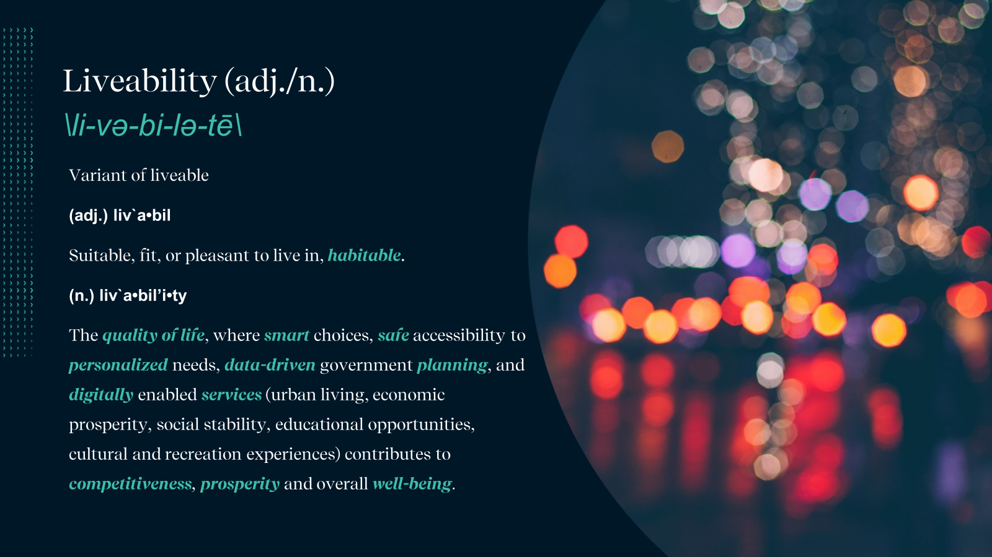
* Add other profile aspects into the website so there is consistency (into home page?)
* 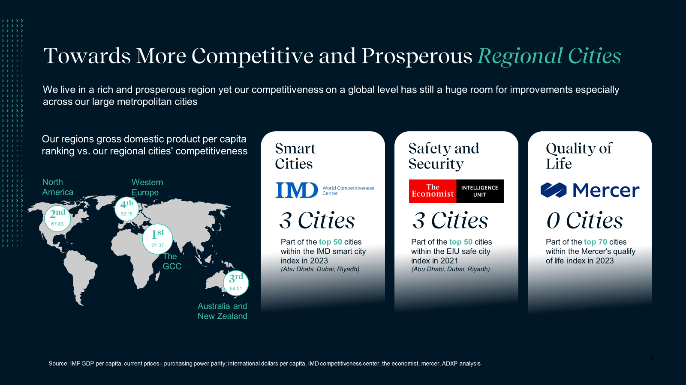
  + When hovering over smarter -> show the list with cities with flags and their ranking as per index) -> table to be taken from: https://datawrapper.dwcdn.net/meVUu/2/
    - Example embedded code
      * <iframe title="IMD Smart City Index" aria-label="Table" id="datawrapper-chart-meVUu" src="https://datawrapper.dwcdn.net/meVUu/1/" scrolling="no" frameborder="0" style="width: 0; min-width: 100% !important; border: none;" height="2909" data-external="1"></iframe><script type="text/javascript">!function(){"use strict";window.addEventListener("message",(function(a){if(void 0!==a.data["datawrapper-height"]){var e=document.querySelectorAll("iframe");for(var t in a.data["datawrapper-height"])for(var r=0;r<e.length;r++)if(e[r].contentWindow===a.source){var i=a.data["datawrapper-height"][t]+"px";e[r].style.height=i}}}))}();
      * </script>
* Update instagram, linked in and X links
* Integrate with google analytics
* Integrate ScoreApp with zoho CRM for leads (???)00
* Zoho One Integration: Collect subscribers with our WordPress plug-in or generate an embeddable sign-up form
* Zoho One Integration: Create a careers page and embed it on a webpage or map your website's domain to it.
* Zoho One Integration: Enable live chat and visitor tracking on your website.
* Link people profiles in website to linkedIn
* Digital maturity page -> similar to services and industries + add some benefits (similar to philosophy under about us section)

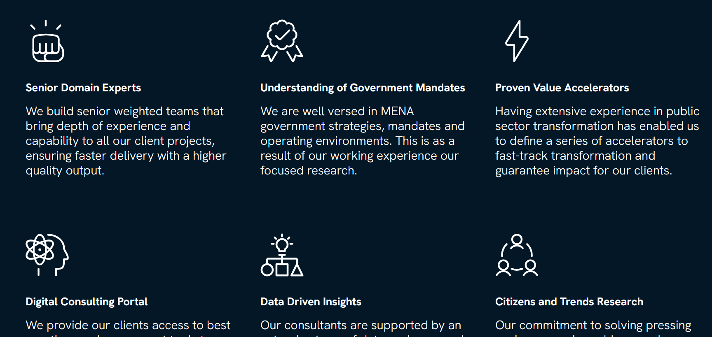

* About us + careers + contact + insights -> similar image at the begining to services and industries
* In the map, would be nice to show a pop up of city iconic landmark (i.e. Dubai -> Burj Khalifa, Riyadh -> Faisaliah Tower, London -> London Eye, etc.)