**User Manual**

**“Project Title : Video Tutorial MAnager”**

**Web Programming Laboratory**

**[ CSE 3200]**

**Project Manager: -**

Dr. Kazi Masudul Alam

Associate Professor

Computer Science and Engineering Discipline,

Khulna University.

**Developed By: -**

**Md Rakibul Hasan Molla**

Student ID: 160206

**Swagato Das**

Student ID:160232

**Mahmud Hasan**

Student ID: 150239

Computer Science and Engineering Discipline,

Khulna University.

Date: 29 October 2018



Computer Science and Engineering Discipline,

Khulna University

**Index**

1. **Login**

1. **Login**

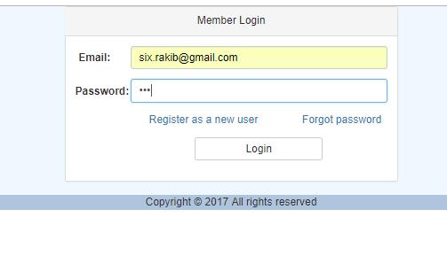

1. **Dashboard**

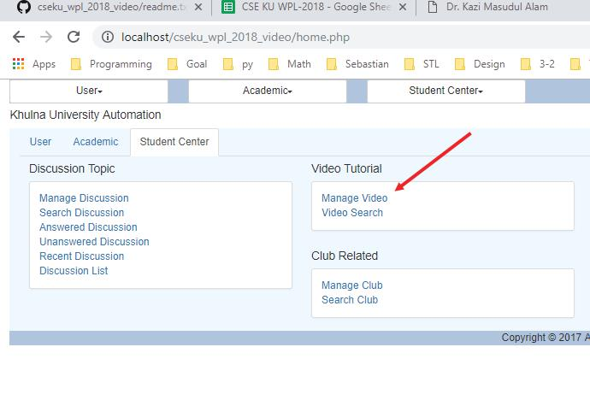

1. **Video Adding Page**

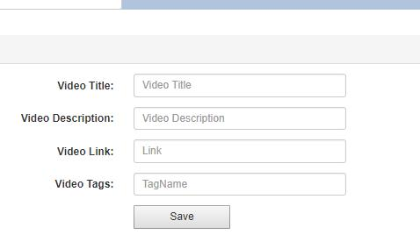

**4. Video view page**

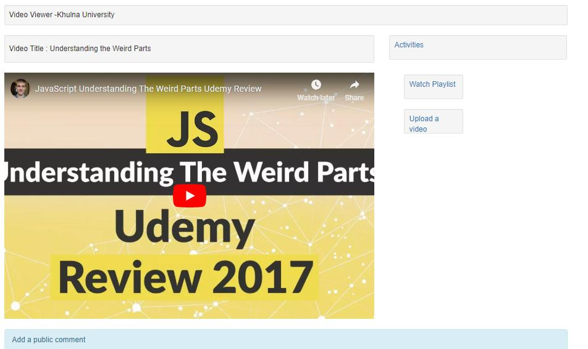

**5. Video Comment Upload:**

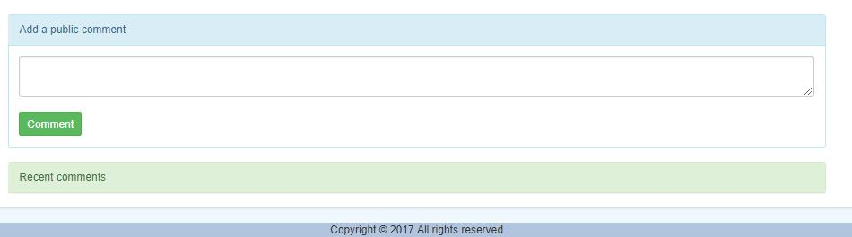

**6. Video View Panel and comment Panel**

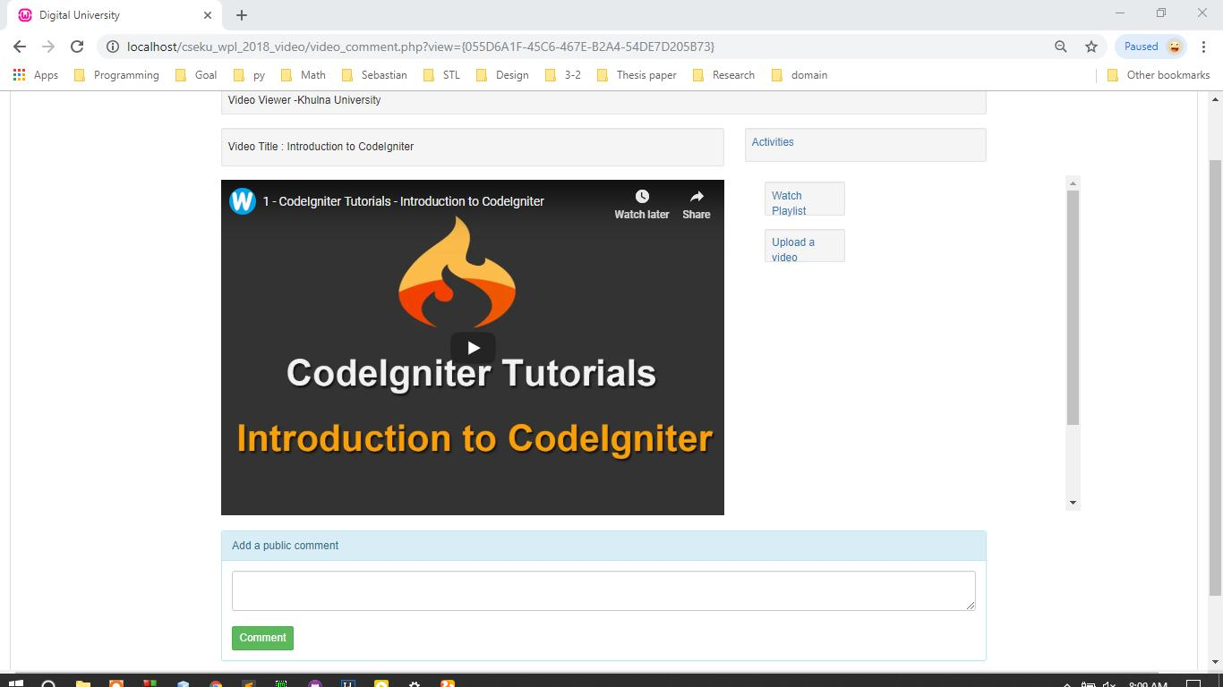

**Video Playlist Page**

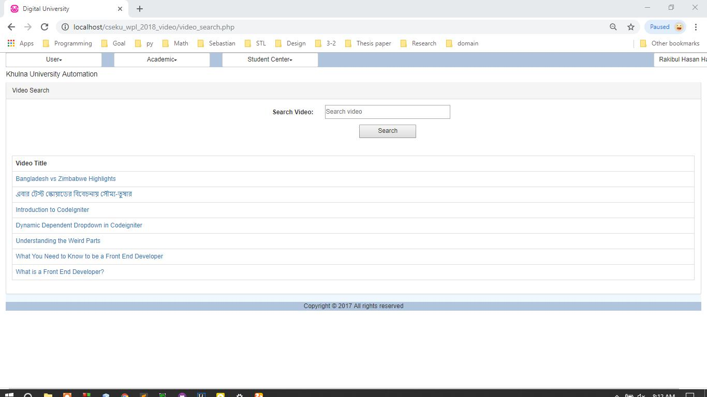

**Tag Search Example**

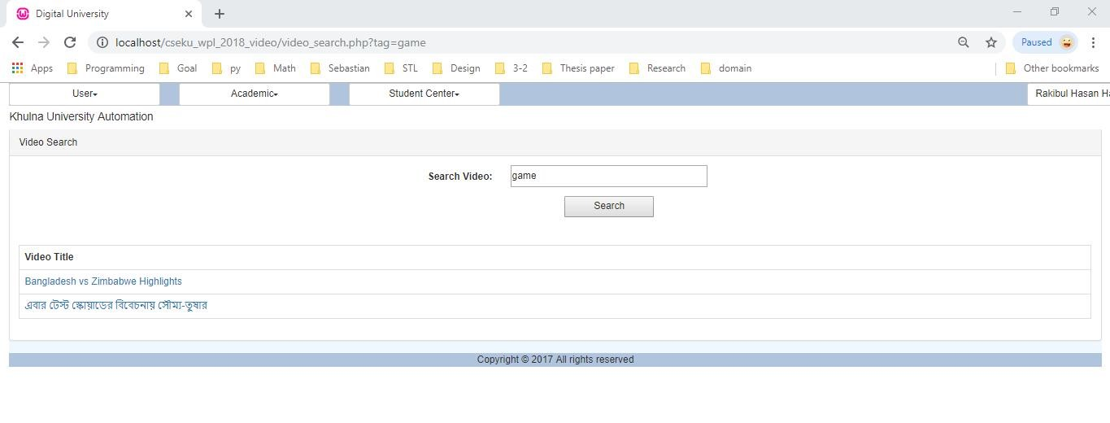

**Title Search Example 1**

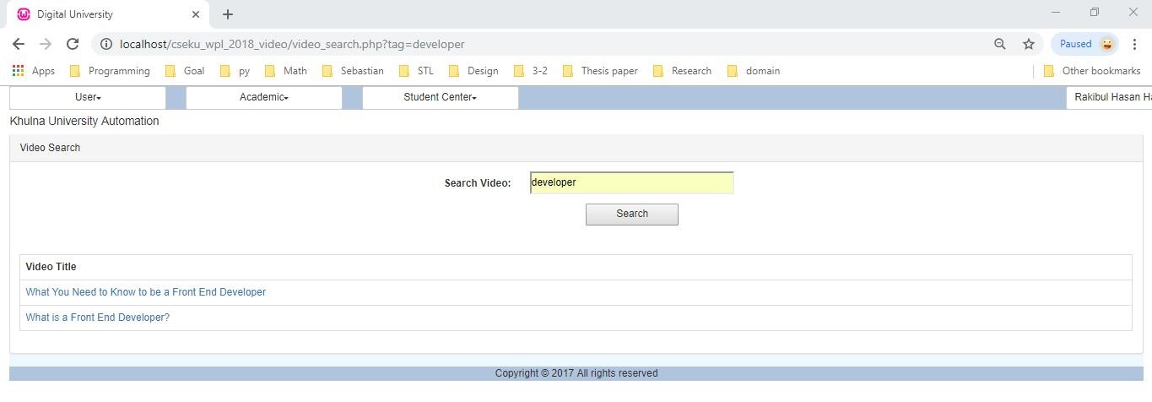

**Tag Search Example 2**

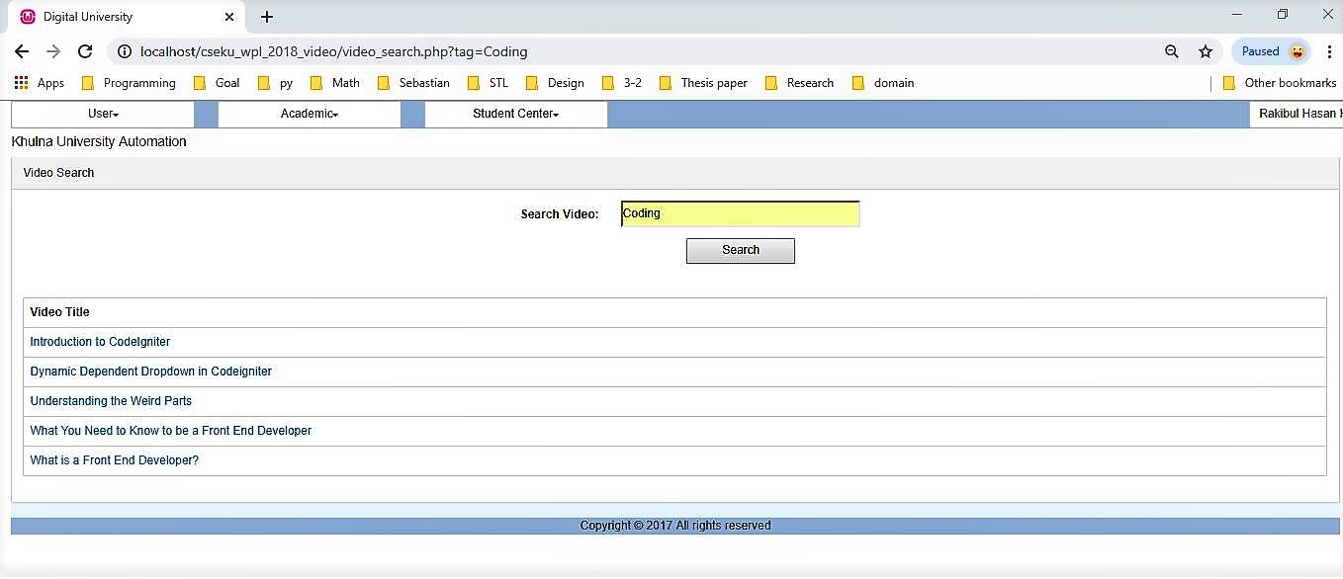

**Comment & Reply**

