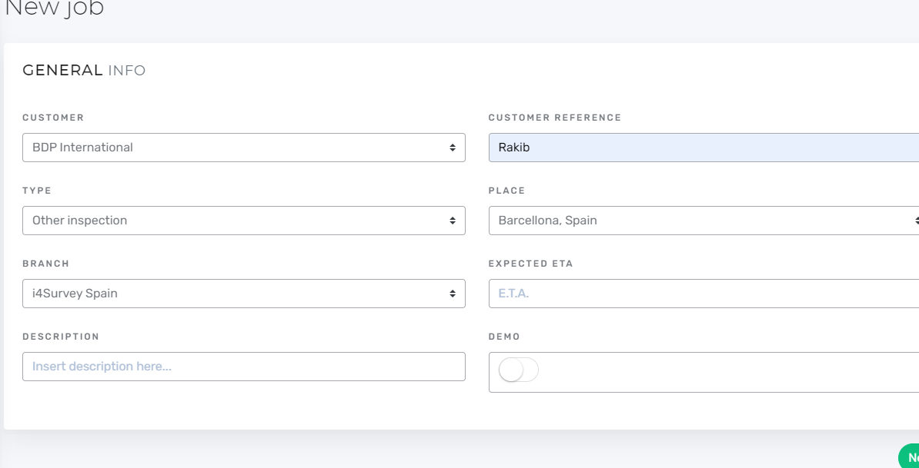

1. Type = Other inspection then Vessel is not applicable, then description input field will be visible.