**System screenshots**

**Home:**

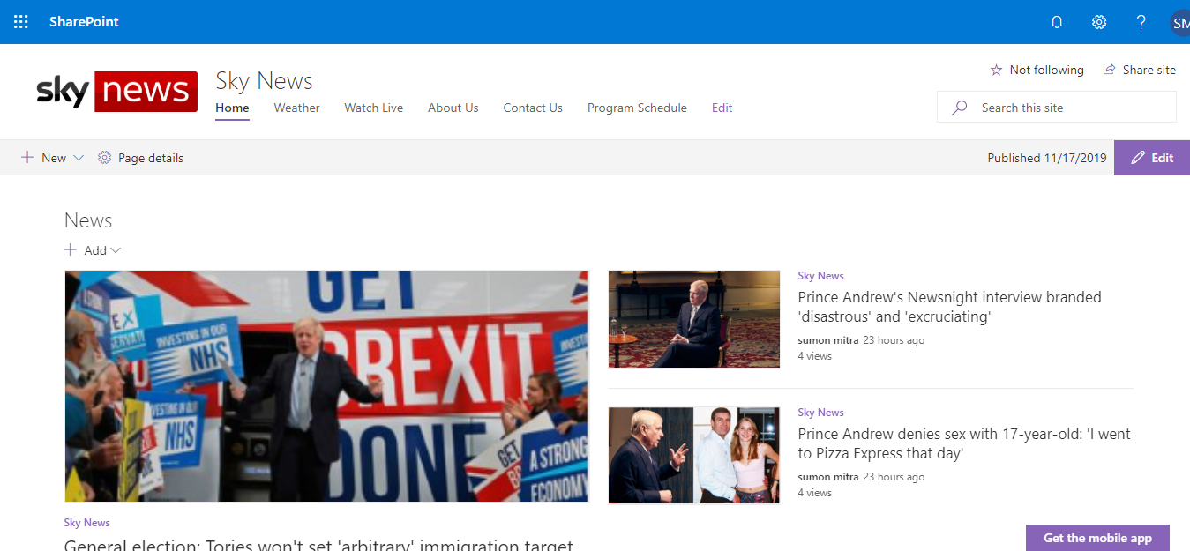

Figure1: Home page of the application

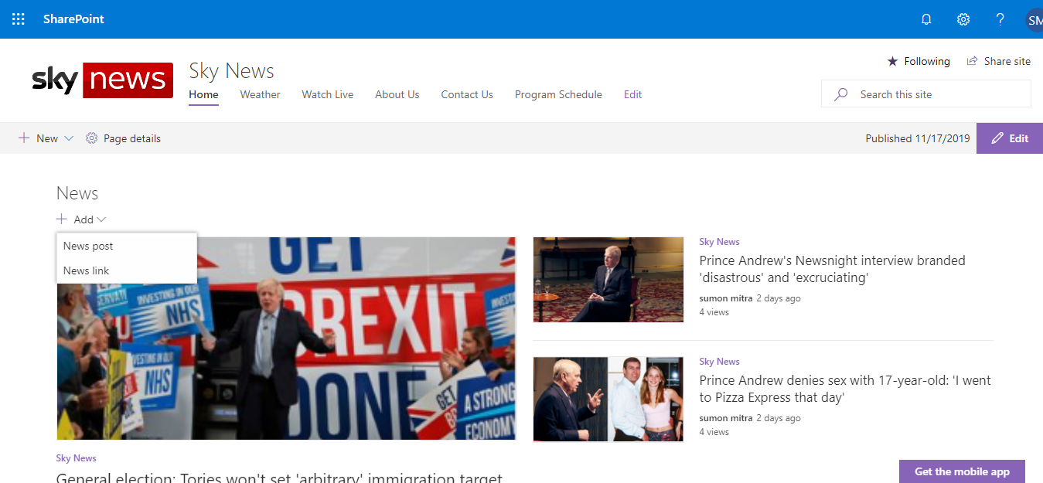

Figure2: Add new Post

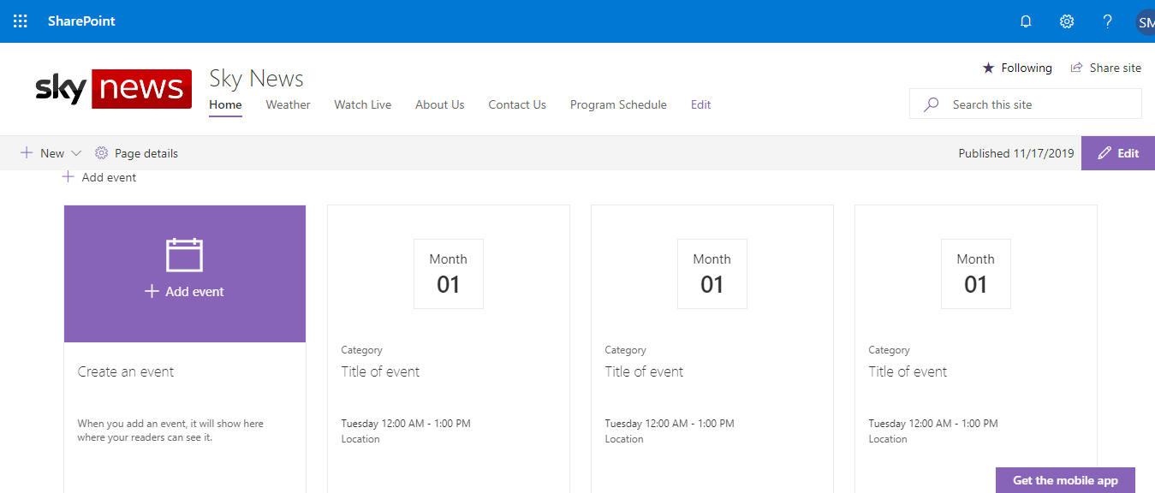

Figure3: Show events

**Weather:**

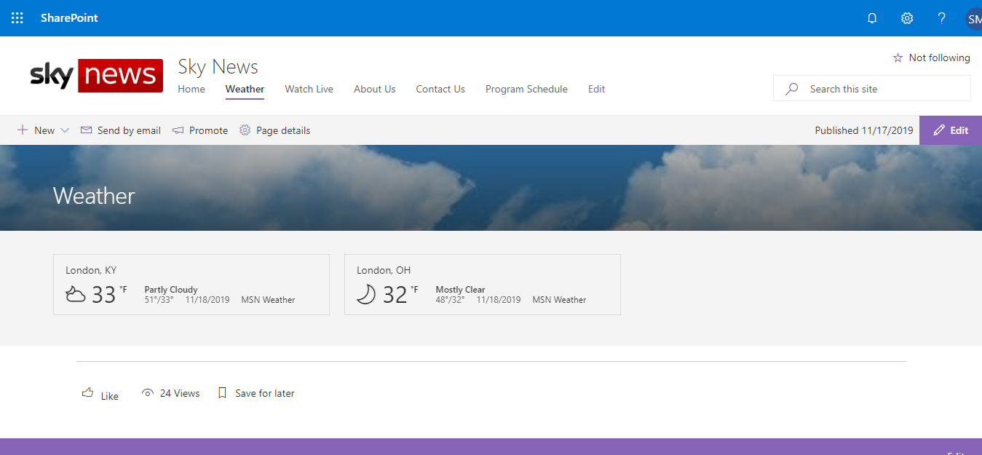

Figure4: Show weather details.



Figure5: Show current weather

**Watch live:**

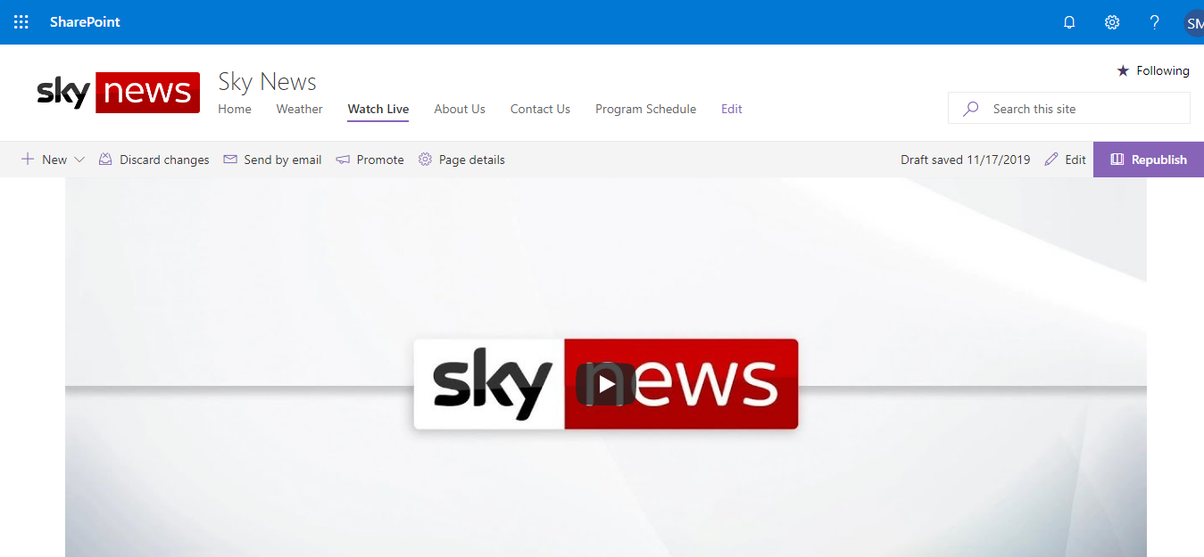

Figure6: Show watch Live.



Figure 7: Show live programs

**About Us:**

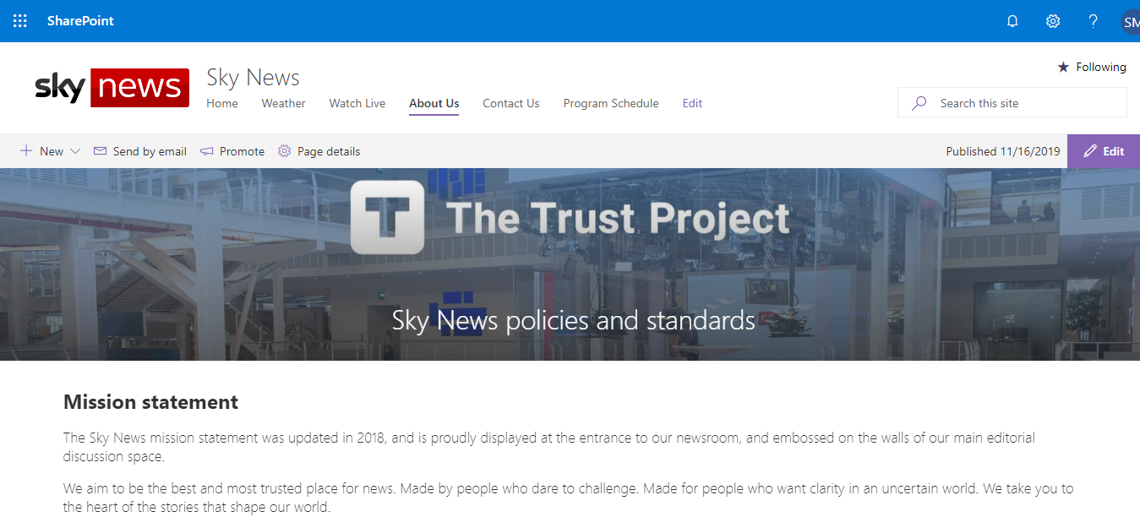

Figure 8: Show About.

**Contact Us:**

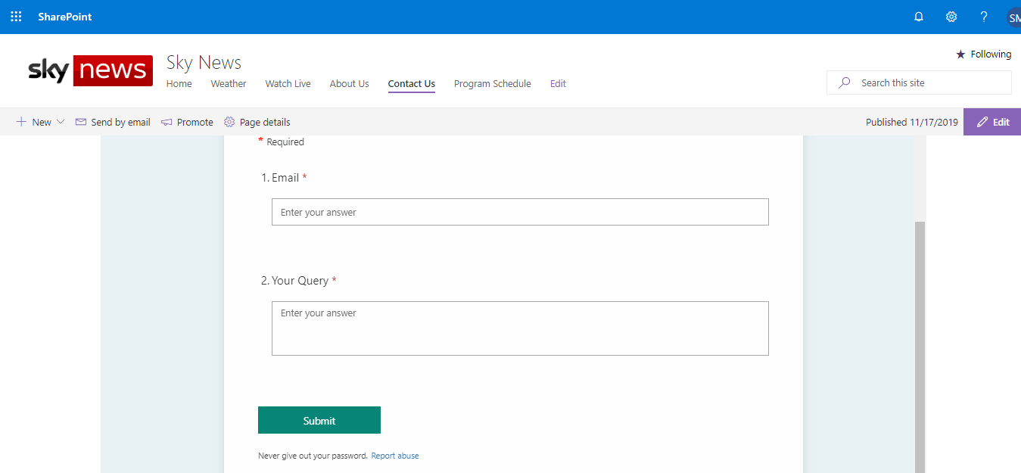

Figure 9: Show contract us page.

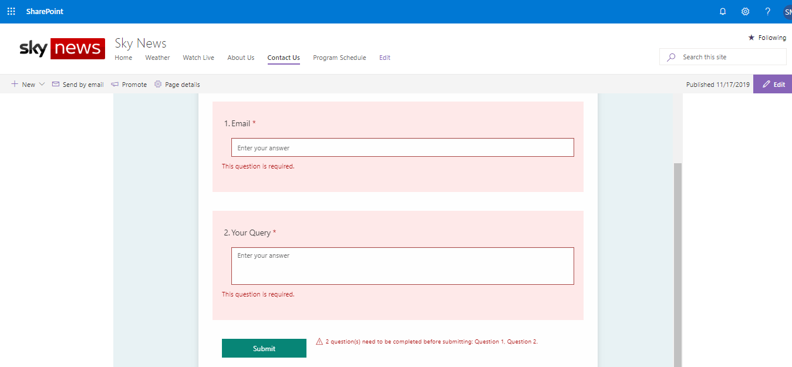

Figure 10: Validation check.

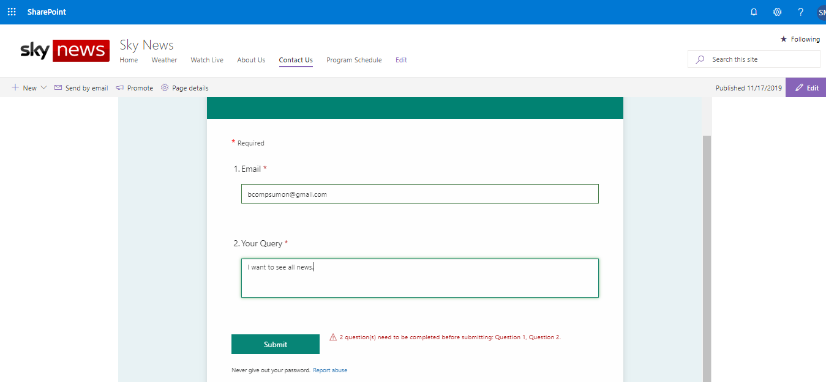

Figure 11: Value input

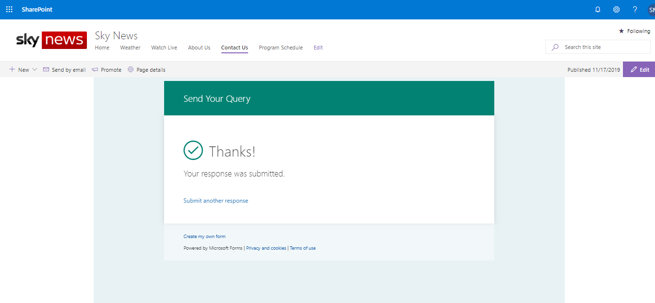

Figure 12: Send query and thank you massage.

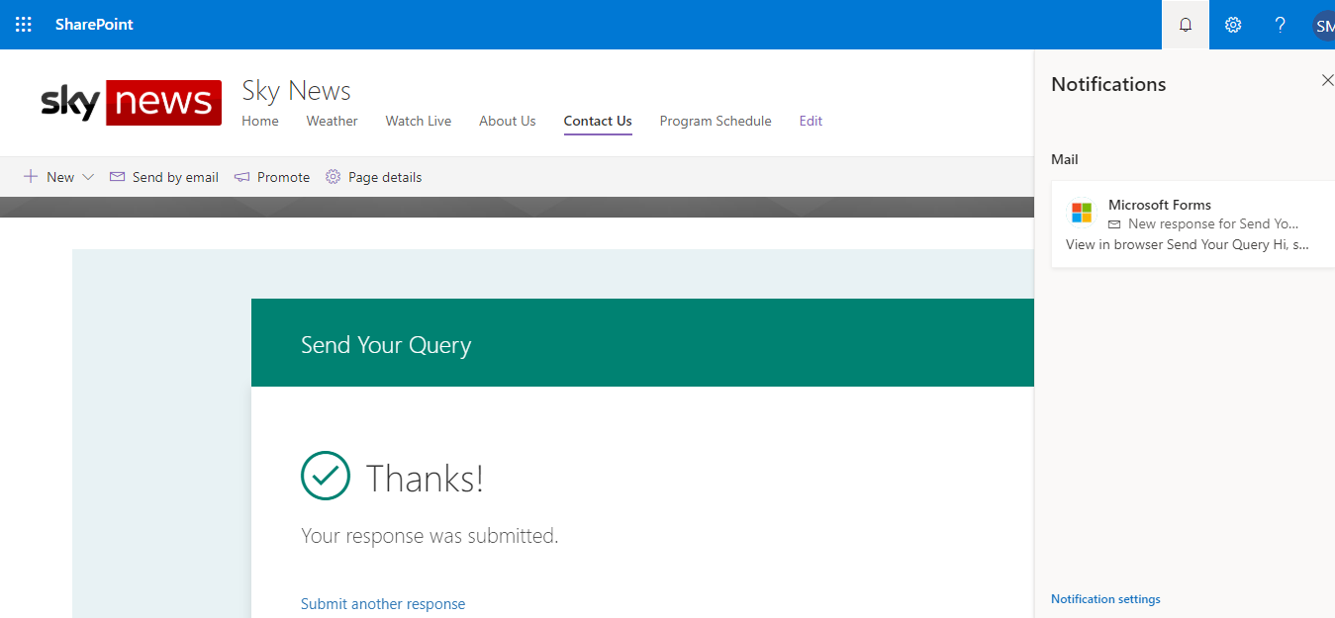

Figure 13 : Show notification.

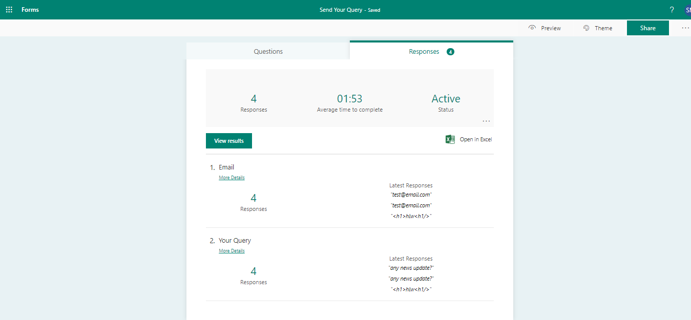

Figure 14: Show emails.

**Program Schedule:**

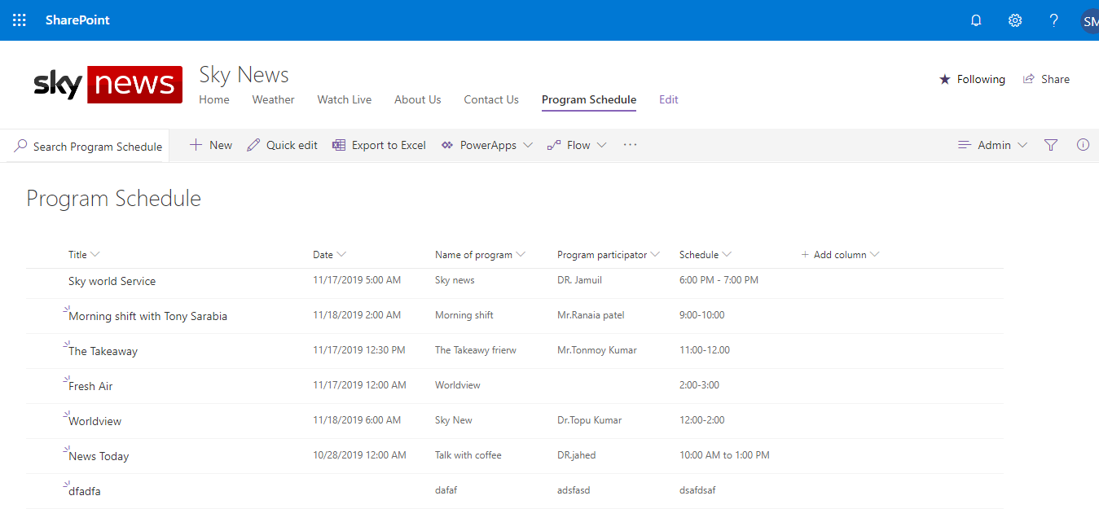

Figure 15: Show program schedule page.



Figure 16: Just admin can control the entire program schedule.

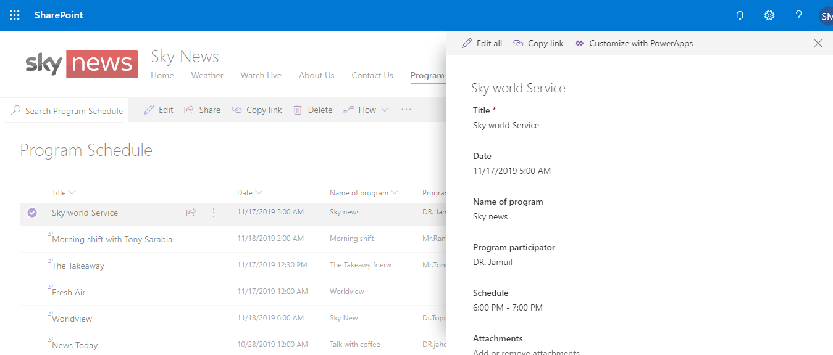

Figure 17: Show program details.

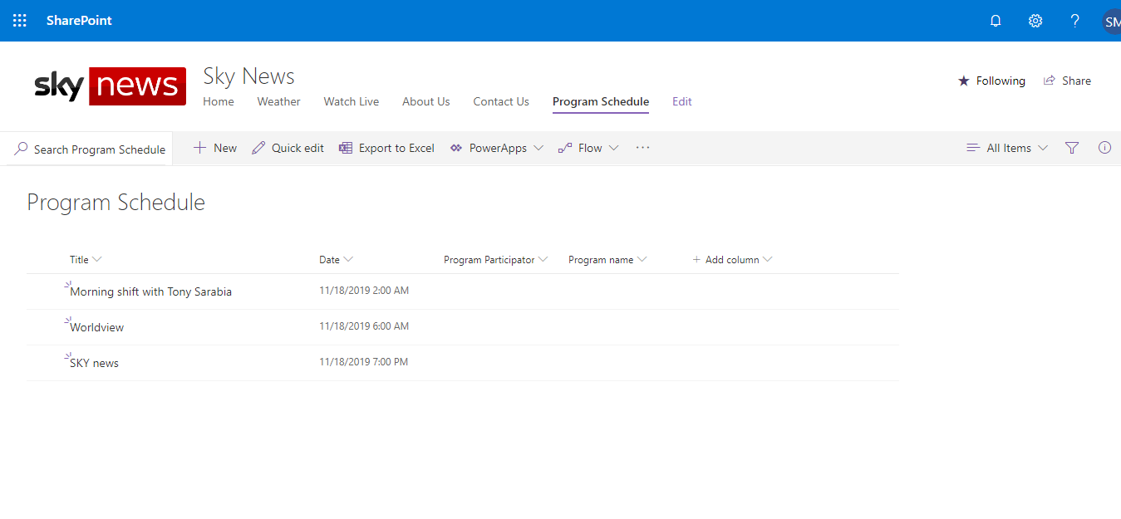

Figure 18: Viewer can see this program schedule