<https://testsiteforclient.com/all-users>

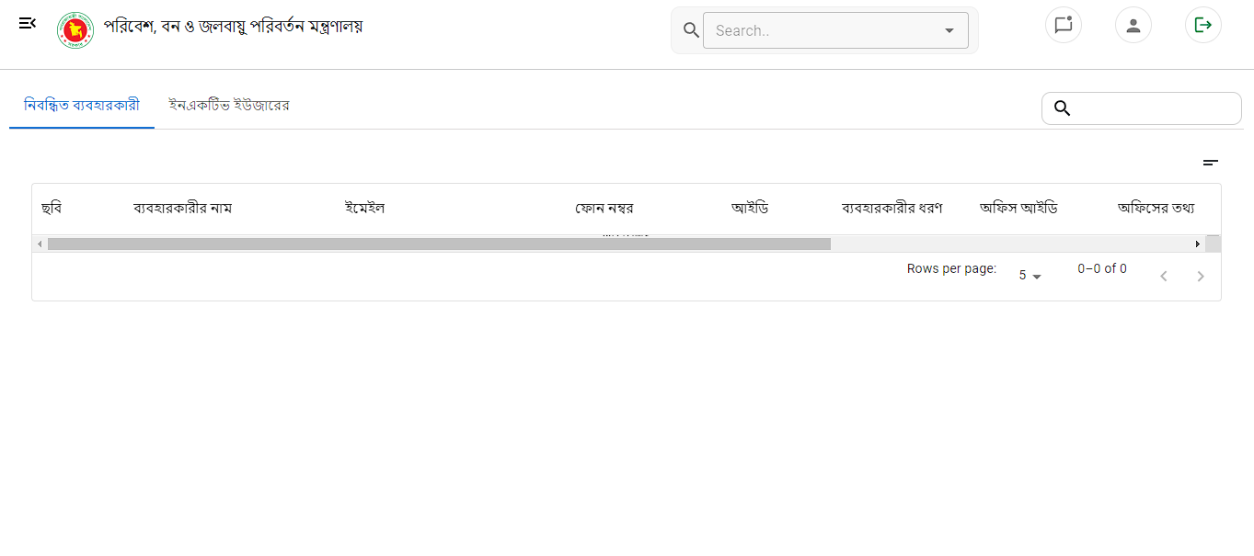No user showing:

<https://testsiteforclient.com/permission-users>

1. Change the Button location
2. 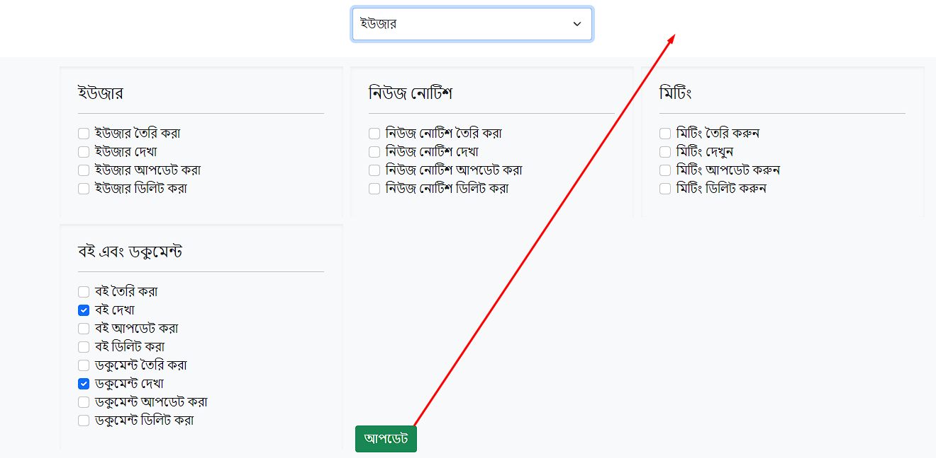User Role should be: a) super admin, b) Admin c) Moderator d)General user e)Guest user

<https://testsiteforclient.com/all-news-notice>

Cond: 2 types of notification will show

1. Notification he made
2. Notification throw for the logged in user

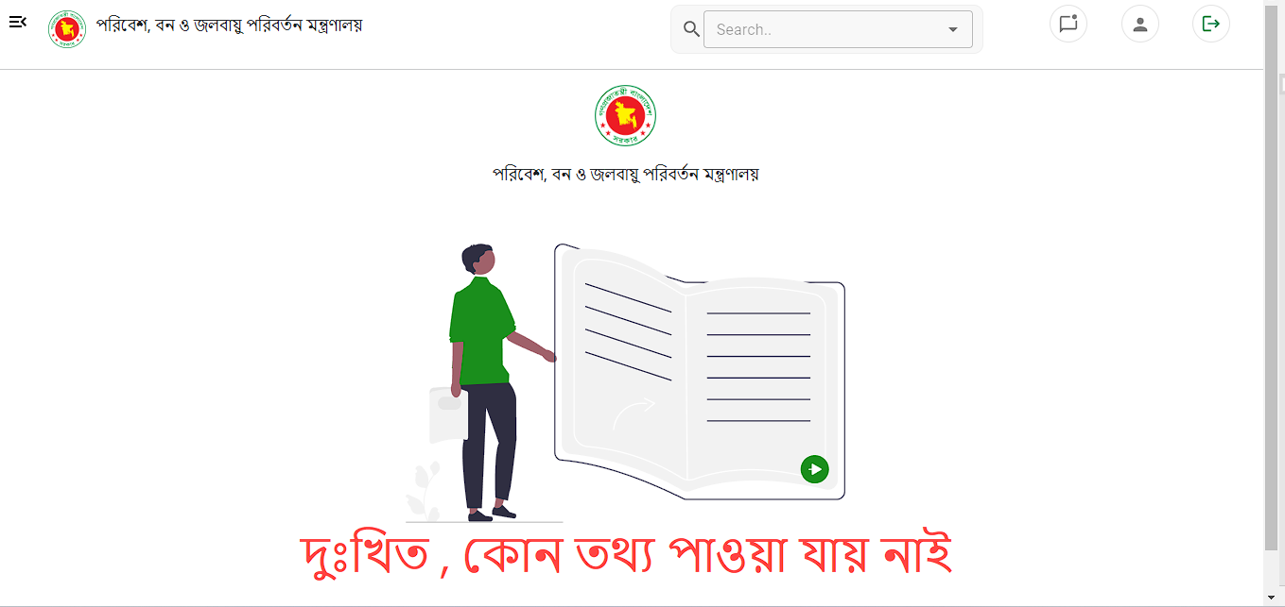

<https://testsiteforclient.com/all-books>

Issue: Show the “created/edited date” and also the last editor (changing person)

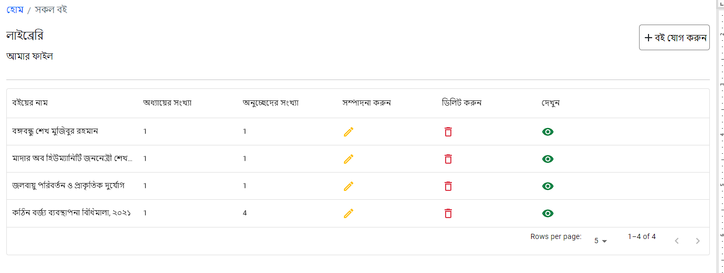

<https://testsiteforclient.com/all-documents>

Issue: Show the “created/edited date” and also the last editor (changing person)

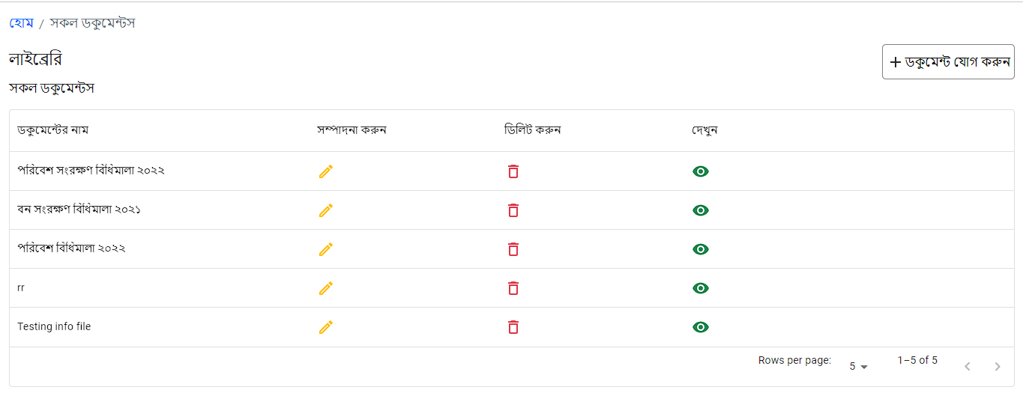

<https://testsiteforclient.com/book-categories>

Issue: Looks messy. Make it beautiful.

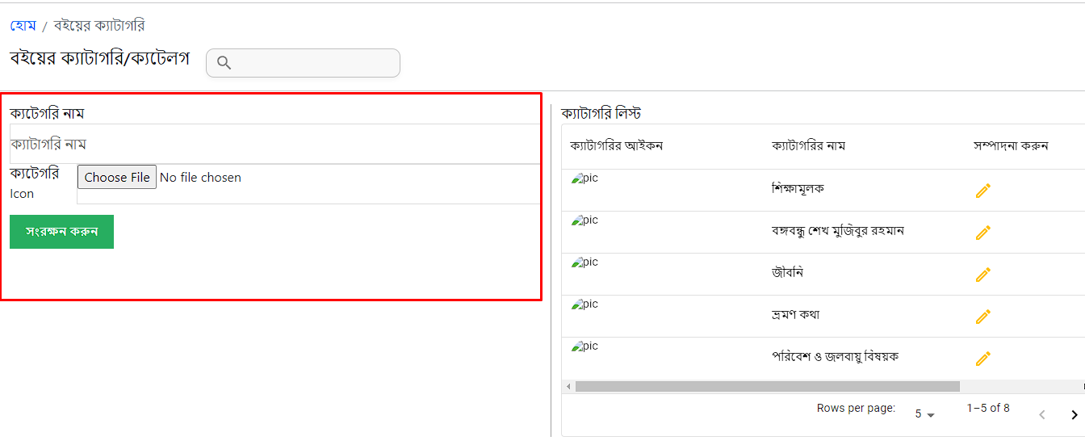

<https://testsiteforclient.com/create-news-notice>

Issue: Add file uploader (pdf and doc file only) provision

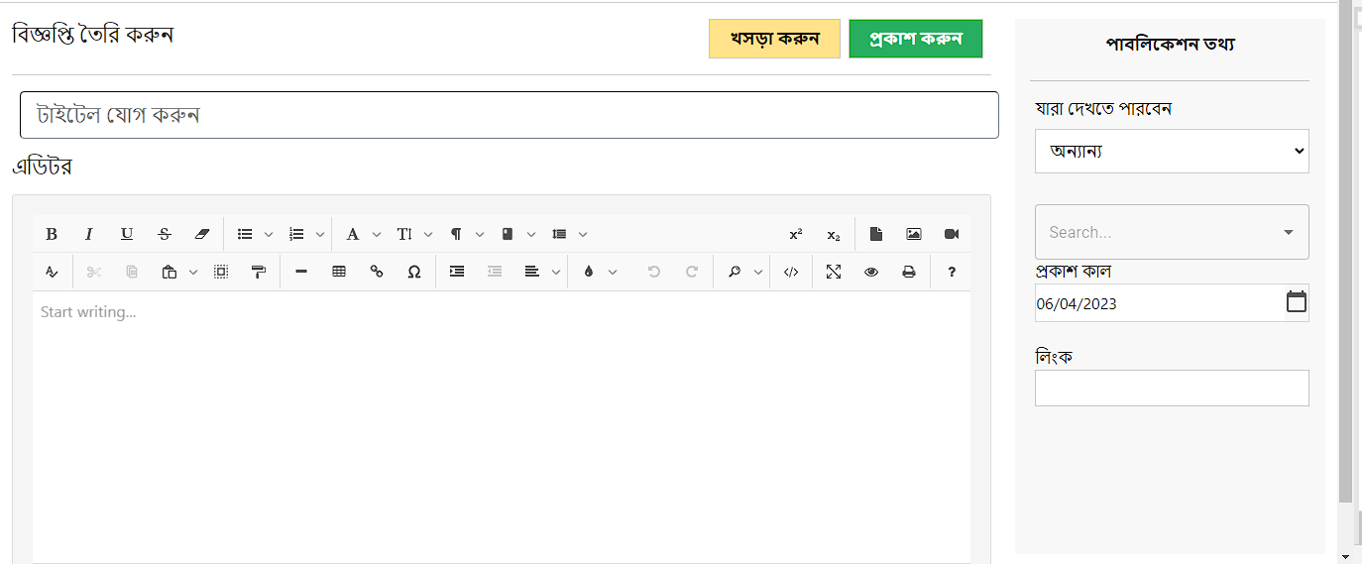

<https://testsiteforclient.com/all-news-notice>

Issue: Not showing anything

<https://testsiteforclient.com/home>

Issue: Add “+” sign after down arrow to quickly add category

