1. Server List Contain all database server connection information.

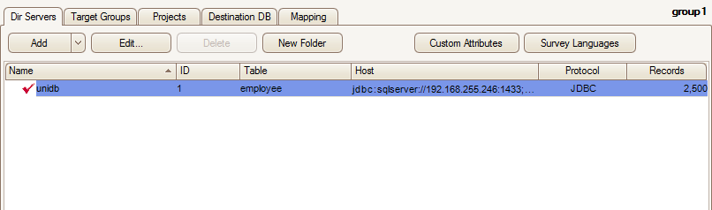

Add and Edit form : 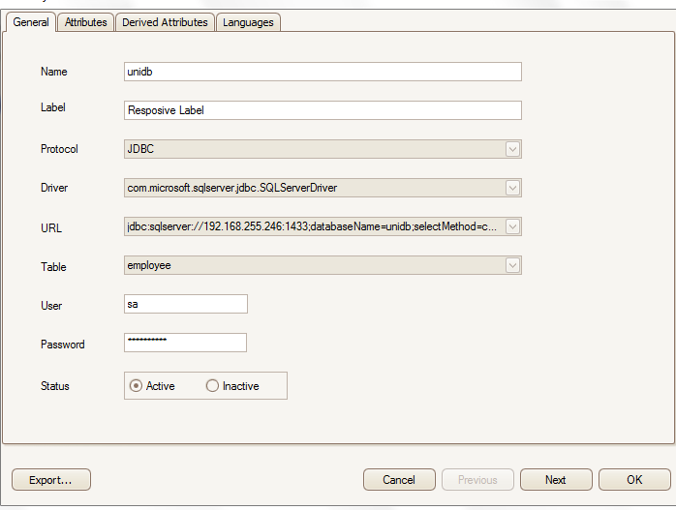

1. **(Not necessary to implement now)**One single connection can contain one table data for send mail. Multiple table select option will be analyze and implement later. User can take multiple field including email field .~~It has four or more default Custom field select option as drop down (Number, String, Email, Name) .User can add more default property type to assign selected filed like below:~~

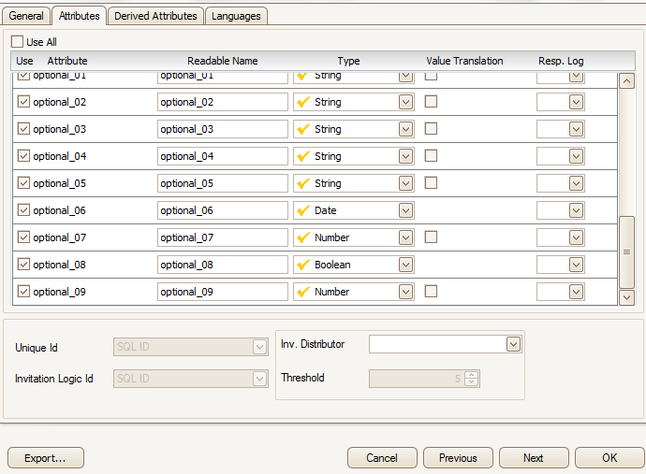

1. Now Add Group or Target Group

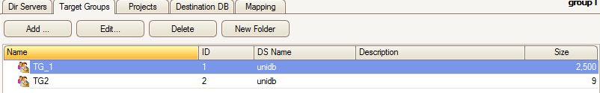

Group Add/Edit Form

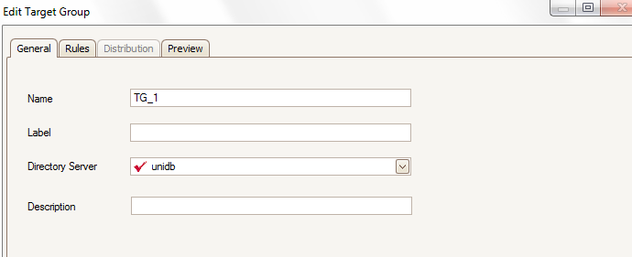

Directory Server is the Connection Name. Preview field contain data depended your assign rule .PK Field select by default. and others two filed you can filter data by selecting field from drop down.

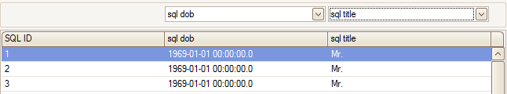

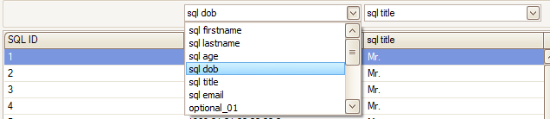

Rules Form given below:

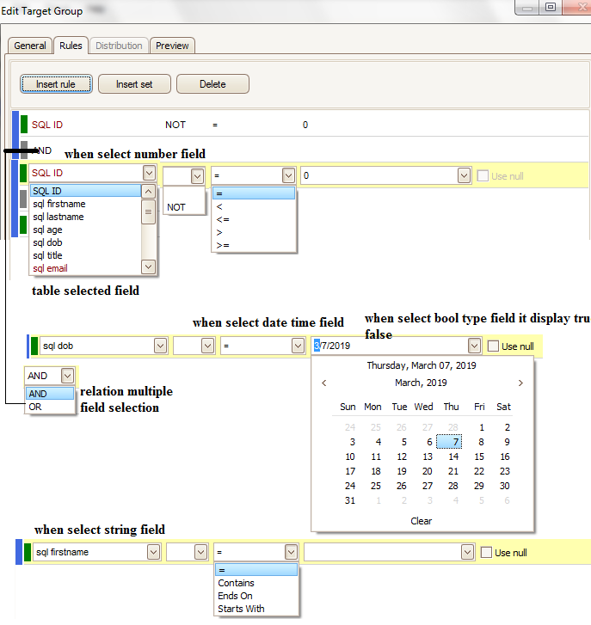**Project Menu**

1. Add Project this is important .User can add multiple Group from one Connection. Project List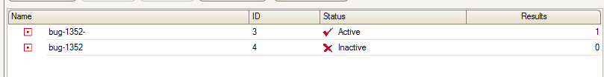
2. Add/Edit Project Form Select multiple groups to send mail …..

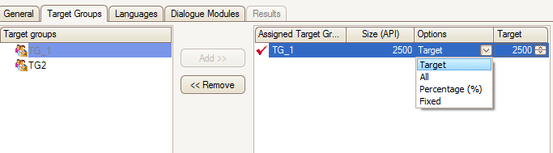

Dialogue Module menu contain Email Template..

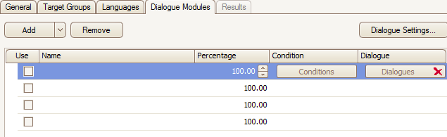

Here user can add multiple template .But only one template selected for send at a time .Dialogue button is the browser button to select template. We need to add another form that take all {0}..{n} fond in the template add assign which value will be fill in that filed when template mail will send.

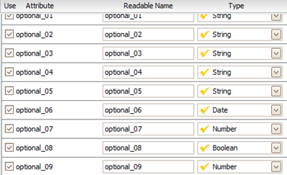

Set time Schedule when add Project

