1. Install node js
2. Install global server (<https://www.youtube.com/watch?v=hkzOsbGIEAI&ab_channel=MimiaTech>)
3. Run cmd as administrator and install npm globally

C:\WINDOWS\system32>node -v

v17.7.2

C:\WINDOWS\system32>npm install npm –global

* Open visual studio code terminal
* Open Folder where we create our app
* Now open terminal and run this command
* PS F:\ASP-Core-Project\UserManagementCore\UserManagementReactJsUI> npx create-react-app usermanagementui
* See tutorials <https://reactjs.org/docs/introducing-jsx.html>
* Npx is installed only of this folder locally not globally
* We suggest that you begin by typing:
* cd usermanagementui
* npm start
* So now run this command

PS F:\ASP-Core-Project\UserManagementCore\UserManagementReactJsUI> cd .\usermanagementui\



After start it will open browser

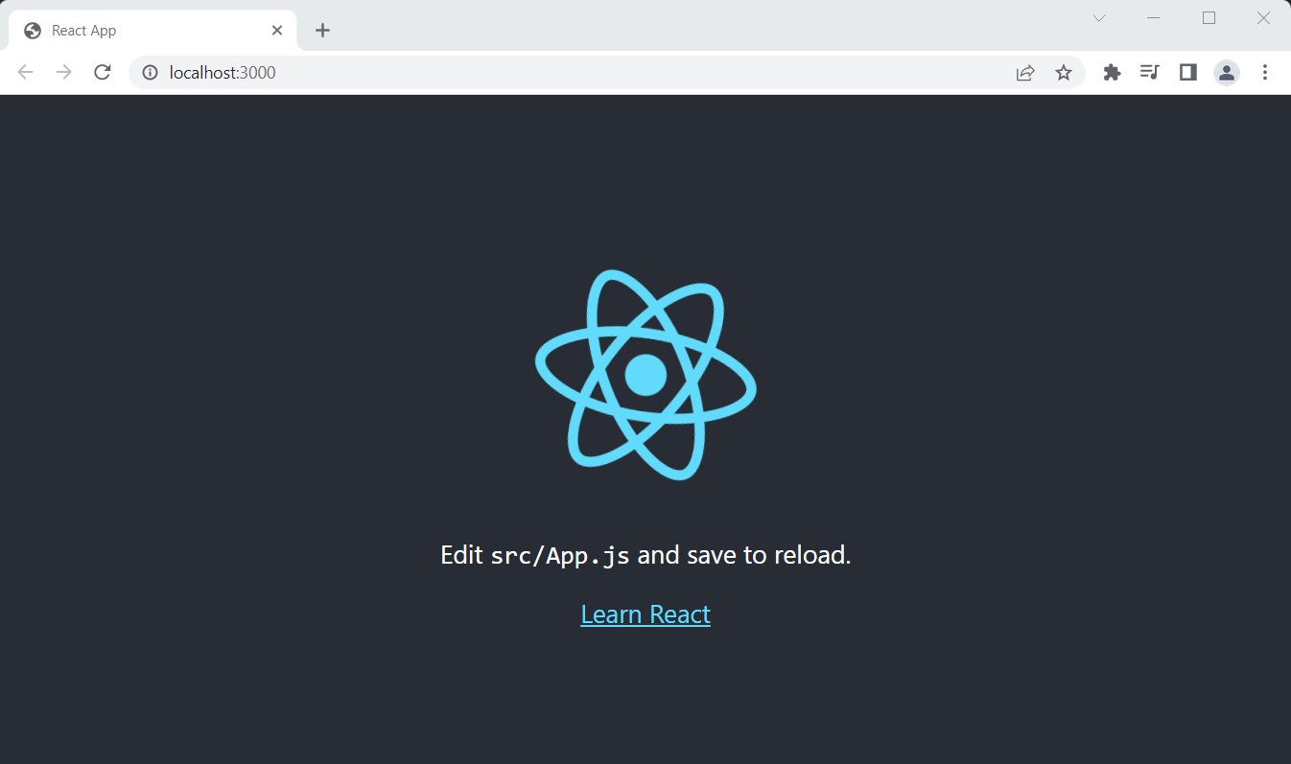

The *serve* static server

The *serve* is a lightweight web server. It serves static site and single page application. It loads fast and consume minimum memory. It can be used to serve a React application. Let us install the tool using *npm* package manager in our system.

npm install serve -g

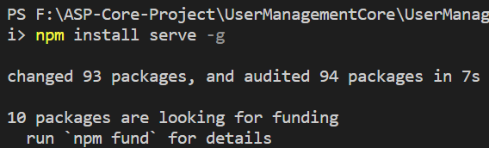

cd F:\UserModuleDotNetCore5