**Blog Site**

**01.Blog Site Setup**

Select a name for a local project directory like:

*multi-author-blogging-site*



In this directory, open command prompt to initialize npm:

*npm init*



A “package.json” file will be created in this directory:



Then, install all kinds of backend dependencies for the project:

*npm i express bcrypt body-parser concurrently cookie-parser date-and-time dotenv formidable jsonwebtoken mongoose nodemailer validator*



*npm i nodemon -D*



Now, the “package.json” file looks like:

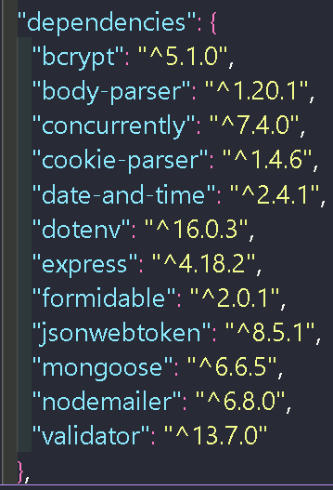

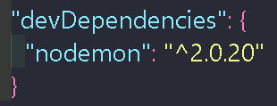

After the installation, “node_modules” directory will be created with “package-lock.json*”* file.

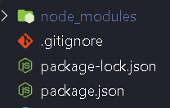

Create an empty directory called “backend” in the project directory.

Then “backend”=>”server.js”

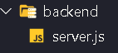

Then install react app in the project root directory:

*npx create-react-app frontend*



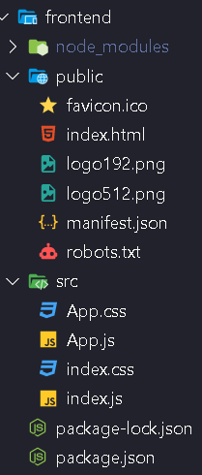

*npm i apexcharts axios jodit jodit-react jwt-decode moment html-to-text node-sass react-apexcharts reactjs-social-login react-helmet react-hot-toast html-react-parser react-icons react-redux react-router-dom redux redux-thunk @emailjs/browser*

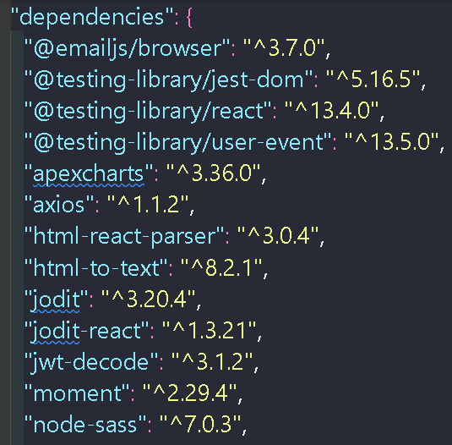

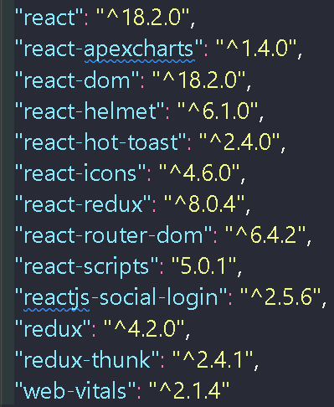

**02.Project Folder Structure**

Create 7 folders in “backend” directory:

config, controller ,middleware, models, routes, utils, validator

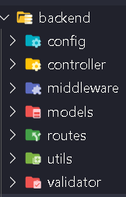

03.Route create

