✈️ SQL Portfolio Report: Flight Data Analysis
📌 Project Title
Flight Operations & Performance Analysis Using SQL

📖 Project Overview
This project analyzes airline, airport, and flight operation data using SQL to uncover insights related to flight frequency, delays, cancellations, and airline performance. The objective was to support data-driven decision-making for customers and aviation stakeholders.

🗂️ Dataset Description
The analysis is based on three main tables:
1️⃣ Airlines Table
- iata_code
- airline
2️⃣ Airports Table
- iata_code
- airport
- city
- State
- Country
- Latitude
- logitude
3️⃣ Flights Table
- flight_id
- flight date
- airline
- flight_number
- origin airport
- destination airport
- delay in minutes
- cancelled
- Cancellation Reason

🛠️ Tools & Technologies
- Database: SQL Server
- Language: SQL
- Environment: Data Analysis Database (data_analysis_flights)

🎯 Business Objectives
- Analyze airline and airport distribution
- Identify major causes of flight cancellations
- Measure airline performance based on delays
- Recommend optimal airlines for passengers
- Evaluate cancellation risks
- Understand seasonal flight patterns

📊 Key Analysis Performed

1️⃣ Total Number of Airlines
Identified the total number of unique airlines operating in the database.
✔️ Used COUNT(DISTINCT iata_code)
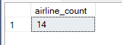

2️⃣ State with Highest Number of Airports
Analyzed airport distribution across states.
✔️ Grouped by state and ranked by airport count
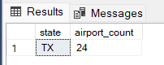

3️⃣ Most Common Cancellation Reason
Determined the primary cause of flight cancellations.
✔️ Filtered NULL values
✔️ Ranked by frequency
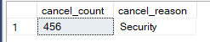

4️⃣ Flights from LAX to MIA (American Airlines)
Measured route-specific performance for American Airlines.
✔️ Filtered by airline and airports
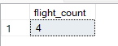

5️⃣ Flights Per Airline
Evaluated airline activity levels.
✔️ Aggregated flight counts by airline
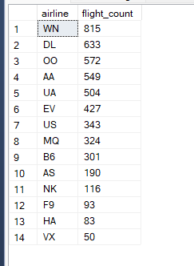

6️⃣ Airline with Highest Total Delay
Identified airlines contributing most to overall delays.
✔️ Summed delay minutes per airline
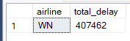

7️⃣ Best Airline Recommendation (LAX → SFO)
Analyzed delay patterns to recommend airlines for passengers.
✔️ Compared maximum delays by airline
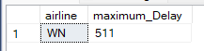

8️⃣ Flight Cancellation Probability
Calculated overall cancellation trends.
✔️ Grouped by cancellation status
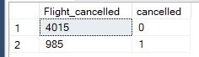

9️⃣ Airline with Highest Cancellation Rate
Identified airlines with frequent cancellations.
✔️ Filtered cancelled flights
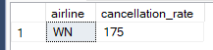

🔟 Security-Related Cancellations
Analyzed security-related disruptions.
✔️ Filtered cancellation reasons using LIKE
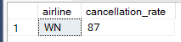

📈 Key Insights
✔️ Identified major airline operators based on flight volume
✔️ Determined leading causes of cancellations
✔️ Highlighted airlines with high delay risks
✔️ Revealed peak travel months
✔️ Found routes with consistent delays
✔️ Measured overall cancellation probability
These insights help passengers and airlines optimize travel planning and operational efficiency.

💡 Business Impact
- Helps customers choose reliable airlines
- Supports airport authorities in capacity planning
- Enables airlines to reduce delay risks
- Improves service quality through performance monitoring
- Assists management in operational decision-making

