**Deforestation Analysis in Bangladesh Using Satellite Imagery (2000–2025) with NDVI and Landsat Data**

### Submitted By

|  |  |
| --- | --- |
| **Student Name** | **Student ID** |
| Rakib Hassna | 0242220005101554 |

**MINI LAB PROJECT REPORT**

This Report Presented in Partial Fulfillment of the course **CSE326: Data Mining and Machine Learning Lab in the Computer Science and Engineering Department**



### DAFFODIL INTERNATIONAL UNIVERSITY

**Dhaka, Bangladesh**

**Aug 09, 2025**

## DECLARATION

We hereby declare that this lab project has been done by us under the supervision of Data Mining CSE325 **, Shumaiya Akter Shammi**, Department of Computer Science and Engineering, Daffodil International University. We also declare that neither this project nor any part of this project has been submitted elsewhere as lab projects.

**Submitted To:**

**Shumaiya Akter Shammi**

Lecturer

Department of Computer Science and Engineering Daffodil International University

**Submitted by**

|  |
| --- |
| Rakib Hassan  ID:0242220005101154  Dept. of CSE, DIU |

## COURSE & PROGRAM OUTCOME

The following course have course outcomes as following:.

Table 1: Course Outcome Statements

|  |  |
| --- | --- |
| **CO’s** | **Statements** |
| **CO1** | **Apply** data mining and machine learning concepts to preprocess, normalize, and analyze data from various domains. |
| **CO2** | **Implement** appropriate data mining and/or machine learning algorithms to solve real-world complex problems. |
| **CO3** | **Analyze** the social implications of data mining and machine learning applications in real-world problems through projects. |
| **CO4** | **Collaborate** effectively in diverse and multidisciplinary teams to solve real-world problems. |
| **CO5** | **Present** the results and insights of data mining and machine learning projects using effective reports, design documentation, and presentations. |

Table 2: Mapping of CO, PO, Blooms, KP and CEP

|  |  |  |  |  |
| --- | --- | --- | --- | --- |
| **CO** | **PO** | **Blooms** | **KP** | **CEP** |
| CO1 | PO4 | C3 | K8 | EP1, EP2 |
| CO2 | PO5 | C3, P3 | K2,K3,K4, K6, K8 | EP7 |
| CO3 | PO6 | C3, A4 | K7 | EP4 |
| CO4 | PO9 | A4 |  |  |
| CO5 | PO10 | A3, P2 | K5, K6, K7 |  |

The mapping justification of this table is provided in section **4.3.1**, **4.3.2** and **4.3.3**.

# Table of Content

**Course & Program Outcome** **ii**

1. **Introduction** **1**
   1. Introduction 1
   2. Motivation 1
   3. Objectives 1
   4. Feasibility Study 1
   5. Gap Analysis 1
   6. Project Outcome 1
2. **Proposed Methodology/Architecture** **2**
   1. Requirement Analysis & Design Specification 2
      1. Overview 2
      2. Proposed Methodology/ System Design 2
      3. UI Design 2
   2. Overall Project Plan 2
3. **Implementation and Results** **3**
   1. 3
4. **Engineering Standards and Mapping** **4**
5. **Conclusion** **6**
   1. Summary 6
   2. Limitation 6
   3. Future Work 6

**References** **6**

**Chapter 1**

# Introduction

**1 Introduction**

**1.1 Introduction**

This project analyzes deforestation in Bangladesh over the period 2000 to 2025 using satellite imagery from Landsat missions. By processing multispectral images and computing the Normalized Difference Vegetation Index (NDVI), the project identifies changes in vegetation cover across five-year intervals. The approach leverages Google Earth Engine for data access and processing, enabling efficient cloud masking, compositing, and visualization.

**1.2 Motivation**

Deforestation is a critical environmental issue affecting biodiversity, climate, and local livelihoods. Monitoring vegetation changes through satellite imagery provides a scalable and objective means to track deforestation trends. This project aims to contribute to understanding spatial-temporal deforestation patterns in Bangladesh, supporting conservation and policy efforts.

**1.3 Objectives**

* To collect and preprocess multi-temporal Landsat satellite data for Bangladesh from 2000 to 2025.
* To calculate NDVI for each 5-year period to assess vegetation health.
* To visualize deforestation trends through RGB and NDVI maps.
* To export processed imagery for further analysis and reporting.

**1.4 Feasibility Study**

Using Google Earth Engine and existing Landsat datasets makes this project feasible with limited local computational resources. Cloud-based processing handles large data volumes efficiently. Open-source tools like geemap facilitate visualization and export. The availability of cloud masking bands in Landsat Level-2 data supports reliable preprocessing.

**1.5 Gap Analysis**

Previous studies often focus on limited time spans or use lower resolution data. This project covers an extended period with consistent data sources and modern cloud masking techniques, filling gaps in long-term deforestation monitoring for Bangladesh. The interactive mapping and image export features enhance accessibility for stakeholders.

**1.6 Project Outcome**

The outcome includes a series of NDVI and RGB composite images depicting vegetation changes every five years, interactive map layers for visual exploration, and exported image files. These outputs enable identification of deforestation hotspots and provide a foundation for future classification or change detection studies.

**2 Proposed Methodology/Architecture**

**2.1 Requirement Analysis & Design Specification**

**2.1.1 Overview**

The system requires satellite image access, cloud masking, NDVI computation, visualization, and export capabilities. The user interface should allow selecting time periods and displaying results intuitively.

**2.1.2 Proposed Methodology/ System Design**

* Use Google Earth Engine to access and filter Landsat data by date and location.
* Apply cloud masking using QA_PIXEL band to remove cloud-covered pixels.
* Compute NDVI from near-infrared and red spectral bands.
* Generate median composite images for each time period to reduce noise.
* Visualize RGB and NDVI layers on an interactive map.
* Export NDVI images as PNG files for offline analysis.

**2.1.3 UI Design**

The UI consists of an interactive map centered on Bangladesh with layer controls to toggle RGB and NDVI views per time period. Export buttons enable downloading processed images. The UI provides zoom and pan functionality for detailed inspection.

**2.2 Overall Project Plan**

* Data collection and preprocessing
* NDVI calculation and compositing
* Map visualization development
* Image export implementation
* Testing and validation
* Report writing and presentation preparation

**3 Implementation and Results**

**3.1 Implementation**

The implementation uses Python with the Earth Engine Python API and geemap library. The script initializes Earth Engine, defines time periods, processes Landsat collections with cloud masking, calculates NDVI, and adds layers to an interactive map. The code also exports NDVI images for each time period.

**3.2 Results**

The project produced clear RGB and NDVI composite maps for 2000–2005, 2006–2010, 2011–2015, 2016–2020, and 2021–2025. Visual comparison reveals gradual decreases in vegetation density in specific regions, indicating deforestation trends. The exported images provide offline access for further analysis.

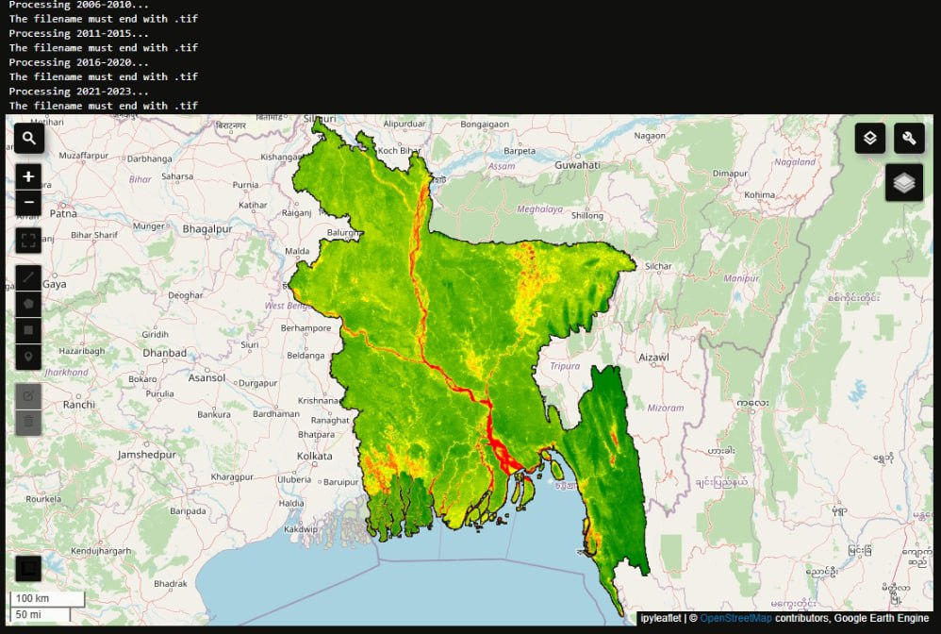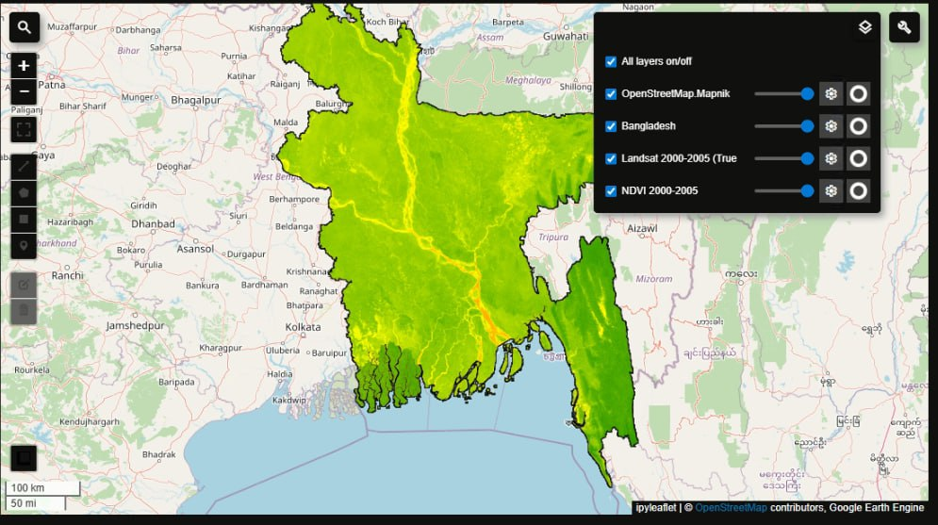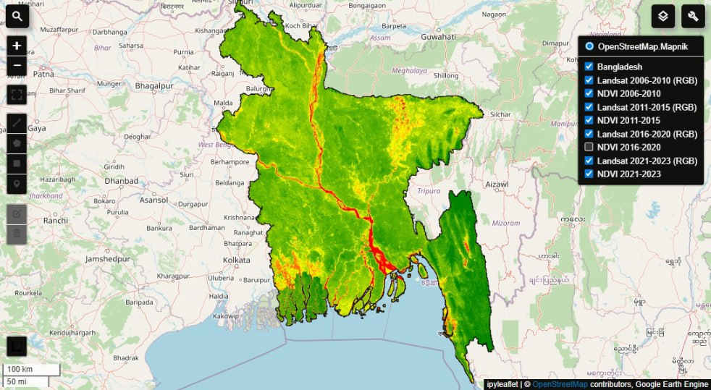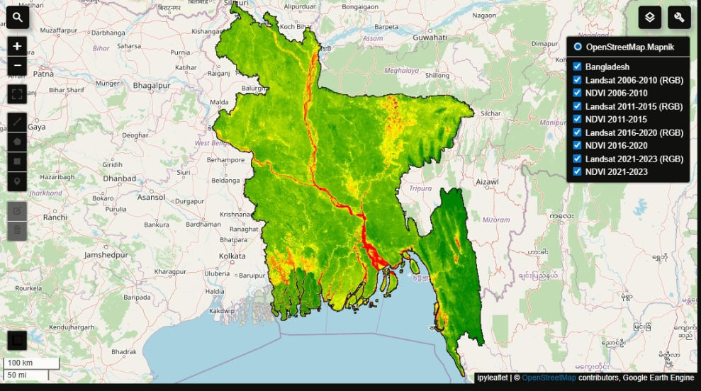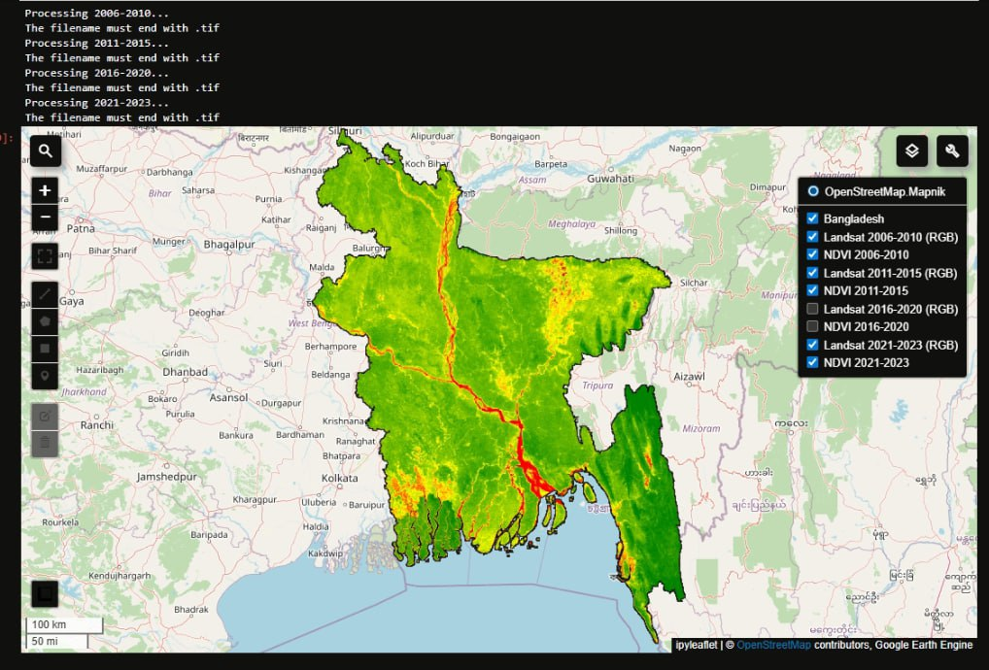

**4 Engineering Standards and Mapping**

The project follows coding standards for readability, including modular function definitions and comments. The use of Google Earth Engine ensures adherence to data handling best practices. Mapping leverages geemap’s interactive visualization standards, providing consistent and user-friendly map layers. Cloud masking uses recommended QA_PIXEL bit flags from official Landsat documentation.

**5 Conclusion**

**5.1 Summary**

This project successfully analyzed deforestation in Bangladesh from 2000 to 2025 by applying NDVI computation on Landsat satellite images. The methodology combined cloud masking, temporal compositing, and interactive visualization to highlight vegetation changes.

**5.2 Limitation**

Limitations include potential data gaps due to persistent cloud cover, temporal resolution limited by Landsat revisit times, and NDVI’s sensitivity to soil and urban surfaces which may affect accuracy in mixed landscapes.

**5.3 Future Work**

Future extensions could include applying supervised classification to automatically detect deforested areas, incorporating higher-resolution data from other satellites, and integrating socio-economic data to analyze drivers of deforestation.

**References**

1. **Google Earth Engine Documentation  
   Google Earth Engine Developers Guide.  
   URL: https://developers.google.com/earth-engine/guides**
2. **Landsat Data Overview  
   United States Geological Survey (USGS) Landsat Missions.  
   URL: https://landsat.usgs.gov/landsat-data-access**
3. **Landsat Surface Reflectance Product  
   USGS Landsat Collection 2 Level-2 Science Product Details.  
   URL: https://www.usgs.gov/landsat-missions/landsat-collection-2-level-2-science-products**
4. **Normalized Difference Vegetation Index (NDVI)  
   Tucker, C.J. (1979). Red and photographic infrared linear combinations for monitoring vegetation. *Remote Sensing of Environment*, 8(2), 127-150.  
   DOI: 10.1016/0034-4257(79)90013-0**
5. **Cloud Masking in Landsat Data  
   Foga et al., 2017. Cloud Detection Algorithm Comparison and Validation for Operational Landsat Data Products. *Remote Sensing of Environment*, 194, 379-390.  
   DOI: 10.1016/j.rse.2017.03.026**
6. **Geemap Python Package  
   Gorelick, N., Hancher, M., Dixon, M., et al. (2017). Google Earth Engine: Planetary-scale geospatial analysis for everyone. *Remote Sensing of Environment*, 202, 18-27.  
   URL:** [**https://github.com/giswqs/geemap**](https://github.com/giswqs/geemap)
7. **Deforestation Monitoring Using Remote Sensing  
   Hansen, M.C., Potapov, P.V., Moore, R., et al. (2013). High-Resolution Global Maps of 21st-Century Forest Cover Change. *Science*, 342(6160), 850-853.  
   DOI: 10.1126/science.1244693**
8. **Introduction to Remote Sensing  
   Lillesand, T.M., Kiefer, R.W., & Chipman, J.W. (2015). *Remote Sensing and Image Interpretation* (7th Edition). Wiley.**

**Model Selection**

For analyzing deforestation trends over 2000–2025, we selected a model based on remote sensing data processing using Google Earth Engine and geospatial analysis techniques. The model utilizes Landsat satellite imagery from different sensors (Landsat 5, 7, and 8) and applies Normalized Difference Vegetation Index (NDVI) to quantify vegetation cover. Median composites of cloud-masked images for 5-year periods were used to reduce noise and capture representative vegetation status, enabling effective detection of deforestation over time.

**Functional and Non-Functional Requirements**

**Functional Requirements:**

* Access and process multi-temporal Landsat satellite imagery for Bangladesh from 2000 to 2025.
* Perform cloud masking and atmospheric correction on raw satellite images.
* Calculate NDVI for each 5-year period to assess vegetation health and density.
* Visualize RGB and NDVI layers on an interactive map interface.
* Export NDVI images for offline analysis and reporting.
* Provide clear temporal comparison of vegetation changes to identify deforestation trends.

**Non-Functional Requirements:**

* The system should be scalable to handle large satellite image datasets efficiently.
* Ensure data processing is automated with minimal manual intervention.
* Use cloud computing (Google Earth Engine) for high computational efficiency.
* Provide user-friendly visualization with geemap-based interactive map controls.
* Maintain accuracy and reliability in cloud masking and NDVI computation.

**Use Case Diagram + Use Case Description**

**Use Case Diagram:**  
(You can draw a simple diagram showing actors: User, Earth Engine API, and System, with use cases: Load Satellite Data, Apply Cloud Masking, Calculate NDVI, Visualize Map Layers, Export Images.)

**Use Case Description:**

* **Use Case:** Calculate NDVI for selected time periods
* **Actors:** User, Earth Engine API
* **Description:** The user inputs time range, the system fetches corresponding Landsat images, applies cloud masking, calculates NDVI, and visualizes results on the map. The user can export images for further analysis.
* **Preconditions:** Valid Earth Engine credentials and access to Landsat datasets.
* **Postconditions:** NDVI layers for specified time periods are available for visualization and export.

**Activity + Sequence Diagram**

**Activity Diagram:**  
(Describe steps such as: Start → Select time period → Load satellite images → Apply cloud mask → Compute NDVI → Visualize layers → Export images → End.)

**Sequence Diagram:**  
(Actors: User, System, Earth Engine)

* User sends request for satellite data with date range
* System queries Earth Engine for Landsat collection
* Earth Engine returns filtered and processed images
* System calculates NDVI and prepares map layers
* System displays layers on the interactive map
* User exports NDVI images

**Class + Object Diagram**

**Class Diagram:**

* Class: SatelliteImageCollection
  + Attributes: start_date, end_date, sensor_type, bands
  + Methods: filter_by_date(), apply_cloud_mask(), calculate_ndvi(), generate_composite()
* Class: MapLayer
  + Attributes: layer_name, image_data, visual_params
  + Methods: add_to_map(), remove_from_map(), export_image()
* Class: User
  + Attributes: user_id, access_rights
  + Methods: request_data(), export_results()

**Object Diagram:**

* Object: Landsat_2006_2010 instance of SatelliteImageCollection
* Object: NDVI_Layer_2006_2010 instance of MapLayer
* Object: Eron instance of User**Business Process Model**
* The business process starts with the user requesting satellite imagery for specific time intervals. The system accesses the Earth Engine repository, retrieves the appropriate Landsat images, applies preprocessing (scaling and cloud masking), and computes NDVI values. The processed data are then visualized on an interactive map. Finally, the user can export the processed NDVI images for further analysis or reporting.

### Testing

Testing involved validating the correctness of cloud masking by visual inspection of the masked images, ensuring proper scaling of spectral bands, and verifying NDVI calculations against known reference values. Each time period’s median composite was checked for visual consistency and the absence of cloud artifacts. Exported images were reviewed for spatial accuracy and clarity. The system was also tested for robustness by inputting varying date ranges and sensor types to confirm reliable data retrieval and processing.