Spatial Soil Variability and Carbon Dynamics in the Moribund Delta of Ganges of Bangladesh

MJ Uddin*, Md. Rakib Hasan, Fazle Zawadul Arabi, Shoumik Zubyer

*Department of Soil, Water and Environment, University of Dhaka, Dhaka-1000, Bangladesh*

# **Abstract**

This study explores the soil properties and carbon dynamics of the Moribund delta in Bangladesh's Ganges floodplain, revealing significant spatial and textural variability. Bulk density varied between 1.4 to 1.77 g/cm³ (average 1.59±0.084 g/cm³), decreasing with depth due to higher organic matter content. The soils were predominantly silt-rich (58.08±13.122%), with sand at 14.72% and clay at 27.4%, influencing nutrient and water retention. Soil organic carbon concentration (SOCC) ranged from 0.31±0.1% in Pakuria to 0.962±0.28% in Sara, with a mean of 0.504±0.313%. Soil organic carbon density (SOCD) averaged 0.0081±0.0052%, while the highest SOC stock (30.95±7.21 Mg ha⁻¹) was found in Sara, indicating high carbon sequestration potential. Principal Component Analysis (PCA) identified sand and pH as dominant factors in PC1 (42.5% variance), while clay and organic matter influenced PC2 (19.5% variance). Cluster analysis revealed three distinct soil groups: deeper profiles in Sara and Mokarimpur, mixed sites in Pakuria and Khemirdiar, and shallower samples from Ruppur and Sara. Findings elucidate the importance of targeted soil management in optimizing carbon storage, highlighting the delta’s potential in mitigating impending climate change through enhanced carbon sequestration.

# **1. Introduction**

The Ganges Delta, also termed the Bengal Delta, is regarded as the third most expansive and dynamic river deltas globally. The deltaic peninsula expands across the Bengal span of the Indian subcontinent, encompassing large parts of southwestern Bangladesh and West Bengal in India. Its formation is attributed to the confluence of the Ganges, Brahmaputra, and Meghna fluvial systems, also referred to as The Ganges-Brahmaputra-Meghna (GBM) river basin, covering an area exceeding 1.7 million km². The GBM is a transboundary river basin divided between Bangladesh (approximately 67%) and India (about 33%) (Allison, 1998; Goodbred & Kuehl, 2000; WorldAtlas, 2017), with only one outlet in Bangladesh to the Bay of Bengal. Thus any change of water resources in GBM basin due to anthropogenically enhanced climate variability will affect Bangladesh predominantly. The GBM is an arcuate or fan-shaped delta characterized by high alluvial deposition. Due to its high nutrient status, fertile soils, dense vegetative cover and abundant water resources, which have historically been crucial to the occupying dense populations, high biodiversity indices (Dušek & Popelková, 2017) and diverse agricultural practices (WorldAtlas, 2017; Brammer, 2012). Himalayan and Tibetan Plateau derived fluvial processes and seasonal flooding (Coleman, 1969; Allison, 1998; Goodbred & Kuehl, 2000) contributes to the delta’s fertile landscape (Brammer, 2012). Within the vast expanse of the Bengal Delta lies the Ganges Moribund Delta, a less dynamic subregion that stretches across the greater Kushtia, Chuadanga, Meherpur, Pabna, and Jashore districts of Bangladesh, as well as parts of the Murshidabad and Nadia districts in India (Paszkowski et al., 2021). Unlike the active sections of the delta, where rivers continuously shape the landscape, Moribund Delta is a characteristic network of silted-up and desiccated river channels, which have lost their connection to the main river systems over epochs, boasting relatively flat topography with numerous abandoned river channels and oxbow lakes. Rivers in the region such as the Hisna, Kaliganga, and Kumar have experienced significant retardation in discharge rates due to land use changes, leading to the desiccation of multiple channels and emergent semi-arid conditions with minimal seasonal flooding (Brammer, 1996; Goodbred & Kuehl, 2000). Reduced hydrological flow has directly influenced the Moribund Delta's alluvial soils, which now possess altered physicochemical character due to the soils being historically enriched by regular sediment input, and now exhibit argillaceous deposition, shifts in texture and overall fertility due to limited freshwater siltation (Allison, 1998; Brammer, 2012; Islam et al., 2016; Darby et al., 2015). This study aims to address edaphic parameters of bulk density, moisture content, particle size distribution, organic matter concentration, nutrient composition and soil organic carbon stock across varying depths and geospatial coordinates within the Moribund Delta with implications for land management in low lying coastal deltaic regions at the advent of climate change stressors (Brammer, 2012; Rahman et al., 2019).

# **2. Materials and methods**

## **2.1. Study area**

The Ishwardi upazila of Pabna district and the Bheramara upazila of Kushtia district in Bangladesh were the focal areas of the study, located at the heart of the Moribund Delta. The sampling location and the digital elevation map (DEM) of the area is given in Fig. (1). Situated between latitudes 24°02'N and 24°07'N and longitudes 88°59'E and 89°04'E, these regions fall under a humid subtropical climate with average annual temperatures ranging from 16.5°C to 29.0°C and mean annual rainfall of approximately 1,488.7 mm (Shamsudduha et al., 2009). The region’s land use is dominated by the cultivation of staple crops, including paddy, wheat, sugarcane, betel leaf and lychee. However, shifts in hydrological regimes have introduced substantial challenges to crop productivity, the long term soil resilience and effectively, local livelihoods.

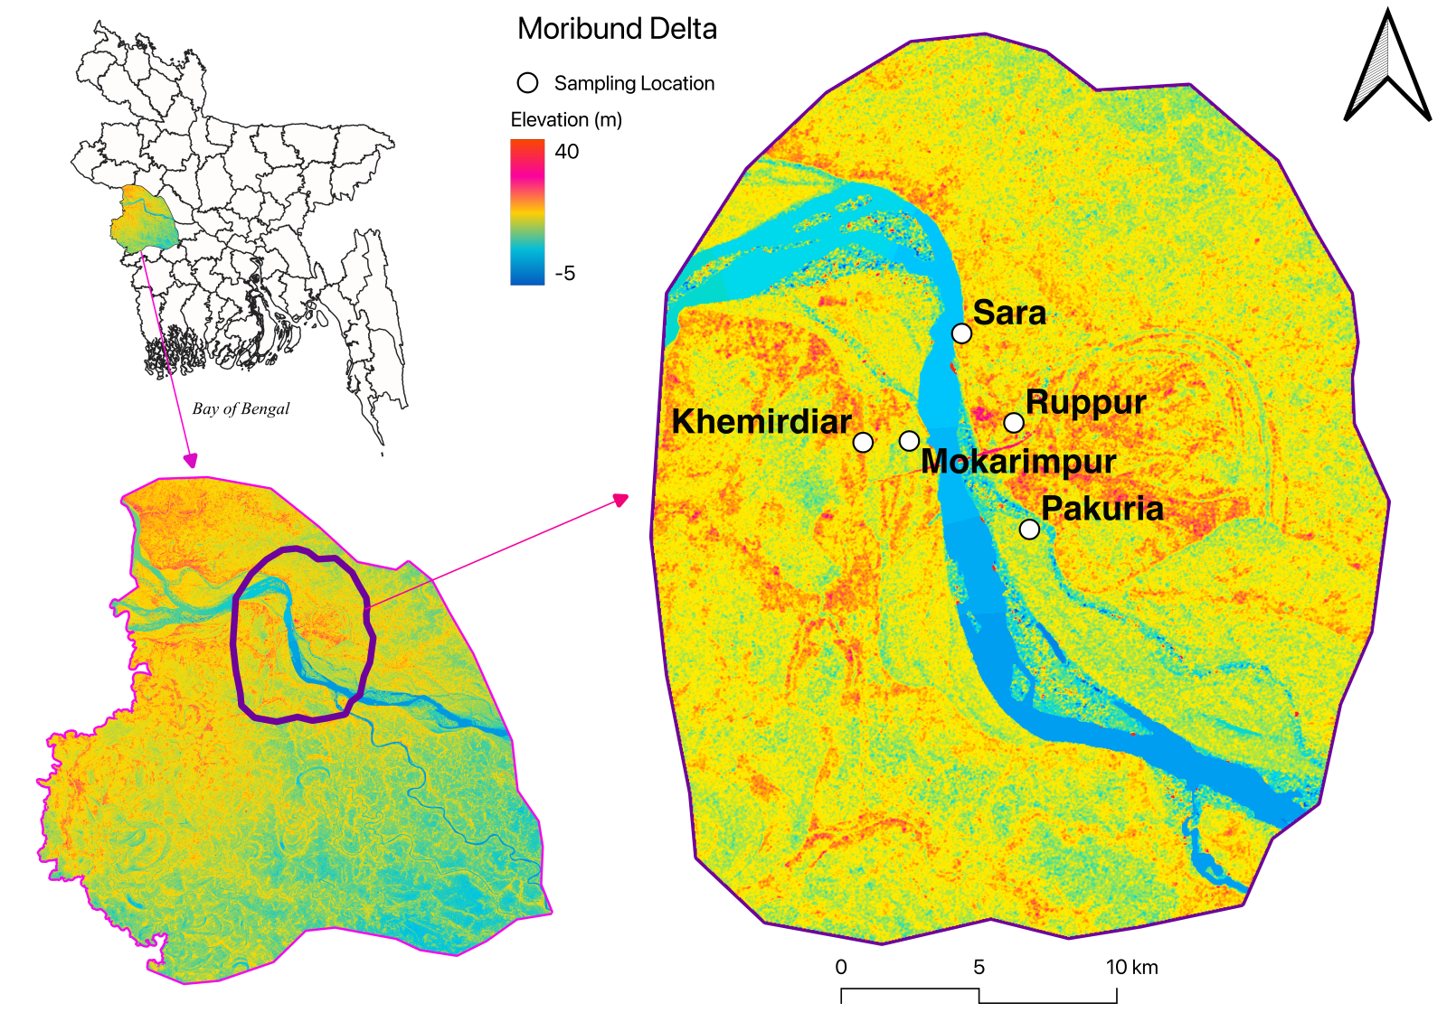

Fig. 1. Digital Elevation Map (DEM) of the Sampling Location of the Moribund Delta

## **2.2. Sample collection and preparation**

The fieldwork and sampling covered five moribund delta sites in the Ganges Bengal delta: Sara, Ruppur, Pakuria, Khemirdiar, and Mokarimpur. At each site, a 1-meter soil profile was excavated, with soil samples collected at 0-20 cm, 20-40 cm, 40-60 cm, 60-80 cm, and 80-100 cm depths, labeled as Sample-1 to Sample-5. Each sample weighed 1-2 kg, collected using a spade and core sampler. A total of 25 soil and 25 core samples were air-dried for a week, crushed, and sieved through 2 mm and 0.5 mm mesh for physical and chemical analyses.

## **2.3. Sample analysis**

The current study involved measuring soil quality parameters, including physical parameters of bulk density by Blake and Hartge (1986), particle size distribution by Gee and Bauder (1986), moisture content , and textural class, as well as chemical parameters such as pH, Salinity (EC), organic matter, total nitrogen by Bremner and Mulvaney (1982), and CEC by Schollenberger and Simon (1945), SOC concentration, SOC density and SOC stock.

The Walkley and Black (1934) wet oxidation method, as reported by Nelson and Sommers (1982), was used to calculate the soil organic carbon concentration (SOCC). The SOCC values were determined by the following equation:

Using the following formula, which Nelson and Sommers (1982) indicated, the organic matter (OM) contents of the soil samples were also calculated as SOCC multiplied by the Van Bemmelen factor (1.72).

The following equation was used to compute soil organic carbon density (SOCD), having Soil bulk density multiplied by soil organic carbon concentration:

As stated by Donato et al. (2011) and Batjes (1996), the following equation was used to calculate the SOC Stocks of the mangrove ecosystem:

**3. Results and Discussion**

The physicochemical variations of the soils of the are given in the Fig.2. The bulk density indicates variability in carbon retention potential, the values ranged from 1.4 to 1.77 g/cm³, with an average of 1.59±0.084 g/cm³. These values generally decreased with depth, suggesting higher organic matter content and lower compaction in deeper layers. Among the sampling locations, Sara showed the highest mean bulk density (1.626 g/cm³), while Pakuria had the lowest (1.53 g/cm³). Soil moisture content varied from 10.98% to 36.97%, with the highest mean moisture content observed at Sara (30.37%) and the lowest at Khemirdiar (23.46%). The particle size distribution indicated a dominance of silt (58.08±13.122%), with clay content averaging 27.4±7.459% and sand at 14.72±16.452%. Notably, Sara exhibited the highest sand content (18%), while Khemirdiar and Ruppur showed relatively lower sand fractions, which likely affects water retention and nutrient availability. The soils were mildly to moderately alkaline, with pH values ranging from 7.69 to 8.84 (mean 8.23±0.244). Electrical conductivity (EC) ranged from 0.06 to 0.262 dS/m, with an overall mean of 0.1328±0.0416 dS/m. Organic matter content ranged from 0.534% to 1.66%, with Sara showing the highest concentration (1.66%) and Pakuria the lowest (0.534%). TN content ranged from 0.02% to 0.12%, with a regional average of 0.042±0.029%. CEC ranged from 0.59 to 6.44 meq/100g, with an average of 2.94±2.333 meq/100g. Locations like Sara and Ruppur exhibited relatively higher CEC values, suggesting a greater capacity for nutrient retention compared to other areas in the delta.

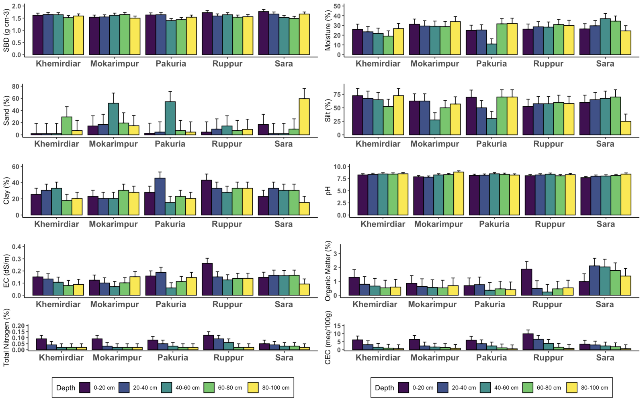

Fig. 2. Physicochemical properties of soils of Soil Bulk Density (SBD), Moisture, Sand, Silt, Clay, pH, Electrical Conductivity (EC), Organic matter (OM), Total Nitrogen (TN) and Cation Exchange Capacity (CEC) across different locations and depths in the Moribund Delta.

Soil organic carbon content metrics revealed substantial spatial variations from 0.31±0.1% in Pakuria to 0.962±0.28% in Sara, with an overall mean of 0.504±0.313% and given in Fig 3. The highest SOCC was recorded in sample Sara 20-40 cm (1.22%), while the lowest was found in sample Ruppur 40-60 cm (0.13%). Soil organic carbon density (SOCD) followed a similar suit, with the highest value of 0.0204% in sample Sara 20-40 cm, and the lowest at 0.0021% in Ruppur 40-60 cm. The average SOCD across the region was 0.0081±0.0052%. To note, Sara exhibited the highest SOC stock (30.9508±7.209 Mg ha−1), while Pakuria showed the lowest (9.6424±3.4254 Mg ha−1). The overall mean SOC stock for the study area was 16.165±10.2775 Mg ha−1. The variations indicate that Sara shows higher organic matter content and therefore greater sequestration potential.

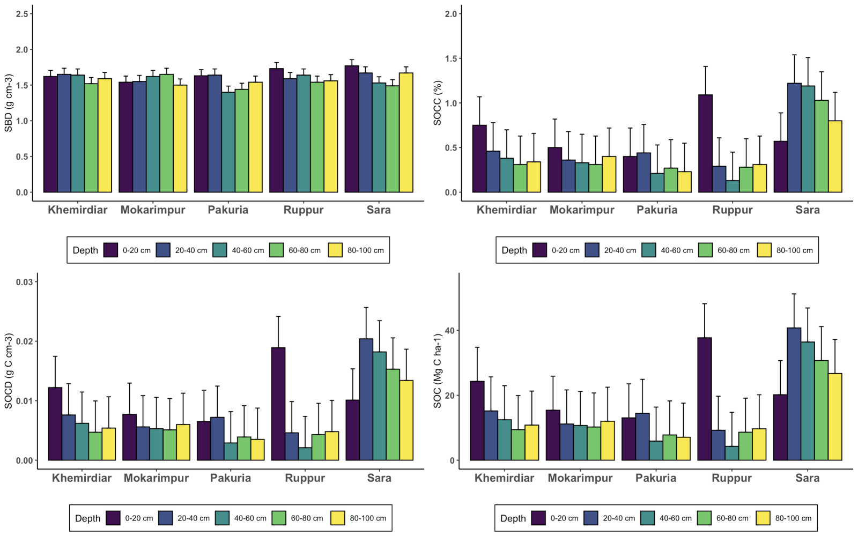Fig. 3. Soil Bulk Density (SBD), Soil Organic Carbon Concentration (SOCC), Soil Organic Carbon Density and Soil Organic Carbon Stocks (SOC) in the Moribund Delta

Correlation analyses given in Fig 4. of soil properties revealed clay and EC held a positive correlation with bulk density and TN, indicating finer particles and salinity are factors of nutrient retention and compaction. Conversely, sand content showed a strong negative correlation with silt and clay, highlighting the texture differences in soil properties indicate carbon storage and nutrient cycling in mangrove ecosystems.

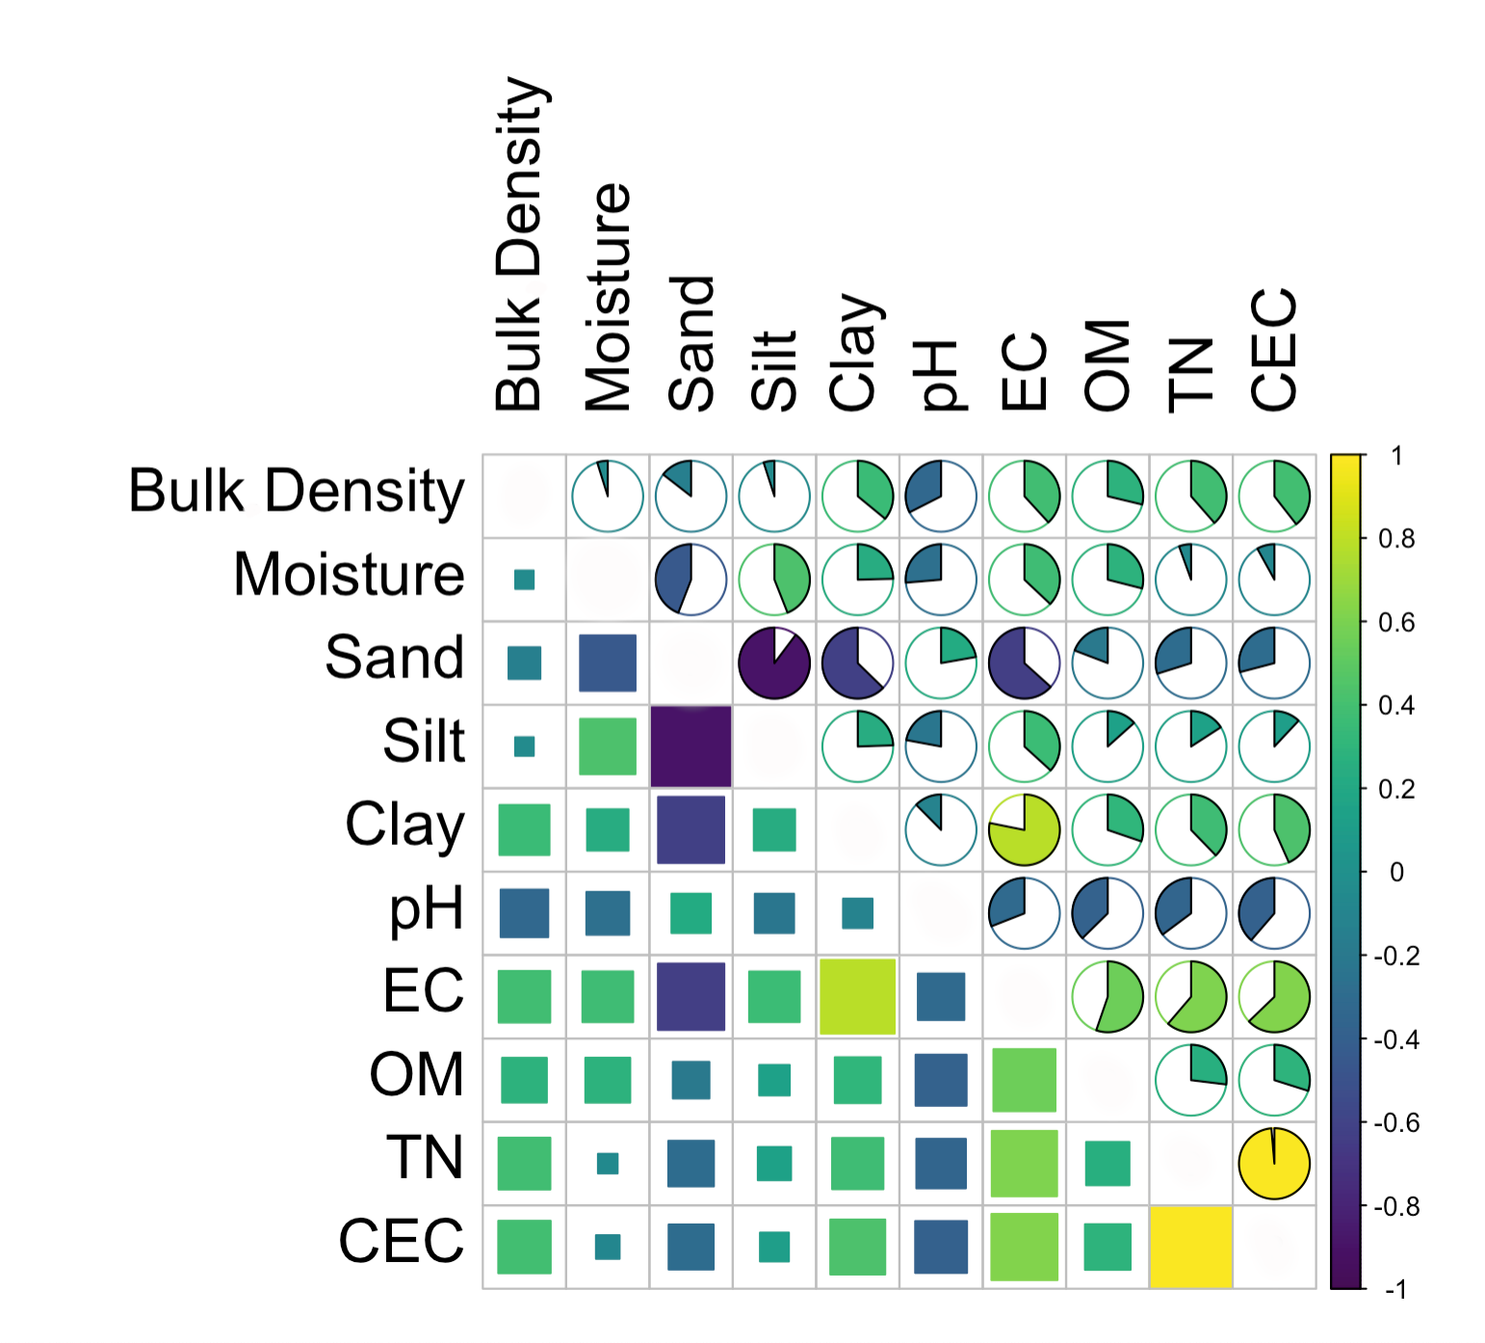

Fig. 4. Correlation matrix of soil physicochemical properties.

Principal Component Analysis (PCA) further elucidated the variability in properties across the sites provided in Fig. 5.. The first two principal components (PC1 and PC2) accounted for 62% of the total variance (PC1: 42.5%, PC2: 19.5%). The PCA biplot showed that sand and pH were the primary drivers of PC1, while clay and OM strongly influenced PC2. Results show that Khemirdiar possessed higher sand content, and Mokarimpur possessed higher clay and OM.

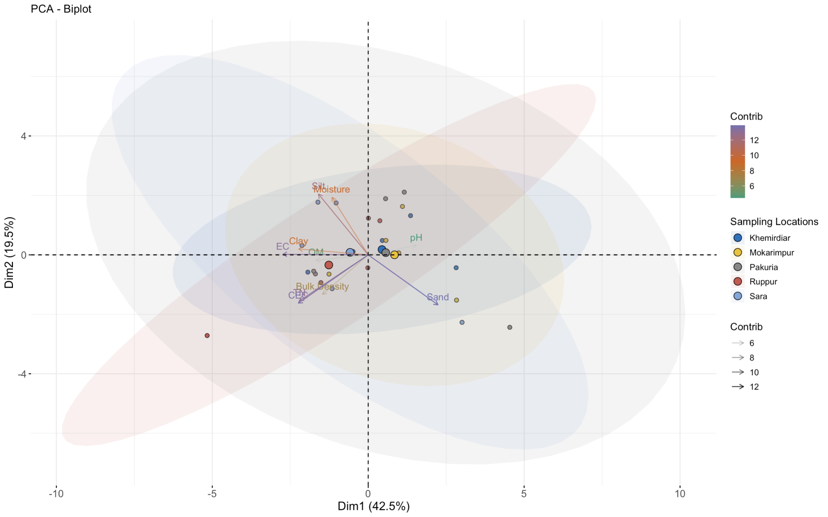

Fig. 5. Principal Component Analysis (PCA) biplot of soil properties in the Moribund Delta, highlighting variance among sampling locations.

Cluster analysis, using Ward's method, grouped the soil samples into three distinct clusters based on similarities in soil properties given in Fig. 6. The first cluster using deeper samples (40–100 cm) from Sara and Mokarimpur, showed consistent soil characteristics, suggesting stable conditions at these depths. The second cluster, which included Pakuria and Khemirdiar, exhibited moderate homogeneity across various depths, suggesting a composite influence. The third cluster, using shallower samples (0–40 cm) from Ruppur and Sara, reflected upper layer characteristics, which are likely more influenced by surface processes.

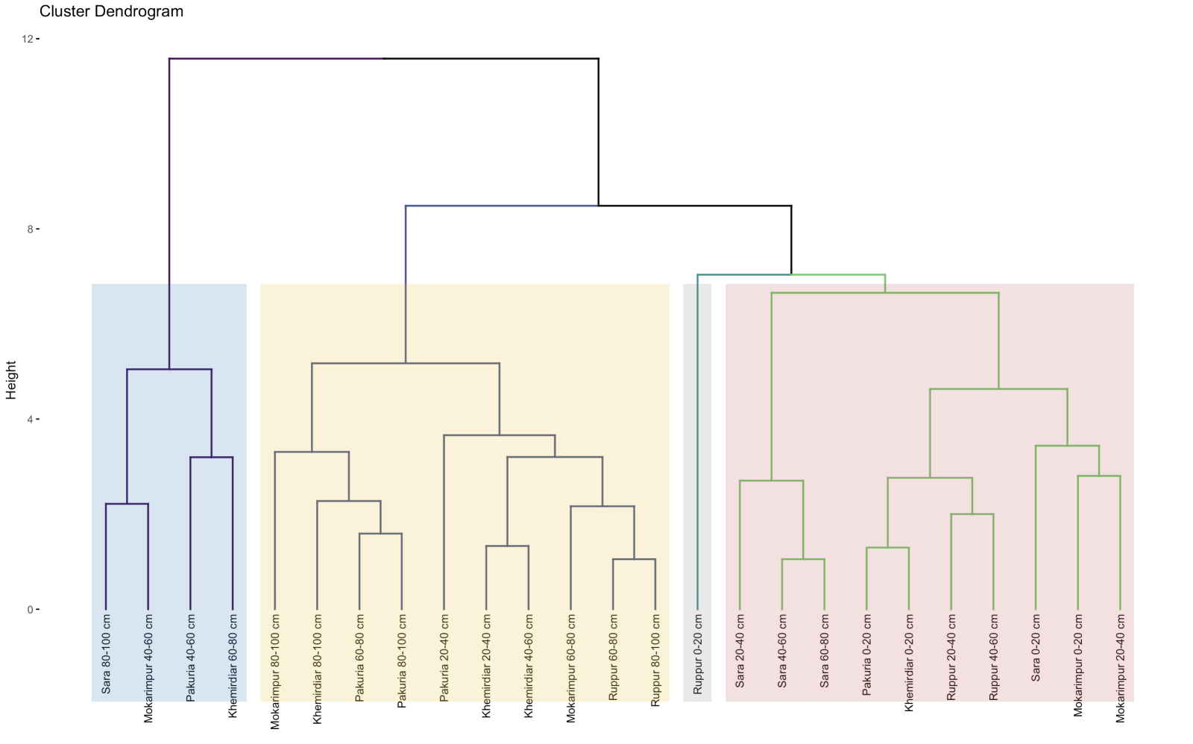

Fig. 6. Hierarchical cluster dendrogram of soil samples based on physicochemical properties in the Moribund Delta.

The Moribund deltaic region exhibits substantial spatial heterogeneity in physicochemical properties, especially in bulk density, notably influencing carbon sequestration potential. Higher bulk density and sand content in Sara corresponded with reduced water retention, conversely elevated silt and clay fractions in Khemirdiar and Ruppur had greater moisture content and nutrient availability. Moderately alkaline pH and low EC values suggest a predominantly non-saline environment, while elevated SOC and CEC values in Sara and Ruppur indicate higher carbon storage and nutrient retention capacity. Correlations highlight the role of clay and EC in nutrient dynamics and compaction, additionally the PCA and cluster analyses identified deeper stable profiles in Sara and Mokarimpur, and surface-influenced heterogeneity in Ruppur and Sara. The findings suggest adopting proper land management within deltaic ecosystems will be foundational to sustainable coastal lowland management.

**Acknowledgement**

The authors deeply appreciate the University of Dhaka authorities for awarding the Centennial Research Grants (CRG) that supported this research.

# **References**

1. Allison, M. A. (1998). Historical changes in the Ganges-Brahmaputra delta front. *Journal of Coastal Research*, 1269-1275.<https://www.jstor.org/stable/4298887>
2. Brammer, H. (1996). *The Geography of the Soils of Bangladesh*.
3. Brammer, H. (2014). *Climate change, sea-level rise and development in Bangladesh*.
4. Paszkowski, A., Goodbred, S., Borgomeo, E., Khan, M. S. A., & Hall, J. W. (2021). Geomorphic change in the Ganges–Brahmaputra–Meghna delta. Nature Reviews Earth & Environment, 2(11), 763–780. <https://doi.org/10.1038/s43017-021-00213-4>
5. Coleman, J. M. (1969). Brahmaputra river: Channel processes and sedimentation. *Sedimentary Geology*, 3(2–3), 129–239. <https://doi.org/10.1016/0037-0738(69)90010-4>
6. Goodbred, S. L., & Kuehl, S. A. (2000). Enormous Ganges-Brahmaputra sediment discharge during strengthened early Holocene monsoon. *Geology*, 28(12), 1083–1086. [https://doi.org/10.1130/0091-7613(2000)28<1083:EGSDDS>2.0.CO;2](https://doi.org/10.1130/0091-7613(2000)28%3C1083:EGSDDS%3E2.0.CO;2)
7. Islam, M., Islam, S., & Hassan, A. (2016). Impact of Climate Change on Water with Reference to the Ganges–Brahmaputra–Meghna River Basin. In Elsevier eBooks (pp. 121–160). <https://doi.org/10.1016/b978-0-12-809330-6.00003-9>
8. Darby, S. E., Dunn, F. E., Nicholls, R. J., Rahman, M., & Riddy, L. (2015). A first look at the influence of anthropogenic climate change on the future delivery of fluvial sediment to the Ganges–Brahmaputra–Meghna delta. *Environmental Science Processes & Impacts*, 17(9), 1587–1600. <https://doi.org/10.1039/c5em00252d>
9. Rahman, M. M., Ghosh, T., Salehin, M., Ghosh, A., Haque, A., Hossain, M. A., Das, S., Hazra, S., Islam, N., Sarker, M. H., Nicholls, R. J., & Hutton, C. W. (2019). Ganges-Brahmaputra-Meghna Delta, Bangladesh and India: a transnational Mega-Delta. In Springer eBooks (pp. 23–51). <https://doi.org/10.1007/978-3-030-23517-8_2>
10. Dušek, R., & Popelková, R. (2017). Theoretical view of the Shannon index in the evaluation of landscape diversity. *AUC GEOGRAPHICA*, 47(2), 5–13. <https://doi.org/10.14712/23361980.2015.12>
11. WorldAtlas. (2017). The Ganges Delta. Retrieved from <https://www.worldatlas.com/articles/the-ganges-delta.html>
12. Shamsudduha, M., Chandler, R. E., Taylor, R. G., & Ahmed, K. M. (2009). Recent trends in groundwater levels in a highly seasonal hydrological system: the Ganges-Brahmaputra-Meghna Delta. Hydrology and Earth System Sciences, 13(12), 2373–2385. <https://doi.org/10.5194/hess-13-2373-2009>
13. Blake, G. R., & Hartge, K. H. (1986). Bulk density. In Soil Science Society of America book series (pp. 363–375). <https://doi.org/10.2136/sssabookser5.1.2ed.c13>
14. Gee, G. W., & Bauder, J. W. (1986). Particle-size analysis. In Soil Science Society of America book series (pp. 383–411). <https://doi.org/10.2136/sssabookser5.1.2ed.c15>
15. Bremner, J., & Mulvaney, C. (1982). Nitrogen-Total. In Agronomy monograph/Agronomy (pp. 595–624). <https://doi.org/10.2134/agronmonogr9.2.2ed.c31>
16. Schollenberger, C. J., & Simon, R. H. (1945). Determination of exchange capacity and exchangeable bases in soil—ammonium acetate method. *Soil science*, *59*(1), 13-24. <https://journals.lww.com/soilsci/citation/1945/01000/DETERMINATION_OF_EXCHANGE_CAPACITY_AND.4.aspx>
17. Mylavarapu, R., Sikora, F. J., & Moore, K. P. (2014). Walkley-Black Method. Soil test methods from the Southeastern United States, 158. <https://aesl.ces.uga.edu/Sera6/PUB/Methodsmanualfinalsera6.pdf#page=166>
18. Nelson, D. W., & Sommers, L. E. (1982). Total carbon, organic carbon, and organic matter. In *Soil Science Society of America book series* (pp. 961–1010). <https://doi.org/10.2136/sssabookser5.3.c34>
19. Donato, D. C., Kauffman, J. B., Murdiyarso, D., Kurnianto, S., Stidham, M., & Kanninen, M. (2011). Mangroves among the most carbon-rich forests in the tropics. Nature Geoscience, 4(5), 293–297. <https://doi.org/10.1038/ngeo1123>
20. Batjes, N. (1996). Total carbon and nitrogen in the soils of the world. *European Journal of Soil Science*, *47*(2), 151–163. <https://doi.org/10.1111/j.1365-2389.1996.tb01386.x>