Supporting Information
Comparative Study of Non-Toxic Triple and Dual Perovskite-Based CZTSSe Tandem Cell: A Combined SCAPS-1D and Machine Learning Approach
Rakib Hossain Sourav, Khondaker Tamanna Nizam, Kashfi Uddin*
ªDepartment of Materials and Metallurgical Engineering (MME), Chittagong University of Engineering & Technology (CUET), Chittagong-4349, Bangladesh

*Corresponding author
Kashfi Uddin
Postal address: Department of Materials and Metallurgical Engineering (MME),
Chittagong University of Engineering & Technology (CUET), Chittagong-4349, Bangladesh.
Email: kumse2001@gmail.com, Phone: +880-1989107903

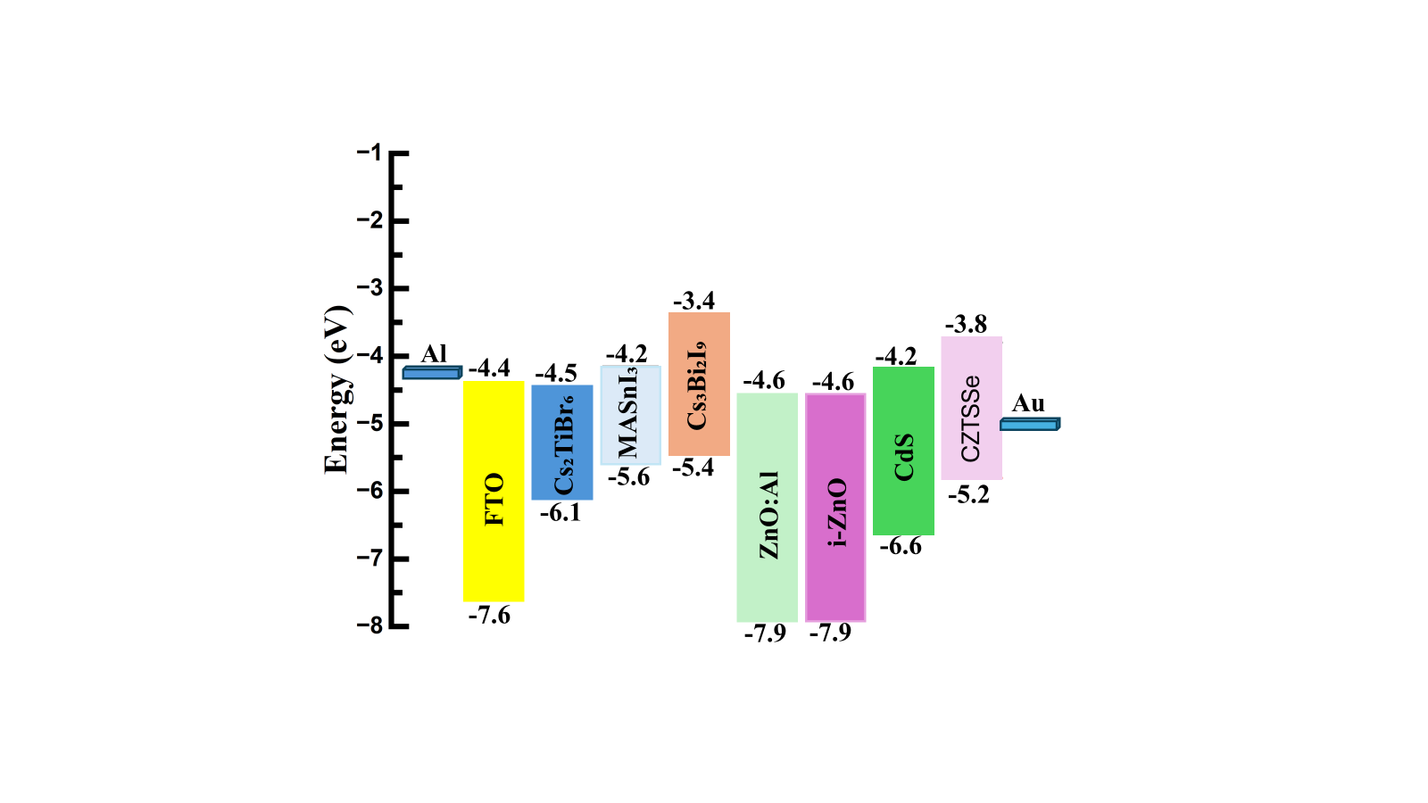
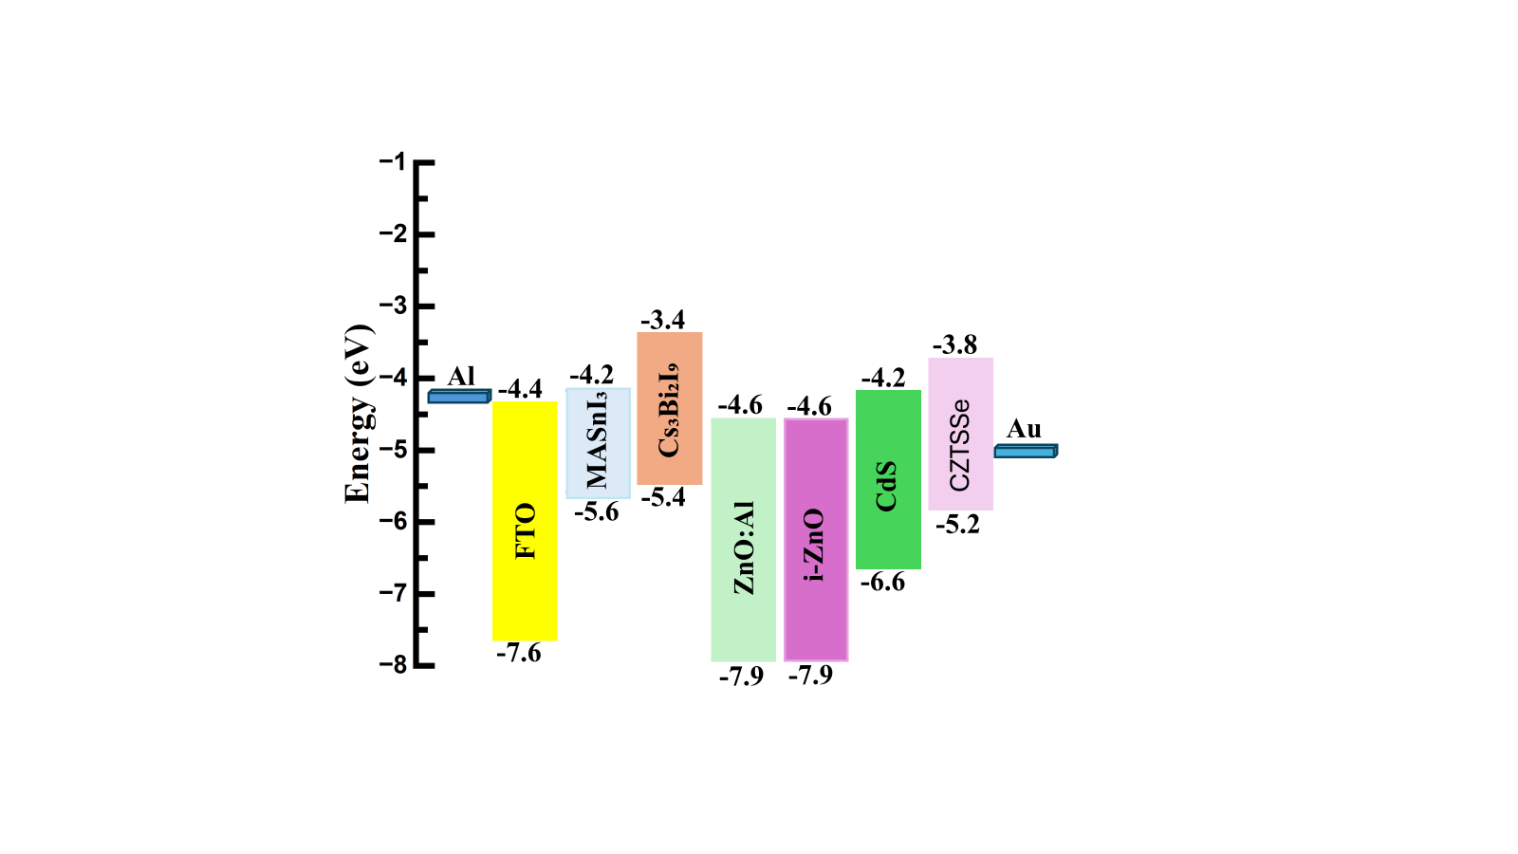
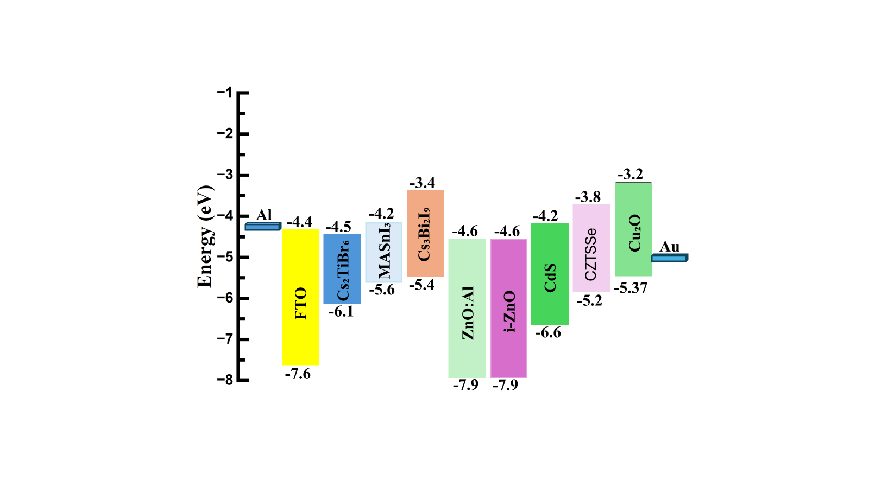
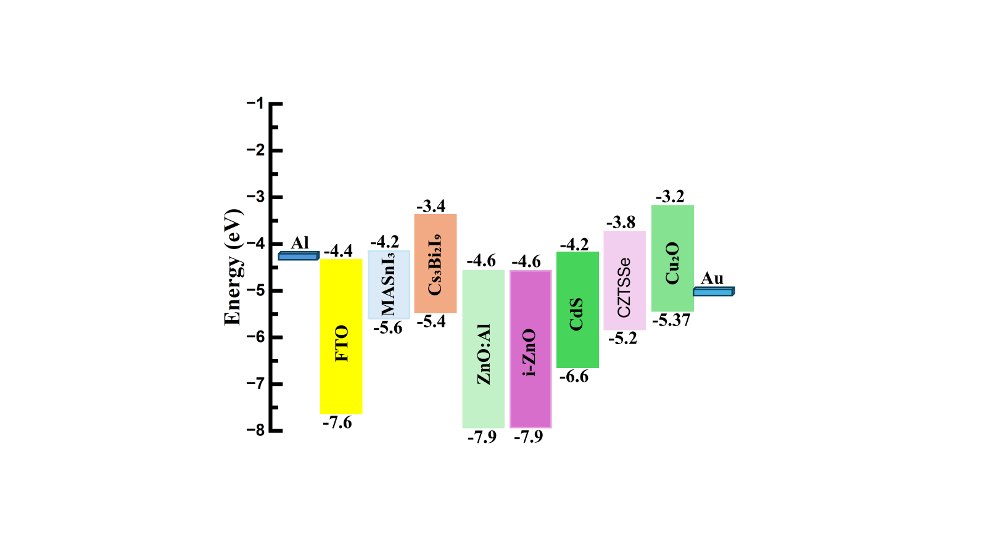
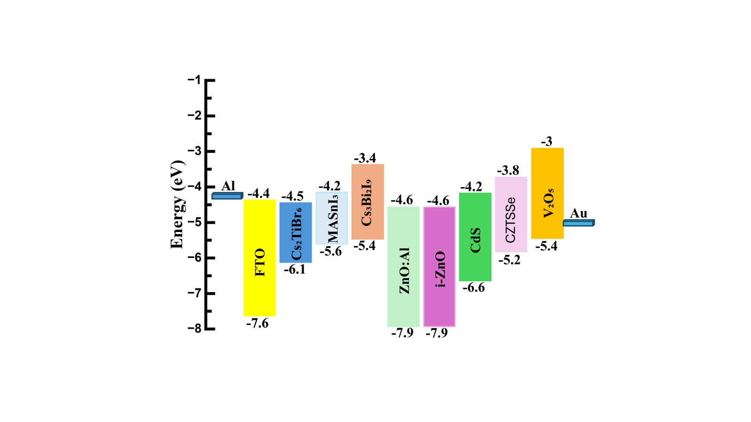
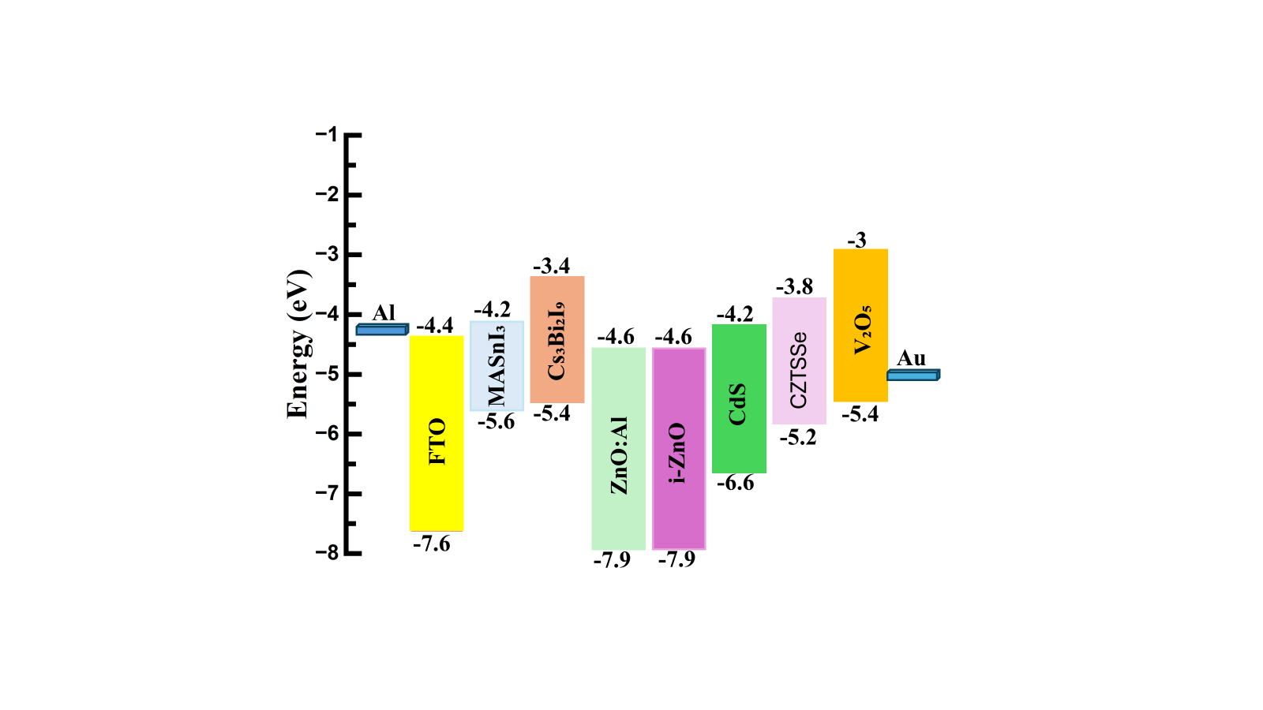
(a)
(b)
(d)
(c)
(e)
(f)
Fig.S 1. Energy-band alignment of the six proposed device structures (a-f).

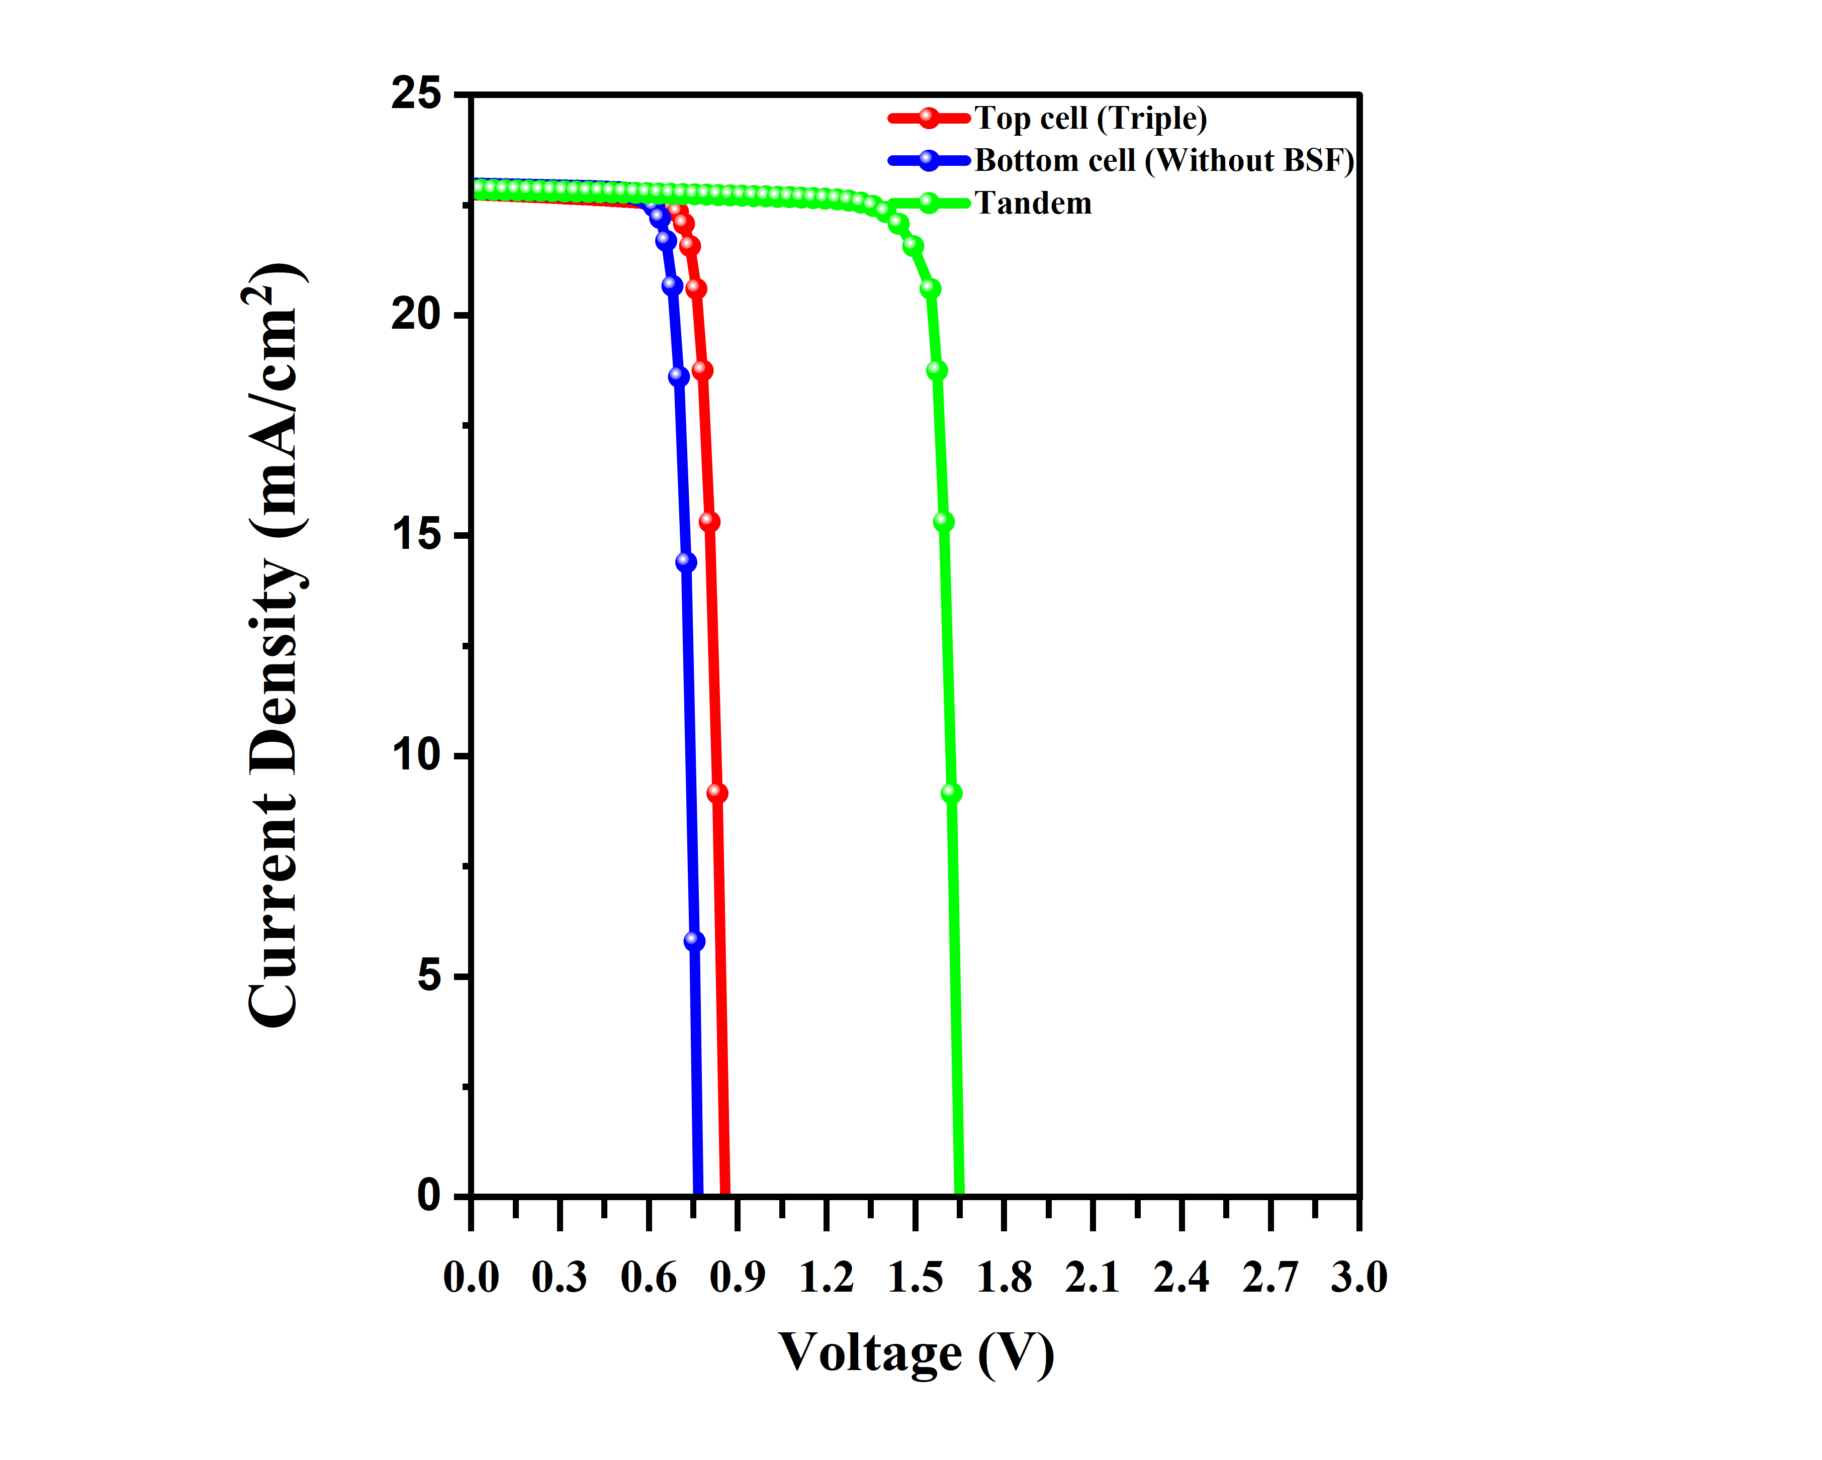
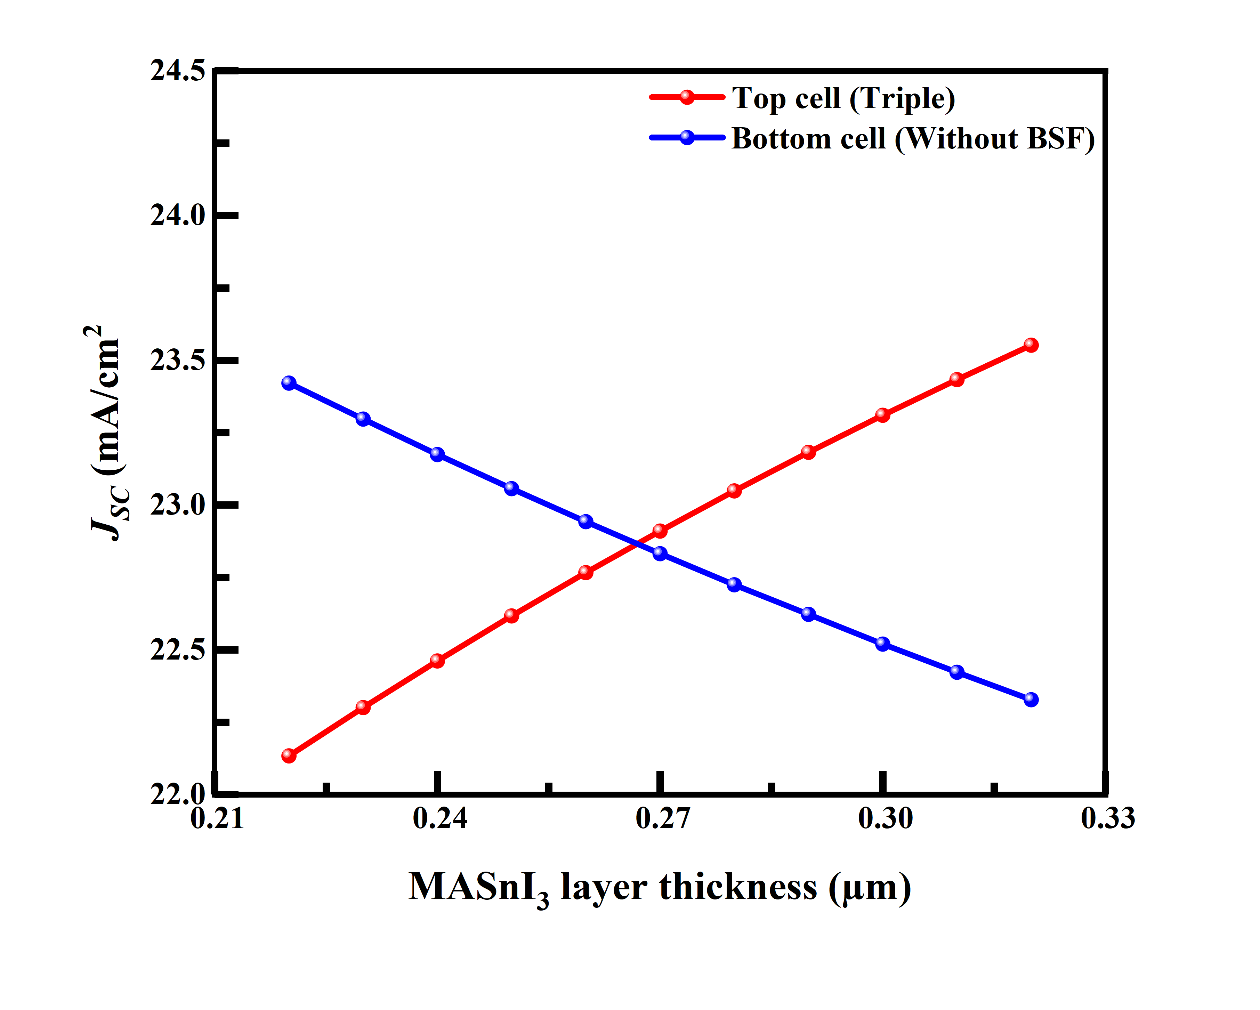
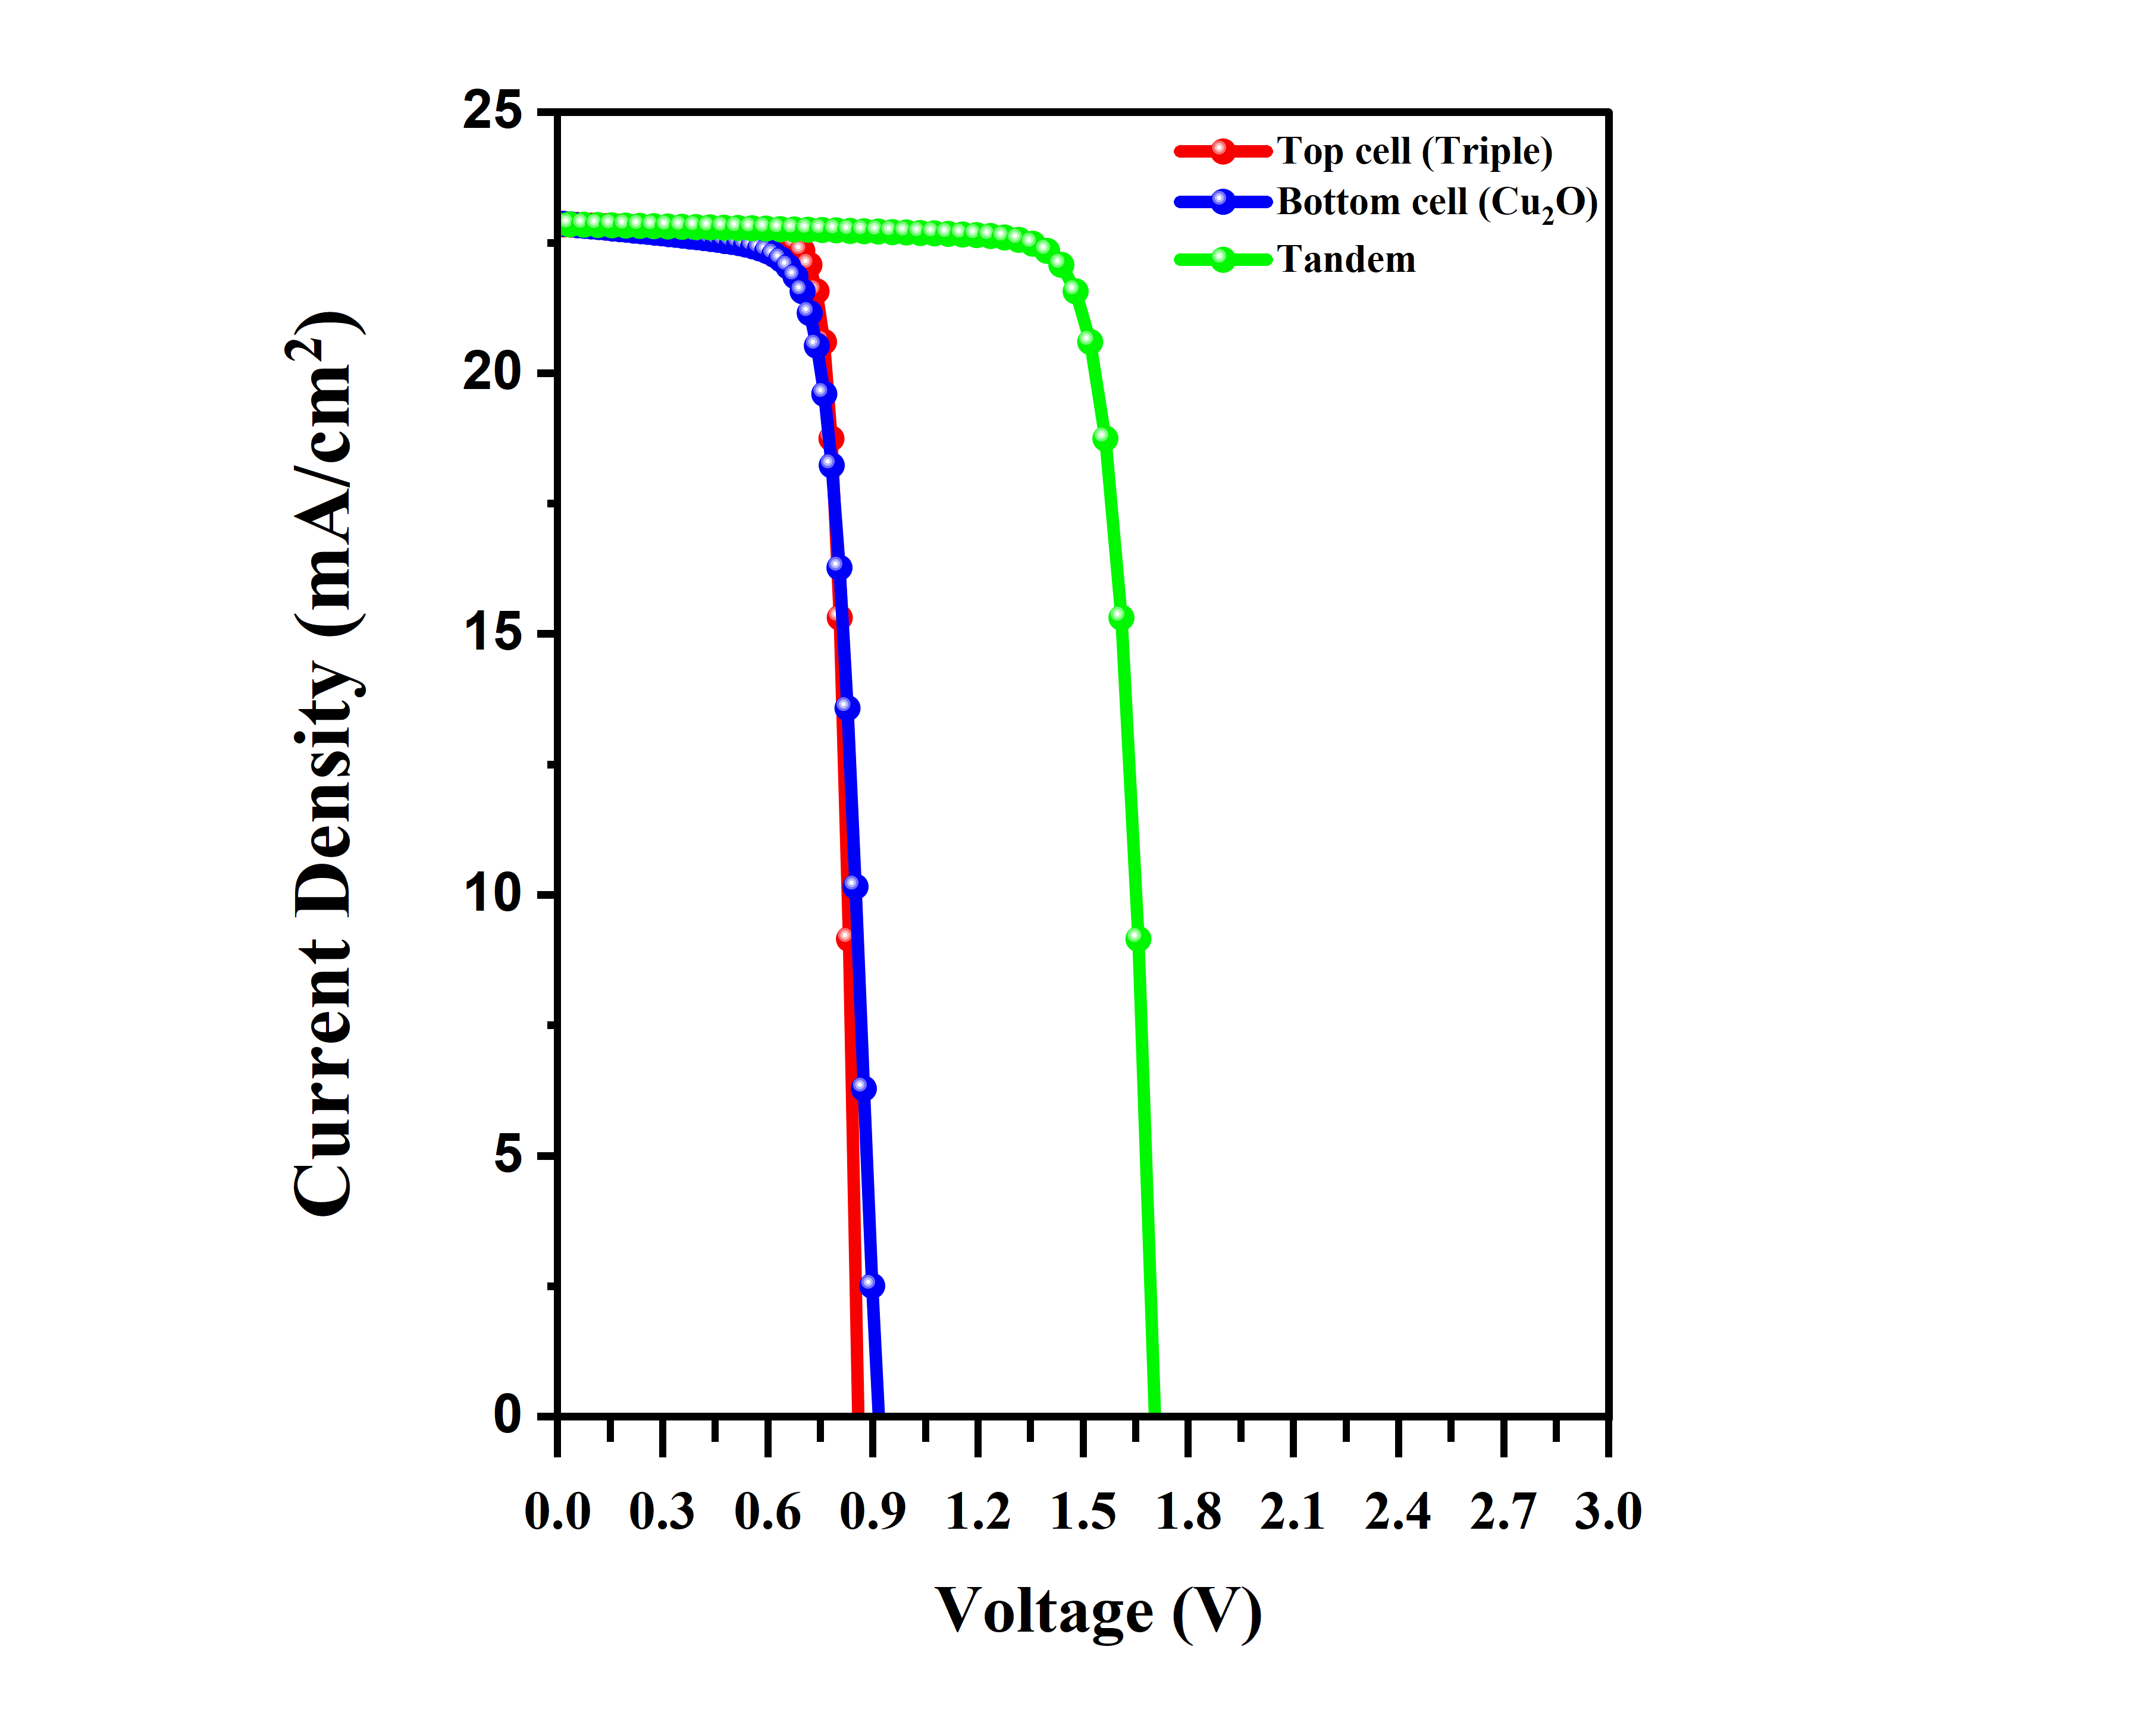
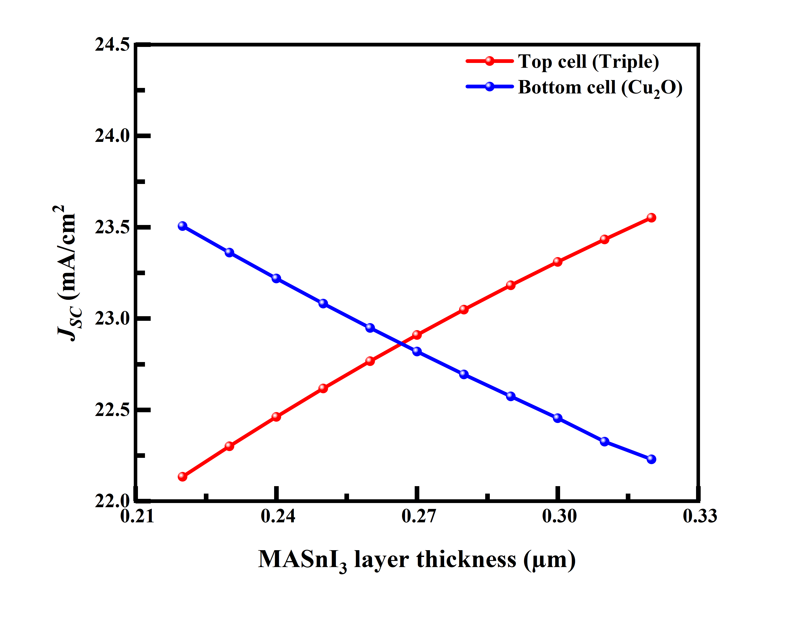
(a)
(b)
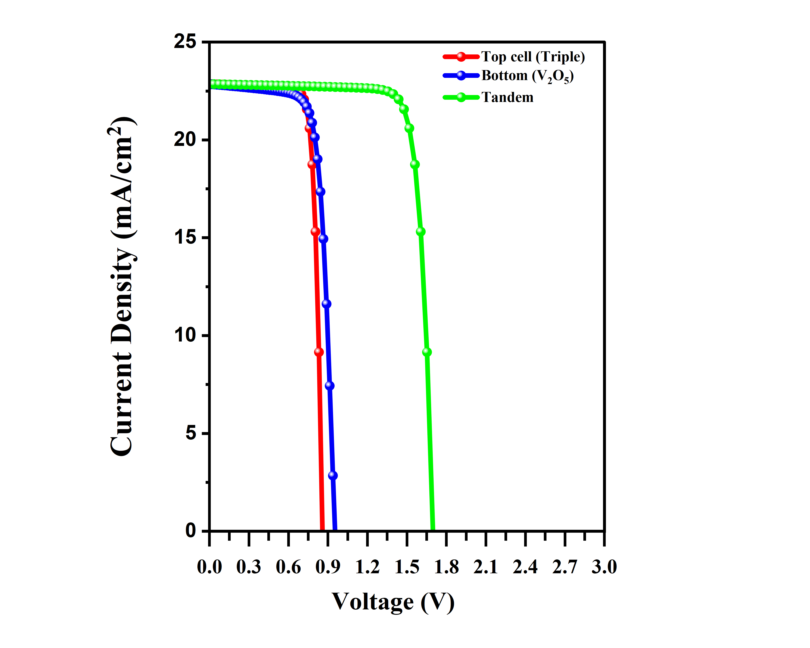
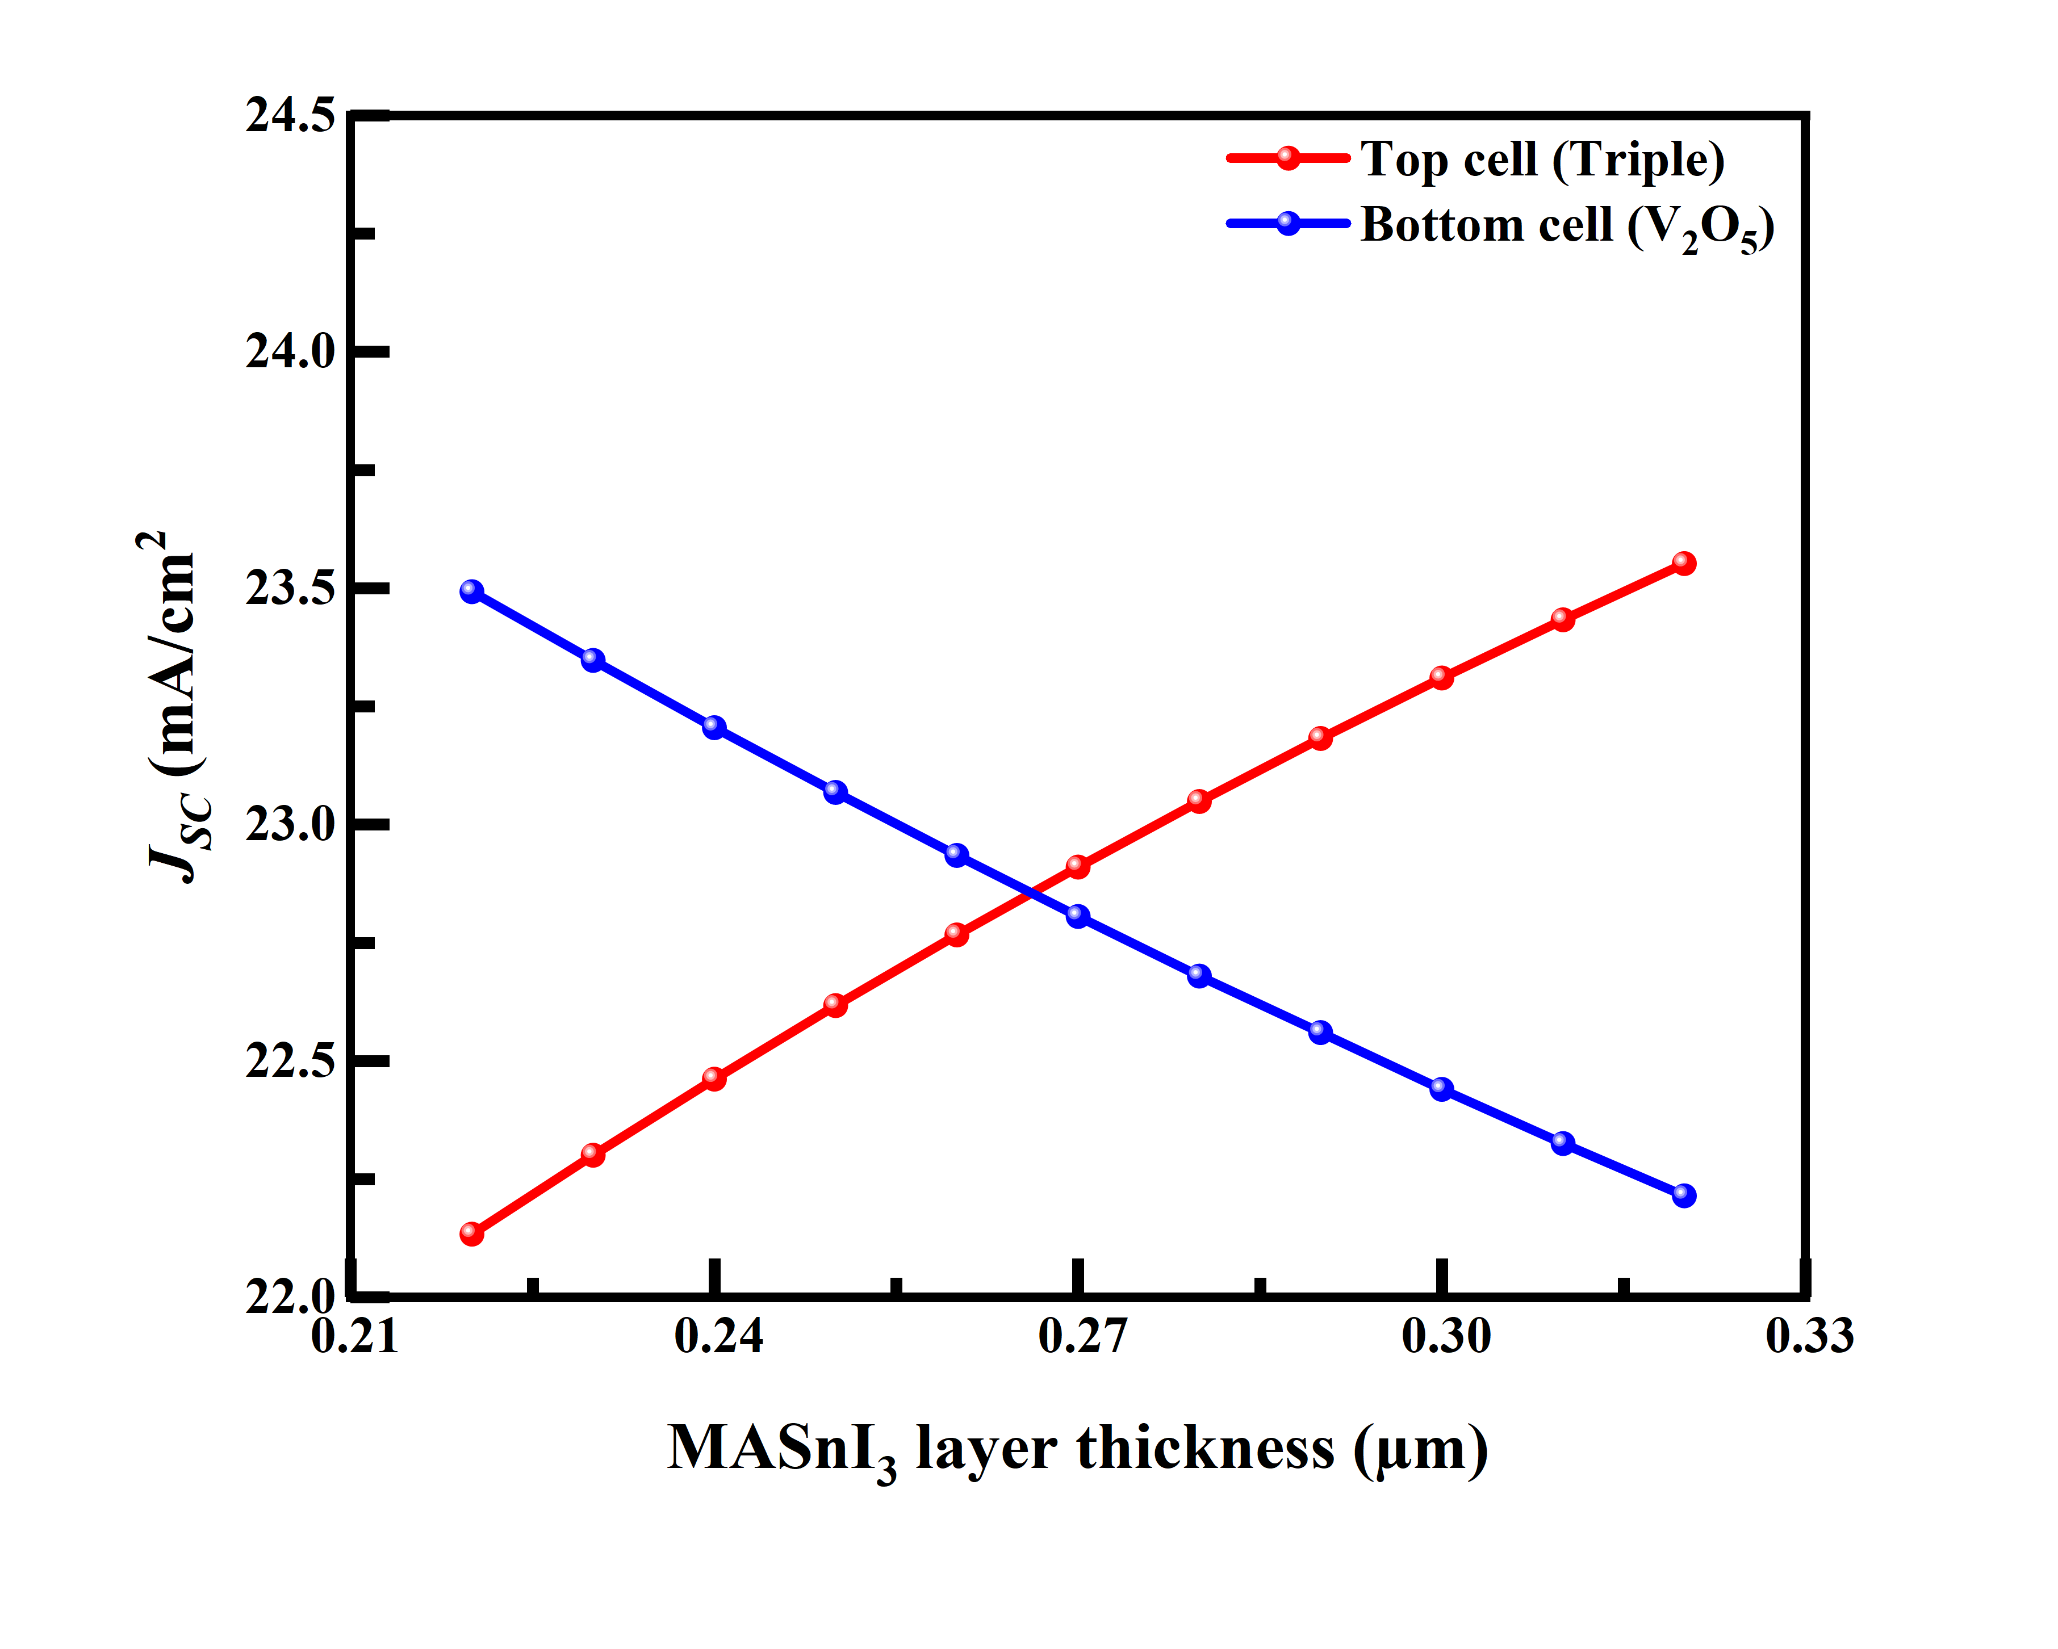
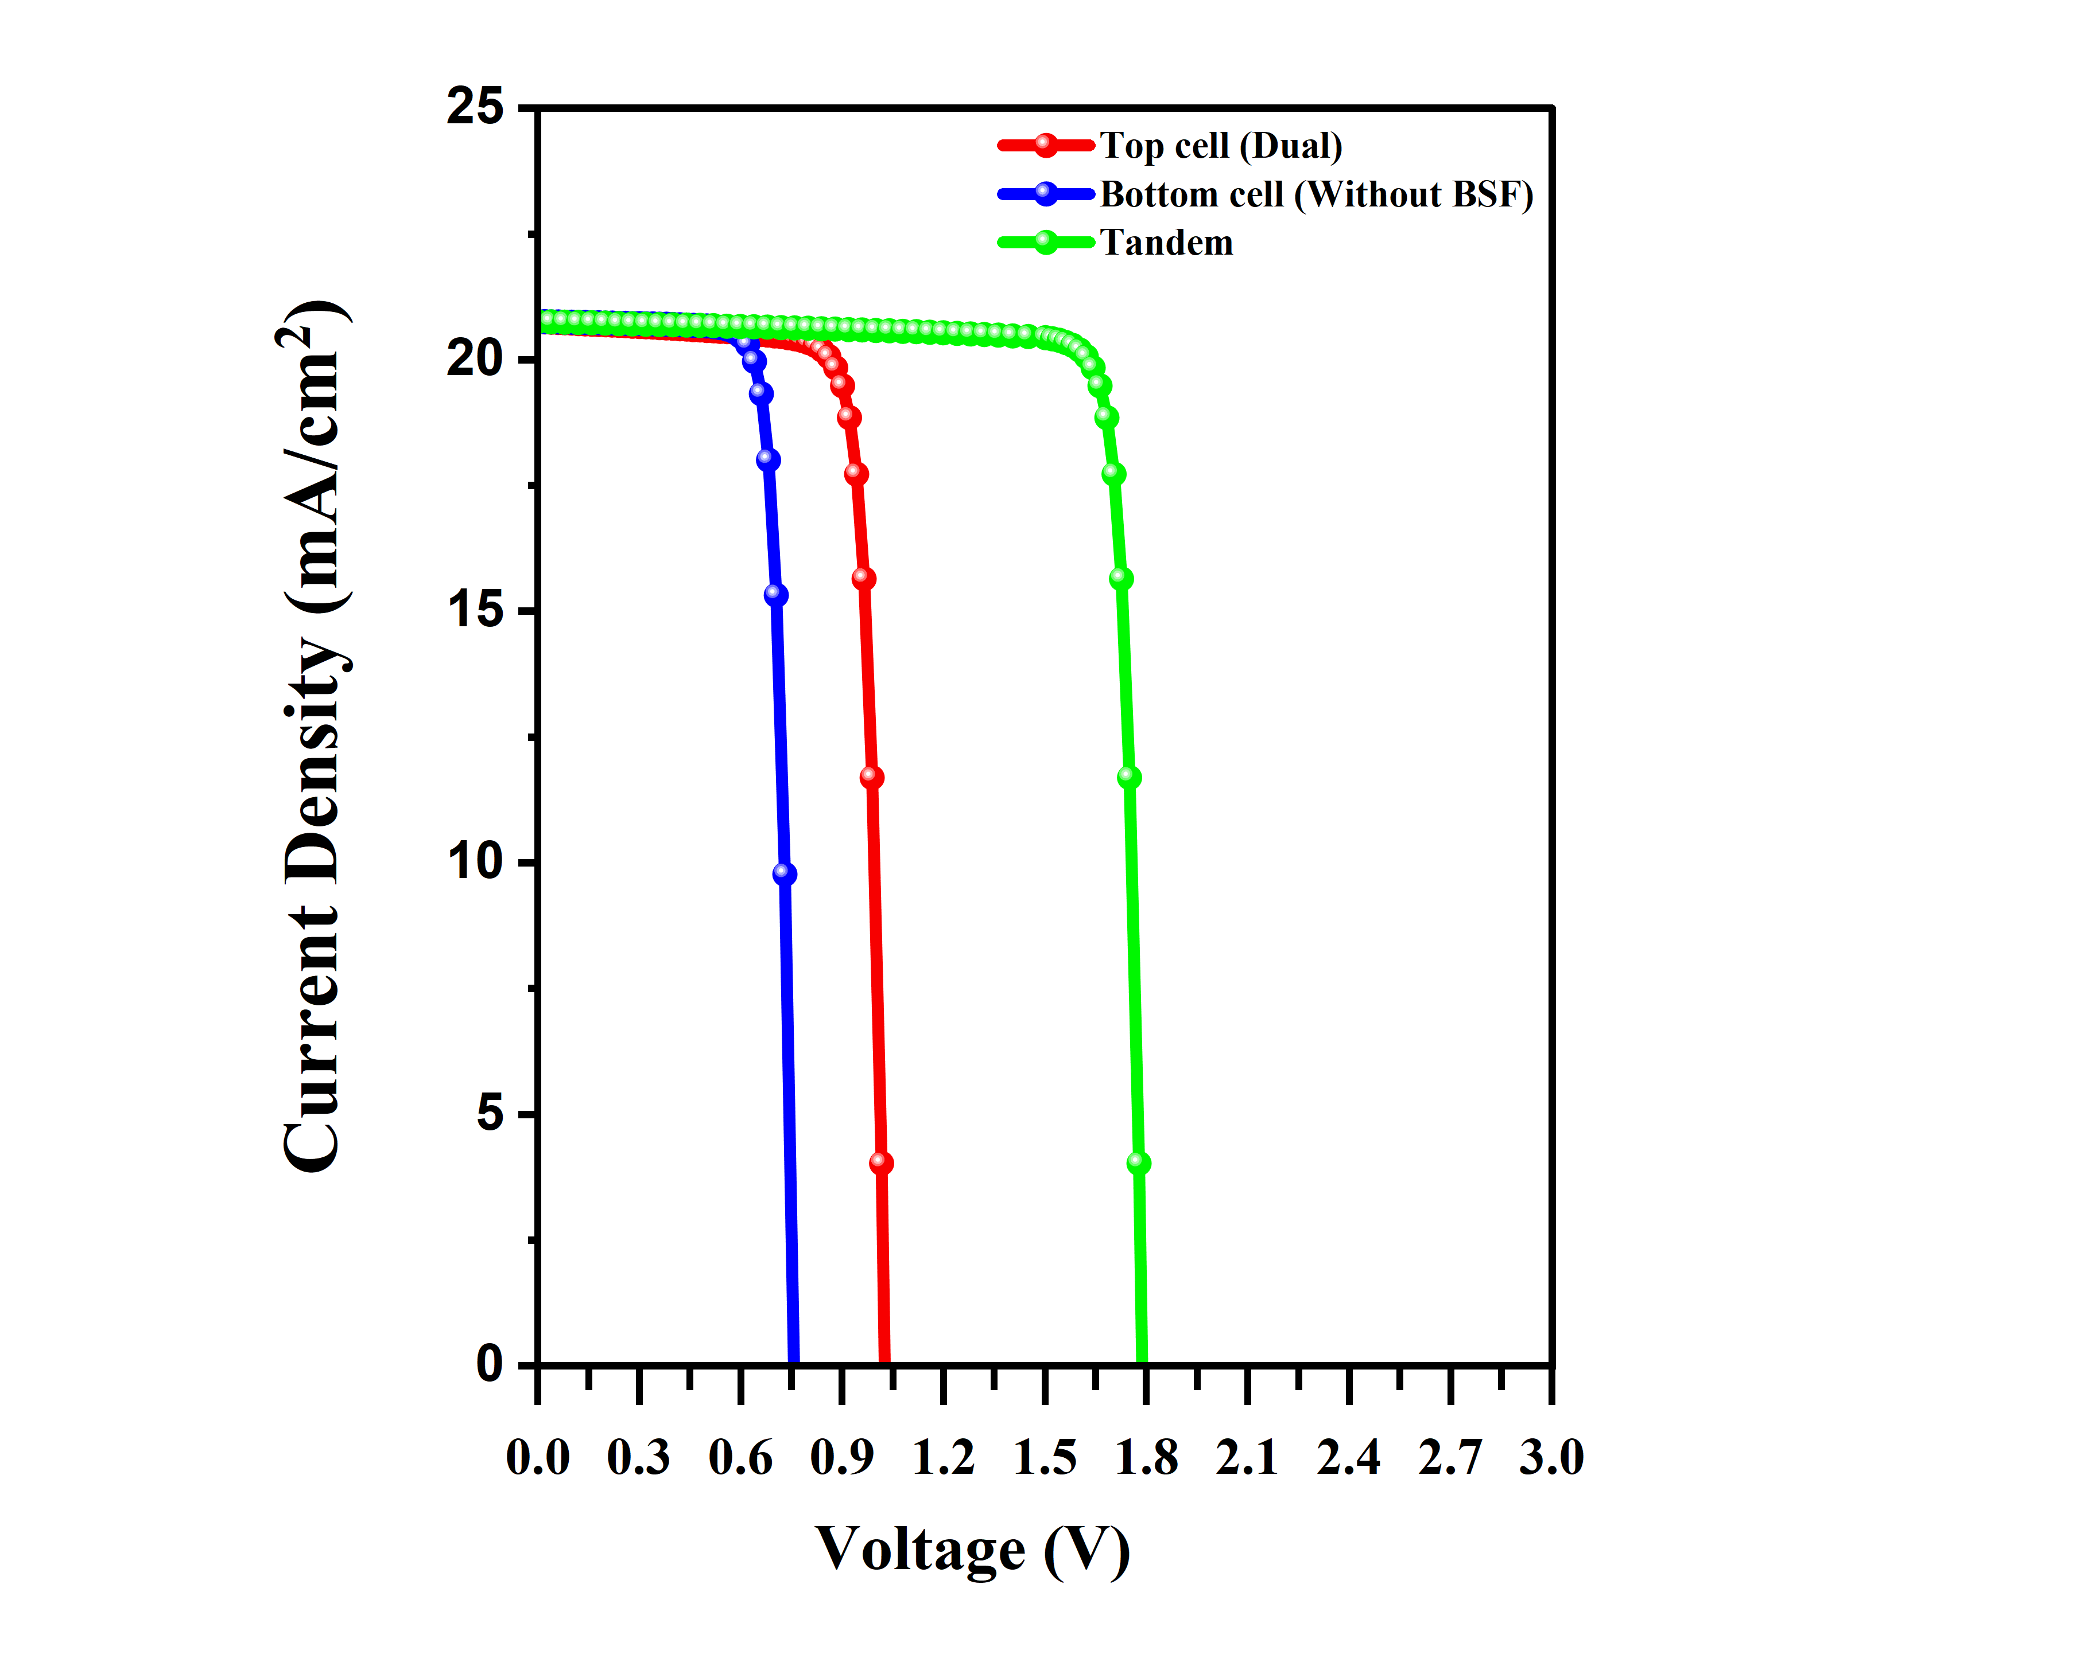
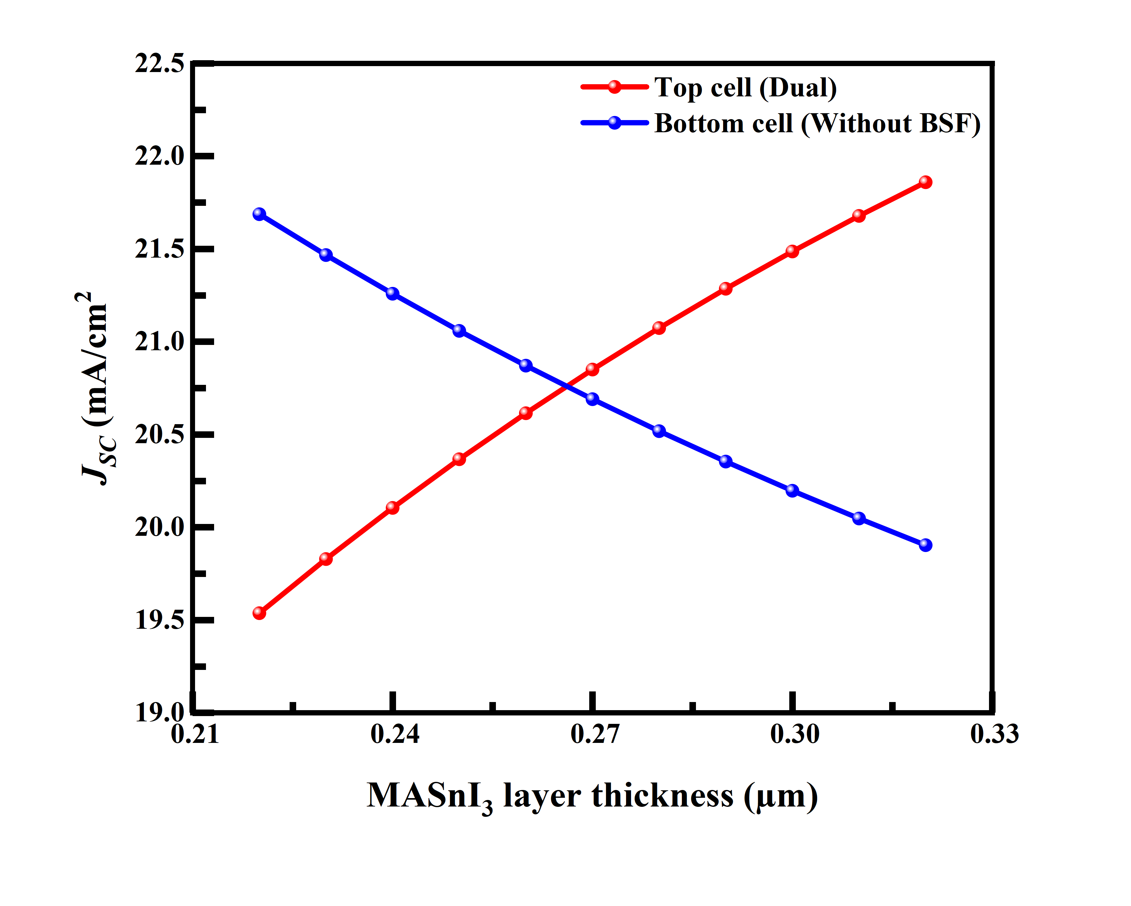
(c)
(d)

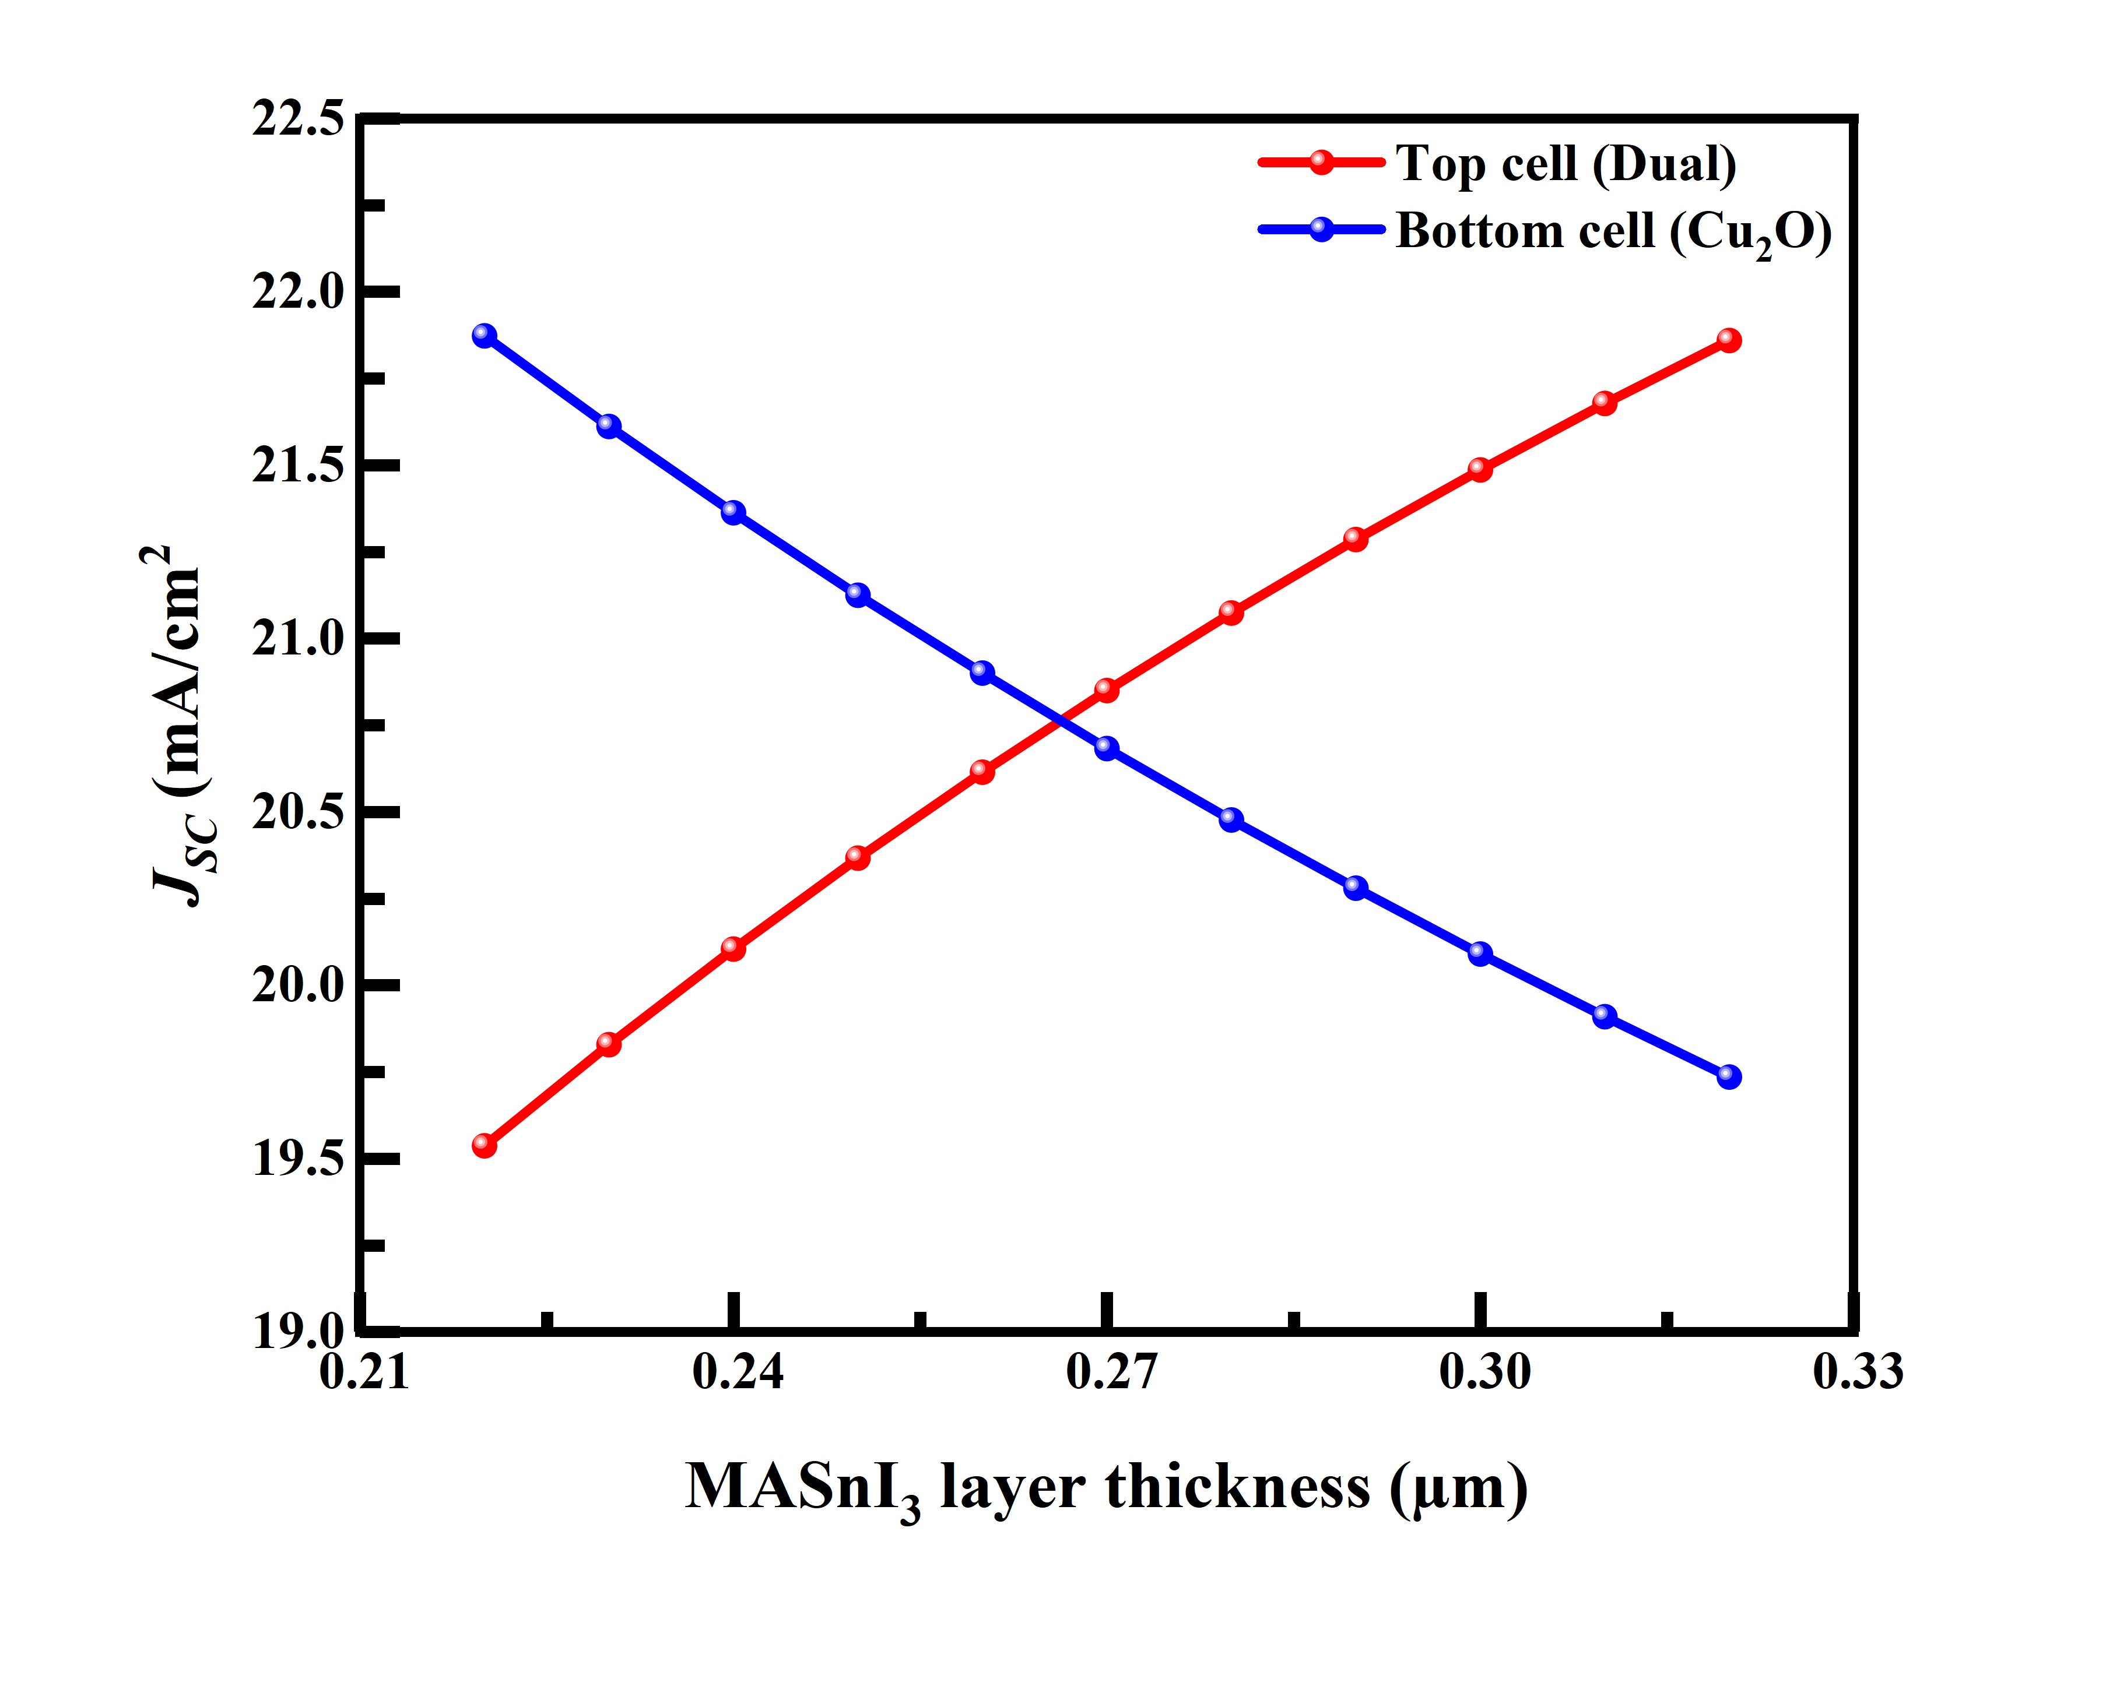
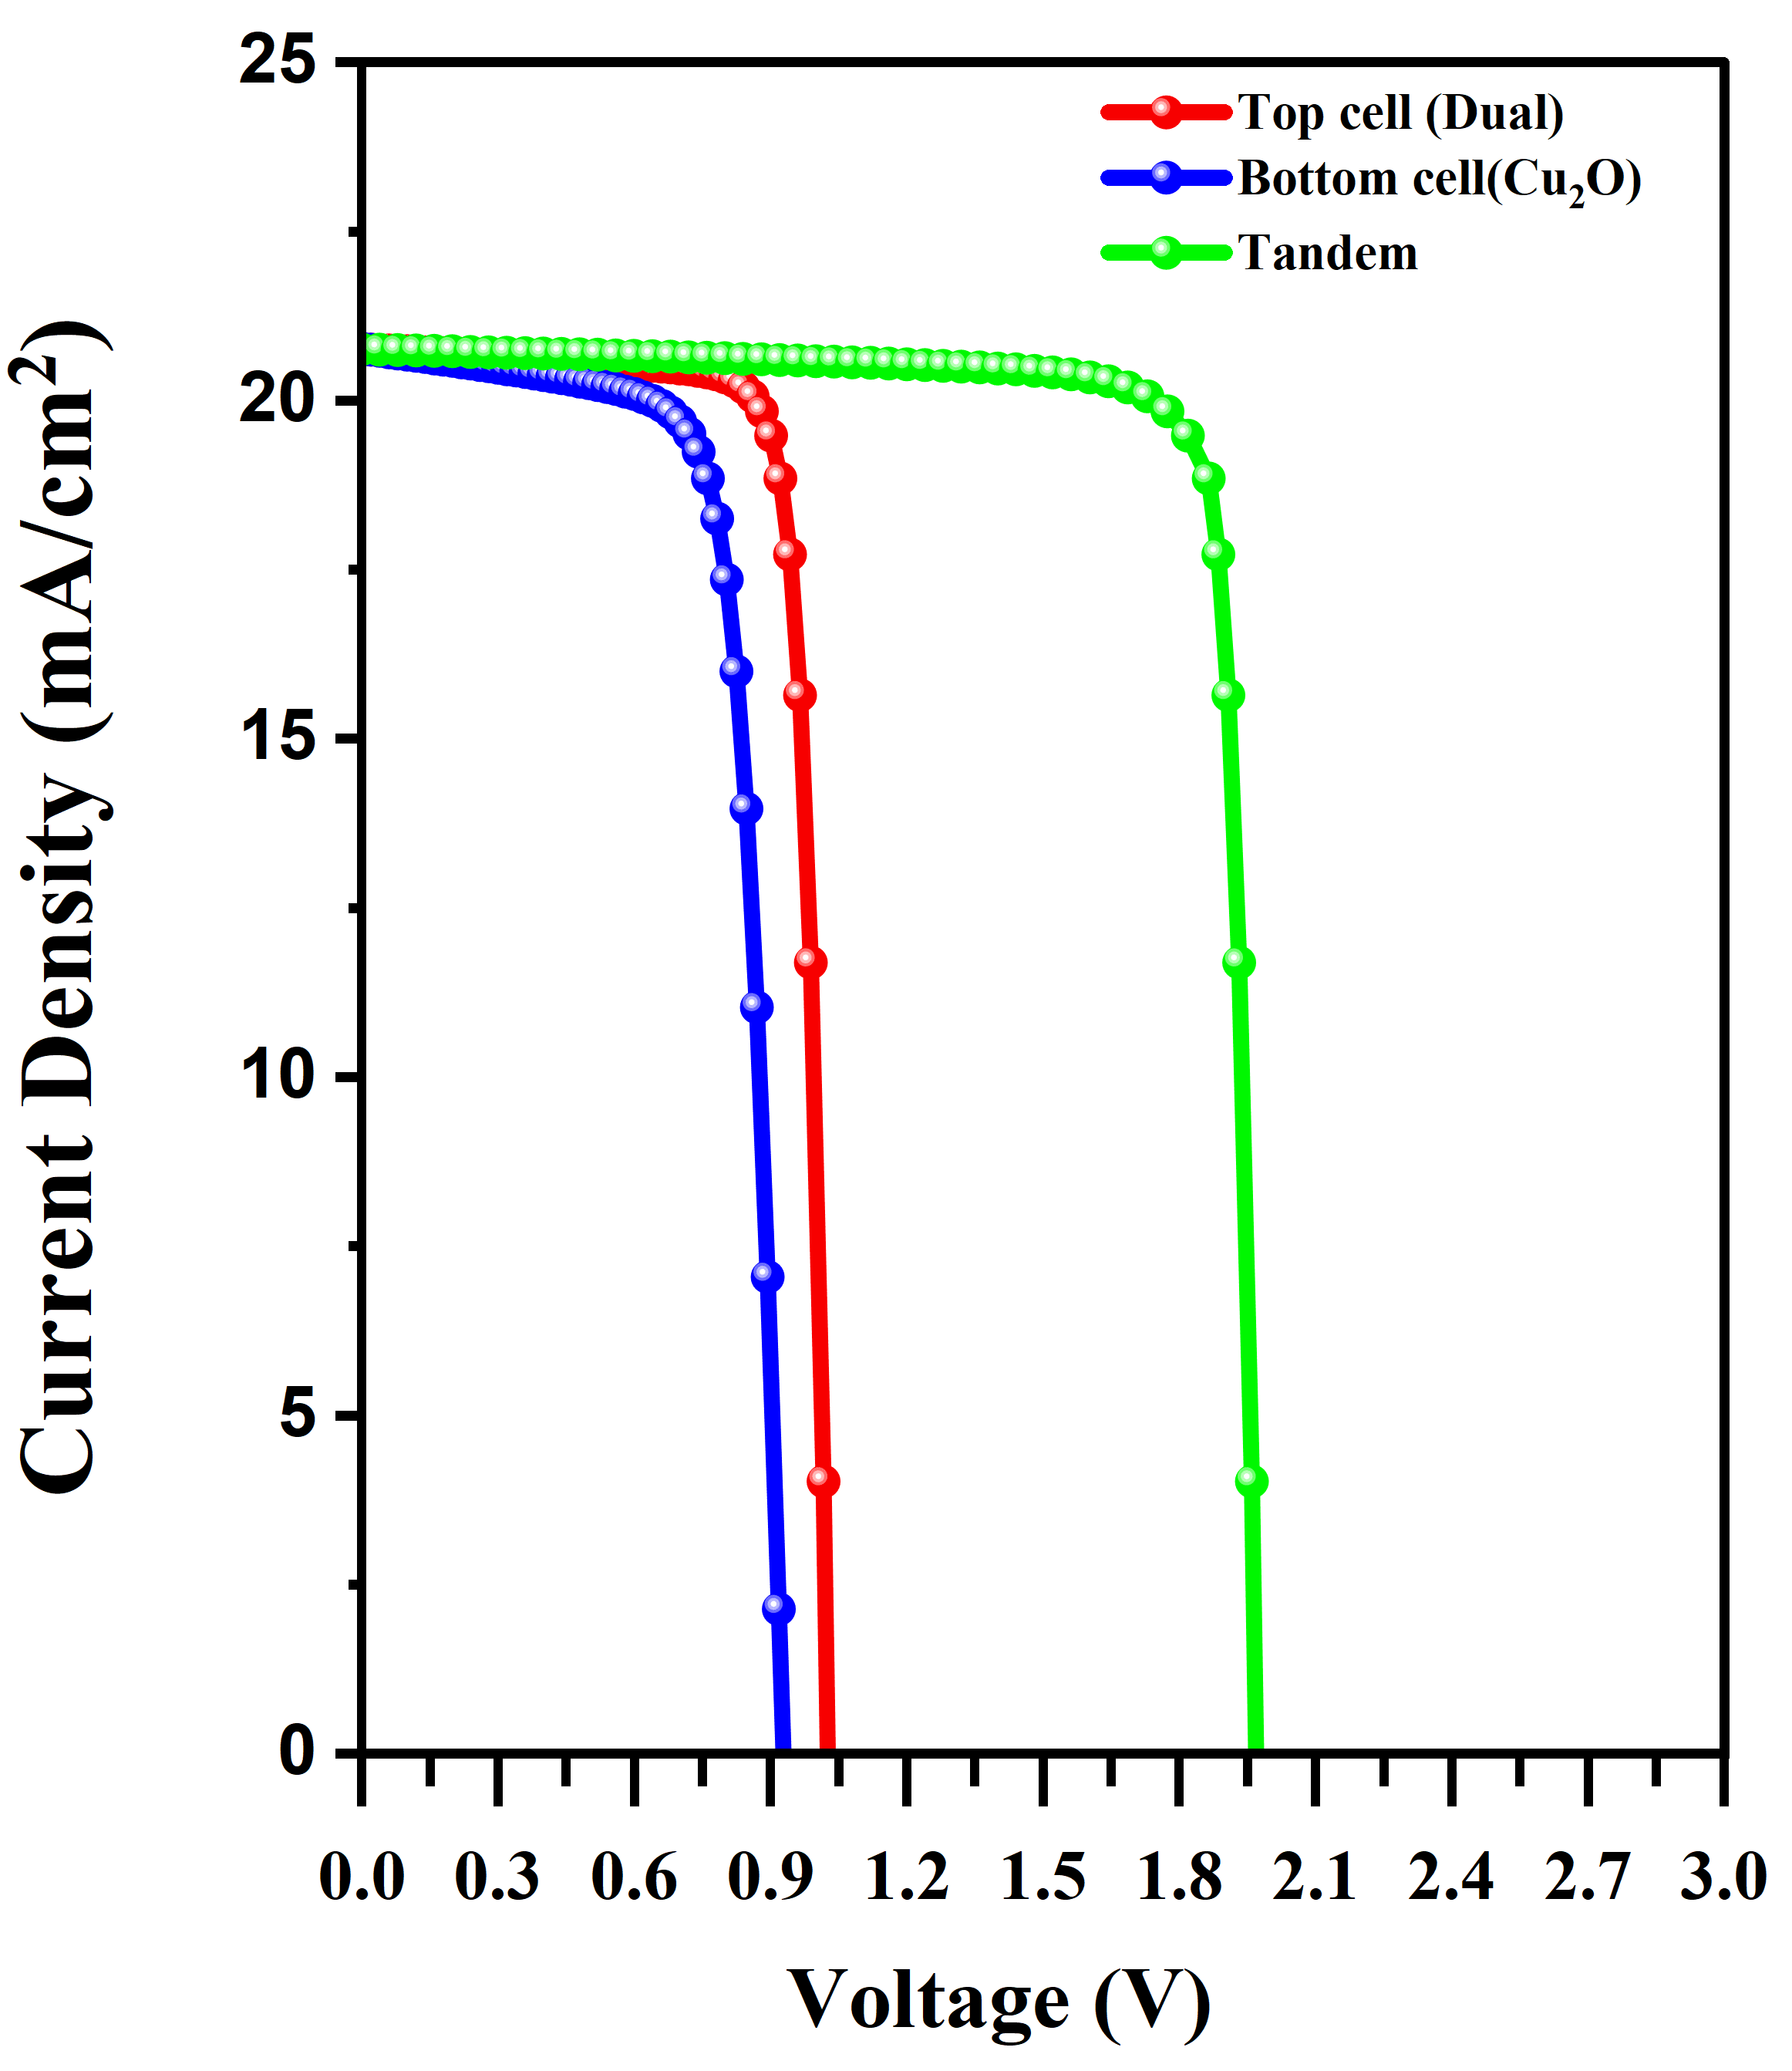
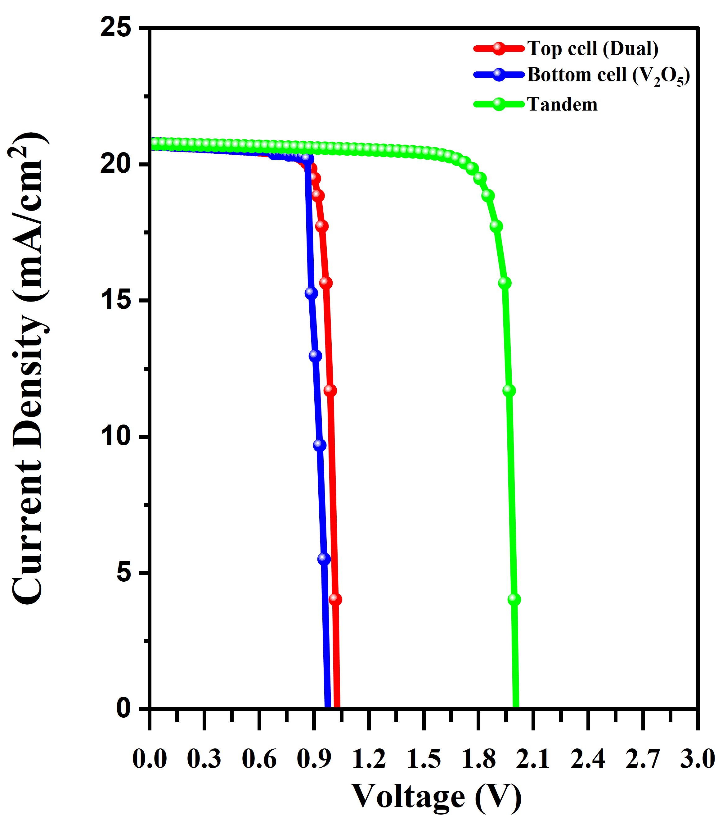
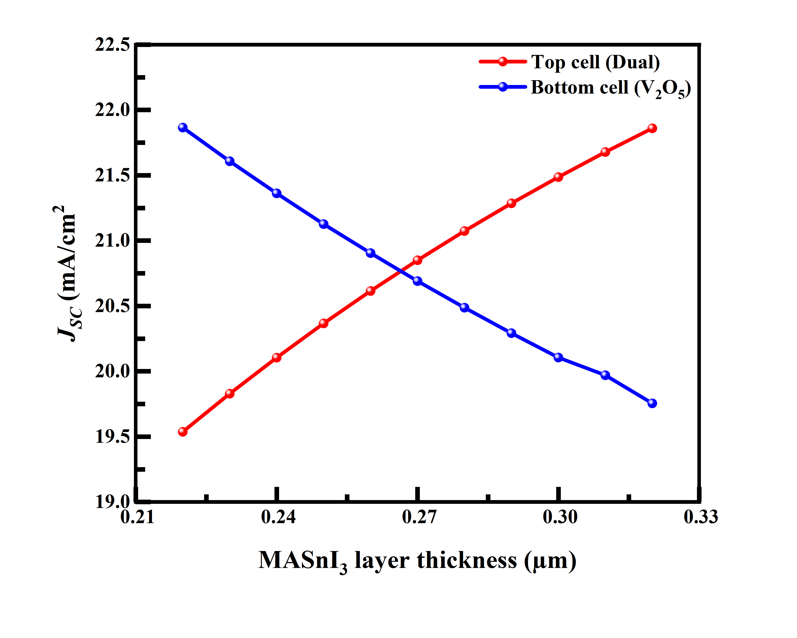
(e)
(f)
Fig.S 2. J-V characteristics and current-matching analysis of the investigated tandem solar cells. (a–f) J–V characteristics of the corresponding six tandem configurations and the dependence of the top- and bottom-sub-cell $J_{SC}$on MASnI₃ layer thickness.

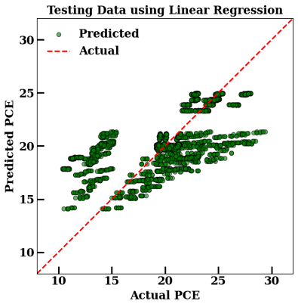
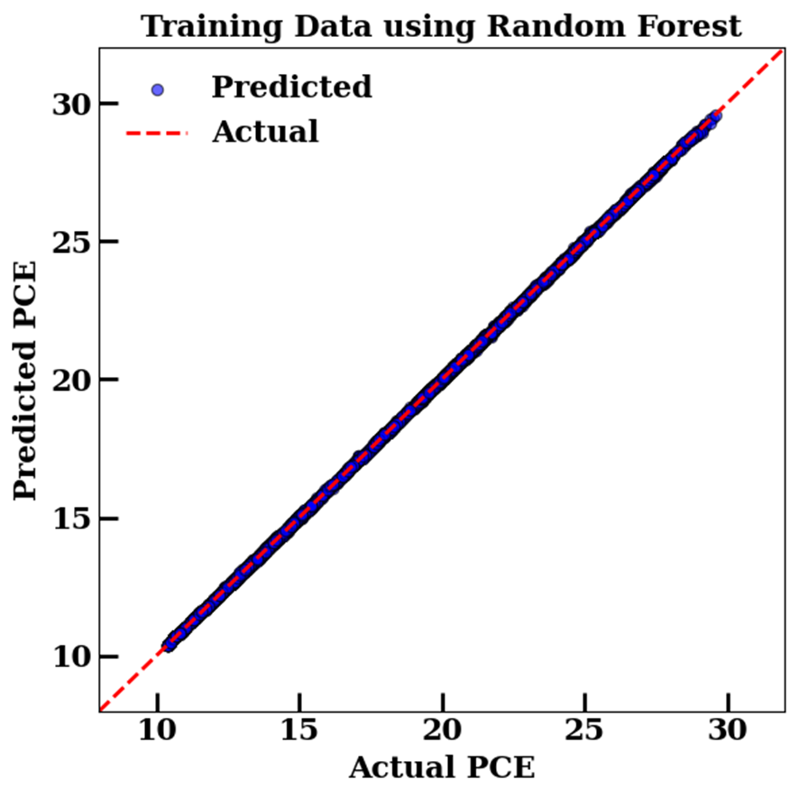
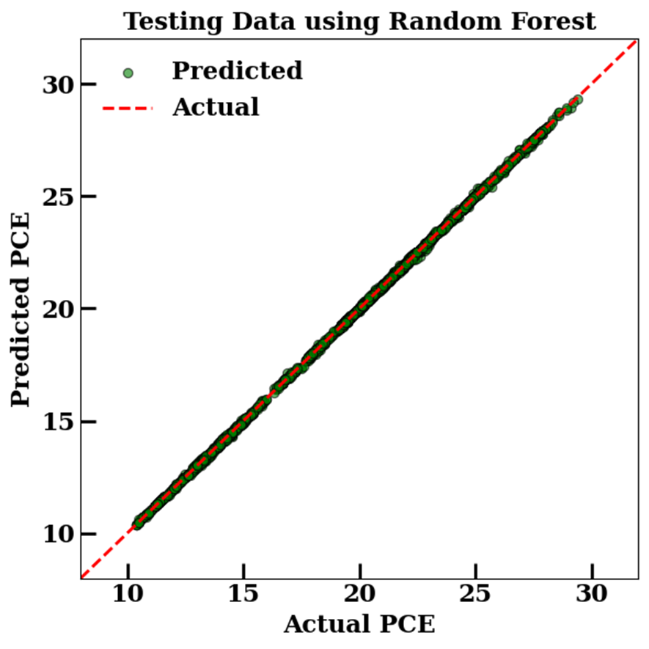
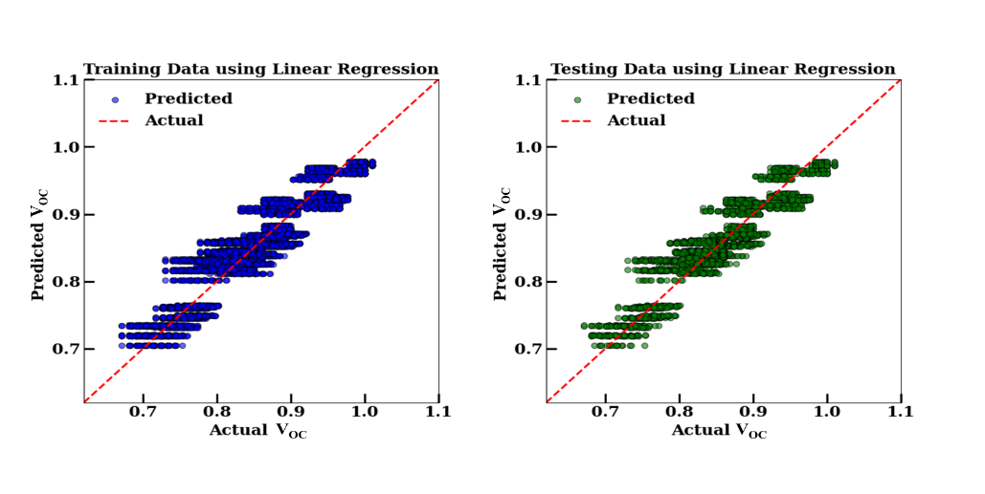
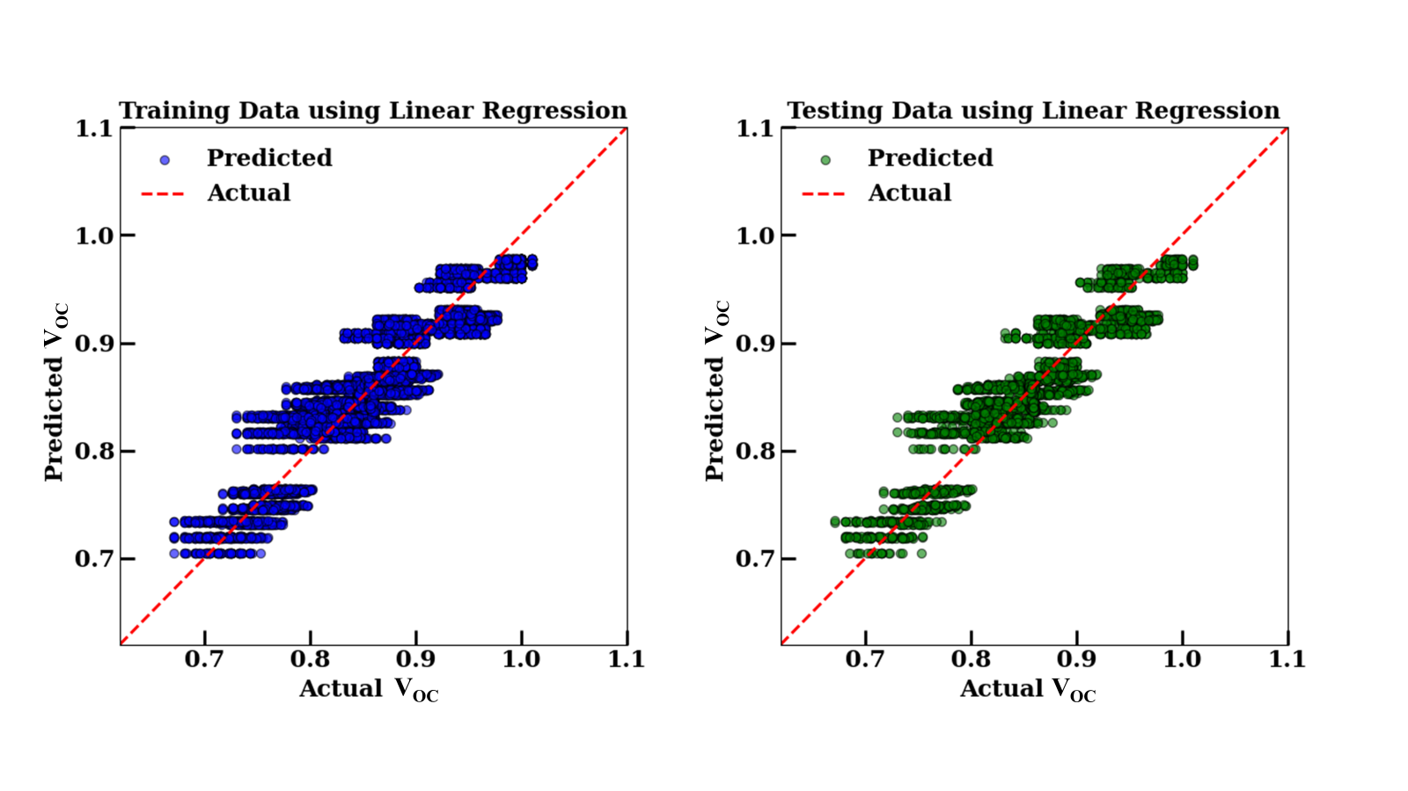
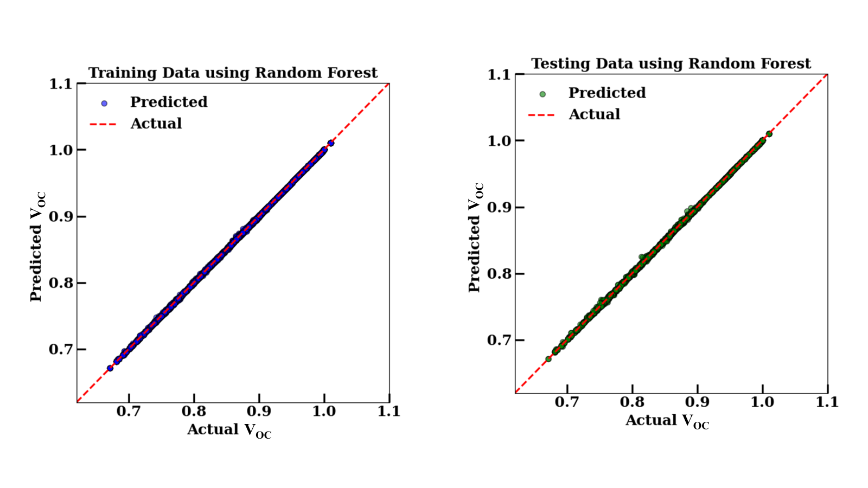
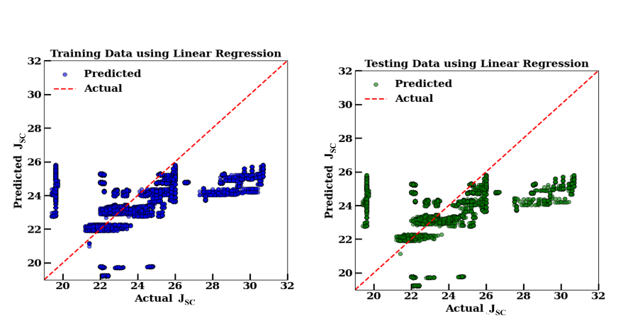
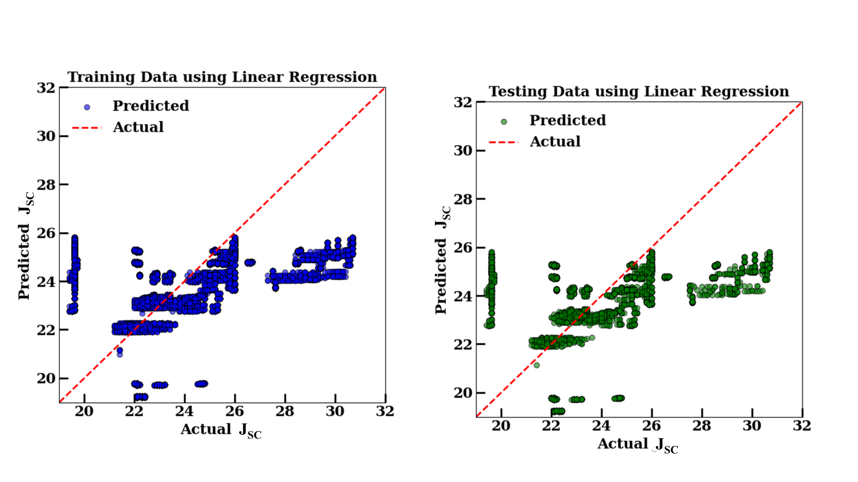
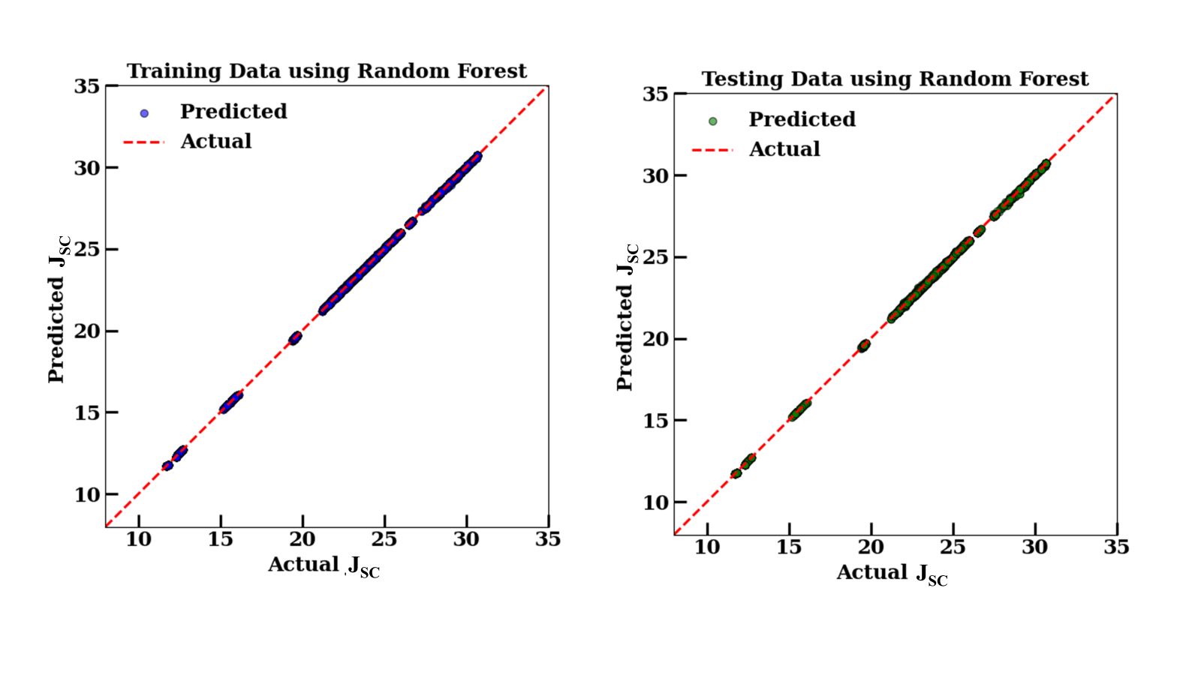
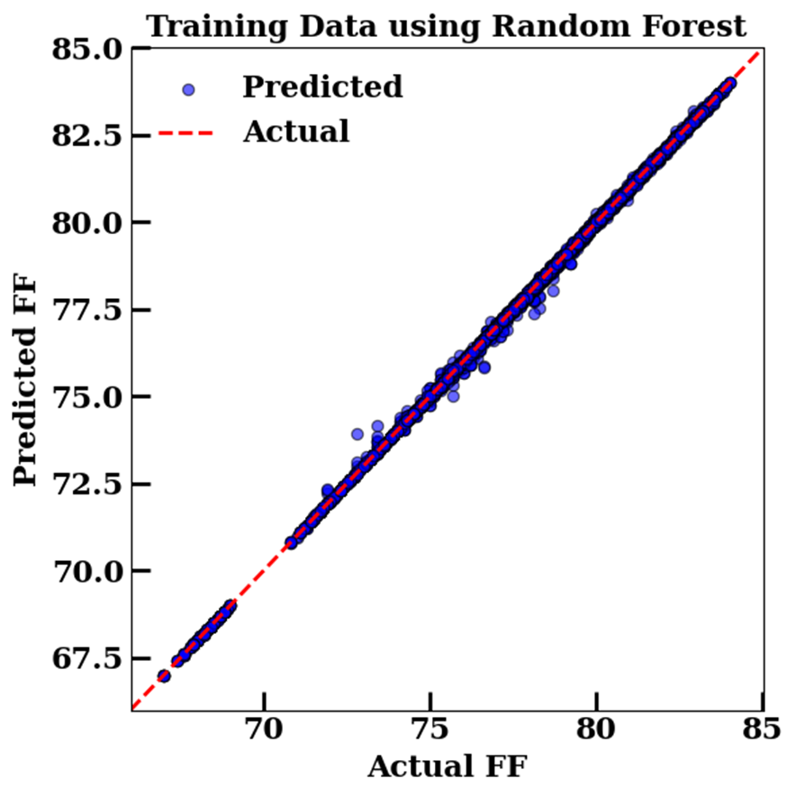
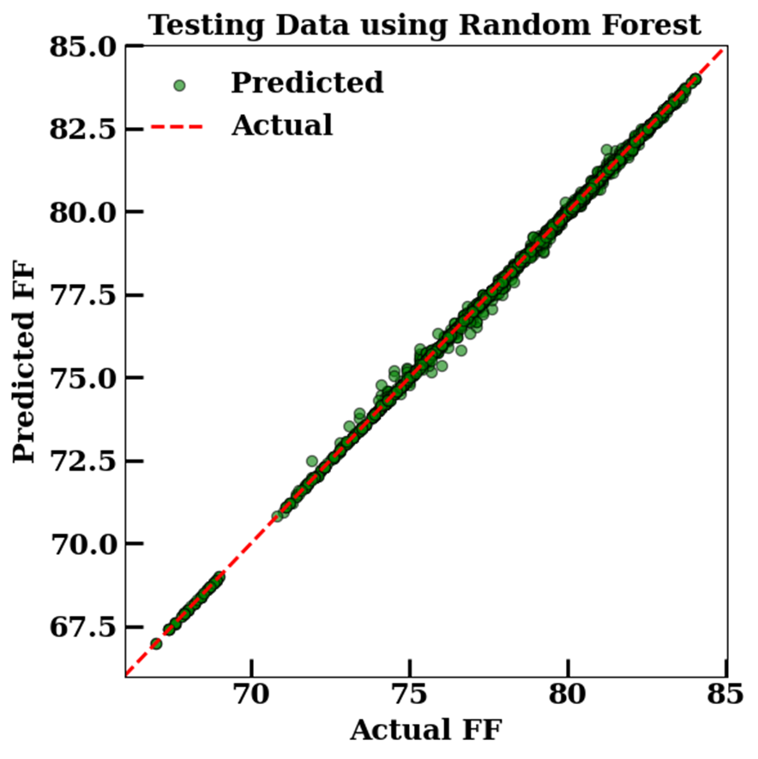
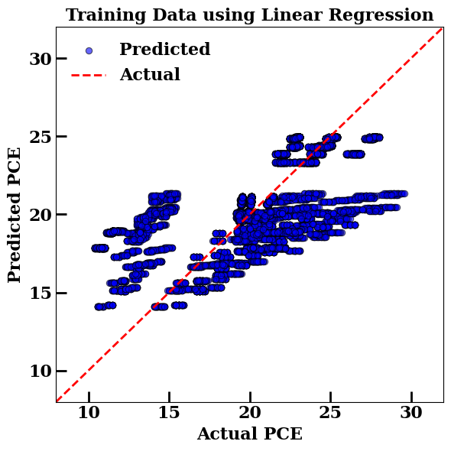
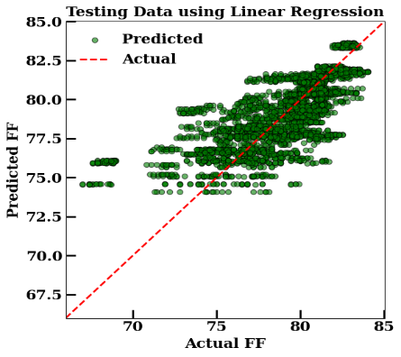
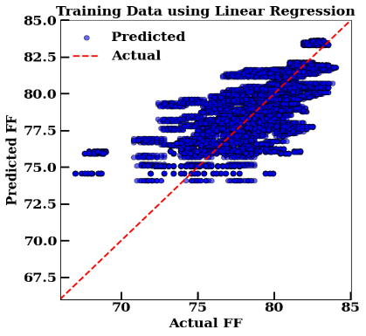
Table S1: Schematic representation of the dataset utilized in the ML models for training and testing data corresponding to three distinct perovskites, denoted as L₁, L₂, and L₃ (representing Cs₂TiBr₆, MASnI₃, and Cs₃Bi₂I₉, respectively). In this framework, t, E_{g},φ, ε, N_{v}, N_{c}, N_{A}/N_{D}, and N_{t} serve as the independent input features, whereas η, V_{OC}, J_{SC}, and $\text{FF}$ constitute the dependent target variables.
(d) FF (%)
(c) J_{SC} (mA/cm²)
(a) PCE (%)
(b) V_{OC} (V)
Fig.S 3. Parity plots of physically simulated versus machine learning predicted photovoltaic parameters for the training and testing datasets, using Linear Regression (LR) and Random Forest (RF) models. (a) PCE, (b) V_{OC}, (c) J_{SC}, and (d) FF. The red dashed diagonal line marks the ideal 45° case, where predicted values coincide exactly with the simulated values. Points closer to this line indicate stronger prediction accuracy.

Cell no. |  | 1 | 2 |  | ……… | 19683 |  | 19684
L₁ | t | 0.10 |  | 0.10 | ……… | 0.05 | 0.05
L₁ | E_{g} | 2.01 |  | 2.01 | ……… | 2.03 | 2.03
L₁ | φ | 3.38 |  | 3.38 | ……… | 3.40 | 3.40
L₁ | ε | 8.00 |  | 8.00 | ……… | 9.68 | 9.68
L₁ | N_{A} | 1E+16 |  | 1E+16 | ……… | 1E+18 | 1E+18
L₁ | N_{t} | 1E+13 |  | 1E+13 | ……… | 2E+14 | 2E+14
L₁ | N_{c} | 1E+18 |  | 1E+18 | ……… | 5E+19 | 5E+19
L₁ | N_{v} | 1E+18 |  | 1E+19 | ……… | 2E+19 | 2E+19
L₂ | t | 0.37 |  | 0.37 | ……… | 0.37 | 0.37
L₂ | E_{g} | 1.30 |  | 1.30 | ……… | 1.30 | 1.30
L₂ | φ | 4.17 |  | 4.17 | ……… | 4.17 | 4.17
L₂ | ε | 8.20 |  | 8.20 | ……… | 8.20 | 8.20
L₂ | N_{A} | 1E+18 |  | 1E+18 | ……… | 1E+18 | 1E+18
L₂ | N_{t} | 1E+14 |  | 1E+14 | ……… | 1E+14 | 1E+14
L₂ | N_{c} | 2E+18 |  | 2E+18 | ……… | 2E+18 | 2E+18
L₂ | N_{v} | 2E+18 |  | 2E+18 | ……… | 2E+18 | 2E+18
L₃ | t | 0.05 |  | 0.05 | ……… | 1.50 | 1.50
L₃ | E_{g} | 1.60 |  | 1.60 | ……… | 1.70 | 1.70
L₃ | φ | 4.47 |  | 4.47 | ……… | 4.48 | 4.48
L₃ | ε | 10.00 |  | 10.00 | ……… | 18.00 | 18.00
L₃ | N_{D} | 1E+18 |  | 1E+18 | ……… | 1E+18 | 1E+18
L₃ | N_{t} | 1E+14 |  | 1E+14 | ……… | 1E+15 | 1E+15
L₃ | N_{c} | 2E+18 |  | 2E+18 | ……… | 1E+18 | 1E+18
L₃ | N_{v} | 2E+19 |  | 2E+19 | ……… | 1E+17 | 1E+18
 | η | 19.37 |  | 19.42 | ……… | 10.70 | 10.70
 | V_{OC} | 0.858 |  | 0.857 | ……… | 0.854 | 0.854
 | J_{SC} | 22.70 |  | 22.30 | ……… | 11.70 | 11.70
 | FF | 81.20 |  | 80.50 | ……… | 83.00 | 83.00

PV parameters | ML model | RMSE | R²
PCE | Random Forest Regression | 0.0335 ± 0.0007 | 0.9999 ± 0.0000
PCE | Decision Tree Regression | 0.0426 ± 0.0013 | 0.9999 ± 0.0000
PCE | Linear Regression | 2.9935 ± 0.0486 | 0.4149 ± 0.0074
PCE | Support Vector Regression | 3.5569 ± 0.0530 | 0.1738 ± 0.0152
V_{OC} | Random Forest Regression | 0.0008 ± 0.0001 | 0.9998 ± 0.0000
V_{OC} | Decision Tree Regression | 0.0007 ± 0.0001 | 0.9999 ± 0.0000
V_{OC} | Linear Regression | 0.0229 ± 0.0004 | 0.8550 ± 0.0026
V_{OC} | Support Vector Regression | 0.0387 ± 0.0004 | 0.5877 ± 0.0172
J_{SC} | Random Forest Regression | 0.0219 ± 0.0009 | 1.0000 ± 0.0000
J_{SC} | Decision Tree Regression | 0.0252 ± 0.0012 | 0.9999 ± 0.0000
J_{SC} | Linear Regression | 2.9259 ± 0.0459 | 0.2496 ± 0.0152
J_{SC} | Support Vector Regression | 3.3374 ± 0.0559 | 0.0239 ± 0.0104
FF | Random Forest Regression | 0.0560 ± 0.0059 | 0.9996 ± 0.0001
FF | Decision Tree Regression | 0.0959 ± 0.0091 | 0.9988 ± 0.0002
FF | Linear Regression | 1.9021 ± 0.0316 | 0.5445 ± 0.0170
FF | Support Vector Regression | 2.5045 ± 0.0558 | 0.2109 ± 0.0039
Table S2: Comparative performance of the trained machine learning models. Mean accuracy is shown alongside RMSE values obtained through a five-fold validation procedure.
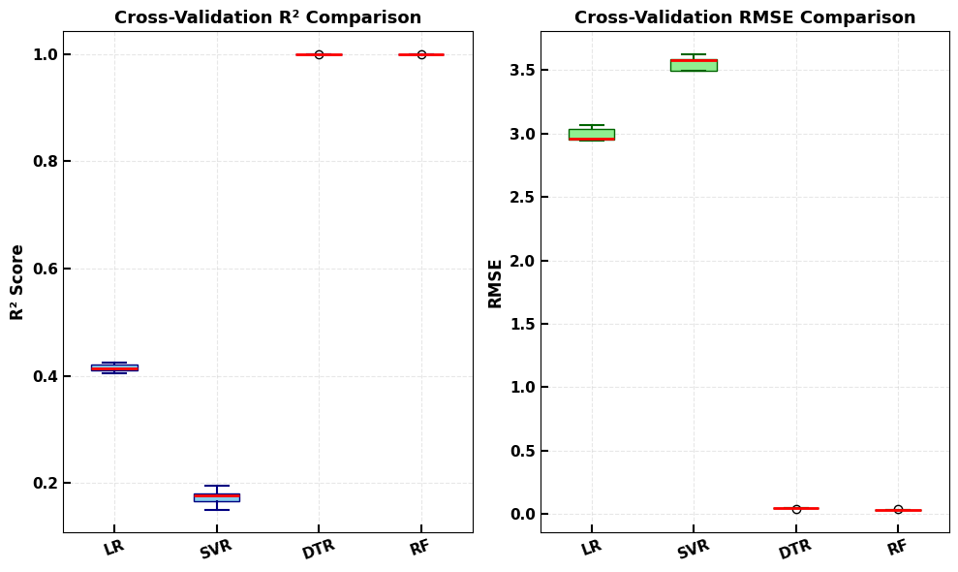
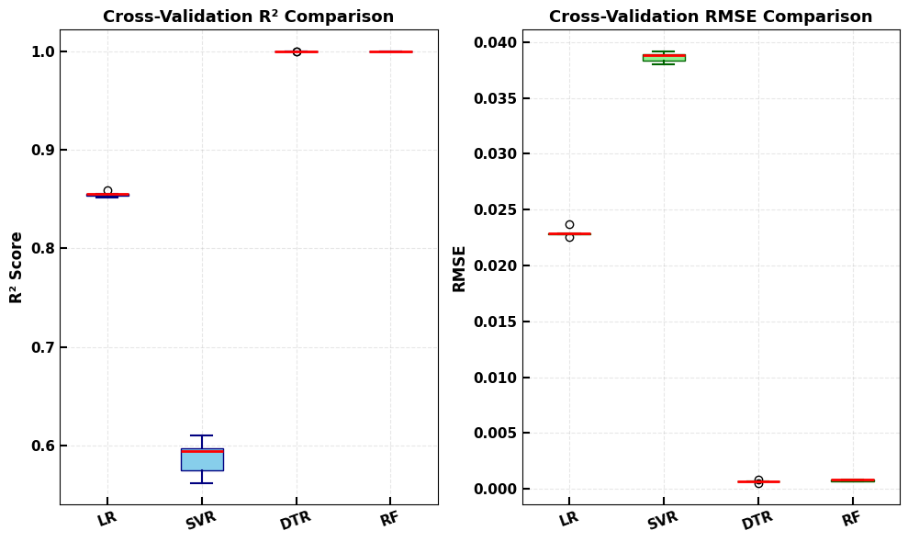
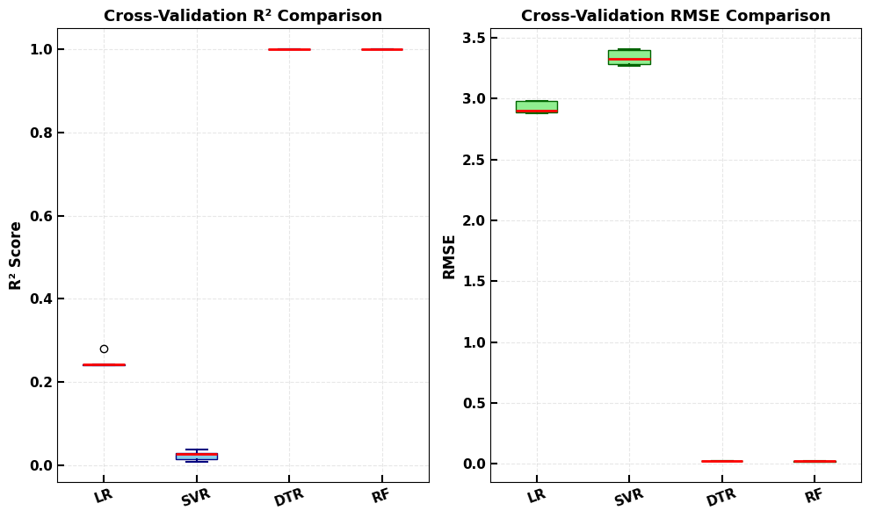
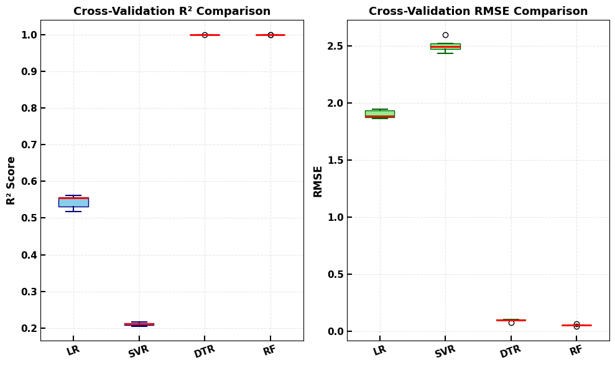
Table S3: Ranking of the eight most influential layer-specific parameters, from highest to lowest. L₁, L₂, and L₃ stand for the Cs₃Bi₂I₉, MASnI₃, and Cs₂TiBr₆ perovskite layers, respectively.
(d) FF (%)
(c) J_{SC} (mA/cm²)
(a) PCE (%)
(b) V_{OC} (V)
Fig.S 4. Evaluation results for the regression models. R² and root mean square error (RMSE) values were obtained from 5 fold cross validation.
PV parameters | Ranking | Features | Relative importance (%)
PCE | 1st | Thickness L₂ | 40.04
PCE | 2nd | Defect density, N_{t} L₃ | 31.51
PCE | 3rd | Thickness L₃ | 9.79
PCE | 4th | Defect density, N_{t} L₂ | 6.66
PCE | 5th | Thickness L₁ | 5.19
PCE | 6th | Valence band DOS, N_{V} L₂ | 2.97
PCE | 7th | Acceptor density, N_{A} L₂ | 1.67
PCE | 8th | Conduction band DOS, N_{C} L₂ | 1.20
V_{OC} | 1st | Valence band DOS, N_{V} L₂ | 55.74
V_{OC} | 2nd | Conduction band DOS, N_{C} L₃ | 30.33
V_{OC} | 3rd | Acceptor density, N_{A} L₃ | 6.13
V_{OC} | 4th | Acceptor density, N_{A} L₂ | 3.80
V_{OC} | 5th | Dielectric permittivity,L₂ | 0.61
V_{OC} | 6th | Bandgap,E_{g} L₂ | 0.61
V_{OC} | 7th | Electron affinity,X L₃ | 0.59
V_{OC} | 8th | Electron affinity,X L₂ | 0.55
J_{SC} | 1st | Thickness L₂ | 44.84
J_{SC} | 2nd | Thickness L₃ | 34.62
J_{SC} | 3rd | Defect density, N_{t} L₃ | 12.78
J_{SC} | 4th | Defect density, N_{t} L₂ | 2.97
J_{SC} | 5th | Thickness L₁ | 1.39
J_{SC} | 6th | Acceptor density, N_{A} L₃ | 1.32
J_{SC} | 7th | Valence band DOS, N_{V} L₁ | 0.93
J_{SC} | 8th | Acceptor density, N_{A} L₂ | 0.57
FF | 1st | Acceptor density, N_{A} L₃ | 28.18
FF | 2nd | Valence band DOS, N_{V} L₂ | 15.72
FF | 3rd | Acceptor density, N_{A} L₂ | 12.86
FF | 4th | Dielectric permittivity,L₂ | 9.80
FF | 5th | Thickness L₃ | 6.55
FF | 6th | Dielectric permittivity,L₃ | 5.47
FF | 7th | Thickness L₂ | 4.70
FF | 8th | Conduction band DOS, N_{C} L₃ | 4.63

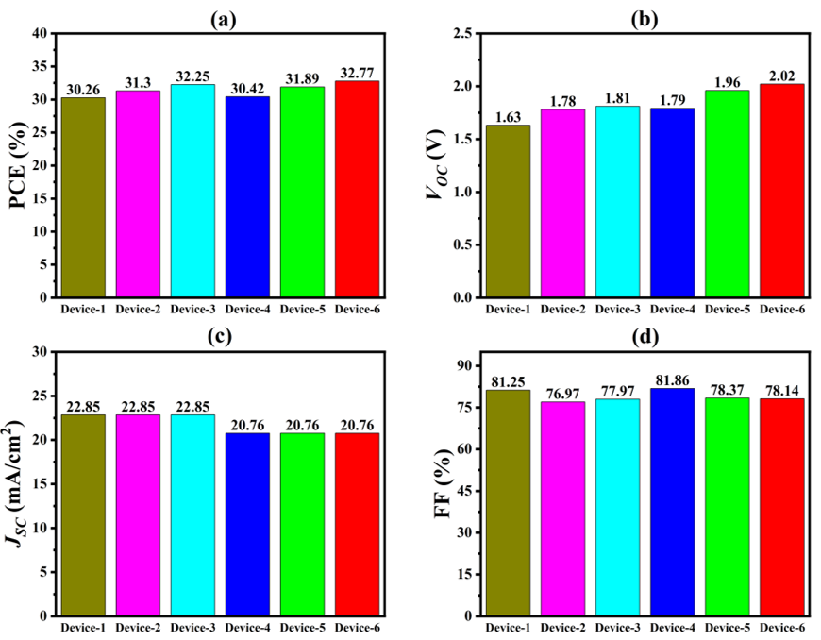
Fig.S 5. Comparative analysis of the photovoltaic figures of merit across the six monolithic tandem configurations (Devices 1-6). (a) PCE, (b) V_{OC}, (c) J_{SC}, and (d) FF

1 How to use the ML algorithm

1.1 Importing the libraries
import numpy as np
import matplotlib.pyplot as plt
import pandas as pd

1.2 Importing the dataset
dataset = pd.read_csv('data.csv')
X = dataset.iloc[:, :-1].values
y = dataset.iloc[:, -1].values

1.3 Splitting the dataset into the Training set and Test set
from sklearn.model_selection import train_test_split
X_train, X_test, y_train, y_test = train_test_split(X, y, test_size = 0.2, random_state = 0)

1.4 Training the Regression models on the whole dataset
- For Linear regression
from sklearn.linear_model import LinearRegression
regressor = LinearRegression()
regressor.fit(X_train, y_train)
- For Support Vector regression
from sklearn.svm import SVR
regressor = SVR(kernel = 'rbf')
regressor.fit(X_train, y_train)
- For Decision Tree regression
from sklearn.tree import DecisionTreeRegressor
regressor = DecisionTreeRegressor(random_state = 0)
regressor.fit(X_train, y_train)
- For Random Forest regression
from sklearn.ensemble import RandomForestRegressor
regressor = RandomForestRegressor(n_estimators = 10, random_state = 0)
regressor.fit(X_train, y_train)

1.5 Predicting the Test Set Results
y_pred = regressor.predict(X_test)
np.set_printoptions(precision=2)
print(np.concatenate((y_pred.reshape(len(y_pred),1), y_test.reshape(len(y_test),1)),1))

1.6 Evaluating the model performance with cross validation
from sklearn.model_selection import KFold, cross_validate
from sklearn.metrics import make_scorer, mean_squared_error

def rmse(y_true, y_pred):
return np.sqrt(mean_squared_error(y_true, y_pred))

# Define models
models = {
"LR": LinearRegression(),
"SVR": SVR(kernel='rbf'),
"DTR": DecisionTreeRegressor(random_state=0),
"RF": RandomForestRegressor(n_estimators=100, random_state=0)
}

# Cross-validation setup
kf = KFold(n_splits=5, shuffle=True, random_state=0)
scoring = {
'R2': 'r2',
'RMSE': make_scorer(rmse, greater_is_better=False)
}

# Storage for results
results = {}
for name, model in models.items():
cv_results = cross_validate(model, X, y, cv=kf, scoring=scoring, return_train_score=False)
r2_scores = cv_results['test_R2']
rmse_scores = -cv_results['test_RMSE'] # negate since greater_is_better=False
results[name] = {'R2': r2_scores, 'RMSE': rmse_scores}
print(f"{name}: Mean R² = {np.mean(r2_scores):.4f} ± {np.std(r2_scores):.4f}, "
f"Mean RMSE = {np.mean(rmse_scores):.4f} ± {np.std(rmse_scores):.4f}")

# Prepare boxplot data
r2_data = [results[m]['R2'] for m in models.keys()]
rmse_data = [results[m]['RMSE'] for m in models.keys()]

plt.figure(figsize=(10, 6))
# Two subplots: one for R², one for RMSE
plt.subplot(1, 2, 1)
plt.boxplot(
r2_data, tick_labels=list(models.keys()), patch_artist=True,
boxprops=dict(facecolor='skyblue', color='navy'),
medianprops=dict(color='red', linewidth=2),
whiskerprops=dict(color='navy', linewidth=1.5),
capprops=dict(color='navy', linewidth=1.5)
)
plt.title('Cross-Validation R² Comparison', fontsize=13, fontweight='bold')
plt.ylabel('R² Score', fontsize=12, fontweight='bold')
plt.xticks(rotation=20, fontsize=11, fontweight='bold')
plt.yticks(fontsize=11, fontweight='bold')
plt.tick_params(direction='in', length=6, width=1.5)
plt.grid(alpha=0.3, linestyle='--')
plt.subplot(1, 2, 2)
plt.boxplot(
rmse_data, tick_labels=list(models.keys()), patch_artist=True,
boxprops=dict(facecolor='lightgreen', color='darkgreen'),
medianprops=dict(color='red', linewidth=2),
whiskerprops=dict(color='darkgreen', linewidth=1.5),
capprops=dict(color='darkgreen', linewidth=1.5)
)
plt.title('Cross-Validation RMSE Comparison', fontsize=13, fontweight='bold')
plt.ylabel('RMSE', fontsize=12, fontweight='bold')
plt.xticks(rotation=20, fontsize=11, fontweight='bold')
plt.yticks(fontsize=11, fontweight='bold')
plt.tick_params(direction='in', length=6, width=1.5)
plt.grid(alpha=0.3, linestyle='--')
plt.tight_layout() plt.show()

1.7 Parity Plot
def parity_plot(y_actual, y_pred, title, filename, color):
plt.figure(figsize=(6, 6))
plt.scatter(
y_actual,
y_pred,
color=color,
alpha=0.6,
edgecolor='k',
label='Predicted',
linewidth=0.8
)
plt.plot(
[10, 30], # fixed x-range line
[10, 30], # fixed y-range line
'r--',
linewidth=2,
label='Actual'
)
# Fix axis ranges
plt.xlim(8, 32)
plt.ylim(8, 32)

# Labels & title with bold font and custom size
plt.xlabel("Actual PCE",
fontsize=label_fontsize,
fontweight='bold')
plt.ylabel("Predicted PCE",
fontsize=label_fontsize,
fontweight='bold')
plt.title(title, fontsize=title_fontsize, fontweight='bold')
# Legend without frame/outline, bold and larger font
legend_font = fm.FontProperties(size=legend_fontsize, weight='bold')
plt.legend(frameon=False, prop=legend_font)
# Ticks: inward and bold tick labels with increased length and width
plt.tick_params(direction='in',
length=10,
width=2,
colors='black',
labelsize=label_fontsize)
plt.xticks(fontweight='bold')
plt.yticks(fontweight='bold')
# No grid
plt.grid(False)
plt.tight_layout()
# Generate plots
parity_plot(y_train, y_train_pred, "Training Data using Random Forest",
"train_RF_plot.png", 'blue')
parity_plot(y_test, y_test_pred, "Testing Data using Random Forest",
"test_RF_plot.png", 'green')
(Same for Linear regression)

1.8 Features Importance
feature_names = list(dataset.iloc[:, :-1].columns)
num_features = len(feature_names)
importances = regressor.feature_importances_ df_importance = pd. DataFrame({"names": feature_names, "importance": importances})
df_importance = df_importance.sort_values('importance', ascending=False).reset_index() display(df_importance)

1.9 SHAP plot
Import shap
# Calculate SHAP values for test set
shap_values = explainer.shap_values(X_test)
# Compute mean absolute SHAP value per feature to find top 8 features
mean_abs_shap = np.abs(shap_values).mean(axis=0)
top8_idx = np.argsort(mean_abs_shap)[::-1][:8] # indices of top 8 features
# Select top 8 feature names and data
top8_features = X_test.columns[top8_idx]
X_test_top8 = X_test[top8_features]
# Select corresponding SHAP values for top 8 features
shap_values_top8 = shap_values[:, top8_idx]
# Plot SHAP summary beeswarm plot for top 8 features only (show=False to customize)
shap.summary_plot(shap_values_top8, X_test_top8, show=False)
# Customize plot: get current axes
ax = plt.gca()
# Customize x-axis ticks: increase font size, bold, inward ticks
ax.tick_params(axis='x', direction='in', length=10, width=2)
for label in ax.get_xticklabels():
label.set_fontsize(16)
label.set_fontweight('bold')
# Finally, show the plot
plt.show()
Simillar code for V_{OC} ,J_{SC} and FF

