CSE321

LAB ASSIGNMENT

Mohammad Rakibul Hasan Mahin

20201220

04

**1. (a)**

touch 20201220_1.txt 20201220_2.txt 20201220_3.txt 20201220_4.txt

mkdir Rakibul1

mkdir Rakibul2

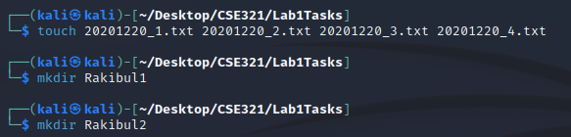

mv 20201220_1.txt Rakibul1

mv 20201220_2.txt Rakibul1

mv 20201220_3.txt Rakibul1

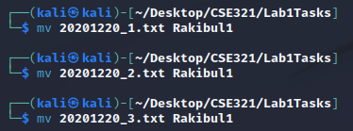

cp ./Rakibul1/20201220_1.txt ./Rakibul2

cp ./Rakibul1/20201220_2.txt ./Rakibul2

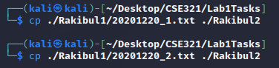

cd Rakibul2

mkdir Rakibul3

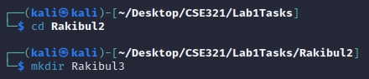

cp -r ../Rakibul1 ./Rakibul3



cd Rakibul3

cd Rakibul1

ls -l

chmod go=rx 20201220_1.txt 20201220_2.txt 20201220_3.txt

ls -l

cd ..

ls -l

chmod go=rx Rakibul1

ls -l

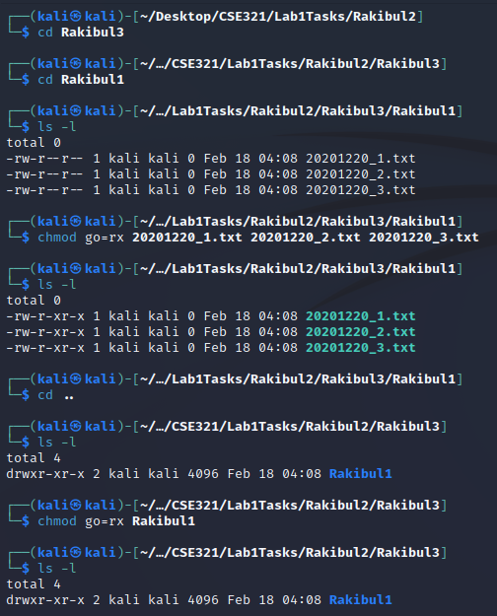

cd ..

ls

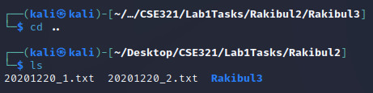

mv ./Rakibul3 ../root



rm -r 20201220_1.txt 20201220_2.txt



**1. (b)**

cat> course.txt

HUM101 - World Civilization and Culture - 08

CSE321 - Operating Systems - 04

CSE438 - Applied Data Science for Practitioners - 01

CSE470 - Software Engineering - 01

grep -c CSE course.txt

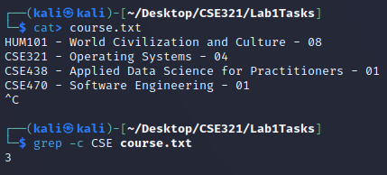

**1. (c)**

cd /

ls -a

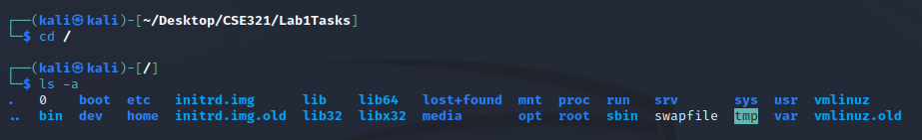

**1. (d)**

cat> a.txt

1

2

3

4

5

6

7

8

9

10

11

12

13

14

15

16

17

18

19

20

sed -n '5,17p' a.txt

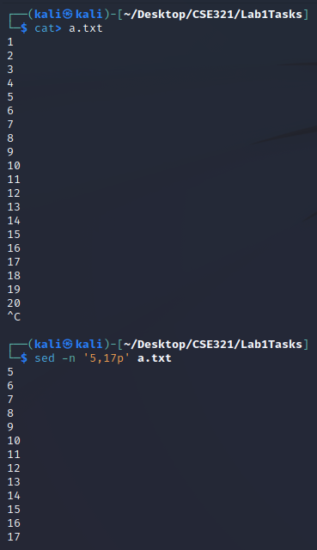

**2. (a)**

#include <stdio.h>

int main(void) {

int num1, num2, res;

char op[1];

printf("Enter Number1: ");

scanf("%d",&num1);

printf("Enter Number2: ");

scanf("%d",&num2);

printf("Enter Operation: ");

scanf("%s",op);

if(num1 > num2){

res = sub(num1, num2);

printf("Result: %d", res);

}else if(num1 < num2){

res = add(num1, num2);

printf("Result: %d", res);

}else if(num1 == num2){

res = mul(num1, num2);

printf("Result: %d", res);

}

return 0;

}

int add(int num1, int num2) {

return (num1 + num2);

}

int sub(int num1, int num2) {

return (num1 - num2);

}

int mul(int num1, int num2) {

return (num1 * num2);

}

**2. (b)**

#include <stdio.h>

int main(void) {

FILE *userInput;

userInput = fopen("task2b_input.txt","r");

FILE *output;

output = fopen("task2b_output.txt", "w");

char res[100];

fgets(res,100,userInput);

char *tok = strtok(res, " ");

while(tok != NULL){

printf("%s ", tok);

fprintf(output, " %s", tok);

tok = strtok(NULL, " ");

}

fclose(userInput);

return 0;

}

**2. (c)**

#include <stdio.h>

int main() {

char password[100];

int len, lowercase, uppercase, digit, special;

lowercase = uppercase = digit = special = 0;

printf("Enter the password: ");

scanf("%s", password);

len = strlen(password);

for(int i = 0; i < len; i++) {

if(islower(password[i])) {

lowercase = 1;

}

else if(isupper(password[i])) {

uppercase = 1;

}

else if(isdigit(password[i])) {

digit = 1;

}

else if(password[i] == '_' || password[i] == '$' || password[i] == '#' || password[i] == '@') {

special = 1;

}

}

if(!lowercase) {

printf("Lowercase character missing, ");

}

if(!uppercase) {

printf("Uppercase character missing, ");

}

if(!digit) {

printf("Digit missing, ");

}

if(!special) {

printf("Special character missing");

}

if(lowercase && uppercase && digit && special) {

printf("OK\n");

}

return 0;

}

**2. (d)**

#include <stdio.h>

#include <string.h>

int main(){

int i;

char email[100];

char *domain;

printf("Enter email ID: ");

scanf("%s", email);

domain = strstr(email, "sheba.xyz");

if (domain){

printf("Email address is okay");

}

else{

printf("Email address is outdated");

}

return 0;

}

**2. (e)**

#include <stdio.h>

int isPalindrome(char *str) {

int i, len = strlen(str);

char *start = str;

char *end = str + len - 1;

for(i = 0; i < len/2; i++) {

if(*start != *end) {

return 0;

}

start++;

end--;

}

return 1;

}

int main() {

char str[100];

printf("Enter a string: ");

scanf("%s", str);

if(isPalindrome(str)) {

printf("Palindrome\n");

}

else {

printf("Not Palindrome\n");

}

return 0;

}