**Curriculum vitae**

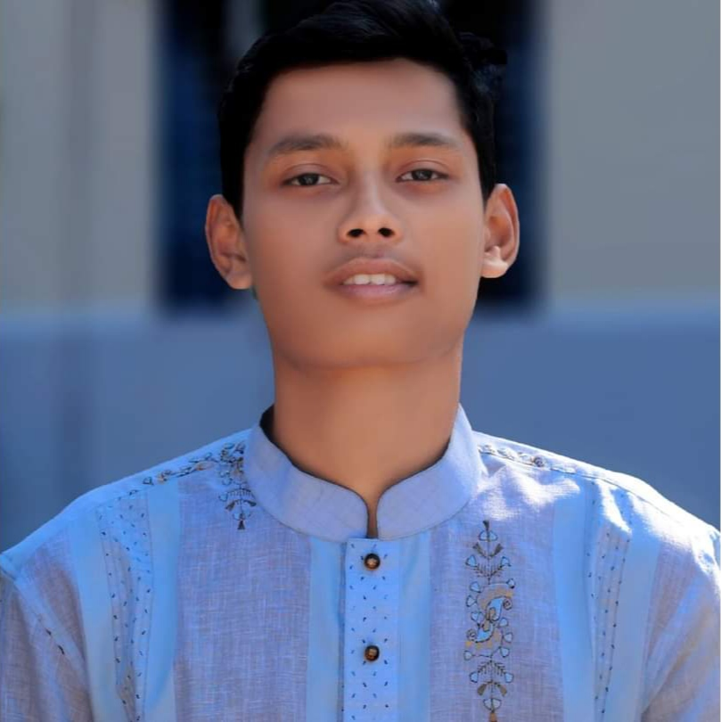

**MD. RAKIBUL ISLAM**

**Address : Mathbaria , pirojpur**

**Phone : 01721299758**

**Email : parsonalrakib808@gmail.com**

**Facebook : Md. Rakibul Islam**

**Objective**

Clothing designer with industry experience in women’s, men’s and children swear . Highly self motivated

And results driven. Take a keen interest in current trends and have a passion for all things fashion

And clothing related. Fast and effective. I want to be a part of your success by offering high motivation ,

Responsibility, quality work and keeping deadlines. I am working with following software: wilcom es 1.5 , melco design shop v9, Corel Draw X6,,adobe Photoshop CS5.1 Adobe Illustrator CS6. I am using high quality fonts fgern.

**Education**

**Exam**  : SSC

**Session**  :2020-2021

**Institution** :Mathbaria Momenia Dhakil Madrasha

**Board** :Dhaka

**Result** :**A+**

**Exam**  :Diploma in computer engineering

**Session**  :2021-2022

**Institution** : Mangrove institute of science and technology

**Board**  :Josser

**Result** :**A+**

**Skill**

HTML: **90%**

CSS: **80%**

JAVA: **50%**

React: **70%**

C ,C## : **50%**