

SOUTHWEST UNIVERSITY OF SCIENCE AND TECHNOLOGY
课程主题研究报告
COURSE REPORT
Topic: Smart Chess Game

学院名称/School | School of Computer Science and Technology
学生姓名/Name | Hasan Md Rakibul
学号/STUDENT ID | 7420250936
课程/SUBJECT NAME | Advanced Software System Analysis and Design
指导教师/TEACHER NAME | Dr. Justice Odoom
提交日期/DATE | 2025-12-17

Abstract
Chess is widely used as a classical problem for studying intelligence, decision-making, and strategic thinking. As part of the course Advanced Software System Analysis and Design, this project focuses on designing and developing a Smart Chess Game that demonstrates both software architecture principles and basic artificial intelligence techniques. The application is implemented as an offline desktop game using Python and provides multiple modes, including Player-vs-Player and Player-vs-AI gameplay. Two levels of artificial intelligence are included: a Random-based AI for beginners and a Minimax-based AI for more challenging gameplay. In addition, the system offers a Puzzle Editor to support learning and practice. Several software design patterns, such as Singleton, Builder, Abstract Factory, Strategy, and Observer, are applied to improve modularity, maintainability, and clarity of the system design. The project shows how theoretical concepts from software system analysis and design can be effectively applied to a practical game development scenario.
Keywords: Smart Chess Game, Artificial Intelligence, Minimax Algorithm, Software Design Patterns, Python Game Development.

Table of Contents
1. Introduction 1
1.1 Project Background 1
1.2 Problem Statement 1
1.3 Proposed Solution 1
1.4 Project Objectives 2
1.4.1 General Objectives 2
1.4.2 Specific Objectives 2
2. System Analysis 3
2.1 Functional Requirements 3
2.1.1 Game Modes 3
2.1.2 Puzzle Editor 3
2.1.3 Save and Load System 3
2.1.4 Visual Assistance 3
2.2 Non-Functional Requirements 4
2.2.1 Performance 4
2.2.2 Usability 4
2.3 Use Case Diagram 4
2.4 System Flowchart 5
3. Software Architecture 6
3.1 High-Level Architecture 6
3.2 Class Diagram 6
3.3 Sequence Diagram: 7
3.4 File Structure Analysis 7
3.5 Design Decision: Integrability 8
4. Design Patterns Implementation 9
4.1 Singleton Pattern 9
4.2 Builder Pattern 9
4.3 Abstract Factory Pattern 10
4.4 Object-Oriented Programming (OOP) Principles 12
4.1.1 Encapsulation 12
4.4.2 Abstraction 12
4.4.3 Polymorphism 12
4.4.4 Composition over Inheritance 12
5. Design Decisions 13
5.1 Performance 13
5.2 Modifiability 13
6. AI Implementation 15
6.1 Random AI Logic 15
6.2 Minimax Implementation 15
6.4 Material Evaluation 16
7. Limitations and Future Enhancements 17
7.1 Current Limitations 17
7.2 Future Enhancements 17
Conclusion 18
References 19

1. Introduction

1.1 Project Background
Chess is one of the oldest and most respected strategy games in the world. It has been the ultimate test of human intelligence, patience, and logic. With the rise of computers in the 20th century, chess became a central problem for computer scientists.
The history of digital chess is vast. It started with simple algorithms in the 1950s that could barely play a legal game. By the 1990s, powerful engines like IBM’s Deep Blue defeated world champions. Today, professional engines are stronger than any human player. However, most of these professional engines are built using complex languages like C++, which makes them very difficult for new developers to understand or modify.
In recent years, the Python programming language has become the standard for Artificial Intelligence and rapid software development. Despite this, there is a lack of simple, open-source chess engines that are powerful enough to play well but simple enough to study. My Smart Chess Game aims to try fill that gap. It is a comprehensive, Python-based application that combines a classic game interface with modern software engineering principles.

1.2 Problem Statement
While there are many chess applications available today, nearly all of them suffer from specific limitations when viewed from a development or educational perspective:
- High System Requirements: Modern commercial chess games often focus heavily on 3D graphics and animations. As a result, they require powerful computers and graphics cards. This makes them inaccessible to users with standard laptops or older hardware.
- Dependence on Internet Connectivity: The most popular chess platforms (such as Chess.com or Lichess) are web-based. They require a constant, stable internet connection. If a user is offline, they lose access to the game and their analysis tools.
- Black Box Design: Most commercial chess software is closed-source. Users can play the game, but they cannot see the code "behind the scenes." They cannot understand how the computer decides on a move or how the board validates rules. This limits the value of the software for anyone who wants to learn about system design.

1.3 Proposed Solution
To solve the problems listed above, I have developed a desktop application that runs entirely in a local Python environment.
- Lightweight Design: Instead of using heavy 3D engines, use a clean 2D interface. This ensures the application starts instantly and runs smoothly on any computer.
- Offline Capability: The logic, including the AI and the Puzzle Editor, is self-contained. No internet connection is required to play or analyze games.
- Transparent Code: The system is built using clear "Object-Oriented Programming" (OOP) principles. This makes the logic visible and understandable.

1.4 Project Objectives
The primary goal of this project is to design and develop a robust chess that balances performance with code clarity.

1.4.1 General Objectives
- To create a fully functional chess simulation that strictly follows the international rules of chess.
- To demonstrate the practical application of software design patterns (such as Singleton, Abstract, and Builder) in a real-world scenario.
- To provide an interactive platform where users can challenge an AI opponent or practice specific scenarios.

1.4.2 Specific Objectives
- Game Loop Implementation: To develop a stable game loop that updates the screen 60 times per second, ensuring responsive mouse input and smooth visual feedback.
- AI Development: To implement two distinct levels of Artificial Intelligence:
  - Level 1 (Easy): An algorithm that makes random decisions, suitable for beginners.
  - Level 2 (Hard): An implementation of the "Minimax Algorithm" that looks ahead into the future moves to select the best possible strategy.
- Puzzle Editor: To build a feature that allows users to place pieces anywhere on the board. This allows for the creation of custom puzzles and endgame practice.
- User Experience (UX) Design: To create a user-friendly interface that includes move history, captured pieces, and visual warnings like Check alerts to guide the player.

2. System Analysis

2.1 Functional Requirements
Functional requirements describe exactly what the system does. These are the specific features and behaviors that the Smart Chess Game provides to the user.

2.1.1 Game Modes
The system allows users to play chess in two different configurations:
- Player vs. Player (P v P): Two human users can play against each other on the same computer. The system automatically manages turns, ensuring that White moves first, followed by Black.
- Player vs. AI (P v AI): A single user can play against the computer. The system includes a AI menu where the user can choose between:

2.1.2 Puzzle Editor
The Puzzle Editor is a creative tool that allows users to set up custom board scenarios.
- Piece Placement: Users can select any piece (King, Queen, Rook, etc.) from the sidebar and place it on any square.
- Color Selection: Users can switch between placing White pieces and Black pieces.
- Scenario Testing: Once a board is built, the user can press "Enter" to immediately start playing a game from that exact position.

2.1.3 Save and Load System
To ensure users do not lose their progress, the system includes a persistence mechanism.
- Save Game (Ctrl+S): The current state of the board, including piece positions, turn timers, and move history, is saved to a JSON file.
- Load Game (Ctrl+L): The system reads the saved file and restores the exact state of the game instantly, allowing the player to continue where they left off.

2.1.4 Visual Assistance
The system provides real-time visual feedback to help the player understand the game state:
- Legal Move Highlighting: When a player clicks a piece, the system highlights all valid squares where that piece can move.
- Check Warning: If the King is under attack, a red "CHECK!" warning appears in the sidebar to alert the player.
- Game Over Popup: When a Checkmate or Stalemate occurs, a window appears declaring the winner.

2.2 Non-Functional Requirements
Non-functional requirements describe how well the system performs. These attributes are critical for a good user experience.

2.2.1 Performance
- Frame Rate: The application is optimized to run at a consistent 60 Frames Per Second (FPS). This ensures that piece movement looks smooth and dragging feels responsive.
- Startup Time: The system initializes in under 2 seconds because it does not rely on heavy external assets or large database connections.

2.2.2 Usability
- Intuitive Controls: The game uses standard Drag and Drop or Click and Click interactions, which are familiar to anyone who has used a computer mouse.
- Clear Visuals: The board uses high-contrast colors like a projector-friendly Mode and large text to ensure the game is visible in classroom environments or on projectors.
2.2.3 Reliability
- Input Handling: The system handles invalid inputs gracefully. For example, if a user tries to move a Knight in a straight line (an illegal move), the piece not move instead of crashing the game.
- Asset Safety: Because the graphics are generated using system fonts, there is no risk of the game crashing due to missing image files.

2.3 Use Case Diagram

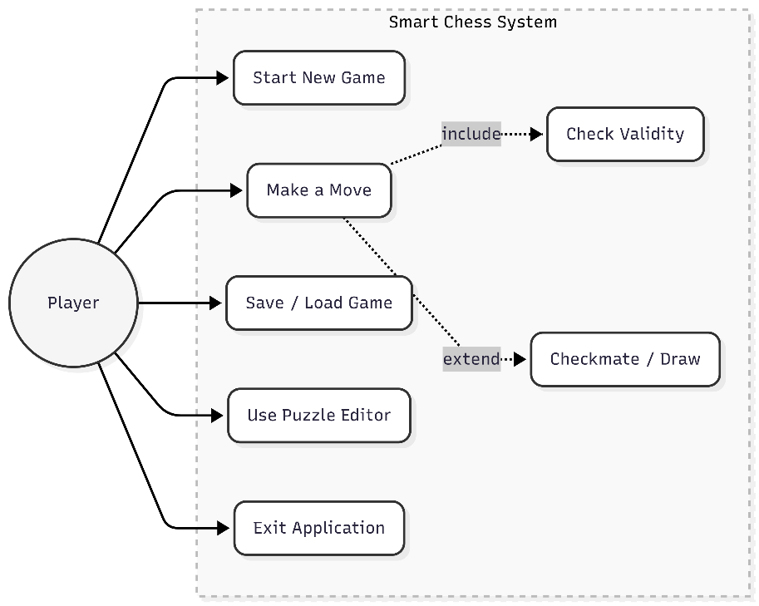
Fig 2.1: use case diagram

2.4 System Flowchart

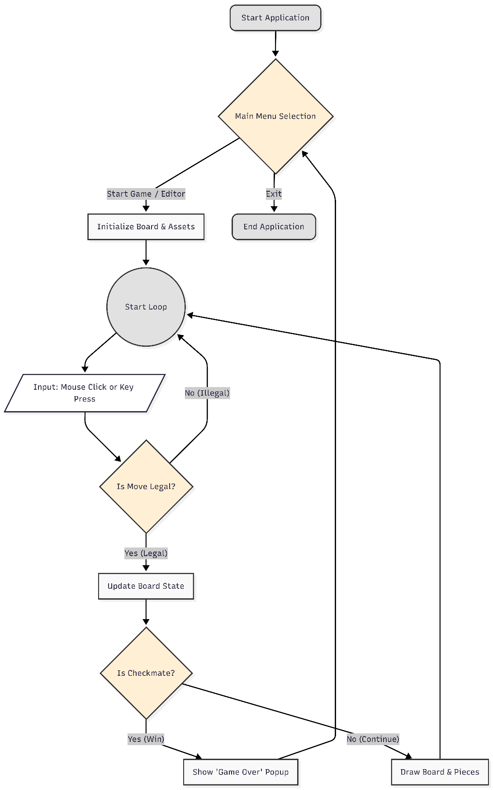
Fig 2.2: System Flowchart

3. Software Architecture

3.1 High-Level Architecture
The architecture of a software system is like the blueprint of a building. It defines how the different parts of the code connect and talk to each other.
This game follows a modified version of the "Model-View-Controller" (MVC) pattern. This is a standard way to organize code in software engineering. It separates the internal logic from the visual graphics.
- The Model (Data): This is the "brain" of the game. The GameState class (located in core/game_state.py) acts as the model. It stores the board position, the timers, and the move history. It does not know about graphics or colors; it only knows data.
- The View (Display): This is what the user sees. The main.py file and the PieceRenderer class handle the drawing. They read the data from the Model and draw the board, pieces, and buttons on the screen.
- The Controller (Input): This handles user actions. When the player clicks the mouse or presses a key (like 'R' to restart), the main.py script captures that event and tells the Model to update.

3.2 Class Diagram

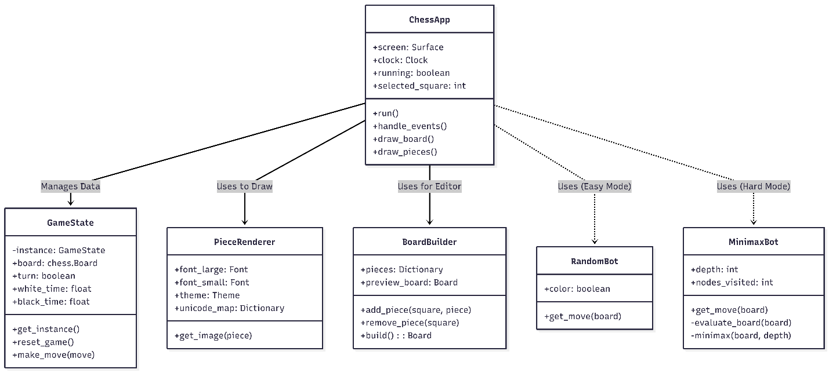
Fig 3.1: Class Diagram

3.3 Sequence Diagram:

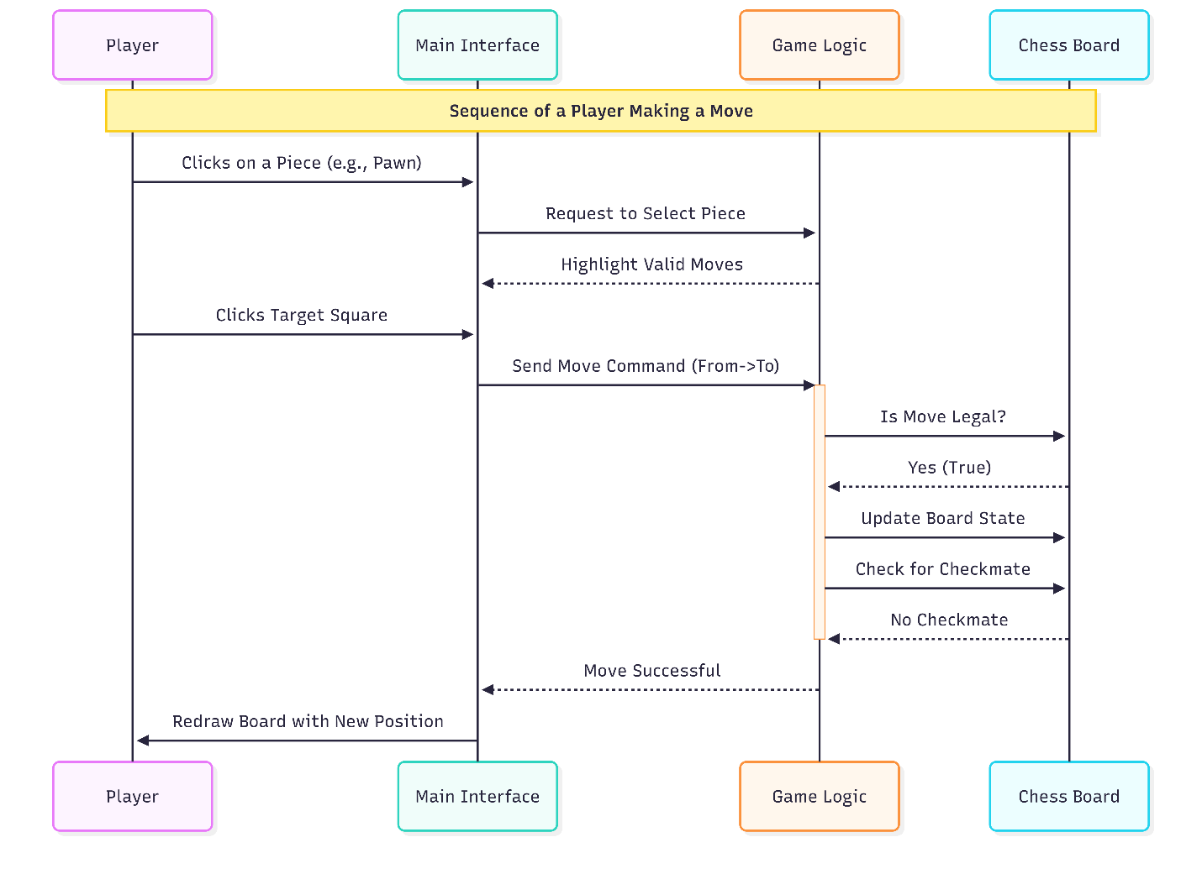
Fig 3.2: Sequence Diagram

3.4 File Structure Analysis
To keep the project organized and modular easy to modify, the code is divided into several folders. Each folder has a specific responsibility.
- main.py: The entry point of the application. It contains the main game loop, initializes the window and coordinates all other parts of the system.
- core/: Contains the essential logic of the game.
  - game_state.py: Manages the board and variables like whose turn it is.
  - settings.py: Stores constants like screen width, colors, and frame rate.
- ai/: Contains the Artificial Intelligence logic.
  - random_bot.py: The logic for the "Easy" difficulty.
  - minimax_bot.py: The logic for the "Hard" difficulty.
- pieces/: Handles the visuals.
  - piece_factory.py: Responsible for loading fonts and drawing the chess pieces (King, Queen, etc.) on the screen.
- editor/: Contains the Puzzle Editor tools.
  - board_builder.py: Logic for placing and removing pieces to create custom scenarios.
- ui/: Manages user interface elements.
  - components.py: Contains the code for the interactive buttons (like "Exit" or "Restart").

3.5 Design Decision: Integrability
One of the most important architectural decisions in this project was the integration of the external ‘python-chess library’.
Instead of writing the complex rules of chess, I decided to integrate an existing, tested library called python-chess to handle the backend logic. This decision greatly improved the Integrability and reliability of the system.
- Accuracy: The library has been tested by thousands of developers know the rule checking is 100% correct.
- Efficiency: It allows us to focus development effort on the "Frontend" (Graphics, UI, and AI) rather than reinventing the basic rules of the game.
- Standardization: The library uses standard formats to represent the board, making it easy to save and load data.

Design Patterns Implementation

Design Pattern is a reusable solution to a common problem. It is like a template that can be applied to many different situations. I implemented four major design patterns to ensure the code is clean, efficient, and easy to maintain.

4.1 Singleton Pattern
The Singleton Pattern ensures that a class has only one instance and provides a global point of access to it.
In a chess game, there must be only one "Game State" active at a time. If accidentally created two board objects, the game would be confused . for example, moving a piece on Board A would not update Board B.
Implemented the Singleton pattern in the GameState class. This ensures that the board, the timers, and the move history are managed in a single, shared location.

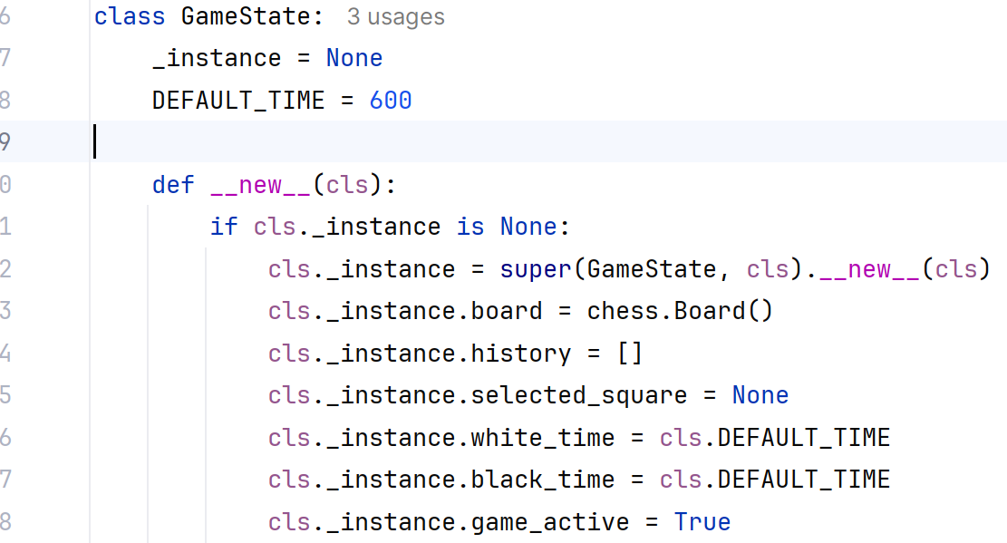

4.2 Builder Pattern
The Builder Pattern separates the construction of a complex object from its representation, allowing the same construction process to create different representations.
The Puzzle Editor allows users to create custom chess scenarios. Creating a valid chess.Board object is complex because it requires setting up 64 squares, ensuring valid turns, and verifying that Kings are present. Trying to do this all in one line of code is difficult and error
Implemented the Builder pattern in the BoardBuilder class. This class holds a temporary internal board (_board) that starts empty. The user acts as the "Director," calling add_piece() step-by-step to place pieces. Finally, the build() method validates the board (checking that both Kings exist) before returning the final, playable object.

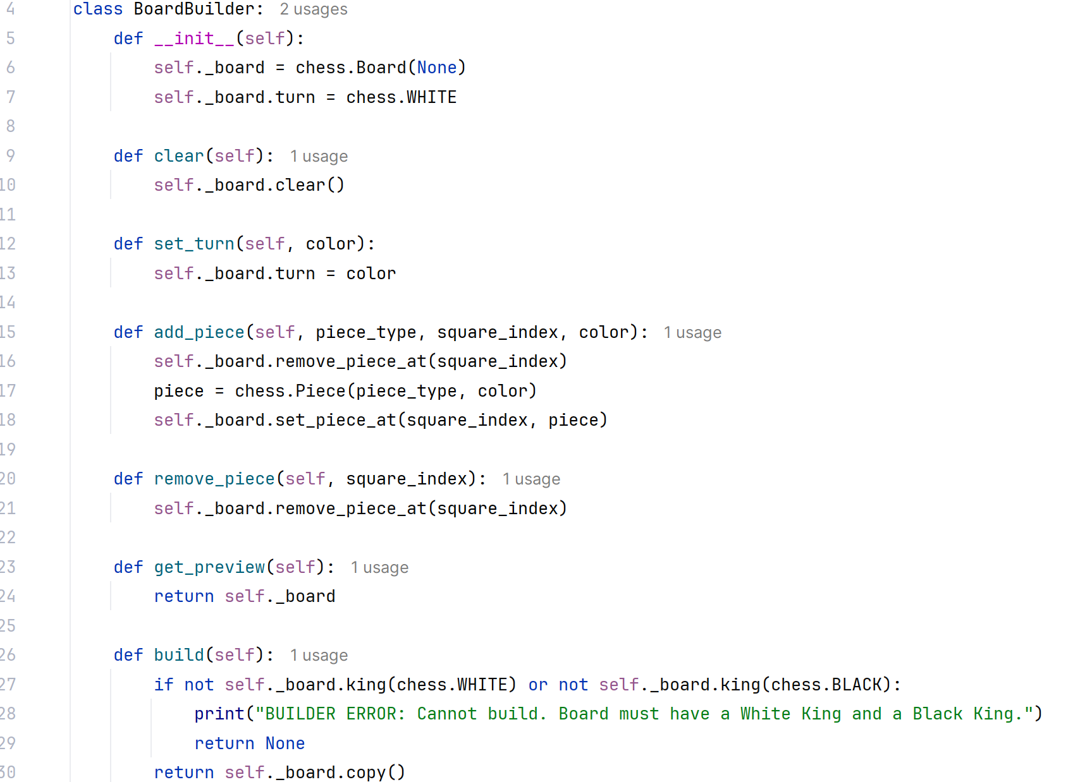

4.3 Abstract Factory Pattern
The Abstract Factory Pattern provides an interface for creating families of related objects without specifying their concrete classes.
The Smart Chess System supports multiple visual themes (Classic and High Contrast). Each theme is a “family” of related outputs (light square color, dark square color, highlight color, piece style). Hard-coding these values in the drawing code makes future modifications difficult.
Implemented Abstract Factory using AbstractThemeFactory as the interface and ClassicTheme / HighContrastTheme as concrete factories. The rendering system can switch themes without changing the board drawing logic.

Abstract Theme Factory Interface:
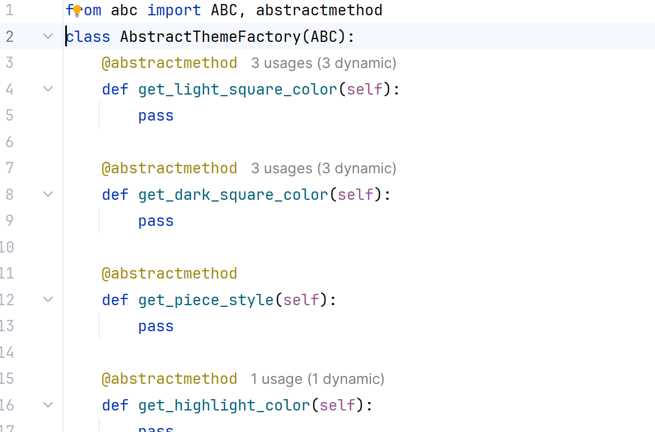

Concrete Factory:
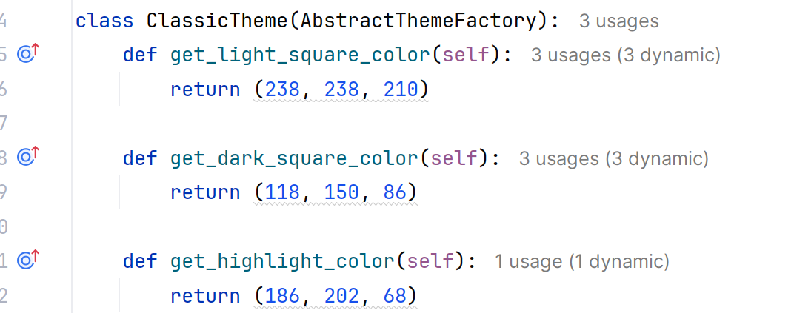

4.4 Object-Oriented Programming (OOP) Principles
In addition to Design Patterns, the Smart Chess System relies on three fundamental Object-Oriented Programming concepts to ensure the code is secure, organized, and easy to expand.

4.1.1 Encapsulation
Encapsulation is the practice of bundling data (variables) and methods (functions) into a single unit and restricting direct access to that data.
Applied Encapsulation in the GameState class. This class encapsulates all the sensitive game data, such as the board object, white_time, black_time
So, external parts of the code cannot accidentally break the game state (e.g., setting the timer to a negative number). They must use specific methods like update_timer() or make_move() to safely modify the data.

4.4.2 Abstraction
Abstraction involves hiding complex implementation details and showing only the necessary features of an object. I applied Abstraction in the BoardBuilder class.
A chess board is complex data structure. However, the BoardBuilder hides this complexity. When the Puzzle Editor needs to place a King, it simply calls add_piece(). The programmer using this class does not need to know how the board is validated or stored in memory; they only interact with the simple, abstract command.

4.4.3 Polymorphism
Polymorphism allows different classes to be treated as instances of the same general type, often by sharing the same method names. I applied Polymorphism in the AI system
The project features two different bots: RandomBot (Easy) and MinimaxBot (Hard). Although their internal logic is completely different, they both share the exact same method: get_move(board). This allows the main game loop to switch between "Easy" and "Hard" modes instantly without needing to rewrite any code. The game simply asks the current bot to "get move," regardless of which bot it is.

4.4.4 Composition over Inheritance
Inheritance creates tight coupling, while composition allows components to be replaced or modified independently.
In my, the main class ChessApp works with other classes such as GameState, PieceRenderer, BoardBuilder, and AI bots by using them as separate components. This allows the game to change behavior easily, such as switching between different AI strategies or rendering styles, without modifying the core structure of the program. Using composition reduces tight coupling between classes and makes the system easier to understand, maintain, and extend in the future.

Design Decisions

Design decisions are the specific technical choices made by developers to improve the quality of the software. In this project focused on three main quality attributes: Performance (speed), Modifiability (ease of change), and Availability.

5.1 Performance
Performance refers to how fast the system responds to user inputs. A major challenge in game development is maintaining a smooth "Frame Rate" (60 FPS).
Loading a font or an image from the hard drive is a slow operation for a computer. If the system tries to load the font every time it draws a square 60 times a second, the game will freeze or lag.The code to load the fonts only once when the game starts. The font is stored in memory and reused instantly for the rest of the game.

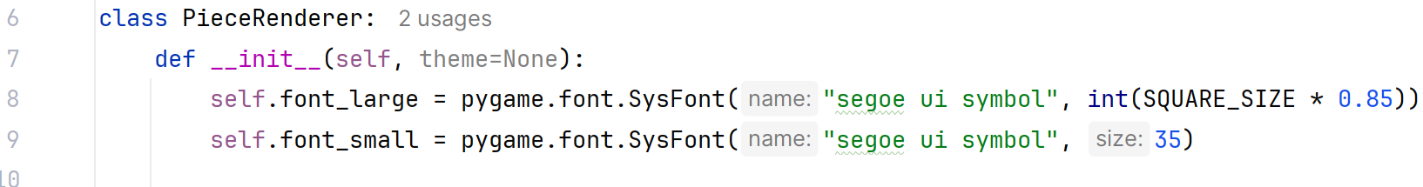

5.2 Modifiability
Modifiability measures how easy it is to add new features or fix bugs without breaking the existing code. If all the code was written in one giant file like main.py, it would be very hard to read. Changing the AI logic might accidentally break the graphics code. I split the code into separate folders (ai, core, pieces). Used to python's import system to connect them. This allows us to work on the AI without touching the UI.

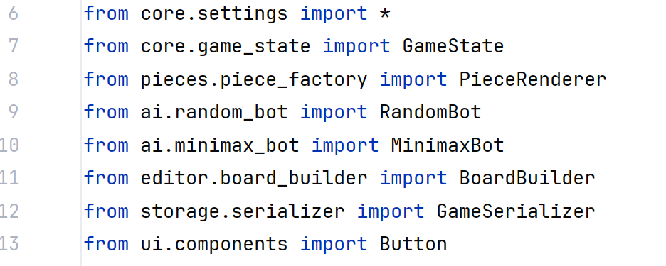
  - Availability
Availability refers to the system's ability to keep running even when errors occur. Sometimes, a file like a background image might be missing or deleted by accident. In poorly designed software, this would cause the program to crash immediately.
Used a try except block. The system attempts to load the image. If it fails, it does not crash; instead, it automatically switches to a default color. This ensures the game is always available to the user.
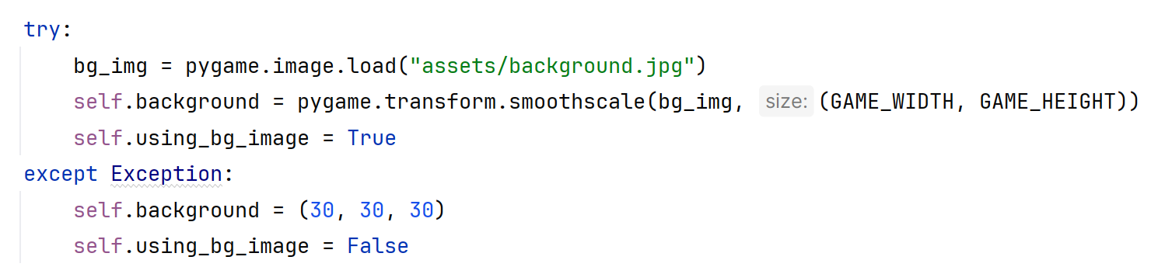

AI Implementation

Artificial Intelligence (AI) in games is different from AI in other fields. In games, the goal is not to "learn" like a human, but to "search" for the best possible move. For the Smart Chess Game, we implemented two different types of AI to support players of different skill levels.

6.1 Random AI Logic
The "Easy Mode" uses a Random AI. This is the simplest form of artificial intelligence.
- How it works: The computer looks at the board, finds every legal move available (for example, Pawn to E4, Knight to F3), and picks one blindly using a random number generator.
- Purpose: This mode is designed for absolute beginners. It allows them to practice moving pieces without being punished for mistakes, as the AI has no strategy.

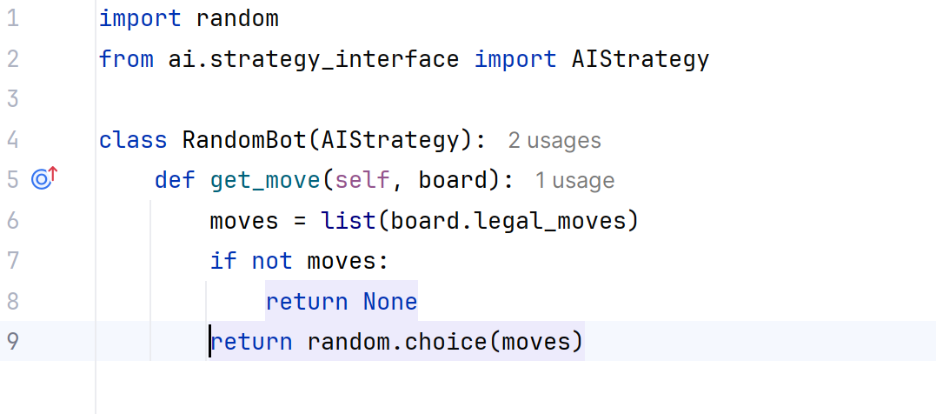

6.2 Minimax Implementation
use Recursion to implement Minimax. Recursion is when a function calls itself.
- Depth: We set the recursion depth to 3. This means the AI thinks 3 turns into the future (AI Move -> Human Reply -> AI Reply).
- The Process:
  - The AI simulates a move.
  - It calls the function again to simulate the opponent's reply.
  - It repeats this until it reaches Depth 3.
  - It calculates the score and sends it back up the tree.

6.4 Material Evaluation
How does the AI know if a board position is "Good" or "Bad"?
Point System: Assign a numerical value to every piece on the board.
  - Pawn: 10 Points
  - Knight / Bishop: 30 Points
  - Rook: 50 Points
  - Queen: 90 Points
  - King: 900 Points (The most valuable)
- Calculation: The AI counts its own pieces (Positive score) and subtracts the player's pieces (Negative score).
Example: If the AI captures a Rook (+50) but loses a Pawn (-10), the total score is +40. The AI sees this as a "Good" trade.
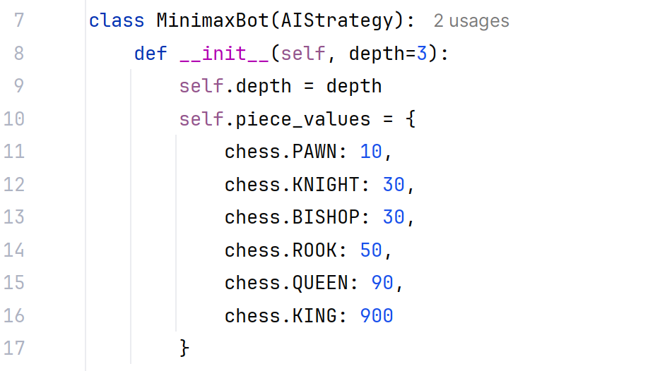

Limitations and Future Enhancements

7.1 Current Limitations
Although the Smart Chess System functions as a complete and stable application, certain constraints exist within the current implementation. These limitations are primarily due to the project's focus on creating a lightweight, offline-first application.
- Local Gameplay Only: The current architecture supports only "Local" gameplay modes. This means that for a Human-vs-Human match, both players must be physically present at the same computer. There is currently no networking capability to support matches against opponents over the Internet or a Local Area Network (LAN).
- AI Knowledge Gap: The Artificial Intelligence calculates moves strictly based on mathematical evaluation of the board state. It does not possess an "Opening Book" (a database of famous chess openings). Consequently, the AI may play sub-optimal or unusual moves in the very early stages of the game compared to professional chess engines that rely on historical data.
- No Analysis Features: The system does not currently offer a "Review" or "Replay" mode. Once a game concludes, the board is reset, and players cannot step backward through the move history to analyze critical moments or identify where mistakes were made.
- Graphical Constraints: To ensure maximum compatibility with older hardware, such as school computers and projectors, the graphics engine is strictly 2D. The interface does not support 3D perspectives, camera rotation, or advanced lighting effects.

7.2 Future Enhancements
To further improve the Smart Chess System and expand its capabilities, several key features are planned for future updates:
- Network Play Integration: A significant planned upgrade is the introduction of network capabilities using Python’s socket programming library. This would allow two distinct instances of the application to communicate, enabling users to challenge friends remotely over the internet.
- Teacher Mode: An automated analysis feature could be added to enhance the educational value of the software. After a game concludes, this system would re-run through the move history, identifying "Blunders" (major errors) and suggesting better alternative moves to help the user improve their skills.
- Audio and Immersion: The user experience could be improved by integrating a sound engine. Adding simple audio cues—such as the sound of a piece landing, a capture sound, and a checkmate alert—would make the gameplay feel more responsive and immersive.
- Opening Book Integration: Connecting the AI to a standard opening database (such as Polyglot files) would significantly boost the computer's strength. This would allow the AI to play instantly and perfectly during the opening phase of the game, mimicking professional play styles.

Conclusion

This project successfully developed a Smart Chess Game as part of the course Advanced Software System Analysis and Design, demonstrating the practical application of software engineering concepts in game development. The system provides essential chess functionalities, including multiple gameplay modes, artificial intelligence opponents, a puzzle editor, and save/load support, while remaining lightweight and easy to understand.
The use of well-known software design patterns such as Singleton, Builder, Abstract Factory create a modular and maintainable system structure. These patterns reduced coupling between components and made the codebase easier to extend and analyze. The implementation of AI opponents, especially the Minimax algorithm, illustrates how decision-making algorithms can be integrated into a real application.
Although the current version does not include features such as online multiplayer or advanced game analysis, it provides a solid foundation for future improvement. Overall, this project confirms that combining software system analysis techniques with game development can produce an effective and educational application, fulfilling the learning objectives of the course.

Github link: https://github.com/rakibul008/ChessMaster_Project

References
- Gamma, E., Helm, R., Johnson, R., & Vlissides, J. (1994). Design Patterns: Elements of Reusable Object-Oriented Software. Addison-Wesley.
- Sommerville, I. (2016). Software Engineering (10th ed.). Pearson Education.
- Larman, C. (2004). Applying UML and Patterns: An Introduction to Object-Oriented Analysis and Design. Prentice Hall.
- Russell, S., & Norvig, P. (2021). Artificial Intelligence: A Modern Approach (4th ed.). Pearson.
- Millington, I., & Funge, J. (2016). Artificial Intelligence for Games (3rd ed.). CRC Press.
- Ramalho, L. (2015). Fluent Python: Clear, Concise, and Effective Programming. O’Reilly Media.
- Fowler, M. (2002). Patterns of Enterprise Application Architecture. Addison-Wesley.
- Pygame Community. (2023). Pygame Documentation. https://www.pygame.org/docs/
- python-chess Contributors. (2023). python-chess Documentation. https://python-chess.readthedocs.io/

