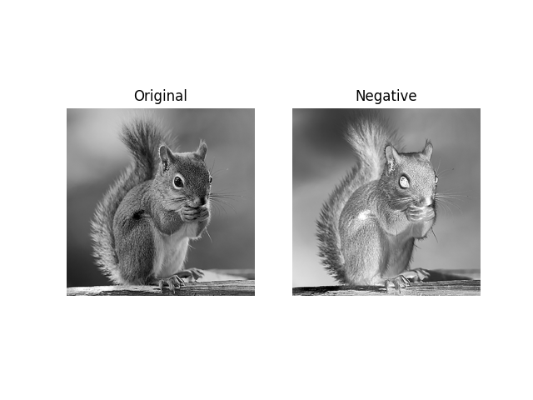

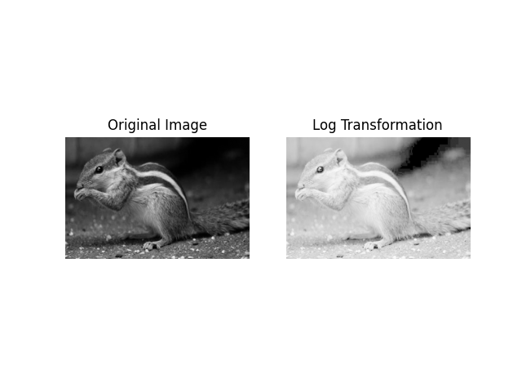

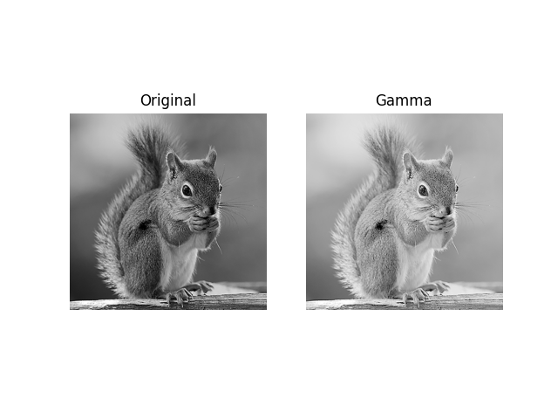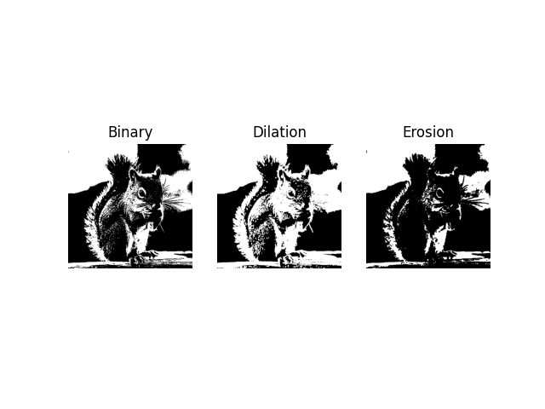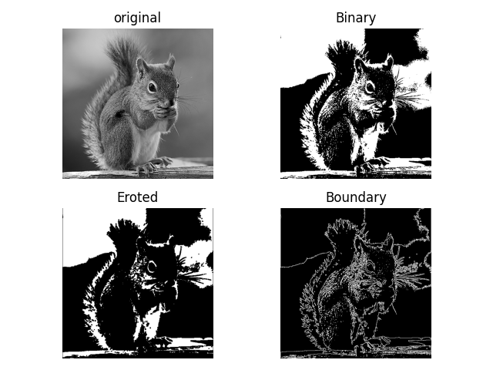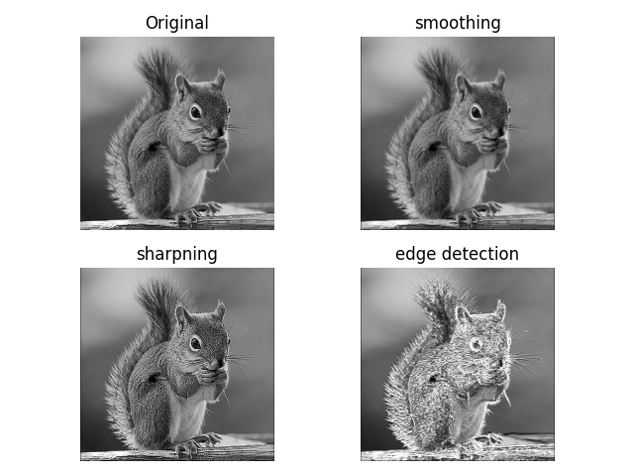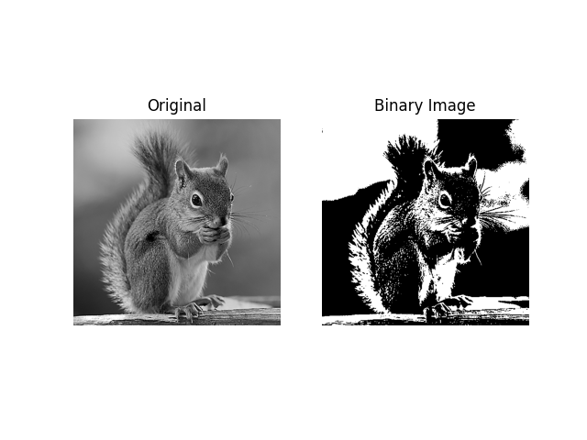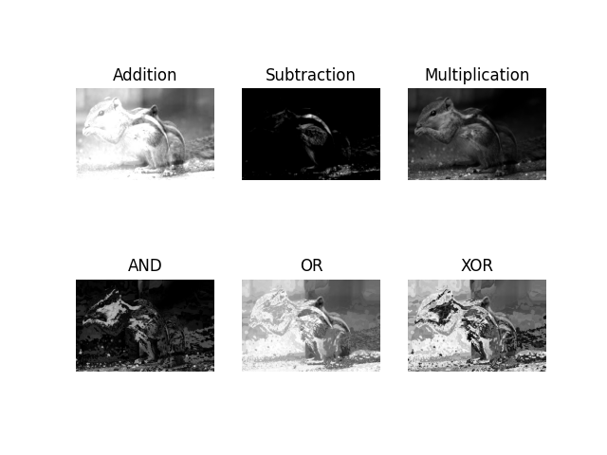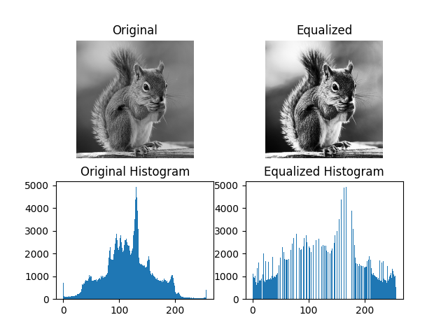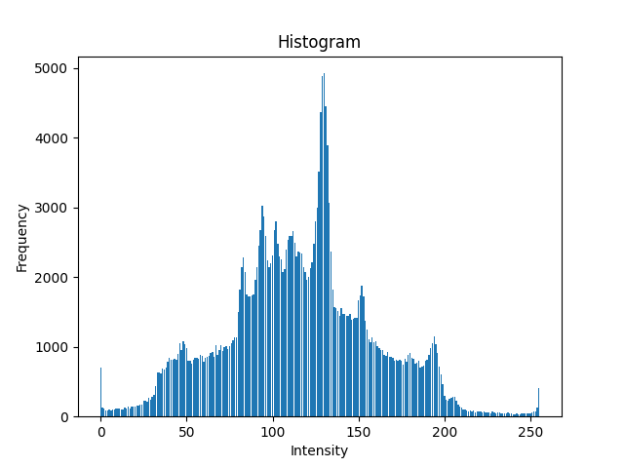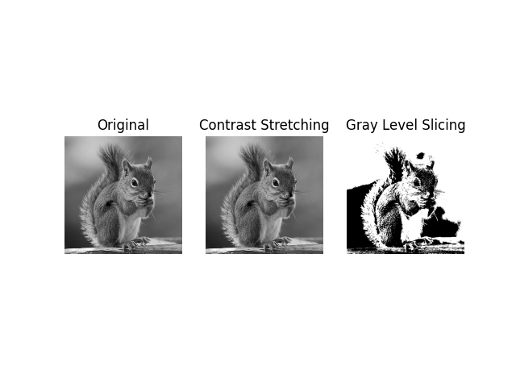



Lab Report
Course Code: CSE 4106
Course Name: Digital Image Processing Sessional

Submitted by
Name: Md. Rakibul Islam Rakib
Student Id: 220134
Department of Computer Science and Engineering
Pabna University of Science and technology

Submitted to
Md. Shafiul Azam
Associate Professor
Department of Computer Science and Engineering,
Pabna University of Science and Technology

Digital Image Processing Sessional
Lab Problem List

Problem  No. | Title | Page
01 | Implementation of Some Basic Gray Level/Intensity Transformations  a) Negative Image  b) Log Transformations  c) Power-Law (Gamma) Transformations | 1-8
02 | Implementation of Contrast Stretching and Gray Level Slicing | 9-11
03 | Draw a histogram of an image without using library function | 12
04 | Implement histogram equalization and plot the original and equalized histogram for visualization | 13-15
05 | Implementation of some Arithmetic and Logical Operations on Images | 16-19
06 | Implementation binary representation of an image | 20-21
07 | Implementation of Spatial Filtering for Image Smoothing, Sharpening, and Edge Detection | 22-25
08 | Implement Morphological Boundary Extraction Using Erosion | 26-28
09 | Implementation of Image Compression Using Huffman | 29-31
10 | Implementation of Basic Morphological Operations: Dilation and Erosion | 32-34

