**CHAPTER-3 SCREENSHOTS**

GUI – Main display window with name of restaurant name current time and date with calculator

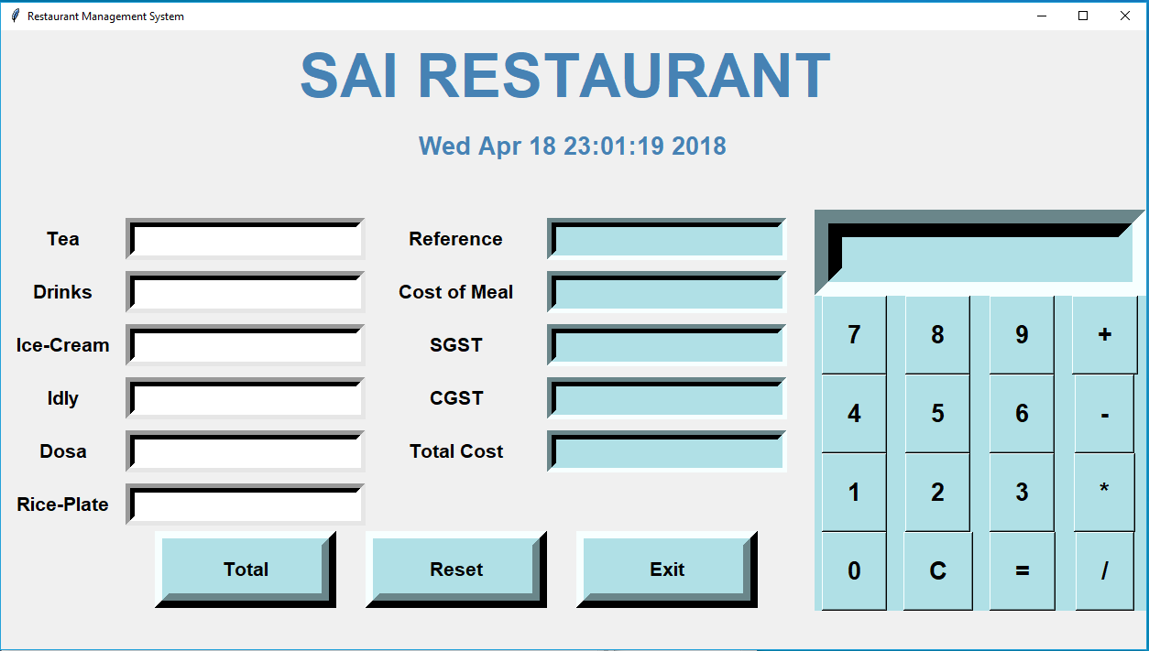

We have added a calculator for instant calculation –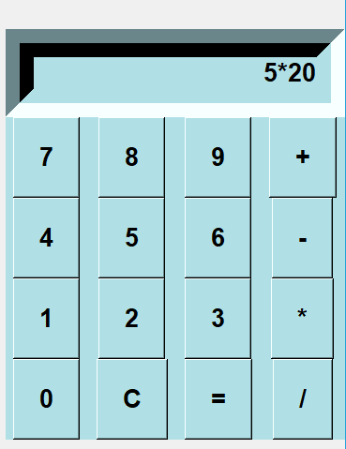 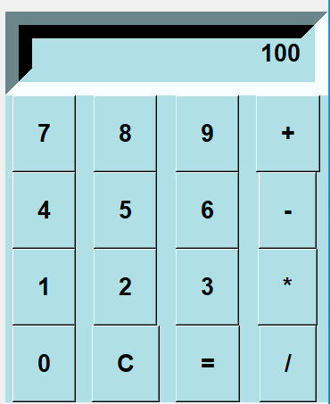Buttons –

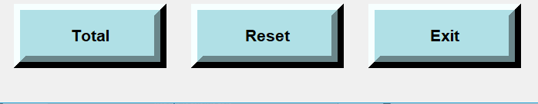

Exit button closes the window

Reset button resets all the values

Total button gives the calculation of Bill

We need to insert number of menu items taken by customer ,after inserting no. of items

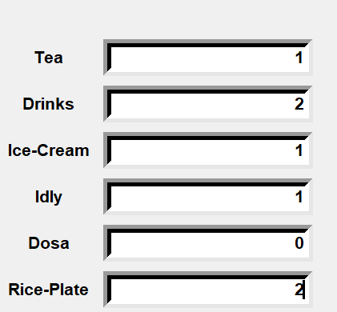

Generated Bill

**/===== BILL NO**

**/===== TOTAL COST OF MEAL**

**/===== TOTAL SGST**

**/===== TOTAL CGST**

**/===== TOTAL COST INCLUDING GST**

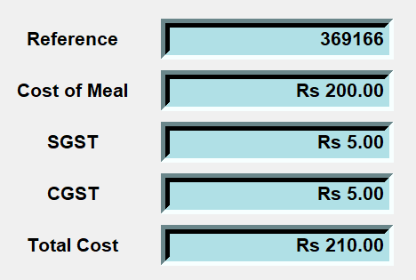

After clicking TOTAL button it will automatically generate the bill

