**Job Selection DSS**

Here, we have developed a system which will helps us to take decision. There are some jobs which are; JOB1, JOB2, JOB3 and JOB 4. The system will help us to take decision which job will be most preferable for us based on priority and job-related data. At first, users need to select priority (High = 3, Medium = 2, Low =1) for each criteria and input data within a range for each job. Here, the range is 1-10. Now we’re going to show out all of them with screenshots.

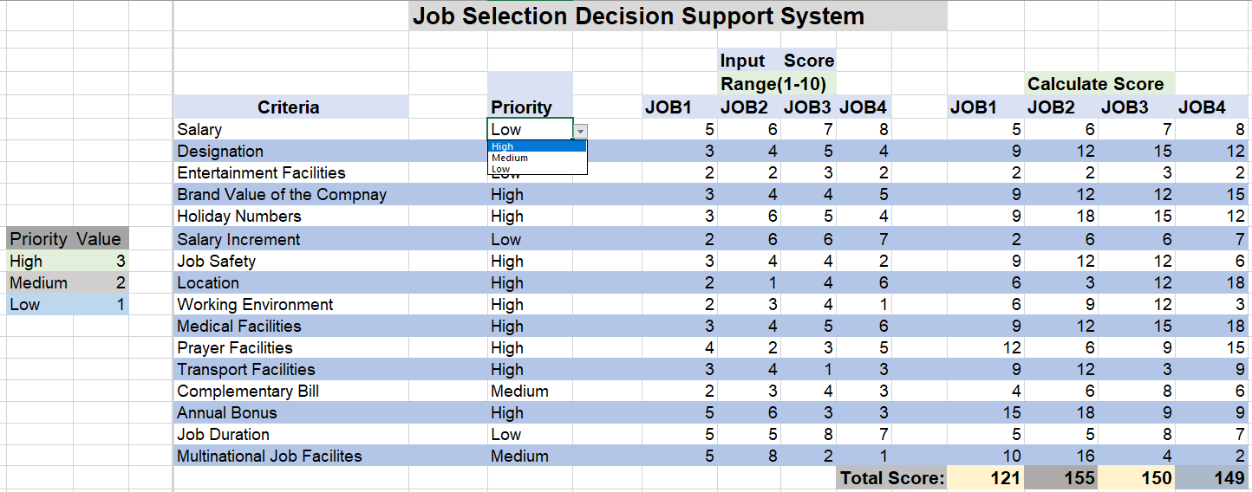

**Figure 1: We can choose the priority as per our choice.**

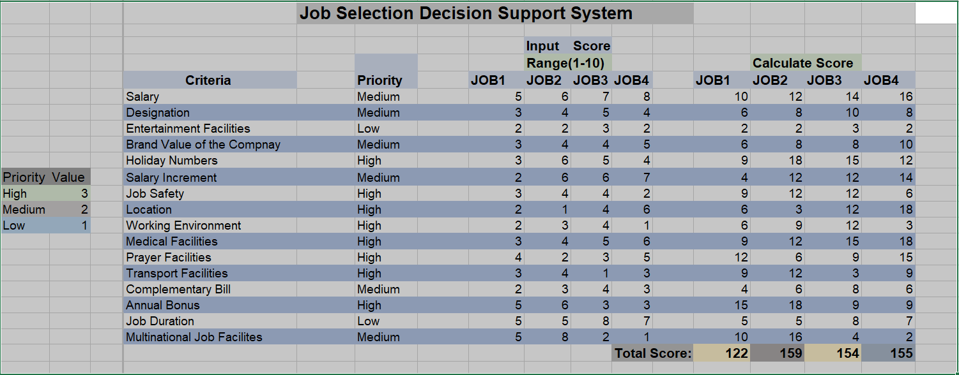

**Figure 2: The calculated score according to inputted score.**

Here, JOB2 total score is most. So, the system suggests us to select JOB2.

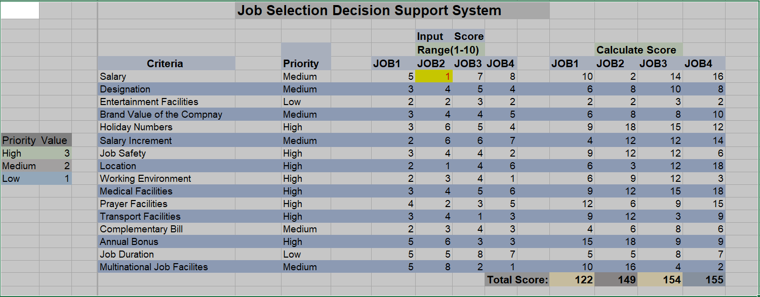

**Figure 3: After changing the Input Score in JOB2**

After changing score for criteria “Salary” in JOB2 (Input score) then its effect on JOB2 calculate Score for salary criteria and also change the total score for JOB2. Now, the system suggests us to select JOB4. So, input score for each Criteria has great impact for selecting the best job.

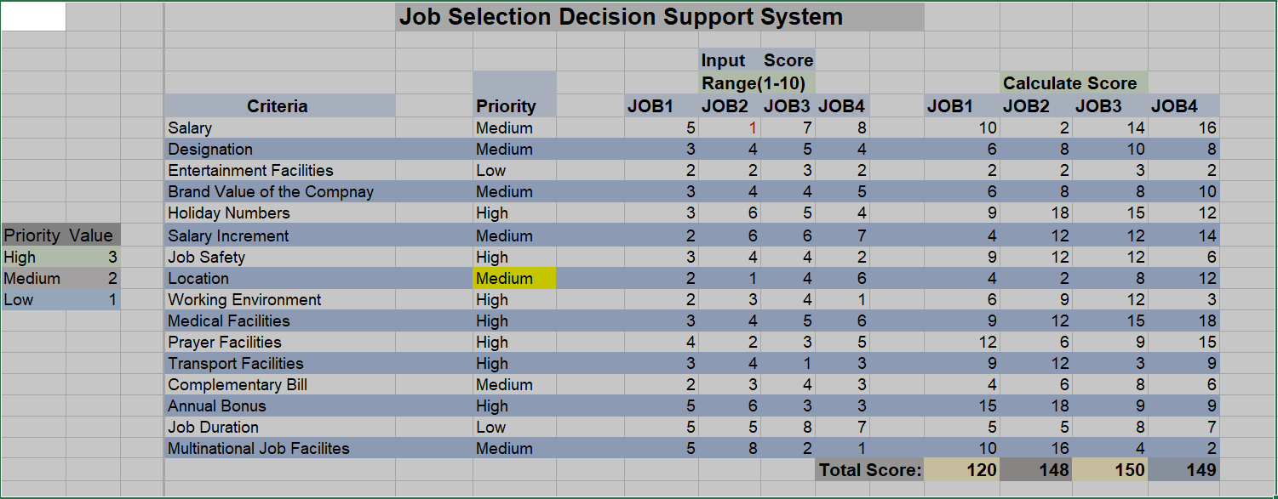

**Figure 4: After changing Priority for the location Criteria**

After changing Priority for criteria “Location” from High to Medium, the Total Score for the all jobs are changed. Now, the best score is for JOB3. So, the system suggests us to choose JOB3. So, changing priority has impact on changing score and for selecting job.

Here, we can see that after inputting data if we change the priority the calculated value is changed. By this way this system can provide result according to input data. And finally, the system is providing us a certain decision that which job we should choose.