

Course Title: Software Engineering

Assignment Title: Megha Enterprise

Spring 2018

Submitted by

Name: Rakibul Alam

Roll: 181-16-285

Submitted to

Nazrana Haque

Lecturer, DIU

Table of Contents

**1** **Introduction:** 4

**1.1** **Purpose** 4

**1.2** **Scope** 4

**1.3 References** 4

**2 Overall descriptions** 5

**2.1 System Architecture** 5

**2.2 User Characteristics** 6

**2.2.1 Customer** 6

**2.2.2 Staff** 6

**2.2.3 Administrator** 6

**2.3 Functional Requirements** 7

**2.4 General Constraints** 8

**2.4.1 Technology Constraints** 8

**2.4.2 Interface Constraints** 9

**2.4.3 Safety and Security Constraints** 9

**2** **Descriptions - System Features** 10

**1.1.1** **Log in and Register procedure** 10

**1.1.2** **Provide comprehensive transport details.** 10

**1.1.3** **Detailed transport Categorizations** 10

**1.1.4** **Provide Search facility.** 10

**1.1.5** **Maintain customer profile.** 11

**1.1.6** **Maintain Booking/rental information.** 11

**1.1.7** **Provide Customer Support.** 11

**1.1.8** **Email confirmation.** 11

**1.1.9** **Detailed invoice for customer.** 12

**1.1.10** **Online tracking of booking/rent** 12

**1.1.11** **Allow multiple payment methods.** 12

**1.1.12** **Allow online change or cancellation of the Booking.** 12

**1.1.13** **Allow Online feedback about staff and transportation service** 12

**1.1.14** **Special offer options.** 12

**1.1.15** **Company promotions and rewards.** 13

**1.1.16** **Maintain staff profile:** 13

**1.1.17** **Maintain customer feedback and reviews:** 13

**1.1.18** **Generating report:** 13

**1.1.19** **Backup of data:** 13

**4 External Interface Requirements** 14

**4.1 User Interface** 14

**4.2** **Software Interface** 20

**4.3 Hardware Interface** 21

**5 Other Nonfunctional requirements** 21

**5.1 Usability** 21

**5.2 Performance** 21

**5.3 Security** 21

**5.4** **Availability and Capacity:** 21

# **Introduction:**

## **Purpose**

This project focuses on developing a transportation website which provides facility to customer rent transports online, know company transport details and other information from remote not going their business center physically. Mega Enterprise (ME) maintains their working manually, which is totally paper based. So, it is time consuming and obstacle to increase market share. That’s why launching a website application, customers can be able to book vehicles from ME transport easily via internet and several booking processes can be maintained at the same time. It will be easy for ME staff to track booking information as system done it automatically. Efficient and effective booking produce and make the transportation process easier should be the main purpose of Megha Enterprise (ME).

## **Scope**

As the new system is computerized and online based, customer shall be able to book from anywhere via internet. The facilities will attract more customers which will enhance company market share in future. Customer information and payment status for the specific customer shall be easily handled with the system. The web system will provide features like, show vehicle details, user profiles for users and customer feedback, staff information for admin and booking process, transportation system handling for staff mainly. Enquiries will do by users easily using the system. Administrator shall be able to track booking, staff and customer, customer feedback information and generate daily, weekly and monthly reports using the system. The GPS system shall not be included in the system for tracking transport location. But the website designed in a way that any new feature easily can be extended and existing features easily can be customized as users needed.

## **1.3 References**

IEEE Software Engineering Standards Committee, “IEEE Std 830-1998, IEEE Recommended Practice for Software Requirements Specifications”, October 20, 1998.

# **2 Overall descriptions**

## **2.1 System Architecture**

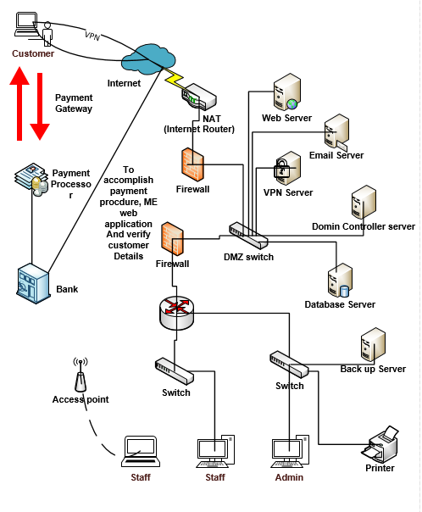

**Figure 1: System Architecture for Megha Enterprise (ME)**

## **2.2 User Characteristics**

There are 3 types of users that will interact with the system: Customer, Staff and Administrator. Each type of user has a different role of using of the system basis on their own requirements. So, access permission will be set associate with each role.

### **2.2.1 Customer**

Customer can view available transports for specific date and time slots and also can able to use online booking system for the available transports. Customers can able to view rent rate and special discount of every transport for a specific period.

### **2.2.2 Staff**

Staff can manage vehicle and booking information and rent rate for transports.

### **2.2.3 Administrator**

Administrator can enable to manage staff (create, update and delete) as well as performing other administrative tasks like the monitoring system operation, editing system configuration.

## **2.3 Functional Requirements**

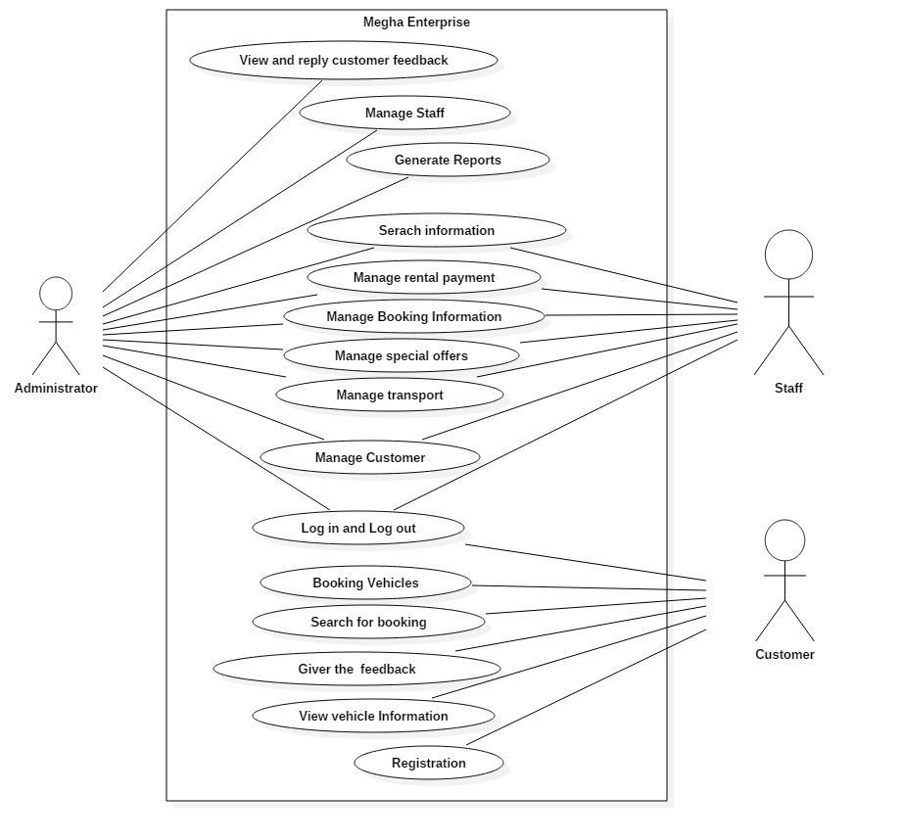

**Figure 2: Use case diagram for Megha Enterprise**

The functional features of the Megha Enterprise site will be:

* It will store all data in a single and centralized database. The database will contain the following information:

1. Customer details
2. Staff details
3. Customer feedback
4. Vehicle Information
5. Booking Information

* The website will provide various offer information to customers.
* All the information including transport details, transportation price and booking date and time also be displayed on the web-application.
* The site will be used by three different types of users: Staff, Customers, and the administrators having different interfaces for each type of user.
* Each user will be provided with a username and password to access his/her account on the site.
* Staff/Admin can add and edit transportation price and transport details.
* Only Admin can generate reports, add/edit staff, view and replay customer feedback.

## **2.4 General Constraints**

### **2.4.1 Technology Constraints**

All customers will not rent vehicles on online that’s why all customer booking information will not available on the system in real time. If one customer booking manually and at the real time, another customer booking the same vehicle at same date using online, that’s an obstacle for the staff to manage the booking information properly using the system. Secure payment handling is also another barrier for staff because they all are not experienced and well-trained up in using technology.

The application will be used HTML, CSS for design purpose and for development purpose, development team can opt for Java technology/PHP/ ASP.NET.

### **2.4.2 Interface Constraints**

Users will browse the web-application from different resolution screen and they may confused when the web pages display differently for various screen sizes. Different web-browsers (chrome, Mozilla, IE) may be the website displayed differently and the colors are almost impossible to match perfectly across all computers and monitors is also an obstacle for users.

Staff are not well-trained and educated, that’s why English language is constraints for them to serve the customer. So, Language selection option should be favorable for them. Select from drop down list will be less error-prone for the users.

### **2.4.3 Safety and Security Constraints**

The application should be emphasized on authentication process so that authorized people can’t access and operate using user data.

Internal threats like employee theft, hardware failure and external threats like phishing attack, malware attack can be happened due to the insecure storage system. Passwords may be hacked if passwords are very easy (4/5 digits or only letters). These are security constraints of data. So, secured data storage system to overcome these constraints.

# **Descriptions - System Features**

Functional features:

How the system should react to particular inputs and how the system should behave in particular situations those services which users get from system is called functional features. It specifies the application functionality that the developers must build into the product to enable users to accomplish their tasks.

### **Log in and Register procedure**

* The system shall allow customers to input his details with email, username and password for registration process.
* The system shall allow user to access to the system as his role. (admin, staff or customer)
* The system shall allow user to update/change his password.
* The system shall allow user to log out from the system whenever users will want.

### **Provide comprehensive transport details.**

* The system shall display detailed information of the selected transport.
* The system shall provide browsing options to see transport details.
* The system shall allow staff and admin to add/delete/change transport information.
* The system shall display the insurance of the selected vehicle.

### **Detailed transport Categorizations**

* The system shall display detailed transport categorization to the user.
* The system shall allow staff and admin to add/delete/change transport category.

### **Provide Search facility.**

* The system shall enable users to enter the search text on the screen.
* The system shall enable users to select multiple options on the screen to search.
* The system shall display all the matching vehicles based on the search
* The system shall enable users to navigate between the search results.
* The system shall notify the users when no matching product is found on the search.
* The system shall display all the matching customers based on the search single transport and date.

### **Maintain customer profile.**

* + The system shall allow users to create profile and set his details.
  + The system shall allow users to update the profile information.
  + The system shall display both the active and previous customer profile.

### **Maintain Booking/rental information.**

* The system shall allow users to select the vehicle from the vehicle list for booking.
* The system shall display the detailed information about the selected booking transport.

### **Provide Customer Support.**

* The system shall provide online help, FAQ’s for customer support.
* The system shall allow user to select the support type he wants.
* The system shall allow user to enter the customer and transport information for the support.
* The system shall display the customer support contact numbers on the screen.
* The system shall display the online help upon request.
* The system shall display the FAQ’s upon request.

### **Email confirmation.**

* The system shall maintain customer email information as a required part of customer profile.
* The system shall send booking and rental confirmation to the user through email.

### **Detailed invoice for customer.**

* The system shall display detailed invoice for current booking once it is confirmed.
* The system shall optionally allow user to print the invoice.

### **Online tracking of booking/rent**

* The system shall allow user to enter the booking information for tracking.
* The system shall display the current tracking information about the Booking.

### **Allow multiple payment methods.**

* The system shall enable users to enter the payment information.
* The system shall display available payment methods for payment.
* The system shall allow user to select the payment method for booking.

### **Allow online change or cancellation of the Booking.**

* The system shall display the booking that is eligible to change.
* The system shall allow user to select the booking to be changed.
* The system shall allow user to cancel the booking
* The system shall allow user to change transportation places, payment method.
* The system shall notify the user about any changes made to the booking.

### **Allow Online feedback about staff and transportation service**

* The system shall display a message option for customer feedback.
* The system shall enable the admin to check and replay customer feedback.

### **Special offer options.**

* The system shall display all the available special offer for customer.
* The system shall allow user to select the special offer option.
* The system shall notify the customer special offer.

### **Company promotions and rewards.**

* The system shall display all the available promotions to the user.

### **Maintain staff profile:**

* The system shall allow admin to update/delete/add staff information.
* The system shall display admin previous and present staff information.

### **Maintain customer feedback and reviews:**

* The system shall allow admin to view/replay customer feedback about staff and transportation process.

### **Generating report:**

* The system shall allow admin to generate report daily, weekly and monthly.
* The system shall allow admin to print report.

### **Backup of data:**

* The system shall backup of all data weekly to prevent data loss.

# **4 External Interface Requirements**

## **4.1 User Interface**

**Figure 3: Home page of Megha Enterprise**

From Figure 3, when user click log in option, then log in page will be displayed.

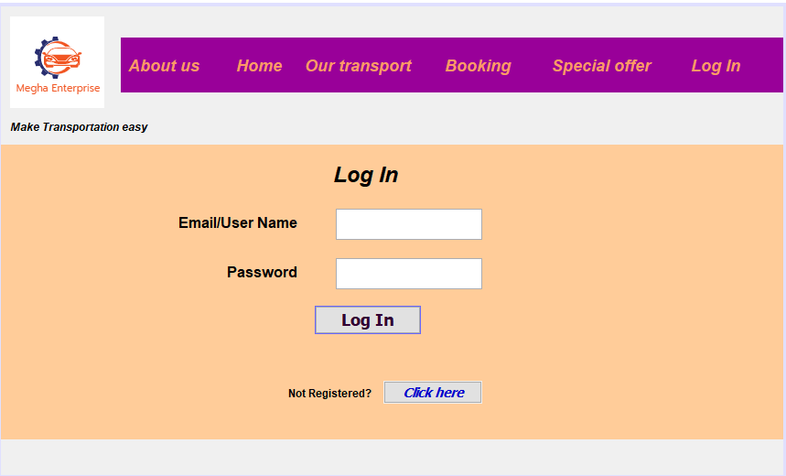

**Figure 4: Log in Page**

In Figure 4, using long page user should be able to view his/her profile and booking information and staff/admin can access using the same log in page as user role. If any customer doesn’t register, he/she should access the registration page from here and then, he/she should be able to log in.

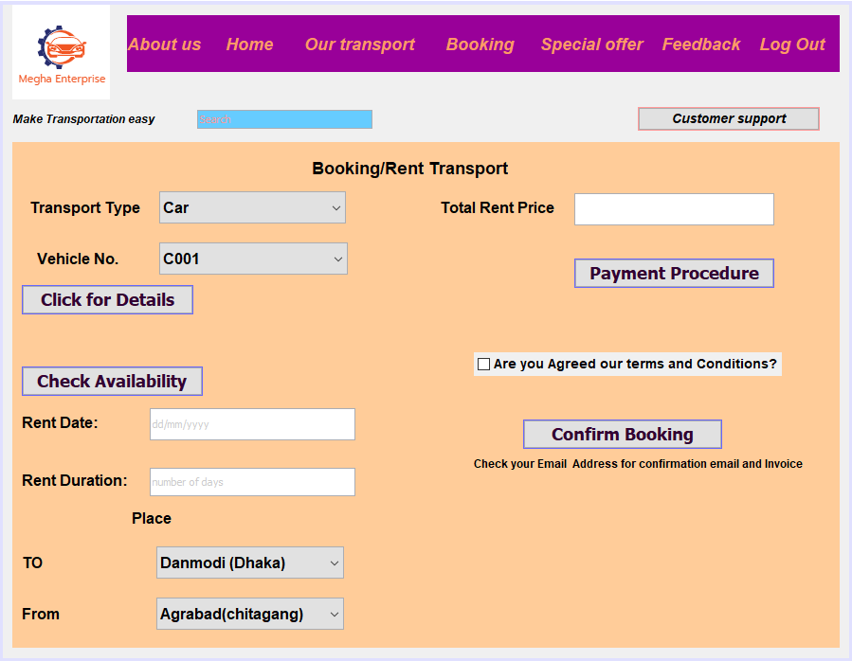**Figure 5: Vehicle booking Page**

In Figure 5, users should be able to select transport type, vehicle no, click to know vehicle details and check availability. Customers should be able to enter start rent and how many days he/she want to rent the vehicle and then selecting from places of the transportation. Finally, total price should be shown on the booking page, users should have option to different payment procedure which should be displayed for user after clicking the payment procedure button and customers must need to check the terms and conditions checkbox and at least, he/she should be click confirm booking button for booking and at the real time a confirmation email and invoice should be sent in user email.

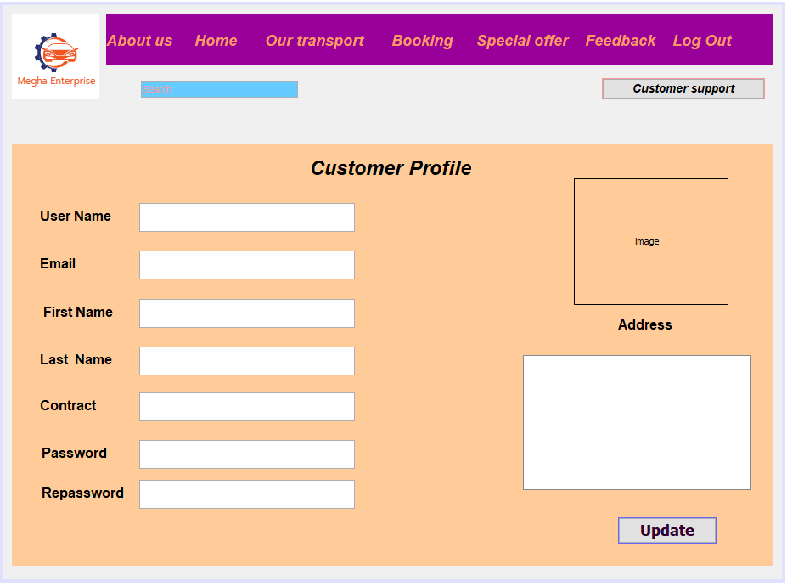

**Figure 6: Customer Profile Page**

In figure 6, users should be able to update his/her information and change his/ her password via clicking update button.

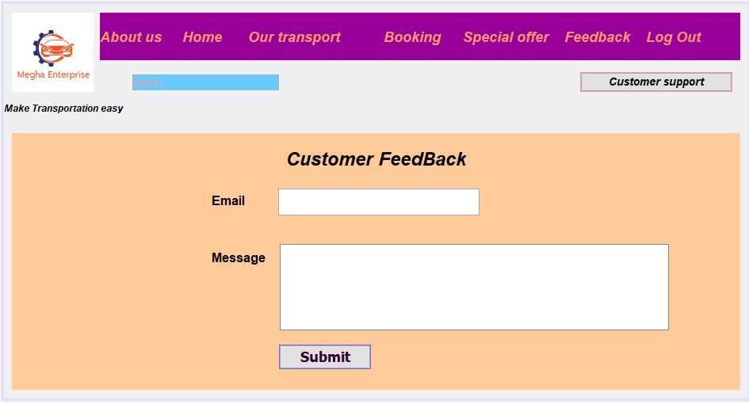

**Figure 7: Customer Feedback Page**

In figure 7, Customer should able to give feedback in the message option about his/her service gets from staff and transportation process his/her reaction and click submit feedback message will be sent.

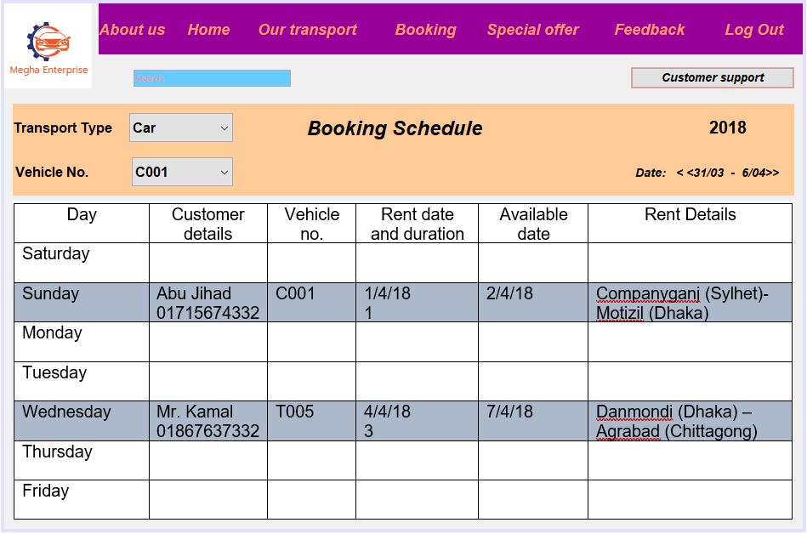

**Figure 8: Booking Schedule Page (Staff and Admin view)**

In figure 7, staff and admin should be able to easily track booking information and schedule and search by specific transport via selecting option car type and vehicle no and they also should be able to search manually via written search box. Various date booking information should be seen via weekly clicking navigation sign.

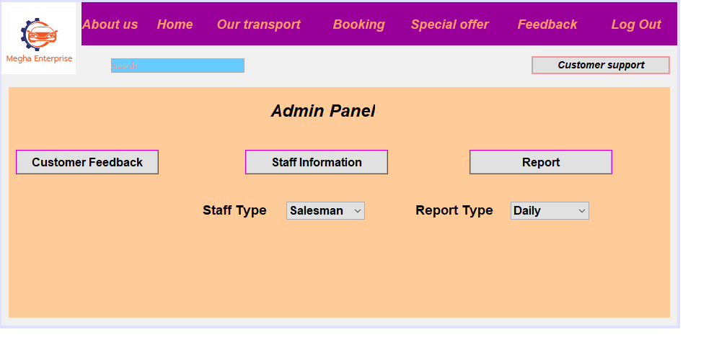

**Figure 9: Admin Panel page**

In figure 9, only administrators should be able to use admin panel and view and replay customer feedback via clicking customer feedback button and selecting staff type admin should able to know a group of staff information at a time and also should able to generate daily, weekly and monthly report as required.

## **Software Interface**

1. The Megha Enterprise application shall communicate to credit management system for handling payment functions.
2. The system shall use third party software like verisign, which will allow user to complete secure transaction over the internet.
3. The The Megha Enterprise system shall communicate with CRM system to provide support.
4. The system shall able to support browsers like Internet Explorer, Mozilla, Google Chrome or Netscape Navigator to interact with clients via different social media (for example: Facebook, Twitter) and other communication sites.
5. The system shall use HTTP protocol for communication and FTP protocol for file transfer over the internet.

## **4.3 Hardware Interface**

As the system is web application that’s why it must run over the internet and all the hardware shall require to connect internet. Router, Modem, WAN, LAN, Ethernet Cables are required for this. PCs, Servers, Printer and scanner shall be required.

# **5 Other Nonfunctional requirements**

## **5.1 Usability**

The website will need to be user-friendly for customer and other users to operate. UI (User Interface) should be easy for the users to operate which will increase the website effectiveness.

## **5.2 Performance**

The web application should able to support all major web-browsers with its all fundamental functions. Several online bookings should be made without downgrading performance which will increase the website efficiency.

## **5.3 Security**

* Server of the Megha Enterprise should have a strong security system to prevent unauthorized users to access.
* The user login system should be implemented using advanced login algorithm which will ensure only authorized user can access the system.
* Password should be hidden using hash algorithm so that staff cannot be able to access customer account and user ID and password should not be shared with other customers.
* Need to use security mechanisms to protect data and encryption methods during transmission of data over the internet.

## **Availability and Capacity:**

The system should have available for access to its user 24 ours in 7 days and initially, it should have a capacity of serving more than a thousand clients at a time.