

*ASSIGNMENT ON*

**Course name: Statistics**

***Submitted To:***

**Md. Ali Imran**

**Lecturer, DIU**

**Submitted By:**

**Team Name: Effect of Smartphone Use in Child Age (ESUCA)**

**Name: Rakibul Alam**

**ID: 181-16-285**

Dept. of CIS

Daffodil International University

Date of Submission: 01/08/2018

Table of Contents

Acknowledgement: 3

Introduction: 4

Survey Methodology: 4

About the Survey: 4

Result and Analysis: 5

Limitation: 12

Recommendation: 12

Conclusion: 13

References: 14

# Acknowledgement:

In performing our assignment, we had to take the help and guideline of some respected persons, who deserve our greatest gratitude. The completion of this assignment gives us much Pleasure. We would like to show our gratitude to our course instructor Mr Ali Imran (CIS department of Daffodil International University) for giving us a good guideline for assignment throughout numerous consultations. We would also like to expand our deepest gratitude to all those who have directly and indirectly guided us in writing this assignment.

# Introduction:

In Bangladesh, smartphone using rate has been increasing remarkably. Most of the middle and upper-class family’s children, here spend their huge amount of times with smartphone for fun or mental refreshment. Normally, parent or siblings are introduced them to smart phone. The purpose of the survey to determine the effect of the usage of smart phone in the child age.

# Survey Methodology:

It is an online based survey. In the survey, we have used a set of closed questions to know people opinions about the survey subject. Google form has been used for the survey to collect data and analysis the data. The methodology gives us opportunity to collect data not only from different places in the Bangladesh but also from Bangladeshis whose are living abroad without face to face meeting with those persons. By collecting email address, it also reduces duplicate entries for the survey.

# About the Survey:

This is the era of the technology. As a developing country, at present, people of Bangladesh, are mostly being depended on technology to accomplish for their daily tasks. For social networking or entertainment or playing game facilities encourages people more use to smart phone. Because it is more portable, cheap and easily accessible than other technological devices like PC, Laptops. But children and school going students are now being addicted using smartphone. The uses of smart phone sometimes may help their education and learning new things. But It has a great impact in their psychological, health, and cultural issue. (Barton, 2017)

So, the purpose of the survey is to know the people opinion and their reaction about the usage of smart phone for their children.

# Result and Analysis:

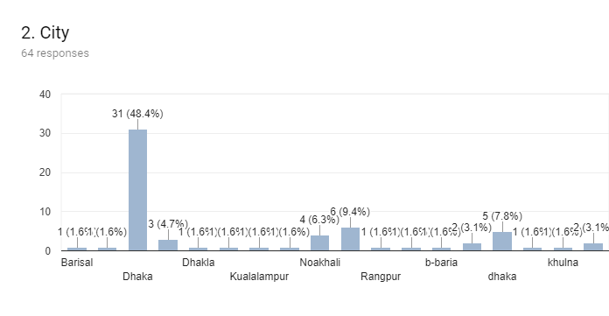

From the above bar chart, it’s clarify that most respondent in the survey from Dhaka. Others are different places from Bangladesh and some respondent from the abroad.

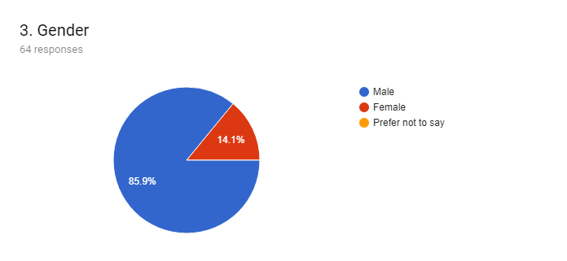

From the pic chart, we mention that only one female respondent among seven in the survey. So, most of the male people have attended in the survey.

**Respondents mean age in the survey:**

Total 64 people are attended in the survey. Which age ranges are given below in the table and has found out the mean of the attended people ages.

|  |  |  |  |
| --- | --- | --- | --- |
| Age Range | Midpoint (x) | Frequency (f) | fx |
| 10 < 20 | 15 | 4 | 60 |
| 20 < 30 | 25 | 50 | 1250 |
| 30<40 | 35 | 8 | 280 |
| 40<50 | 45 | 1 | 45 |
| 50<60 | 55 | 1 | 55 |
|  |  | $$\sum{f=64}$$ | $$\sum{fx=1690}$$ |

**Mean (**x̅) = $\frac{\sum{fx}}{\sum{f}}$ = $\frac{1690}{64}$ = 26.41 = 26 age

So, People whose responded in the survey, their average ages are 26. The following pie chart shows people age groups whose responded in the survey.

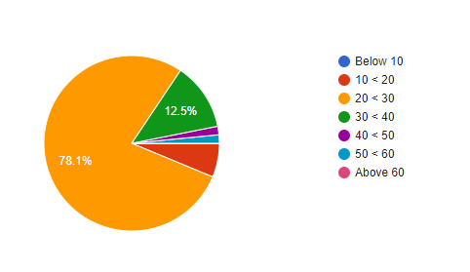

From above pie chart, we conclude that most people whose responded in the survey their age group is 20 to 30.

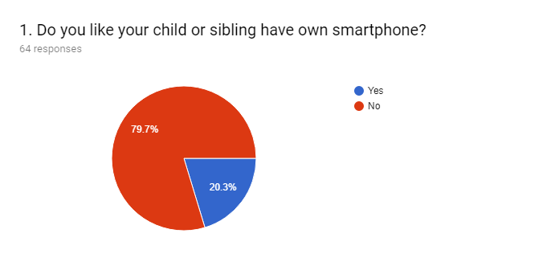

From the above pie chart, we mention that most people don’t like their children have own smartphone.

**Children average time spent on smart phone daily:**

Respondents response how many hours, they allow for their child to spend on smart phone in a day. Most people don’t like to see their children has involved with smartphone most of the time in a day. Here, 64 people responses.

|  |  |  |  |
| --- | --- | --- | --- |
| Time (Hours) | Midpoint (x) | Frequency (f) | fx |
| 0<1 | .5 | 33 | 16.5 |
| 1<2 | 1.5 | 17 | 25.5 |
| 2<3 | 2.5 | 6 | 15 |
| 3<4 | 3.5 | 5 | 17.5 |
| 4<5 | 4.5 | 3 | 13.5 |
|  |  | $$\sum{f=64}$$ | $$\sum{fx=88}$$ |

**Mean (**x̅) = $\frac{\sum{fx}}{\sum{f}}$ = $\frac{88}{64}$ = 1.38 (2dp)

From the above calculation, it clarifies that people want their children to use smartphone at average 1.38 hours in a day. The following pie chart shows people reaction about their children smart phone daily using time.

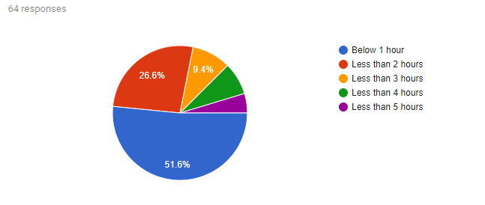

From above pie chart, we conclude that most people like their children spend time on smart phone below one hour.

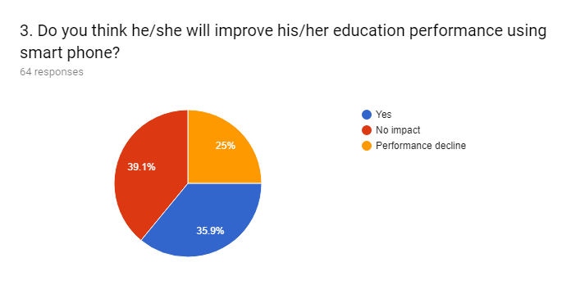

From above graph, we mention that most people think using smart phone does not impact their children education and a good number of people think, it will improve their educational performance. Least number of people think, using smart phone will decline their educational performance.

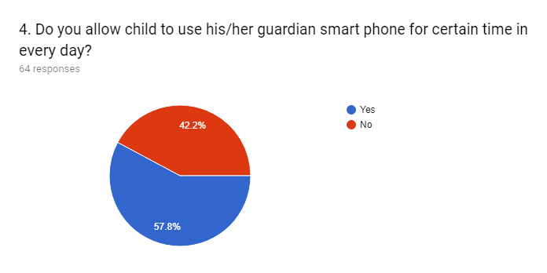

From the above Pie chart, we conclude that most people allow their child using smart phone but also a good number people don’t allow.

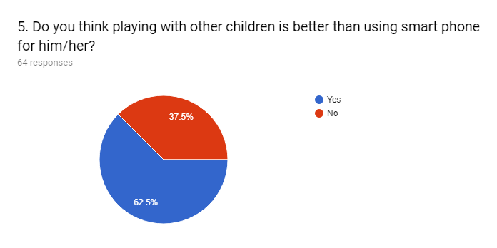

From the above graph, we mention that most people think playing with other children is better for their child than using smart phone.

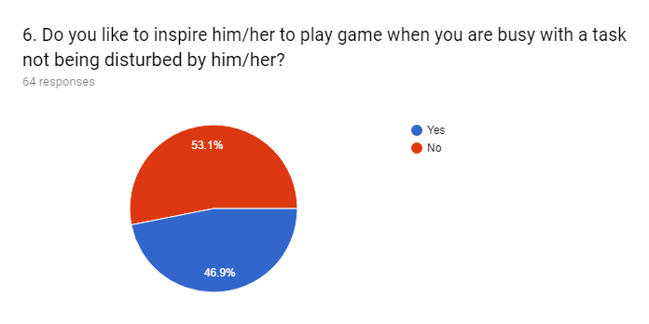

From the above Pic Chart, we conclude that most people don’t like to inspire their child to play game in smart phone even children disturbed their tasks.

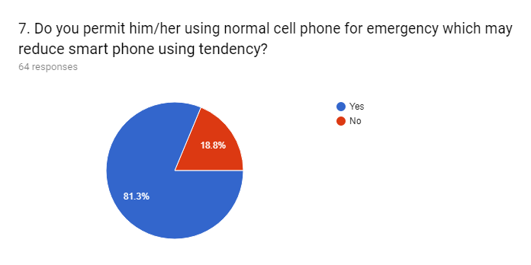

From the above Pic Chart, we can take decision that most people think that using normal cell phone can reduce smart phone using tendency for their children.

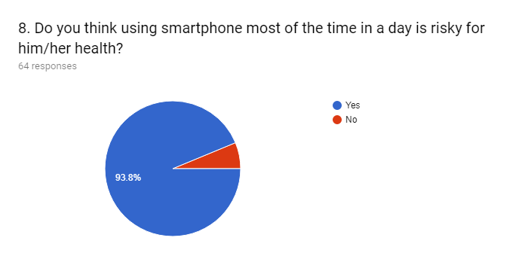

From the above graph, we mention that more than 9 persons among 10, think using smart phone most time in harmful for children health.

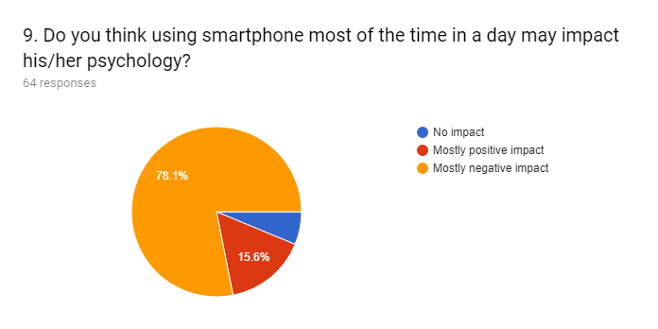

From the above Pie Chart, we conclude that using smartphone most of the times can affect badly in children psychology. Only a few thinks, it has positive impact.

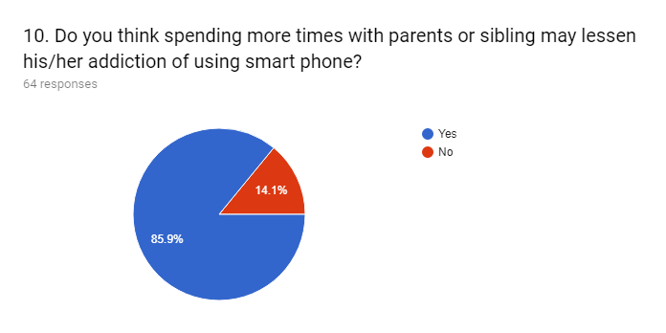

From the above Pie chart, we can take decision that if parents and siblings passing more time with their children can lessen children addiction on smart phone.

# Limitation:

* Only a few numbers of people have responded in the survey.
* Only a few numbers of female are attend in the survey.
* Many people have faced difficulties to fill up google form as it is online survey such as they don’t have internet connection.

# Recommendation:

From the survey, we recommend that smartphone may be beneficial for children of their education and self-improvement. But according to the most people, they need to use it limited time less than one hour in a day. So, parents need to be careful about their children smartphone usage because spending large amount of time on smartphone impact negatively children health, education and psychology.

# Conclusion:

The survey was very interesting for us and it is very effective to us for learning how to use google form to make survey. During the assignment, we learn how to analyze statistical data from various type of graph like bar char, pie chart. The topic of the survey is very concerning issue at present scenario of our country. So, we hope that the outcome of the survey will be beneficial for the people.

# References:

Barton, H. (2017) *6 Negative Effects of Smartphones and Mobile Devices on Children*, 20 September , [Online], Available: <http://activehealthykids.ca/2013ReportCard/en> [29 July 2018].