Student ID: 240338
Name: Shakila Jahan

Project Plan: Retail Website Development for Snow Clothes & Gear
Executive Summary
This report details the comprehensive project plan for the development of a winter-themed retail website for Snow Clothes & Gear. The project involves designing and deploying a responsive, desktop- and mobile-friendly e-commerce platform. It must meet a fixed budget of $5000 and tight deadlines, with a prototype required by mid-April 2025 for marketing and a full launch scheduled for 1 June 2025. The report includes a stakeholder analysis, scope statement, detailed Work Breakdown Structure (WBS), resource and schedule planning, Gantt chart, budgeting, risk and quality management, and a communication plan. A hybrid project management approach using PMBOK®, PRINCE2®, and Agile (Scrum) principles is applied to ensure the project is controlled, flexible, and delivered on time.

1. Introduction
This report outlines the project plan for developing a winter-themed retail website. The goal is to create an e-commerce platform named Snow Clothes & Gear. The project includes website design and deployment. It must be responsive, working on both desktop and mobile devices.
The project has a budget of $5000. There are also strict deadlines. A prototype is needed by mid-April 2025 for the marketing team. The full website launch is set for 1 June 2025. The report details several key areas. These include stakeholder analysis, project scope, and a Work Breakdown Structure (WBS). It also covers resource and schedule planning. A Gantt chart will be used. Budgeting, risk management, and quality management are included. Finally, a communication plan is outlined.
To manage this project, a hybrid approach will be used. This combines elements from PMBOK®, PRINCE2®, and Agile (Scrum). This approach aims to provide both control and flexibility. The hybrid approach helps ensure the project is delivered on time and within budget. This comprehensive plan aims to guide the development process. It will help the team create a successful online retail presence for Snow Clothes & Gear, meeting all requirements and deadlines.

2. Methodology
2.1 PMBOK® Principles
The PMBOK® (7th Edition) framework offers adaptable performance domains rather than rigid processes. Key principles applied here include:
- Stakeholder Engagement: Continuous interaction with stakeholders (marketing departments, investors, customers, developers) to align project goals with their expectations, ensuring the final product meets their needs and is well received. This involves regular communication, feedback sessions, and collaborative decision-making.
- Team: Importance of leadership, coordination, and role clarity within the project team leads to efficient collaboration, clear accountability, and optimal performance. The project manager will foster a supportive environment, facilitate communication, and ensure each team member's skills are utilized effectively.
- Cost, Schedule & Risk Domains: Vital due to the tight budget of $5000 and the strict deadlines (mid-April 2025 for prototype, 1 June 2025 for launch). These domains will be managed rigorously, with a focus on accurate estimation, proactive risk identification and mitigation, and adherence to the schedule to ensure timely and cost-effective delivery.
2.2 PRINCE2® Governance
The following PRINCE2 principles are applied:
- Manage by Exception: Ensures only critical issues or deviations from the project plan that exceed agreed tolerances are escalated to executive management. This principle streamlines decision-making, allowing the project team to handle routine matters while keeping executives informed of major concerns.
- Defined Roles: Clear state of authority and responsibilities for development, QA (Quality Assurance), and management. This establishes accountability, reduces confusion, and ensures that each phase of the project (design, build, test, release) is executed efficiently and effectively.
- Stage Control: Divides the project into distinct management stages: design, build, test, and release phases. This structured approach facilitates better planning, monitoring, and control, allowing the project manager to track progress, identify potential issues early on, and make necessary adjustments at each stage.
2.3 Agile (Scrum)
Agile supports:
- Incremental Delivery: Fast delivery of a working prototype and iterative enhancements to the website. This allows for early feedback from stakeholders, ensures the project remains aligned with their needs, and enables continuous improvement throughout the development process.
- Scrum Ceremonies: Implementation of daily stand-up meetings, sprint planning sessions, and sprint reviews. These ceremonies promote transparency, facilitate communication, and enable the team to track progress, address roadblocks, and adapt to changing requirements quickly.
- Backlog Refinement: Continuous alignment of project priorities with stakeholder needs and business value. This ensures that the development effort is focused on the most important features, maximizing the value delivered to Snow Clothes & Gear and their customers.
2.4 Hybrid Justification
The hybrid model allows for strong governance (via PRINCE2 and PMBOK) and development flexibility (via Agile). This combination ensures project quality, strict cost control, and adaptability across development sprints, enabling the project team to respond effectively to changes and deliver a high-quality e-commerce platform within the given constraints.
3. Stakeholder Identification and Influence
Stakeholder | Role in Project | Influence | Impact & Management Strategy
Director of Management | Authority over budget and final sign-offs | High | Conduct meetings and re-direct budget and goals
Marketing Lead | Receive prototype and building marketing plans | High | Weekly demos, early feature freeze
Front-end Developer | Design and develop front-end of the app (UI/UX) | Medium | Iterative reviews, design walkthroughs
Back-end Developer | Handles database, APIs, and integrations | Medium | Regular API integration and test cycles
QA/Test Specialist | Leads testing and quality control | Medium | Test planning, shared defect logs, update UAT oversight

4. Scope Statement
Project Title: Winter-Theme E-Commerce Website for Snow Clothes & Gear
Purpose:
To develop a responsive retail website that increases seasonal engagement and supports product sales, with $5000 budget and defined deadlines.
Objectives:
- Develop a Responsive E-commerce Platform: Design and deploy a website that functions seamlessly across both desktop and mobile devices, providing optimal user experience for all customers.
- Deliver a Functional Prototype: Create a working prototype of the website by mid-April 2025 to be used for marketing purposes and to gather early stakeholder feedback.
- Launch a Complete E-commerce Website: Fully develop and launch the e-commerce website by June 1, 2025, enabling Snow Clothes & Gear to sell their products online.
- Stay Within Budget: Complete the project within the allocated budget of $5000, ensuring cost-effectiveness and financial responsibility.
- Ensure High-Quality Delivery: Develop a high-quality website that meets the needs of Snow Clothes & Gear and their customers, adhering to quality standards throughout the development process.
Deliverables:
- Prototype (HTML/CSS/JS, mock data, sample mobile app).
- Production site with user auth, catalog, cart, and multiple payment system.
- Test/UAT report with <5 unresolved issues.
- Final closure report and deployment logs.
Acceptance Criteria:
- Acceptance of prototype from the marketing department.
- 3 seconds max load time of the UI.
- Budget variance under 5%.
Constraints:
- Fixed timeline and budget.
- Use of open-source technologies.
- Hosting is managed externally.
Assumptions:
- Marketing will provide content/assets by 1 March.
- Payment API is freely available.

5. Work Breakdown Structure
The full WBS is provided in Appendix A. It decomposes the project into six major phases:
- Initiation
- Planning
- Design (including prototype development)
- Development (front and back-end)
- Testing (including buffer/fix phase)
- Closure (deployment, launch, final reporting)
Each phase contains Level 2/3 subtasks, including:
- Task IDs
- Resource assignments
- Duration estimates
- Milestones

6. Resources, Schedule, and Budget
6.1 Resource Table
Role | Rate (AU$/day) | Days | Cost (AU$)
Project Manager | $500 | 2.0 | $1000
Front-end Developer | $400 | 3.0 | $1200
Back-end Developer | $400 | 2.0 | $800
QA/Test Specialist | $300 | 2.0 | $600
Total |  |  | $3,600
Combined Tasks |  |  | $1,400
Final Total |  |  | $5,000
Note: Marketing, Dev Team, and All are zero-cost roles.
6.2 Gantt Chart Summary
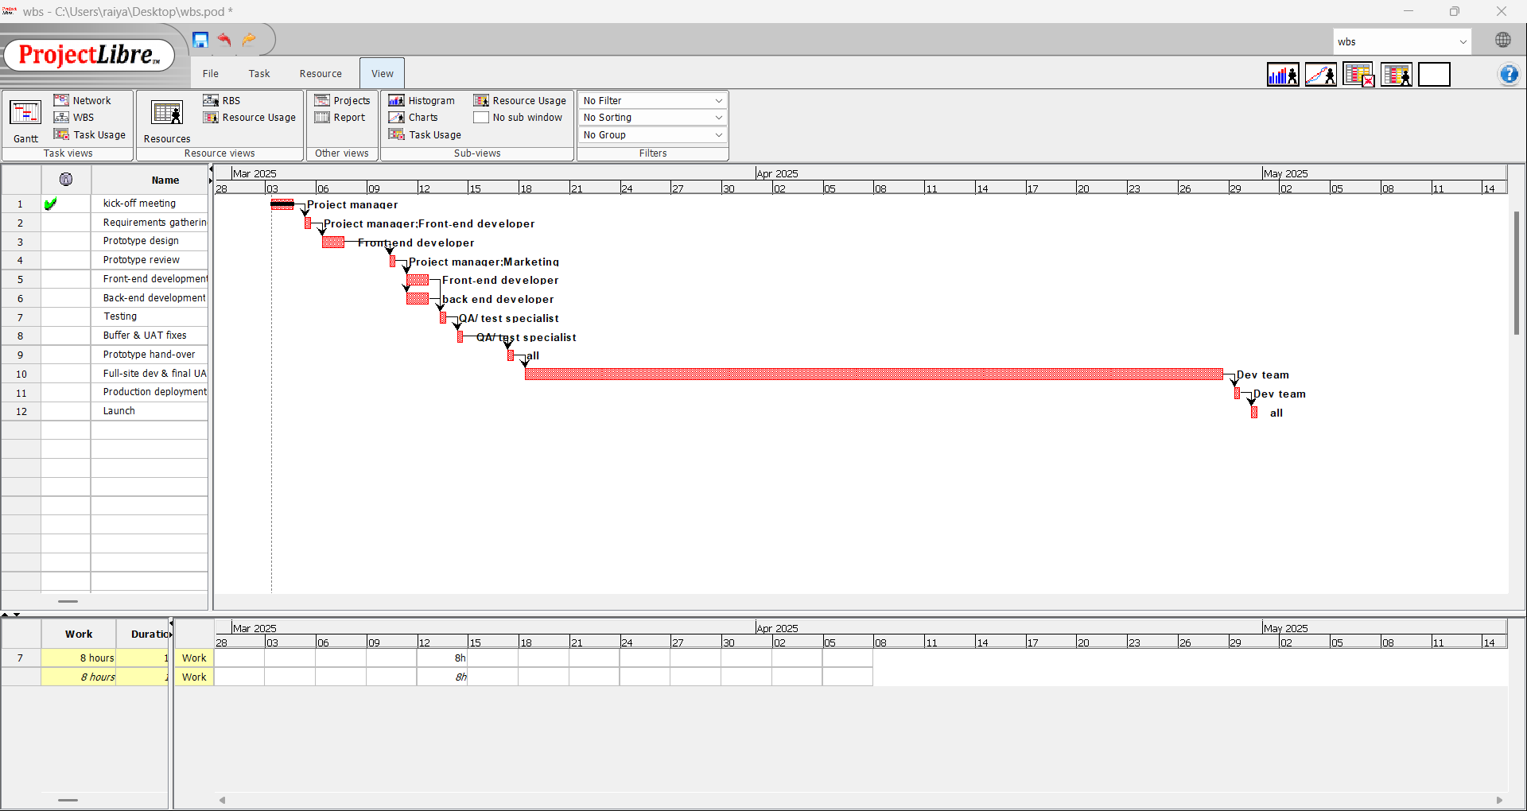

7. Communication Plan
Stakeholder | Message | Channel | Frequency | Owner
Director of Management | Status, KPIs, Budget | Email, Meetings | Bi-weekly | Project Manager
Marketing | Prototype Demos | Video call, Email | Weekly | PM/Front-end Dev
Developers | Daily task updates | Stand-ups, Slack | Daily | Scrum Master
QA Team | Bug reports, coverage | Dashboard, Email | As needed | QA Lead
End-Users (UAT) | Test Instructions | Wiki, Email | One-time | QA Lead

8. Risk & Change Control
8.1 Risk Table
Risk | Probability | Impact | Mitigation
Marketing assets delayed | Medium | High | Request early; placeholder assets
API failure | Low | High | Use sandbox/test environment
Scope creep | Medium | Medium | Formal change requests only
Team turnover | Low | Medium | Documentation; overlapping roles
Performance issues | Medium | High | Load testing in pre-release sprint
8.2 Change Management
Changes require written approval with proper auditing from the Change Control Board (PM + Director). Impact assessment includes cost/schedule effects and any budget changes. The project adheres to PRINCE2's "Manage by Exception" policy, ensuring that only deviations exceeding agreed tolerances are escalated.
9. Quality Management Plan
Quality Aspect | Method
Code Standards | ESLint, Prettier
Code Review | Weekly peer reviews via GitHub PRs
Testing | Unit (Jest), Integration (Mocha)
UAT Criteria | ≤ 5 minor issues at launch
Deployment | Manual deployment; rollback plan in place

10. Conclusion
This project plan provides a framework for the successful development and launch of a winter-themed e-commerce website for Snow Clothes & Gear. By connecting the control of PMBOK® and PRINCE2® with the flexibility of Agile, the project aims to deliver a high-quality, responsive website within the $5000 budget and by the June 1, 2025 deadline. Effective stakeholder engagement, clear roles, and proactive risk management will be crucial to achieve these objectives and provide Snow Clothes & Gear with a valuable online presence.

References
- Project Management Institute (PMI). (2021). A Guide to the Project Management Body of Knowledge (PMBOK® Guide) – 7th Ed.
- Schwaber, K., & Sutherland, J. (2020). The Scrum Guide. Scrum.org.
- Office of Government Commerce (OGC). (2017). Managing Successful Projects with PRINCE2®.
- PMI. (n.d.). Hybrid Project Management Strategies. ProjectManagement.com.

Appendix A: WBS (Level 2/3)
(Insert your own WBS diagram or table here)
