**Management of Judicial System**

**Requirement & Feasibility Analysis**

**Report**

**Group No.: 04**

**Group Members:**

**Chowdhury Md Rakin Haider, 1005009**

**Shakil Ahmed, 1005014**

**Md. Touhiduzzaman, 1005018**

**Shohan Al Jannat, 1005023**

**Tanzeer Hossain, 1005029**

* **Subsystems:**
  1. Case Filing
  2. Cause List Generation
  3. Magistrate Assignment
  4. Document Collection
  5. Trial Documentation
* **Subsystem 1: Case Filing:** 
  + 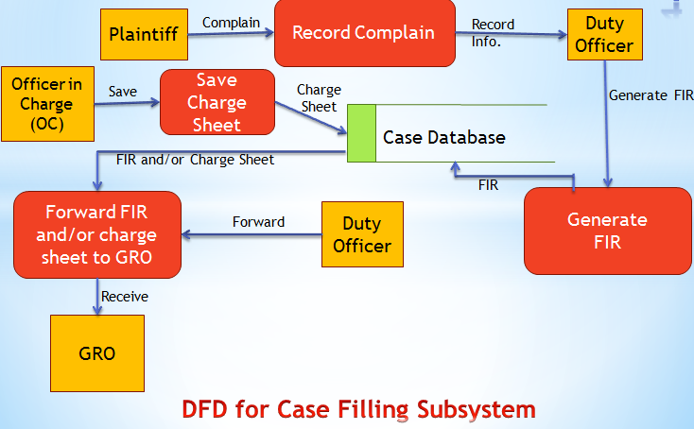**Data Flow Diagram (DFD):**
  + 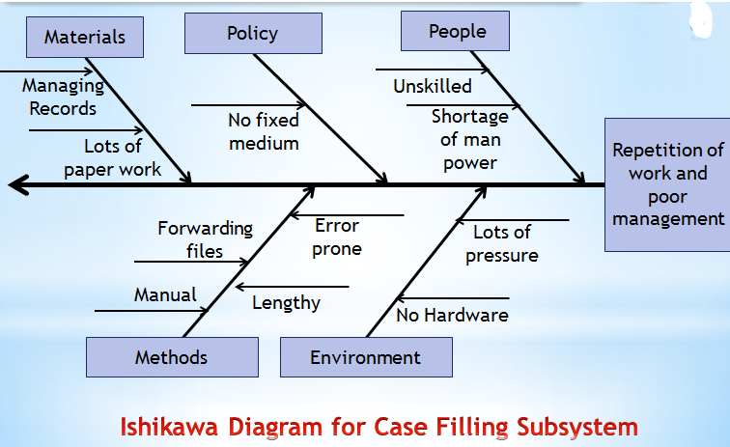**Ishikawa Diagram:**

* **Subsystem 2: Cause List Generation:** 
  + 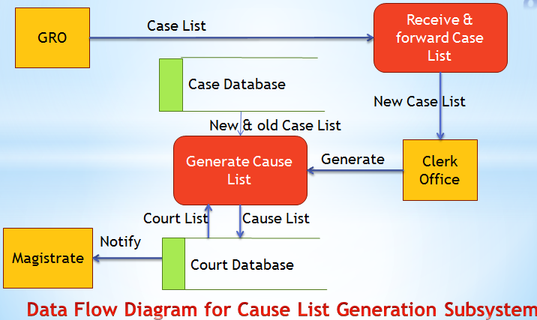**Data Flow Diagram (DFD):**
  + 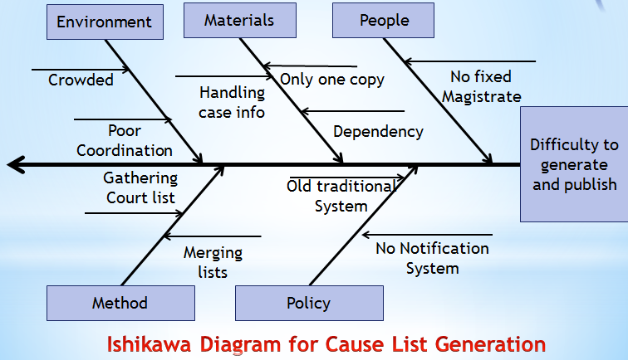**Ishikawa Diagram:**
* **Subsystem 3: Magistrate Assignment:** 
  + 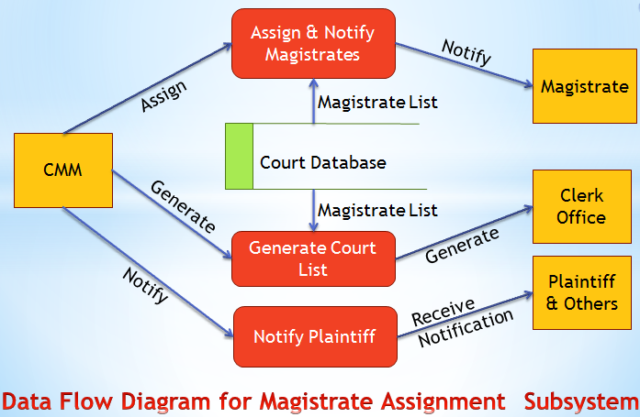**Data Flow Diagram (DFD):**
  + 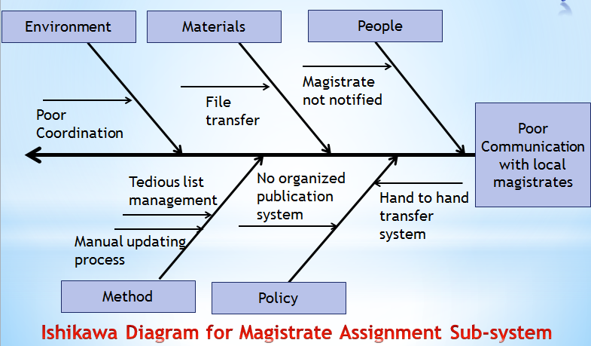**Ishikawa Diagram:**
* **Subsystem 4: Document Collection:** 
  + 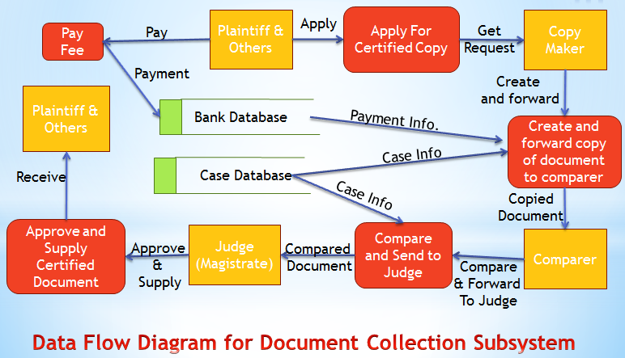**Data Flow Diagram (DFD):**
  + 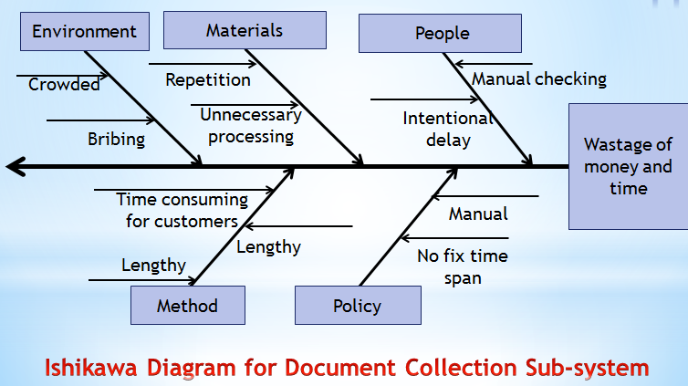**Ishikawa Diagram:**
* **Subsystem 5: Trial Documentation:** 
  + 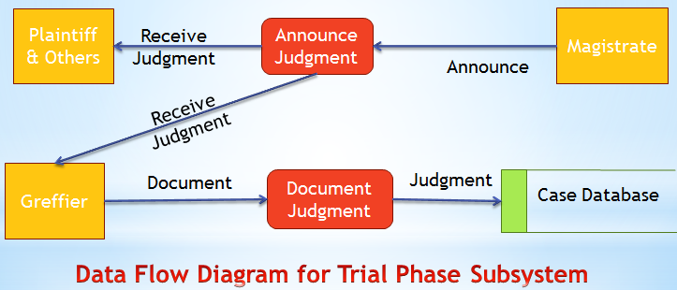**Data Flow Diagram (DFD):**
  + 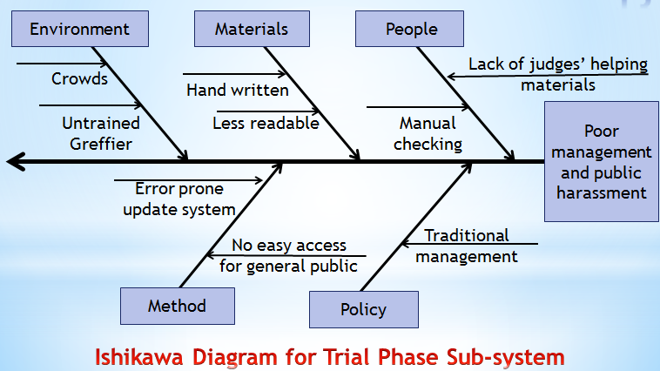**Ishikawa Diagram:**

* **Feasibility Analysis:** 
  + **Operational Feasibility:**
* **PIECES Analysis:**
* **P: Performance:**
  + - In this system, all documents will be transferred immediately saving much manual labor and time;
    - No re-writing of any document will be necessary;
    - There will be almost no paper works when this system gets well-implemented;
    - There will be almost zero manual labor in this system compared to the current system.
* **I: Information:**
  + - All information of any case will be available in web after the FIR is submitted, so that anyone as plaintiff, accused, witnesses and even lawyers can see the documents when needed – since these were legally supposed to be open to all people;
    - In this system, the previous case-documents are also saved in an organized way, so that any lawyer/judge may collect any information of any case for the help of any decision/reference for any later case;
    - The system is capable of sending notifications to magistrates about the cause & court list, which keeps them informed regularly in a much fast, convenient & trustworthy way;
    - The system can also send notifications to plaintiffs & other interested people-when they register themselves to get notification.
* **E: Economics:**
  + - All transportation costs for document transfers among police station, magistrate office, CMM office and courts is saved, since the documents are readily forwarded to the expected location when the respective people completes those;
    - The management of the case files will have about no paper document cost;
    - The documentation cost of any case will be lower in this system.
* **C: Control:**
  + - A database for the whole process with secured backups will be in control for the system;
    - Well isolated desktop apps for DO, GRO, greffier and so on will control the data flows among these entities;
    - Passwords protection with IP/MAC address tracking will ensure the safety of the system;
    - Only authenticated documents will be viewable via a website, which ensures the local laws;
    - No excessive controls / bureaucratic procedures will be followed, so that the users may get bored or disgusted with the system.
* **E: Efficiency:**
  + - All case docs will be generated from a single time input saving a huge time and manual labor;
    - Necessary fields will be timely placed to generate next docs;
    - Regular updates of a running case will be enabled in the system.
* **S: Service:** 
  + - More accurate case structure will result, which is verified at different levels;
    - Consistent service is a great outcome of the system;
    - The service is also flexible;
    - Notification service is a unique feature of the system;
    - All services of the system are easy to learn & use;
    - All services of the system will cost less time, money & labor.
  + **Cultural Feasibility:**
    - Web-based communications are getting common, so the system will be easily acceptable;
    - Now the employees are getting much skilled;
    - Future development on this digital data system will make the system much acceptable;
    - The system can bring a good recognition of our country in the international area also.
  + **Technical Feasibility:**
* **Required Hardware:**
  + - Computers with Printers
    - Internet Connection
    - Electronic Signature Pad(Optional)
    - Fingerprint reader
* **Required Language/Platforms:** 
  + - Java Desktop App Development Environment
    - PHP Framework
    - MySQL for DB Operations
    - SMS Gateway
* **Feasibility Analysis:** 
  + **Fixed Costs:**

|  |  |
| --- | --- |
| **Post Name** | **Cost (BDT)** |
| System Analyst | 50,000 |
| Program Analyst | 35,000 |
| GUI Designer | 20,000 |
| Database Specialist | 15,000 |
| **TOTAL** | 1,20,000 |

* + **Development Cost:**

* + **Training Cost:**

|  |  |
| --- | --- |
| **Post Name** | **Cost (BDT)** |
| DO (Police Station) | 10,000 |
| GRO & Clerks (Magistrate Office) | 30,000 |
| CMM | 5,000 |
| Copy Maker & Greffier (Court) | 25,000 |
| **TOTAL** | 70,000 |

* + **Hardware & Software Implementation Cost:**

|  |  |  |
| --- | --- | --- |
| **Hardware/Software** | **Quantity(around)** | **Cost (BDT)** |
| Computer | 49+2+2+2+1+14=70 | 17,25,000 |
| Domain | 1 | 20,000 |
| Web-service setup | 70 | 50,000 |
| **TOTAL** | | 48,30,000 |



* + **Annual Costs:**

|  |  |
| --- | --- |
| **Topic** | **Assumed Cost (BDT)** |
| Special Tech. Team’s Salary (5) | 24,00,000 |
| Web service consumption | 4,14,000 |
| Annual Domain Charge | 5,000 |
| Upgrade/Maintenance | 50,000 |
| **TOTAL** | 28,69,000 |

* **Benefit Analysis:** 
  + **Tangible Benefits:** 
    - No Paper Document cost
    - Reduction of book-cost for the lawyers
  + **Intangible Benefits:** 
    - Time saving
    - Saving of huge money
    - Reducing of manual labor
    - Reducing crowd
    - Automation
    - Easy management
    - Efficient searching
    - No data loss
    - Easily collectable documents for the lawyer

**\*\*\* The End \*\*\***