**2. zadanie**

**SYNTÉZA KOMBINAČNÝCH LOGICKÝCH OBVODOV**

Navrhnite prevodník číslic 0-9 v kóde BCD84-2-1 do kódu BCD8421 + 3. Prevodník realizujte s minimálnym počtom členov NAND a NOR.

Vlastné riešenie overte progr. prostriedkami ESPRESSO a LogiSim (príp. LOG alebo FitBoard).

Úlohy:

1. Navrhnite vlastné riešenie skupinovej minimalizácie a odvoďte B-funkcie v tvare MDNF.
2. Vytvorte vstupný textový súbor s opisom vstupu pre ESPRESSO.
3. Navrhnuté B-funkcie v tvare MDNF overte programom pre ESPRESSO. Pri návrhu B-funkcií klaďte dôraz na skupinovú minimalizáciu funkcií.
4. Optimálne riešenie (treba zhodnotiť, ktoré riešenie je lepšie a prečo) vytvorte obvod s členmi NAND (výhradne NAND, t.j. ani žiadne NOT).
5. Z Karnaughovej mapy odvoďte B-funkcie v tvare MKNF a vytvorte obvod s členmi NOR (výhradne NOR, t.j. ani žiadne NOT).
6. Výslednú schému nakreslite v simulátore LogiSim (príp. LOG alebo FitBoard) a overte simuláciou.
7. Riešenie vyhodnoťte (zhodnotenie zadania, postup riešenia, vyjadrenie sa k počtu logických členov, vstupov obvodu, vhodnosti použitie NAND alebo NOR realizácie).

|  |  |  |  |  |  |  |
| --- | --- | --- | --- | --- | --- | --- |
|  |  |  |  |  | c | |
|  |  |  |  | d | |  |
|  |  |  |  |  |  |  |
|  |  |  | 0011 | xxxx | xxxx | xxxx |
|  | b |  | 0111 | 0110 | 0100 | 0101 |
|  |  |  | xxxx | xxxx | 1100 | xxxx |
| a |  |  | 1011 | 1010 | 1000 | 1001 |

**Riešenie**

|  |  |  |  |  |  |  |  |  |  |  |  |  |  |  |  |  |  |  |
| --- | --- | --- | --- | --- | --- | --- | --- | --- | --- | --- | --- | --- | --- | --- | --- | --- | --- | --- |
|  | | | BCD84-2-1 | | | | | | | | BCD8421+3 | | | | | | | |
| # | a | | | b | | c | | d | | A | | | B | | C | | D | |
| 0 | | 0 | | | 0 | | 0 | | 0 | | | 0 | | 0 | | 1 | | 1 | |
| 1 | | 0 | | | 1 | | 1 | | 1 | | | 0 | | 1 | | 0 | | 0 | |
| 2 | | 0 | | | 1 | | 1 | | 0 | | | 0 | | 1 | | 0 | | 1 | |
| 3 | | 0 | | | 1 | | 0 | | 1 | | | 0 | | 1 | | 1 | | 0 | |
| 4 | | 0 | | | 1 | | 0 | | 0 | | | 0 | | 1 | | 1 | | 1 | |
| 5 | | 1 | | | 0 | | 1 | | 1 | | | 1 | | 0 | | 0 | | 0 | |
| 6 | | 1 | | | 0 | | 1 | | 0 | | | 1 | | 0 | | 0 | | 1 | |
| 7 | | 1 | | | 0 | | 0 | | 1 | | | 1 | | 0 | | 1 | | 0 | |
| 8 | | 1 | | | 0 | | 0 | | 0 | | | 1 | | 0 | | 1 | | 1 | |
| 9 | | 1 | | | 1 | | 1 | | 1 | | | 1 | | 1 | | 0 | | 0 | |

A,B,C,D

**Kaurgnaughove mapy a DNF**

|  |  |  |  |  |  |  |
| --- | --- | --- | --- | --- | --- | --- |
|  |  |  |  |  | c | |
|  |  |  |  | d | |  |
|  |  |  |  |  |  |  |
|  |  |  | 0 | X | X | X |
|  | b |  | 0 | 0 | 0 | 0 |
|  |  |  | X | X | 1 | X |
| a |  |  | 1 | 1 | 1 | 1 |

A

|  |  |  |  |  |  |  |
| --- | --- | --- | --- | --- | --- | --- |
|  |  |  |  |  | c | |
|  |  |  |  | d | |  |
|  |  |  |  |  |  |  |
|  |  |  | 0 | X | X | x |
|  | b |  | 1 | 1 | 1 | 1 |
|  |  |  | X | X | 1 | X |
| a |  |  | 0 | 0 | 0 | 0 |

B

|  |  |  |  |  |  |  |
| --- | --- | --- | --- | --- | --- | --- |
|  |  |  |  |  | c | |
|  |  |  |  | d | |  |
|  |  |  |  |  |  |  |
|  |  |  | 1 | X | x | X |
|  | b |  | 1 | 1 | 0 | 0 |
|  |  |  | X | X | 0 | X |
| a |  |  | 1 | 1 | 0 | 0 |

C

|  |  |  |  |  |  |  |
| --- | --- | --- | --- | --- | --- | --- |
|  |  |  |  |  | c | |
|  |  |  |  | d | |  |
|  |  |  |  |  |  |  |
|  |  |  | 1 | X | X | X |
|  | b |  | 1 | 0 | 0 | 1 |
|  |  |  | X | X | 0 | X |
| a |  |  | 1 | 0 | 0 | 1 |

D

MDNF:

$$A=a$$

$$B=b$$

$$C=c↑$$

$$D=d↑$$

**Vstup pre ESPRESSO:**

# prevodník z BCD84-2-1 do BCD8421+3

.i 4

.o 4

.ilb a b c d

.ob A B C D

.type fr

.p 10

0000 0011

0111 0100

0110 0101

0101 0110

1011 0111

0101 1000

1010 1001

1001 1010

1000 1011

1111 1100

.e

**Výstup z ESPRESSO:**

A = (a);

B = (b);

C = (!c);

D = (!d);

Riešenia sú totožné.

**Prepis na NAND:**

$$A=a$$

$$B=b$$

$$C=c↑$$

$$D=d↑$$

Vyjadrenie k počtu logických členov obvodu: 2

Vyjadrenie k počtu vstupov do logických členov obvodu: 4

**Kaurgnaughove mapy a KNF**

|  |  |  |  |  |  |  |
| --- | --- | --- | --- | --- | --- | --- |
|  |  |  |  |  | c | |
|  |  |  |  | d | |  |
|  |  |  |  |  |  |  |
|  |  |  | 0 | X | X | X |
|  | b |  | 0 | 0 | 0 | 0 |
|  |  |  | X | X | 1 | X |
| a |  |  | 1 | 1 | 1 | 1 |

A

|  |  |  |  |  |  |  |
| --- | --- | --- | --- | --- | --- | --- |
|  |  |  |  |  | c | |
|  |  |  |  | d | |  |
|  |  |  |  |  |  |  |
|  |  |  | 0 | X | X | x |
|  | b |  | 1 | 1 | 1 | 1 |
|  |  |  | X | X | 1 | X |
| a |  |  | 0 | 0 | 0 | 0 |

B

|  |  |  |  |  |  |  |
| --- | --- | --- | --- | --- | --- | --- |
|  |  |  |  |  | c | |
|  |  |  |  | d | |  |
|  |  |  |  |  |  |  |
|  |  |  | 1 | X | x | X |
|  | b |  | 1 | 1 | 0 | 0 |
|  |  |  | X | X | 0 | X |
| a |  |  | 1 | 1 | 0 | 0 |

C

|  |  |  |  |  |  |  |
| --- | --- | --- | --- | --- | --- | --- |
|  |  |  |  |  | c | |
|  |  |  |  | d | |  |
|  |  |  |  |  |  |  |
|  |  |  | 1 | X | X | X |
|  | b |  | 1 | 0 | 0 | 1 |
|  |  |  | X | X | 0 | X |
| a |  |  | 1 | 0 | 0 | 1 |

D

MKNF:

$$A=\overline{a}$$

$$B=\overline{b}$$

$$C=c$$

$$D=d$$

**Prepis na NOR:**

$$A=a↓$$

$$B=b↓$$

$$C=c$$

$$D=d$$

$↓$*- Peirceova operácia (NOR)*

Vyjadrenie k počtu členov obvodu: 2

Vyjadrenie k počtu vstupov do logických členov obvodu: 4

**Schéma:**

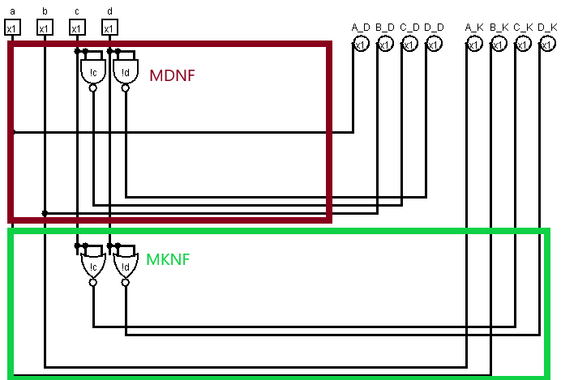

**Zhodnotenie**

*Nakoľko moj prevod bol taký jednoduchý, nebol potrebný okrem negacii žiaden iný člen.*

*Prikladám výstup z espressa , ktorý sa zhoduje s mojím riešením. Obvod je maximálne optimalizovaný.*