Angular 4 cli documentation.

For first you should to install the node on your mavchine.

For mac or linux or windows you can download the node from the folloing link

'https://nodejs.org/en/download/'

Install angular cli in windows command is.

'npm install -g @angular/cli'

once you hava installed on your machine you can check by using command

'ng -v'

this will generate output like this.

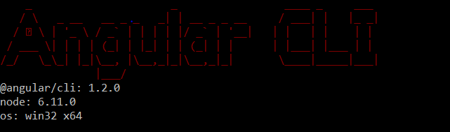

You can generate new project by using angular cli is

'ng new -name of your project-'

example: ng new my-first-project

move into your project directory using below command.

'cd my-first-project'

ng new: this command is used to create new angular project usig angular cli.

ng generate: this used to generate components routes services and pipes with simple command This cli also creates simple test shells foe all of these.

ng serve: Easily test your app locally while developing.

To install angular 4 without using angular cli you can download the Quick start project from the angular Quick start

you can clone the repository into your local machine

' git clone https://github.com/angular/quickstart.git quickstart'

move into your project directory using below command.

'cd quickstart'

'npm install' to install what are the packages that are mentiones on your package.json file.

'npm start' torun your project.

If you have installed angular 2 project you have t ugrade your project to angular four by using the folloing command.

on mac:
npm install @angular/{ required packages names in angular}@next –save

example: npm install @angular/{common,compiler,compiler-cli,core,forms,http,platform-browser,platform-browser-dynamic,platform-server,router,animations}@next --save

on pc:

npm install package names @next –save

example: npm install @angular/common@next @angular/compiler@next @angular/compiler-cli@next @angular/core@next @angular/forms@next @angular/http@next @angular/platform-browser@next @angular/platform-browser-dynamic@next @angular/platform-server@next @angular/router@next @angular/animations@next –save

--save to update the package.json file on your machine.

