

LAB EXPERIMENT RECORD
SET 10

Department | Artificial Intelligence and Data Science
Course Code / Course Name | DSA0601 / Data Handling and Visualization
Name / Register Number | Rakkesh Karan .R / 192524253
Date / Day | 06/10/2026

Aim
To analyze survey responses analysis using the requested visualizations and dashboard views.

Dataset
Survey Responses Analysis
Survey_ID | Question_1 | Question_2 | Question_3
1 | A | B | C
2 | B | A | D
3 | C | A | B

R Data Setup
Run this setup once before the R programs below. The dataset is defined inline so each record can be copied and run without a separate CSV file.
R data setup
dat <- data.frame(
Survey_ID = c(1, 2, 3),
Question_1 = c("A", "B", "C"),
Question_2 = c("B", "A", "A"),
Question_3 = c("C", "D", "B")
)

PROGRAM 1: Question 1 Answer Distribution
Create a grouped bar chart showing the distribution of answers for Question 1.
R code
barplot(table(dat$Question_1), col="skyblue3", xlab="Answer", ylab="Responses", main="Question 1 Answer Counts")

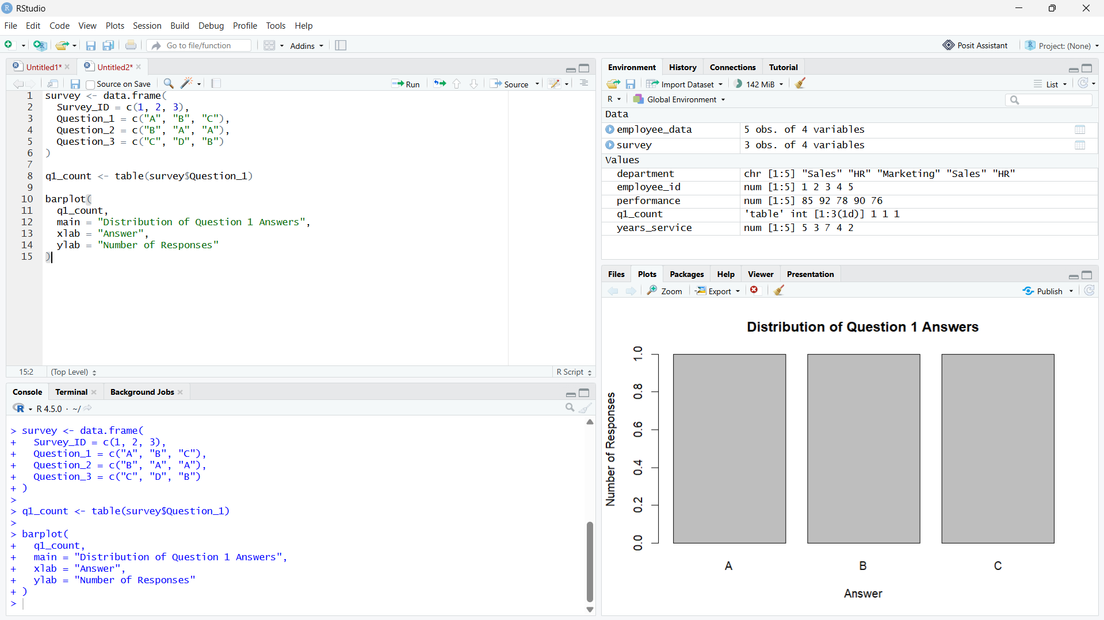
Output 1: Question 1 Answer Distribution

Observation: Answers A, B, and C each occur once for Question 1.

PROGRAM 2: Stacked Responses Across Questions
Create a stacked bar chart showing the overall response distribution across all three questions.
R code
resp <- rbind(table(factor(dat$Question_1, levels=c("A","B","C","D"))), table(factor(dat$Question_2, levels=c("A","B","C","D"))), table(factor(dat$Question_3, levels=c("A","B","C","D"))))
barplot(t(resp), col=rainbow(4), legend=TRUE, xlab="Question", ylab="Responses", main="Answer Distribution Across Questions")

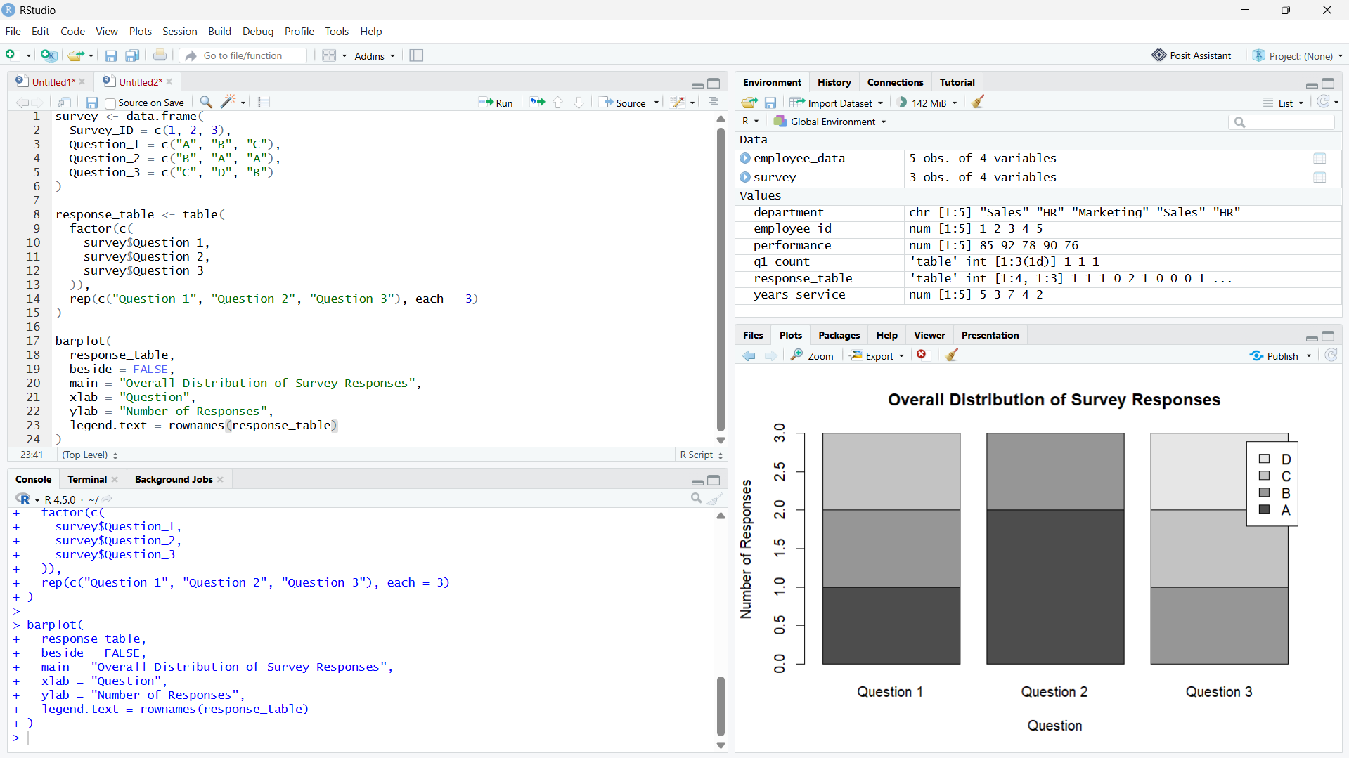

Output 2: Stacked Responses Across Questions

Observation: Question 2 has two A responses, while Question 3 has one each of A, B, and D.

PROGRAM 3: Survey Response Table
Display all survey answers in a labeled table.
R code
print(dat)

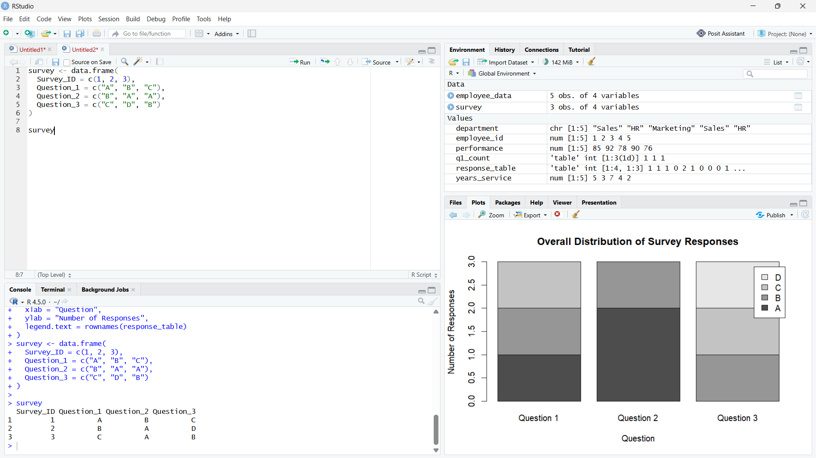
Output 3: Survey Response Table

Observation: The table contains all three respondents and their answers to the three questions.

PROGRAM 4: Survey Responses Dashboard
Create a Tableau dashboard combining the Question 1 answer chart, stacked response chart, and response table.
Tableau build steps
Tableau dashboard build
1. Connect to the survey response table.
2. Create a bar chart of Question_1 answer counts.
3. Pivot Question_1, Question_2, and Question_3 to a Question/Answer structure for the stacked response view.
4. Add the response table and coordinate the sheets with a Question filter.

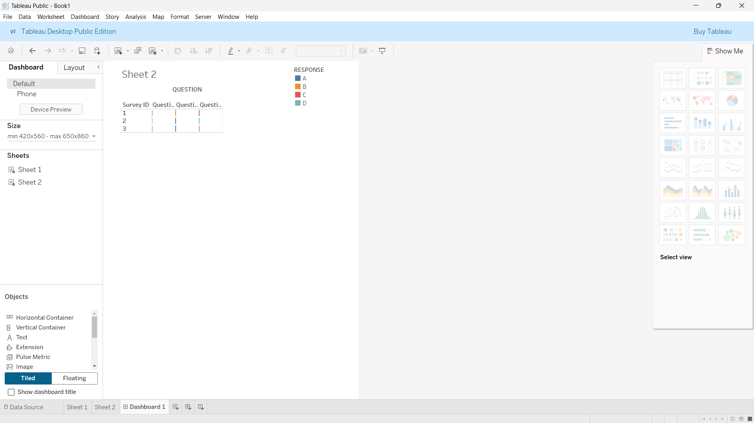
Output 4: Survey Responses Dashboard

Observation: The preview combines answer counts and respondent-level details. Selecting a question or answer can filter the table in Tableau.

Procedure
1. Review the dataset table and confirm any illustrative fields noted in the record.
2. Run the R setup block once, then run the requested program code.
3. Compare the output screenshot with the observation and replace illustrative values when actual data is available.
4. For Tableau tasks, connect to the displayed data and follow the dashboard build steps.

Result
The requested charts and dashboard views for Set 10 were prepared from the displayed dataset. Outputs include labels, short observations, and code or dashboard construction steps.

Key Functions Used
plot(), barplot(), hist(), boxplot(), table().

