

LAB EXPERIMENT RECORD
SET 12

Department | Artificial Intelligence and Data Science
Course Code / Course Name | DSA0601 / Data Handling and Visualization
Name / Register Number | Rakkesh Karan .R / 192524253
Date / Day | 06/10/2026

Aim
To analyze website traffic using the requested visualizations and dashboard views.

Dataset
Website Traffic
Date | Page_Views | Click_Through_Rate
2023-01-01 | 1500 | 2.3
2023-01-02 | 1600 | 2.7
2023-01-03 | 1400 | 2.0

R Data Setup
Run this setup once before the R programs below. The dataset is defined inline so each record can be copied and run without a separate CSV file.
R data setup
dat <- data.frame(
Date = c("2023-01-01", "2023-01-02", "2023-01-03"),
Page_Views = c(1500, 1600, 1400),
Click_Through_Rate = c(2.3, 2.7, 2.0)
)
dat$Date <- as.Date(dat$Date)

PROGRAM 1: Daily Page Views
Create a labeled line chart of daily page views.
R code
plot(dat$Page_Views, type="o", xaxt="n", xlab="Date", ylab="Page views", main="Daily Website Page Views", col="#276B9A")
axis(1, at=seq_len(nrow(dat)), labels=dat$Date)

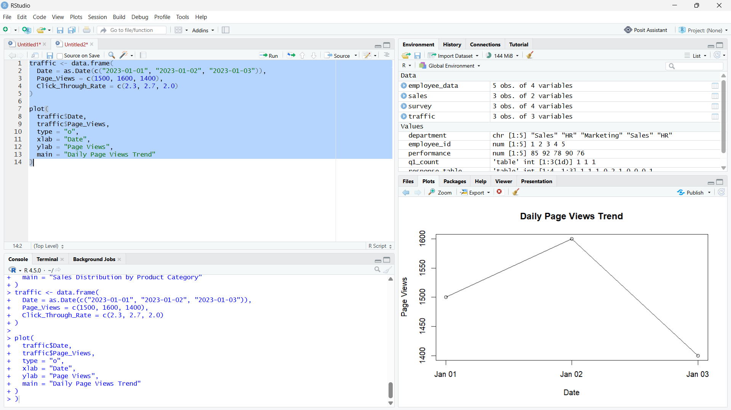

Output 1: Daily Page Views

Observation: Page views rise from January 1 to 2, then fall on January 3.

PROGRAM 2: Click-Through Rate by Day
Show the days with the highest click-through rates in a labeled bar chart.
R code
barplot(dat$Click_Through_Rate, names.arg=dat$Date, col="skyblue3", xlab="Date", ylab="CTR (%)", main="Click-Through Rate by Day")

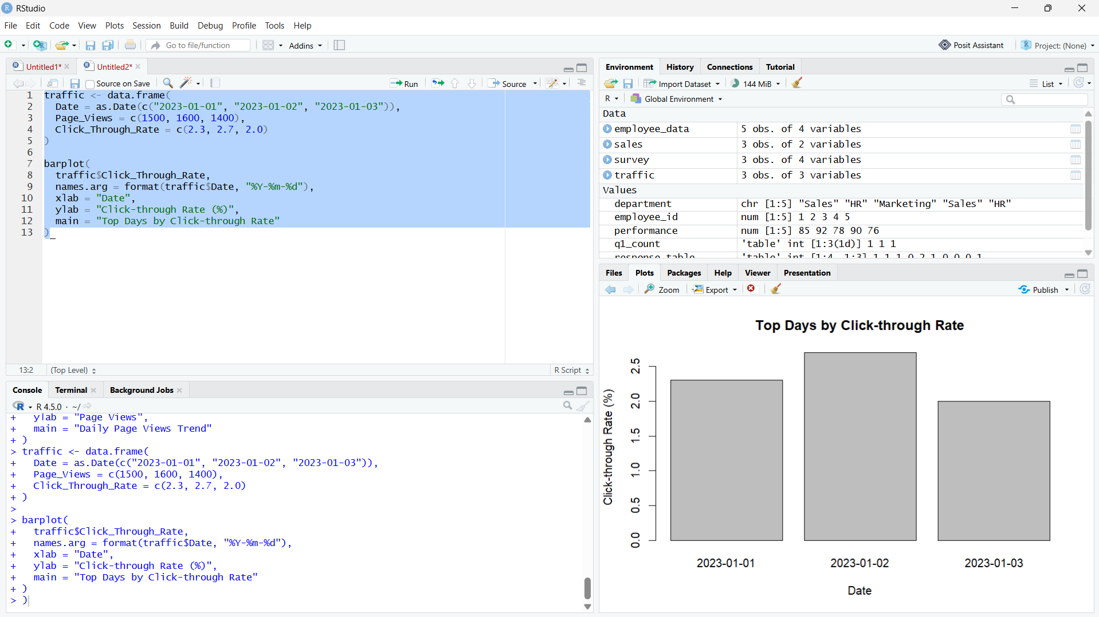

Output 2: Click-Through Rate by Day

Observation: January 2 has the highest click-through rate (2.7%).

PROGRAM 3: Website Traffic Table
Display the website traffic data for each day in a labeled table.
R code
print(dat)

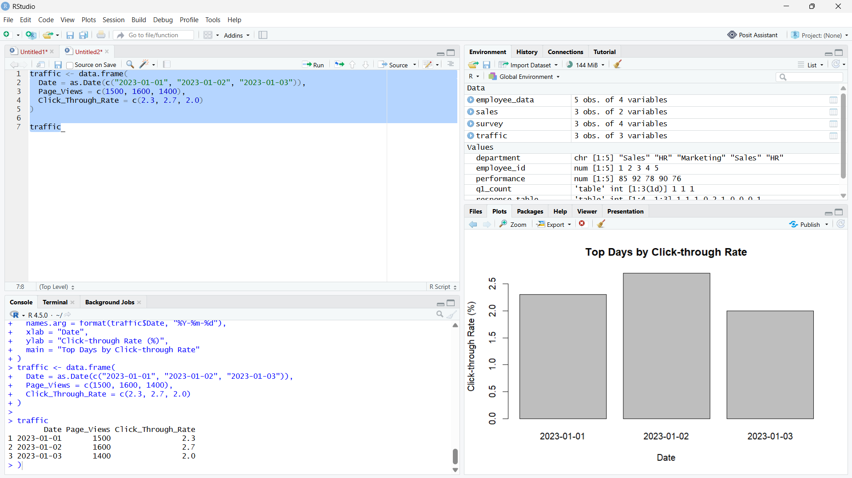

Output 3: Website Traffic Table

Observation: The table contains all three supplied dates, page-view totals, and click-through rates.

PROGRAM 4: Website Traffic Dashboard
Build a Tableau dashboard combining the page-view line chart, click-through bar chart, and data table.
Tableau build steps
Tableau dashboard build
1. Connect to the website traffic table.
2. Build a line chart of Page_Views by Date and a bar chart of Click_Through_Rate by Date.
3. Create a text table containing Date, Page_Views, and Click_Through_Rate.
4. Arrange all sheets on a dashboard and show a Date filter.

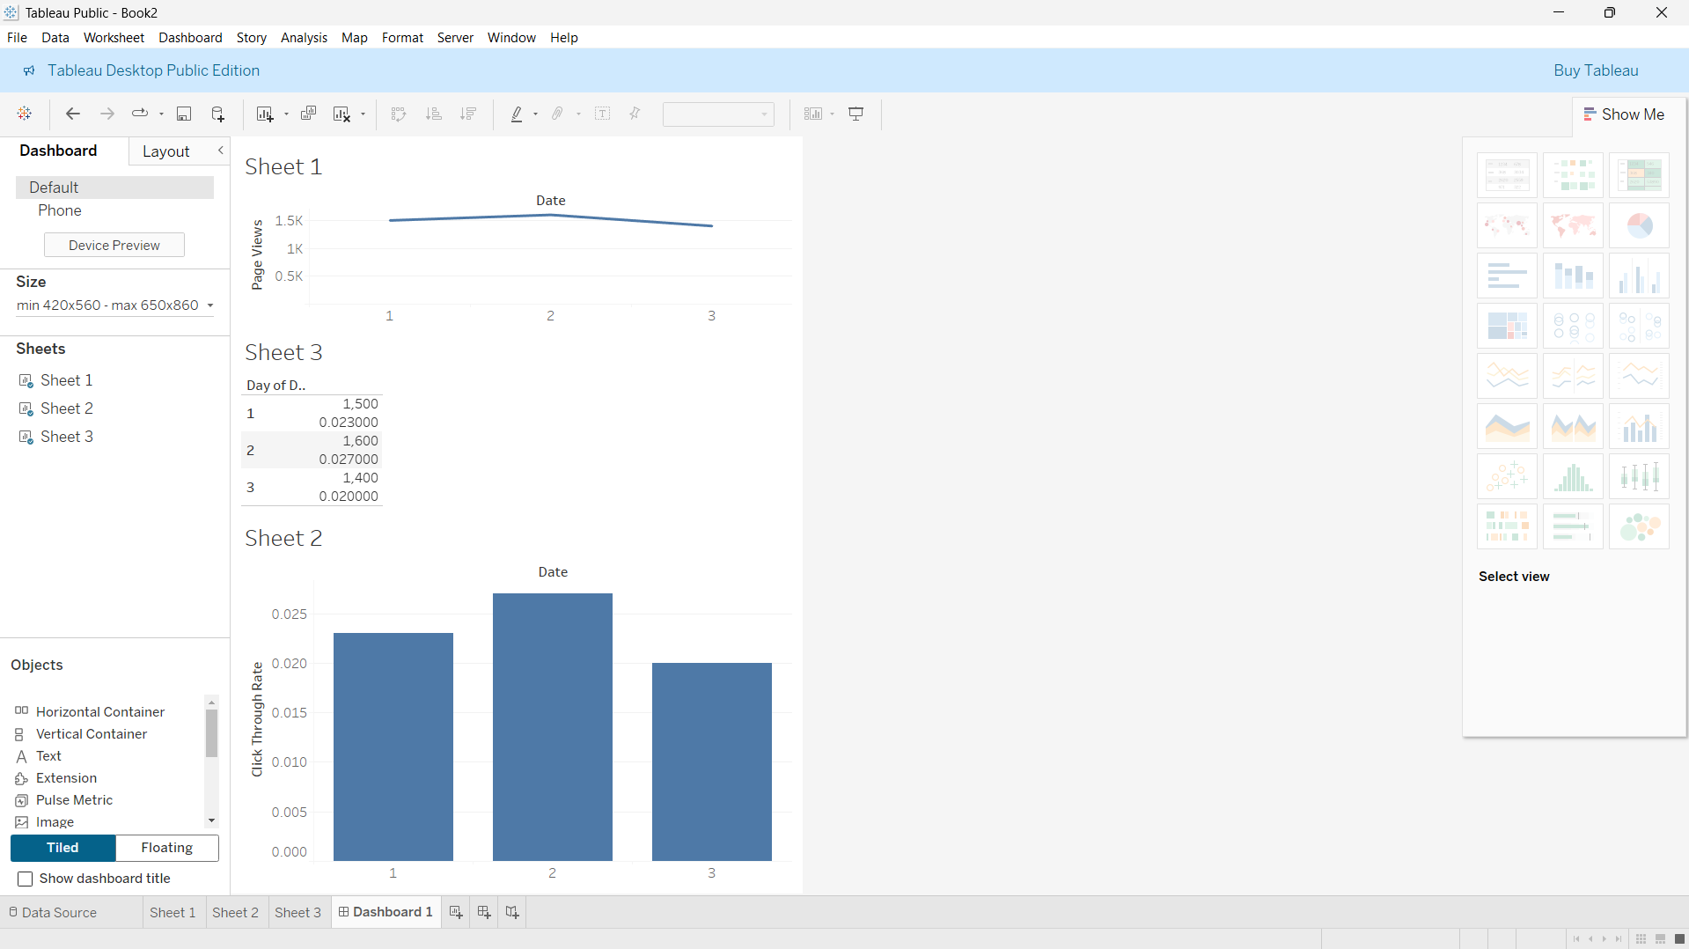

Output 4: Website Traffic Dashboard

Observation: The preview aligns the date-level chart outputs with the traffic table; a date filter can coordinate all views.

Procedure
1. Review the dataset table and confirm any illustrative fields noted in the record.
2. Run the R setup block once, then run the requested program code.
3. Compare the output screenshot with the observation and replace illustrative values when actual data is available.
4. For Tableau tasks, connect to the displayed data and follow the dashboard build steps.

Result
The requested charts and dashboard views for Set 12 were prepared from the displayed dataset. Outputs include labels, short observations, and code or dashboard construction steps.

Key Functions Used
plot(), barplot(), hist(), boxplot(), table().

