Wireframe Document
Project: Insurance Premium Prediction App
Prepared by: Rakesh Ranjan
Wireframe type: Current desktop form, represented schematically

1. Page structure
┌─────────────────────────────────────────────────────────────────────┐
│ Welcome to your │
│ FREE │
│ Health Insurance Premium Predictor App │
├─────────────────────────────────────────────────────────────────────┤
│ What is your age? │
│ [ Age: whole number, 1–130 ] │
│ │
│ What is your gender? │
│ [ Select gender ▾]│
│ │
│ Don't know your BMI? Enter your weight and height (optional) │
│ [ Weight in kilograms, 0.1–300 kg ] │
│ [ Height in centimeters, 50–250 cm ] │
│ BMI = weight in kg ÷ (height in meters × height in meters). │
│ Enter both values to calculate automatically. │
│ │
│ What is your BMI value? │
│ [ BMI, greater than 0 and no more than 53.1 ] │
│ Or enter your BMI directly if you know it. │
│ │
│ How many children do you have? (optional) │
│ [ Whole number, 0–10 ] │
│ │
│ Do you smoke? │
│ [ Select yes/no ▾]│
│ │
│ Which region do you belong to? │
│ [ Select region ▾]│
│ │
│ [ Your annual premium would be: ] │
│ │
│ Premium: <predicted amount> │
└─────────────────────────────────────────────────────────────────────┘

2. Interaction states

Initial state
- Age and BMI are required.
- Gender, smoker status, and region have a selected value from their dropdown options.
- Weight and height are blank and optional.
- Children is blank and optional; blank is treated as zero by the server.
- Result area is empty.

BMI from height and weight
- User enters both values.
- Browser calculates and displays BMI rounded to one decimal place.
- Both values must be within their input bounds. Height must be between 50 and 250 cm.
- Server calculates from the original submitted values and validates the resulting BMI before predicting.

Invalid or incomplete input
- Browser blocks standard required/range failures or shows the custom weight-height pairing error.
- Server rejects invalid submissions with HTTP 400 and a message.
- The result area displays Error: <message>.

Successful prediction
- During the request, the result area shows a waiting message.
- On HTTP 2xx, it displays Premium: <predicted amount>.

3. Responsive behavior
The page uses a Bootstrap container and responsive viewport metadata. This wireframe captures content hierarchy rather than exact pixel spacing; controls flow vertically and use available container width.

4. Reference screenshots
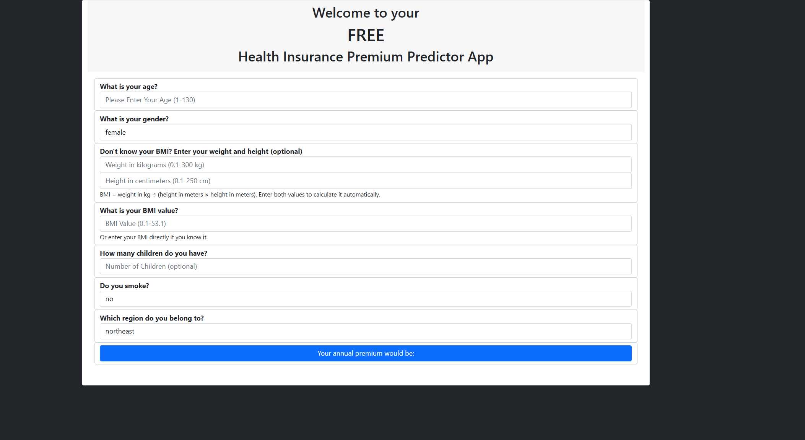
Current insurance premium prediction form
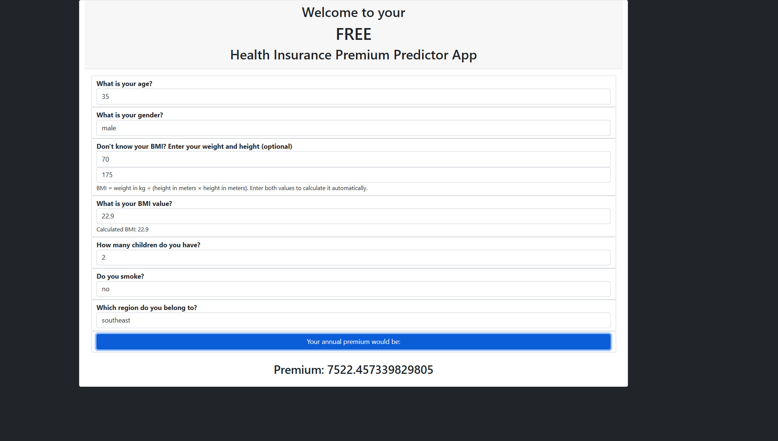
Insurance premium prediction example

