WIREFRAME

Store Sales Prediction

|  |  |
| --- | --- |
| **Written By** | Rakesh Ranjan |
| **Document Version** | WF - V.1.1 |
| **Last Revised Date** | 15-Apr-2023 |

Document Version Control

**Change Record:**

|  |  |  |  |
| --- | --- | --- | --- |
| **Version** | **Date** | **Author** | **Comments** |
| **WF - V.1.0** | 10-Apr-2023 | Rakesh Ranjan | WIREFRAME data creation |
| **WF - V.1.1** | 15-Apr-2023 | Rakesh Ranjan | Document updated |

**Home Page**

The home page consists of a single page having 9 input sections, and submit and reset buttons. The page is designed in such a way that users can insert their inputs according to their item description.

1. The user can view the following web page once entering the web application.
2. Enter the values in the fields as needed.

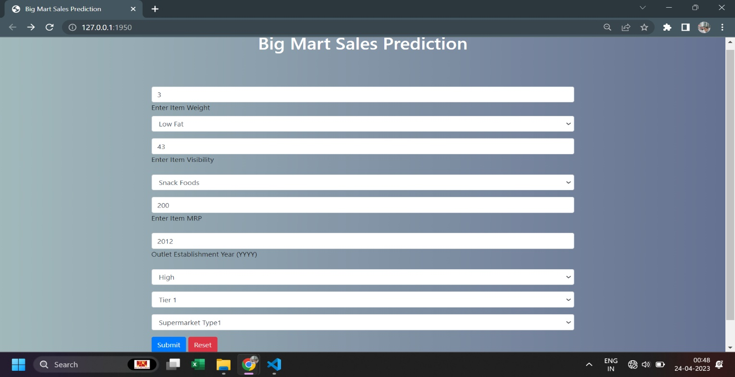

**Result Page**

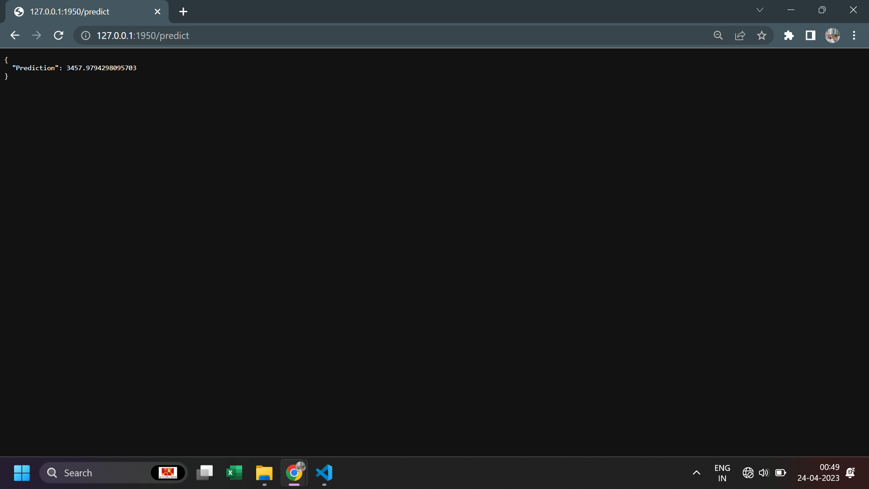After clicking the “Submit” button, the User can see the prediction result on the next page with auto navigation.

Based on User Inputs, Store Sales Prediction will predict the Item Outlet Sales.