rest: If you get some rest or have a rest, you sit or lie quietly, not doing anything active, and relax, e.g. It was weeks before I got a decent night’s rest … They wanted a rest …
If you rest or if you rest your body, you do not do anything active for a period of time, e.g. Go back to bed and rest … The boy stopped for a moment to rest … Stop to relax and rest your muscles.
[Collins Cobuild Essential English Dictionary]

To rest (RELAX) is to stop being active for a period of time in order to relax and get back your strength, or to cause (someone or something) to stop doing an activity so that they can get back their strength
We hiked for five miles and then rested for a while. [I]
The coach decided to rest some of the team's starters tomorrow night. [T]
I just need to sit down and rest my legs. [T]
rest (noun) [C/U]
What you need is a nice long rest. [C]
The doctor told him to get plenty of rest and drink lots of fluids.
[Cambridge Dictionary of American English]

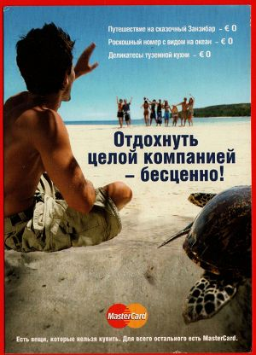
- A: What did you do over the holidays?
B: I really had a great time. On New Year’s Eve, I went to a friend’s apartment and we did the usual—we drank and stuffed ourselves and drank some more. In the middle of the night, we went out and played in the snow. I took a couple of days to recuperate after that and then I went skiing and skating.

- A: How was your trip? Did you drive straight through?
B: We almost made it without having to stop, but my foot got tired so we had to stop at one of the rest areas along the turnpike.

- A: How was your summer vacation?
B: Fantastic! I spent the whole summer doing nothing, just relaxing.

- A: Well, it’s about time you got up! Did you have a good rest?
B: Yeah. It’s a good thing, too. When I got home from school, I could hardly keep my eyes open. Now I’m ready to correct some papers.

- patient: I’ve been feeling run down lately.
doctor: It’s nothing serious. You just need a nice long rest. Why don’t you take a couple of weeks off and lie in the sun?

- A: What are you planning on doing this weekend?
B: I really need to take a break from studying. I think I’ll watch a couple of movies, play some basketball—maybe even go dancing on Saturday night.

- A: How are you feeling? Any better?
B: Well, actually I’m still a bit achy. Maybe I should go back to bed and get some more rest.

- A: You know, I’m tired. We’ve been climbing for the last two hours and we’ve got a steep stretch ahead of us before we get up to the peak. Why don’t we stop for a few minutes and rest?
B: Sure. Why not? I’m a bit worn out myself.

- A: How did you spend your vacation?
B: We went to a resort in South Carolina and played tennis for two whole weeks. I can’t think of a better way to unwind.

- A: Why are you lying around doing nothing?
B: I’m resting up for tomorrow night’s game. This is what our coach told us to do.

