**COVID 19 INDIA 2023**

**DASHBOARD PROJECT**



|  |
| --- |
| Index |
| 1. Overview of the project PG 2 |
| -Description PG-2  -Dashboard PG-3  -Guide to use the project PG 4-6 |
| 1. Steps to view the project from Git PG 7 |

**COVID 19 INDIA 2023**

This dashboard analyses and helps the readers to understand the covid status in India for the year 2023 Till (2nd November 2023).

Infographics has been used to make the dashboard more communicative. The dashboard contains links to the data source and also lets users navigate to INDIAN government and WHO websites for checking the updated data.

Description :

1. This Dashboard focuses on the covid cases and vaccination doses of each state showing a detailed analysis of the numbers of active, deaths, discharged cases along with vaccination details of number of 1st dose 2nd dose and precautionary dose of each state in India.
2. The data is till (2nd November 2023)
3. Excel file ‘Book1.xlsx’ contains the project. There are 4 excel sheets:

a)**’FINAL DASHBOARD**’ – contains the Dashboard to be viewed.

b)’covidstatewise2ndnov’ – contains 2 data tables - total covid cases and vaccination status

c)’Sheet4’ – Has the Pivot table.

d)’StateWiseVaccination’ – table representing vaccination data

DASHBOARD :

WHO website

Mygov.in

DATA SOURCE LINK

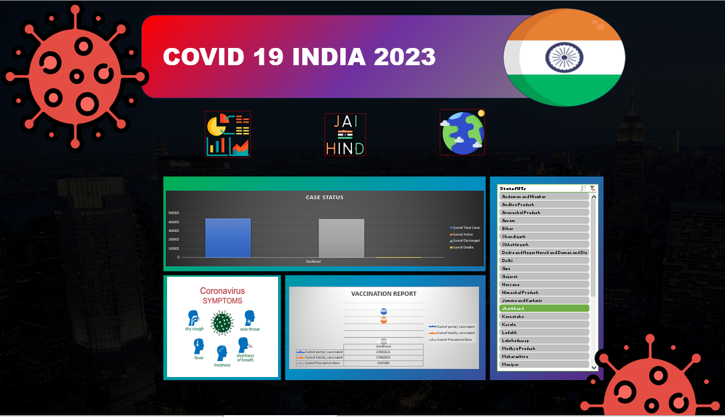

SLICER

CHART REPRESENTING TOTAL CASES

IN

VACCINATION STATUS

Guide to use :

Use the slicer provided to navigate the state/ union territories list and view individual data of covid cases and vaccination doses.

SAY YOU WANT TO SEE THE DATA FOR GOA.-🡪**SELECT GOA** FROM SLICER.

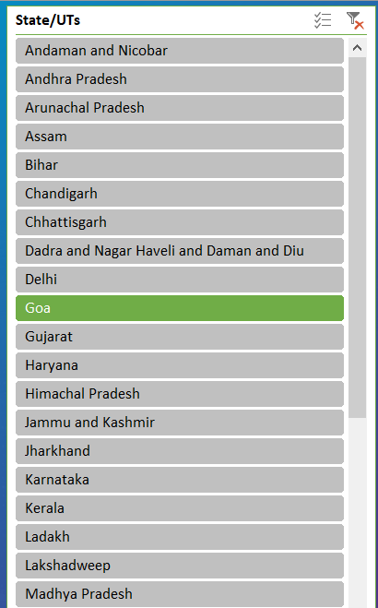

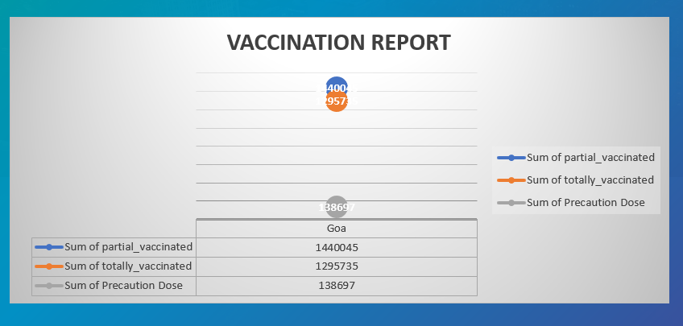

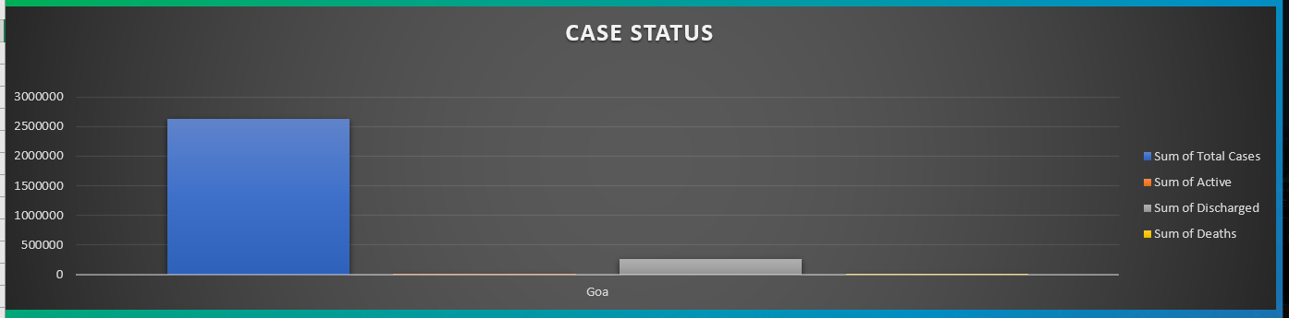

NOW SAY YOU WANT TO SEE THE DATA FOR ANOTHER STATE (SAY ASSAM)

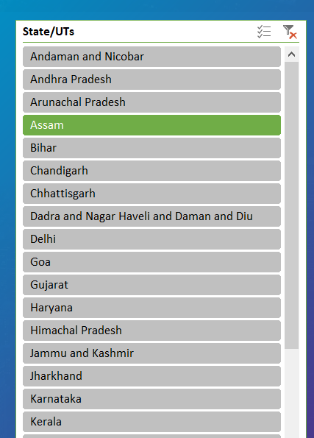



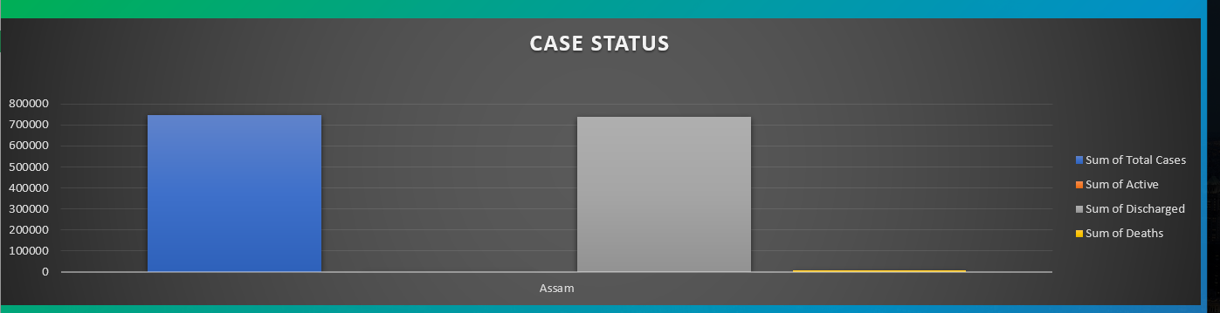

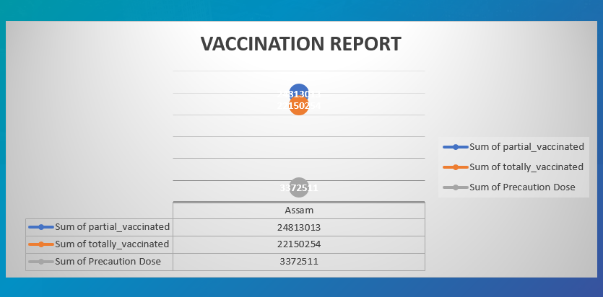

STEPS TO VIEW THE PROJECT FROM GIT

1. Open the URL : https://github.com/rakmo-n/Rakesh_Kumar_Project
2. Click on Excel file – ‘ Book1.xlsx‘
3. Download the file to your local system, clicking the download button as shown below.

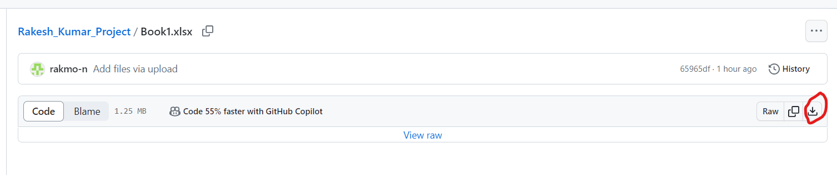

1. Enable ‘Editing’ option while opening the file.

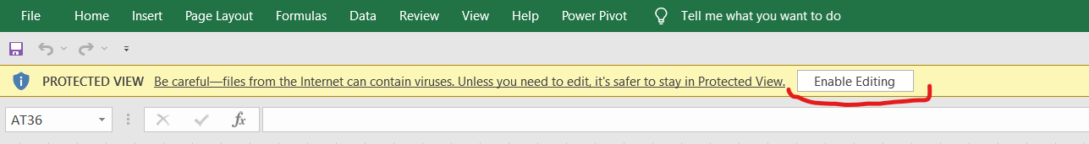

5)Navigate to ‘FINAL DASHBOARD’ sheet to view the Dashboard.