## Exercise 0: Hello World!

Install shiny package. Download and extract 00_hello_world.zip file from <http://jdem.cz/bapnb8>. Edit the path in run.R and run it.

## 

## Exercise 1: Minimal sample size calculator

Look at power.t.test function and make a minimal sample size calculator for two-sample, two-sided T-test.

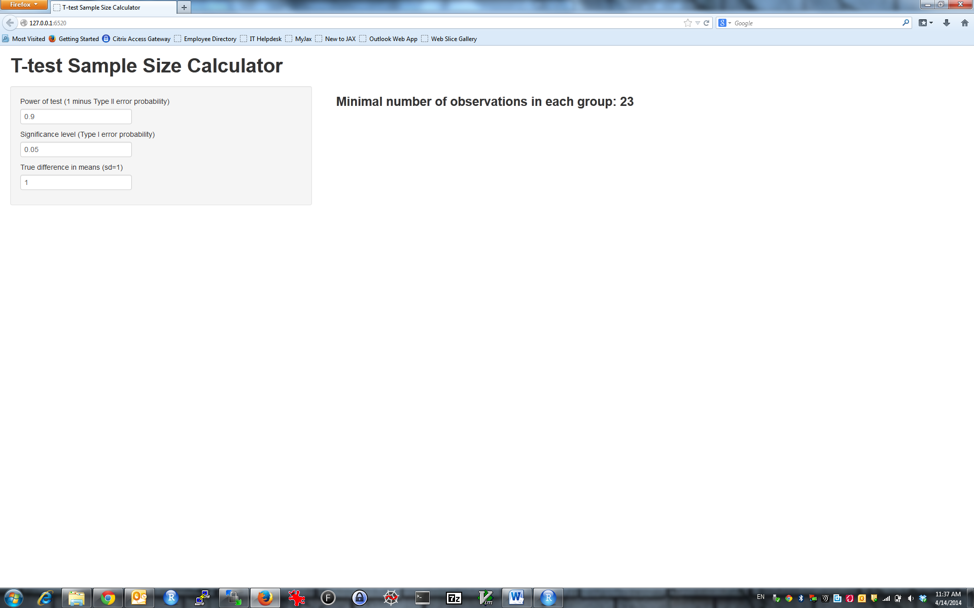

HINT 1: Inputs are characters; you need to convert them to numeric with as.numeric.  
HINT 2: textInput fields in ui.R must be separated by commas  
HINT 3: Use h3(textOutput(…)) to make output more visible

## Exercise 2: Better min. sample size calculator

Improve your sample size calculator:

1. Use sliderInput instead of textInput.
2. Enable user to set other parameters of power.t.test function with radioButtons, selectInput and checkboxInput
3. Print complete power.t.test output (not just n) with verbatimTextOutput
4. *Optional:* Remove dots from type / alternative options (“two sample” instead “two**.**sample”)

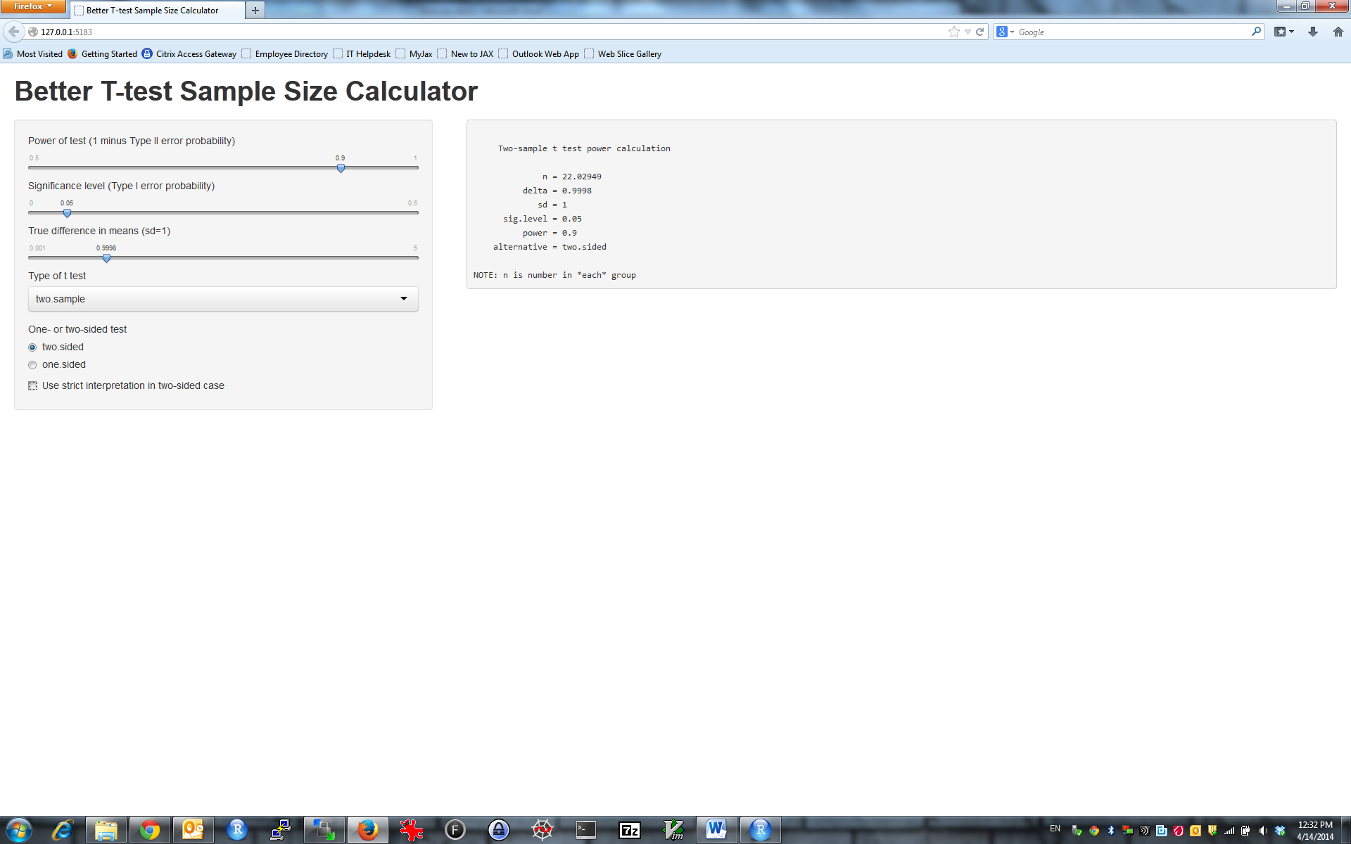

## Exercise 3: Simulated p-value distribution

And now let us do simulations. User should specify Nsim (=number of simulations), n (= number of observations in each sample) and delta (= true difference in means). The output should be a histogram of p-values for two-sided two-sample T-test. (hint: use imageOutput instead of textOutput).

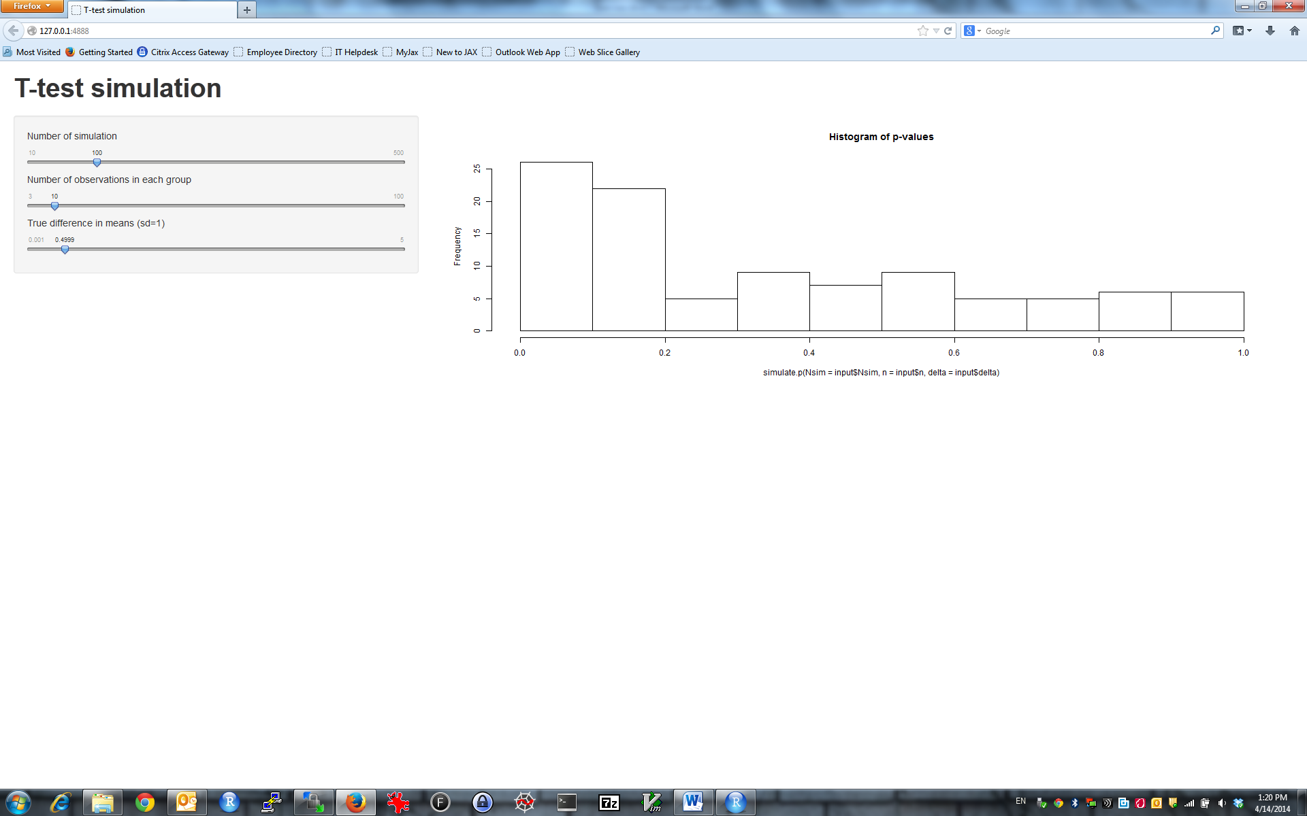

Extra 1: Add downloadButton and enable user to download simulated p-values  
Extra 2: Add button “Generate New” that set random number generator (set.seed) to a new value  
Extra 3: Generate histogram for p-values uploaded by user (use fileInput)