Image Classification for Autonomous Vehicule
Ewan Rakotoanosy – D00243375

Github repository of the work achieved : https://github.com/rakotoew/compi8031_ca1_repeat_cnn_classification

1. Dataset exploration and pre-processing

Our dataset is currently organized like this :

dataset
├─train
│├─image1.jpg
│├─...
│├─image2.jpg
│└─train_labels.json
├─val
│├─image3.jpg
│├─...
│├─image4.jpg
│└─train_labels.json
└─test
├─image5.jpg
├─...
└─image.jpg
To pre process our data the way we want, we first need to extract from each image some subframe according to boundaries given by the labels.
We then select only the frame we consider having enough quality (we discard all image having less than 8000 pixels)
We find ourselves with this distribution for the training set :
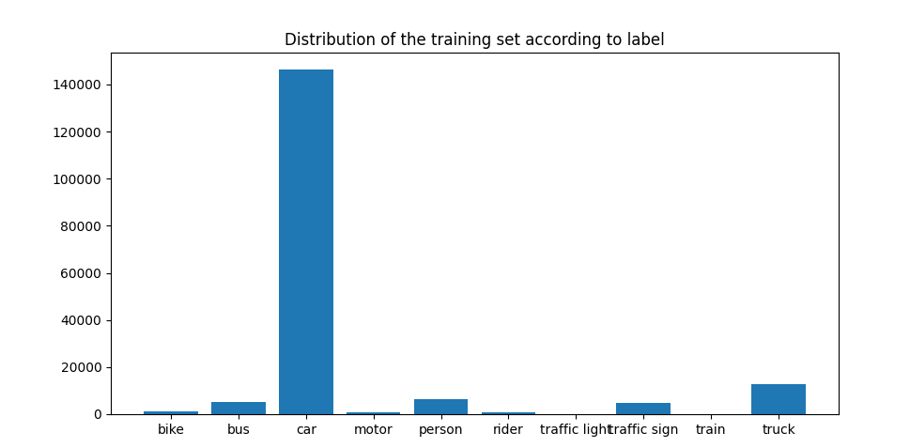

We can see that we have a majority of car (almost 60 %), and very few train, traffic light, rider and motor.
In order to not have a bias due to too much car in the training set, we will train our model with at maximum 20000 samples.
In order to have a uniform set for our model training and testing, we will resize and grayscale every image from ours sets.
After the pre-processing we expect to have our output directory with our train, val and test set to be composed of image that are identified like this :

output
├─test
│ ├─bike
│ │ ├─image1.jpg
│ │ ├─...
│ │ └─image2.jpg
│ ├─bus
│ │ ├─image1.jpg
│ │ ├─...
│ │ └─image2.jpg
│ ├─car
│ │ ├─image1.jpg
│ │ ├─...
│ │ └─image2.jpg
│ ├─motor
│ │ └─...
│ ├─person
│ │ └─...
│ ├─rider
│ │ └─...
│ ├─traffic light
│ │ └─...
│ ├─traffic sign
│ │ └─...
│ ├─train
│ │ └─...
│ └─truck
│ └─...
├─train
│ └─...
└─val
└─...
As the test image in our dataset don’t have a label and so can’t be used for testing our model, we create our testing set from a part of the training set (20%).

2. Model Building and Training

In order to have a model relevant compared to our dataset, meaning an accuracy superior to 60% as if we get less than 60%, a dumb algorithm predicting only car would be more accurate than ours due to 60% of the total dataset being car.

For our model we choose to use the CNN model that we had for the traffic-sign project :
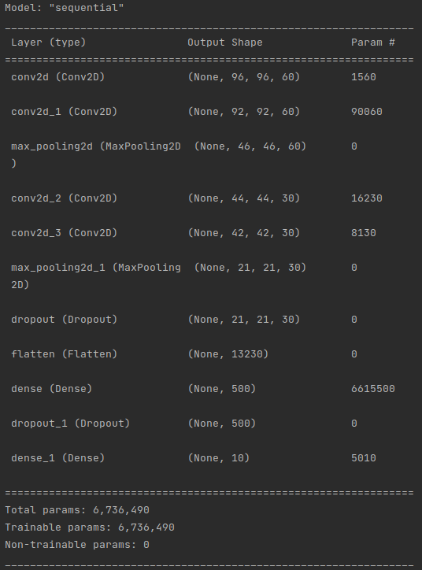

For the training of our model, we have used 20 epochs with a batch size of 64 and 100 steps for each epochs.

This resulted in almost 90% accuracy for our training set and 80% for our validation set :

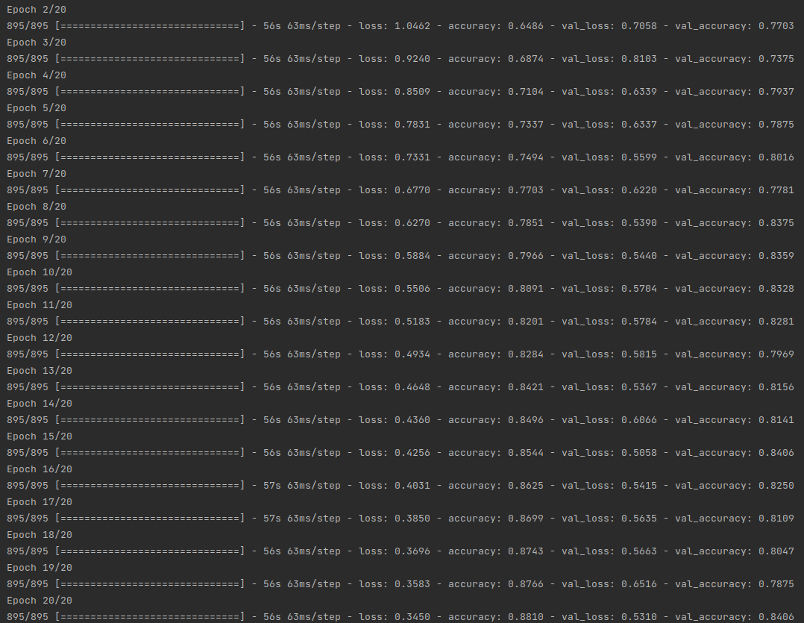
3. Model prediction and Evaluation

We used our model to evaluate the real accuracy of our model with our training set and got roughly an accuracy of 75% :

