Έντυπο Καταγραφής & Ανάλυσης Απαιτήσεων

για την εργασία

Εφαρμογή για ξενάγηση σε μουσείο με info-kiosks

1. Ρακοβίτης Δημήτριος, ΑΜ: 32634, Επαν/κός
2. Λειβιδιώτης Κωνσταντίνος, ΑΜ: 29204, Επαν/κός
3. Κλουβάτος Μάριος, ΑΜ: 30891, Επαν/κός

**Πίνακας Περιεχομένων**

1. Εισαγωγή 3

1.1. Σκοπός του παρόντος κειμένου 3

1.2. Συμβάσεις του κειμένου 3

1.3. Στόχος και εύρος του προϊόντος 3

2. Γενική Περιγραφή 1

2.1. Γενική περιγραφή των λειτουργιών του προϊόντος 3

2.2. Κατηγορίες χρηστών 3

2.3. Περιβάλλον εργασίας 3

2.4. Περιορισμοί στη σχεδίαση και την υλοποίηση 3

3. Απαιτήσεις για τις εξωτερικές διεπαφές 3

3.1. Επαφή χρήστη 3

3.2. Διεπαφές Λογισμικού 3

4. Μη λειτουργικές απαιτήσεις 3

4.1. Επιδόσεις 3

4.2. Φυσική ασφάλεια 3

4.3. Ασφάλεια πληροφορίας 3

4.4. Ποιότητα λογισμικού 3

**1. Εισαγωγή**

## 1.1. Σκοπός του παρόντος κειμένου

Οι προδιαγραφές απαιτήσεων λογισμικού περιγράφουν τις λειτουργικές και μη λειτουργικές απαιτήσεις για το έργο «**Εφαρμογή για ξενάγηση σε μουσείο»**. Το παρών έγγραφο έχει σκοπό να ενημερώσει για τη λειτουργία του προγράμματος.

## 1.2. Συμβάσεις του κειμένου

* Το κείμενο είναι γραμμένο με γραμματοσειρά Arial.
* Οι κύριες επικεφαλίδες έχουν μέγεθος 18 (έντονη γραφή), οι δευτερεύουσες 14 (έντονη γραφή) και το υπόλοιπο κείμενο μέγεθος 12 (απλή γραφή).

# **1.3. Στόχος και εύρος του προϊόντος**

Με την ανάπτυξη και λειτουργία του συγκεκριμένου λογισμικού προσπαθούμε να δημιουργήσουμε έναν εύκολο και χρηστικό τρόπογια την ενημέρωση των πολιτών των νέων εκθεμάτων του μουσείου, πληροφορίες για αυτά , χάρτη για την προσβασιμότητα, ώρες λειτουργίας και τηλέφωνα για οτιδήποτε άλλο χρειαστεί.

**2. Γενική Περιγραφή**

## 2.1. Γενική περιγραφή των λειτουργιών του προϊόντος

Το λογισμικό θα χρησιμοποιείται από επισκέπτες και τον διαχειριστή. Η πρόσβαση τον διαχειριστή θα ελέγχεται μέσω password.

## 2.2. Κατηγορίες χρηστών

|  |  |
| --- | --- |
| Διαχειριστής | **Ο διαχειριστής έχει δικαίωμα να εκτελέσει όλες τις λειτουργίες του λογισμικού. Αναλυτικότερα:**  * Περιήγηση στο μουσείο και προβολή εκθεμάτων * Ανανέωση της βάσης δεδομένων της βάσης του μουσείου |
| Απλοί Χρήστες | **Οι απλή χρήστες μπορούν, μόνο, να περιηγηθούν στο μουσείο και να διαβάζουν πληροφορίες σχετικά με τα εκθέματα.** |

## 2.3. Περιβάλλον εργασίας

# **Το περιβάλλον του λογισμικού θα πρέπει να είναι λιτό αφού οι Η/Υ είναι χαμηλής επεξεργαστικής ισχύος.**

* Η εφαρμογή θα τρέχει σε Microsoft Windows XP.
* Τα infokiosk θα έχουν την δυνατότητα ασύρματης και ενσύρματης δικτύωσης ανάλογα με τις απαιτήσης της τοποθεσίας
* Τα περιεχόμενα μπορεί να ανανεώνονται είτε μέσω δικτύου είτε τοπικά από τον διαχειριστή

# **Περιορισμοί στη σχεδίαση και την υλοποίηση**

* Τα χαρακτηριστικά των υπολογιστών που θα εγκατασταθεί η εφαρμογή είναι: Επεξεργαστής: Pentium 2GHz, μνήμη RAM: 2GB
* O κώδικας του λογισμικού είναι υλοποιημένος σε γλώσσα java.

# 

# **3.** **Απαιτήσεις για τις εξωτερικές διεπαφές**

## 3.1. Επαφή χρήστη

* Η αρχική οθόνη της εφαρμογής είναι χωρισμένη σε δύο τμήματα
* Στην αριστερή πλευρά όπου είναι ο χάρτης του μουσείου
* Στην δεξιά πλευρά εμφανίζονται οι πληροφορίες σχετικά με τα εκθέματα

<print screen>

* Ο διαχειριστής μπορεί να μπει στο σύστημα με το κουμπί login
* Αφού εισάγει τον κατάλληλο κωδικό για να μπει στο σύστημα, θα εμφανίζεται ο κατάλογος και τα αρχεία των εκθεμάτων του μουσείου

Οι λειτουργίες που θα μπορεί να εκτελέσει ο διαχειριστής είναι:

1. Περιήγηση στα δεδομένα
2. Ανάγνωση των δεδομένων
3. Διαγραφή των δεδομένων
4. Αποθήκευση των δεδομένων
5. Αλλαγή των δεδομένων

## 3.2. Διεπαφές Λογισμικού

## Θα χρησιμοποιηθεί μια βάση δεδομένων η οποία θα βρίσκεται εγκατεστημένη στον server του μουσείου. Όλα τα ikiosk έχουν την δυνατότητα ενσύρματης και ασύρματης σύνδεσης με τον server όπου βρίσκετε η βάση δεδομένων.

## ☺ Σε περίπτωση όπου δεν υπάρχει δυνατότητα δικτύωσης υπάρχει η δυνατότητα τοπικής ενημέρωσης από τον διαχειριστή.

# 

# **4. Μη λειτουργικές απαιτήσεις**

## 4.1. Επιδόσεις

* Το σύστημα να λειτουργεί επί 24ώρου βάσεως
* Οι λειτουργίες λήψης και εμφάνισης πληροφοριών θα πραγματοποιήστε σε λιγότερο από 1 δευτερόλεπτο
* Οι λειτουργίες τροποποίησης πληροφοριών από τον διαχειριστή θα γίνεται σε λιγότερο από 3 δευτερόλεπτα

## 4.2. Φυσική ασφάλεια

Δεν υπάρχουν πληροφορίες για την φυσική ασφάλεια του έργου.

## Ασφάλεια πληροφορίας

* + - Μόνο ο administrator θα ξέρει τον κωδικό πρόσβασης για την επεξεργασία της βάσης δεδομένων.

## Ποιότητα λογισμικού

Διαθεσιμότητα: Το σύστημα να μπορεί να είναι διαθέσιμο προς τους επισκέπτες επι 24ώρου βάσης

Διαγράμματα UML

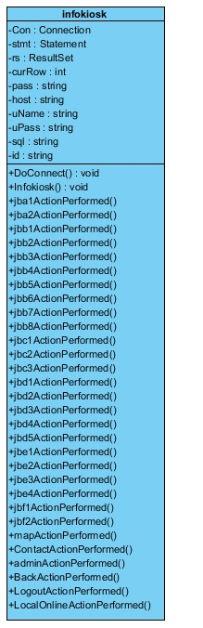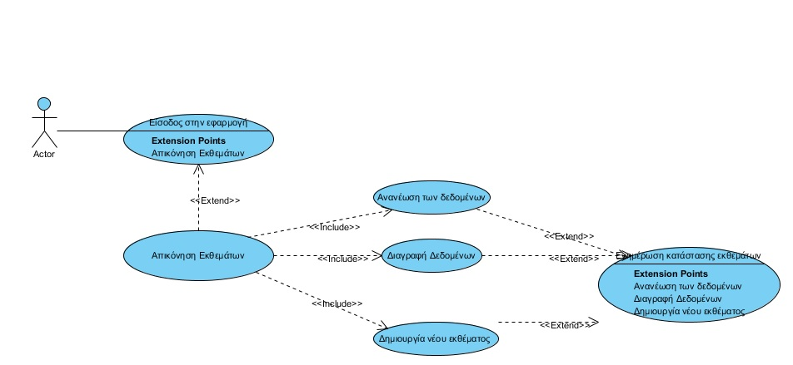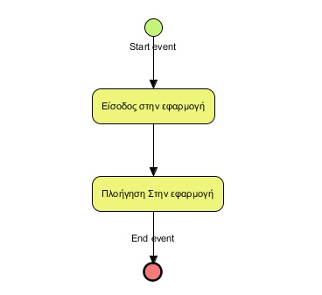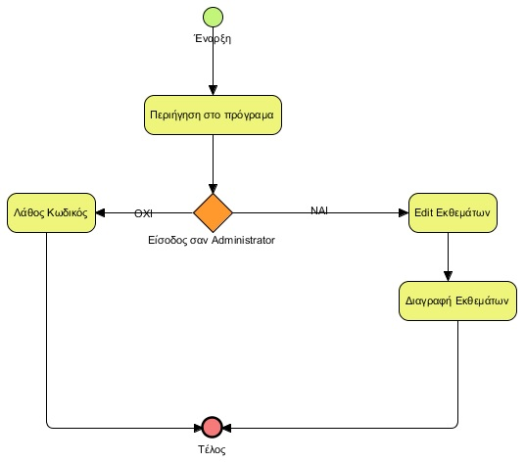

**Η εφαρμογή με εικόνες**

Η εφαρμογή υλοποιήθηκε στο Netbeans. Στο τέλος αυτής της ενότητας μπορείτε να δείτε και τον κώδικα της εφαρμογής.

Στις επόμενες σελίδες βρίσκεται η εφαρμογή με εικόνες.

Παρακάτω βλέπουμε την αρχική εικόνα του προγράμματος

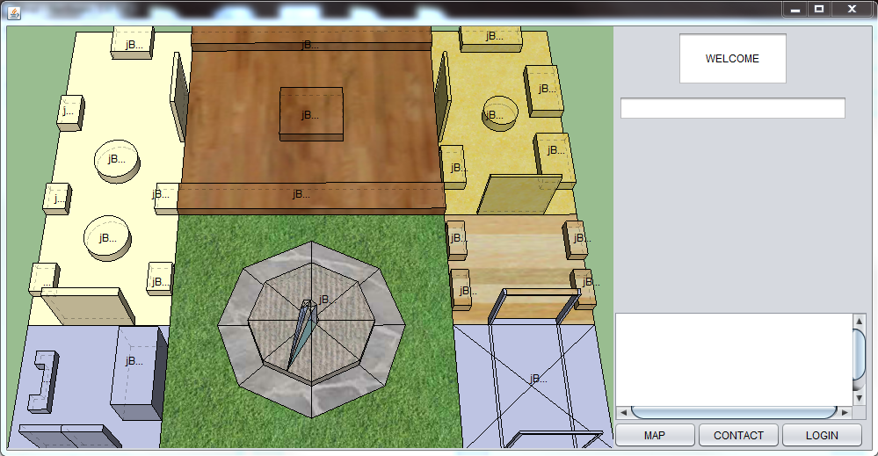

Ο χρήστης μπορεί να περιηγηθεί στα εκθέματα πατώντας πάνω τους και θα βλέπει στο δεξί μέρος της εικόνας πληροφορίες για το κάθε έκθεμα

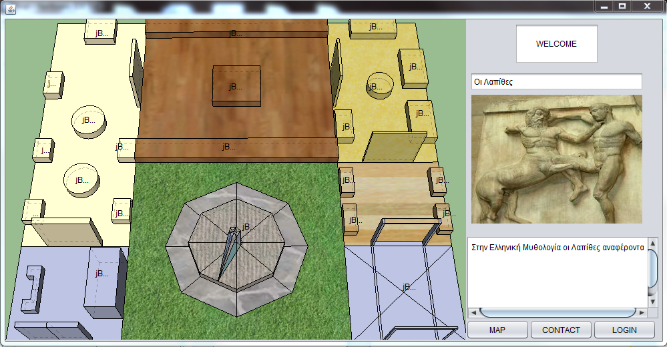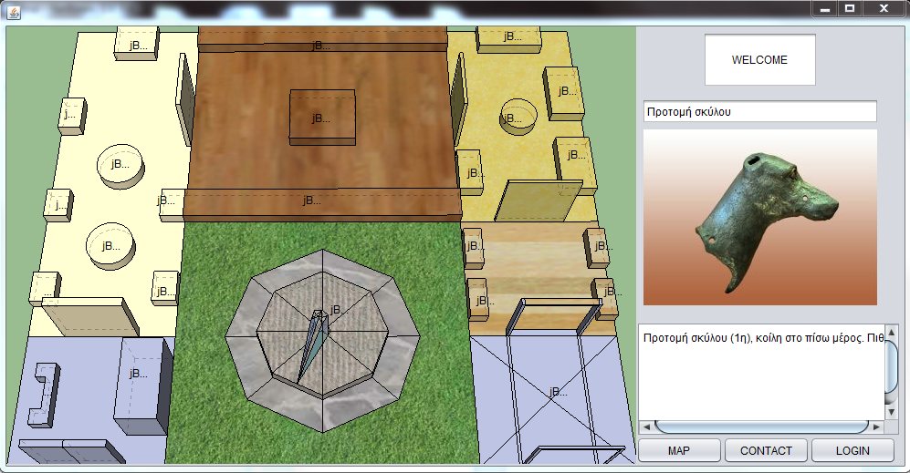

Επίσης υπάρχουν και πληροφορίες για το κτήριο όσο αφορά που μπορεί ο χρήστης να ζητήσει πληροφορίες

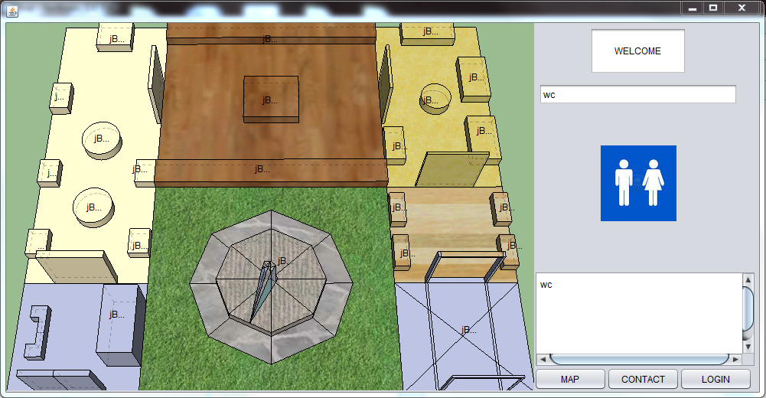

Επίσης στην επιλογή Map μπορεί να δει που βρίσκετε το μουσείο

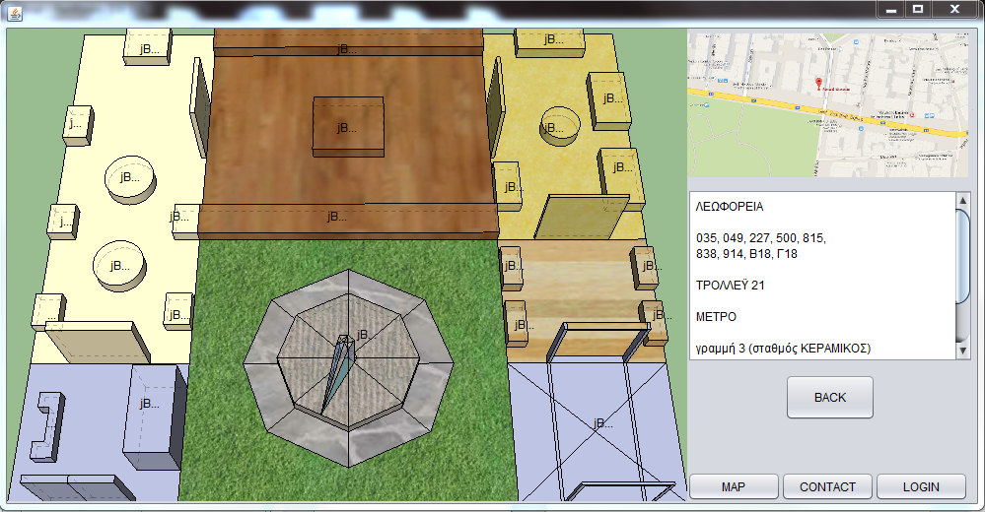

Και με την επιλογή Contact μπορεί να δει τι ώρες λειτουργεί το μουσείο και με ποιον μπορεί να επικοινωνήσει

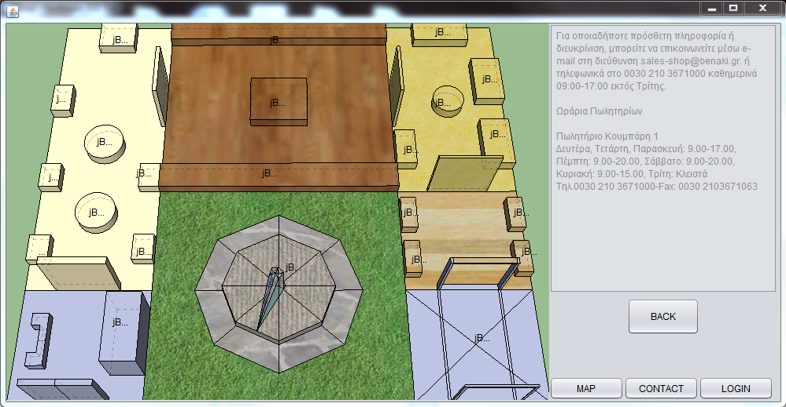

Για να συνδεθεί ο διαχειριστής πατάει το Login.

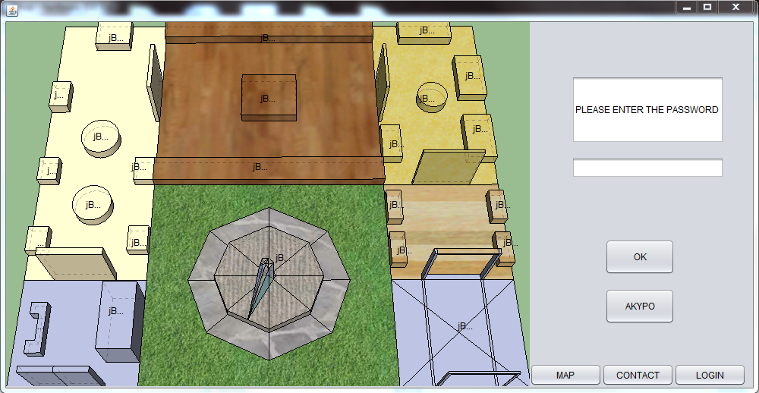

Το πρόγραμμα ζητά να εισάγει ο διαχειριστής τον κωδικό ο οποίος είναι ο 12

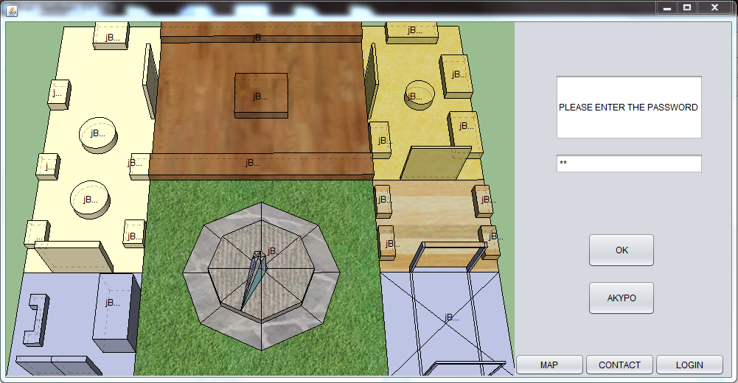

Αφού συνδεθεί πατάει το κουμπί EDIT

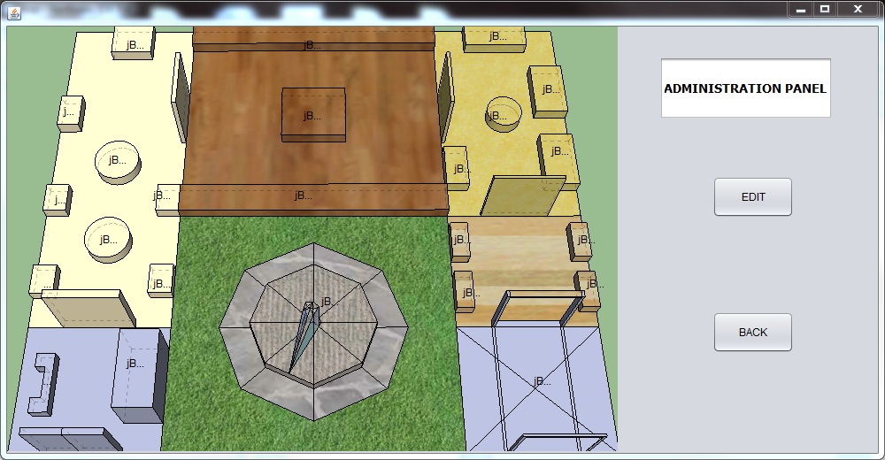

Του δίνετε η επιλογή για να κάνει EDIT εκθέματα. Διαλέγει το δωμάτιο που θέλει να κάνει την αλλαγή καθώς και τον αριθμό του εκθέματος που θέλει να αλλάξει. Πληκτρολογεί στα κενά το όνομα του καινούργιου εκθέματος καθώς και πληροφορίες γι΄αυτό

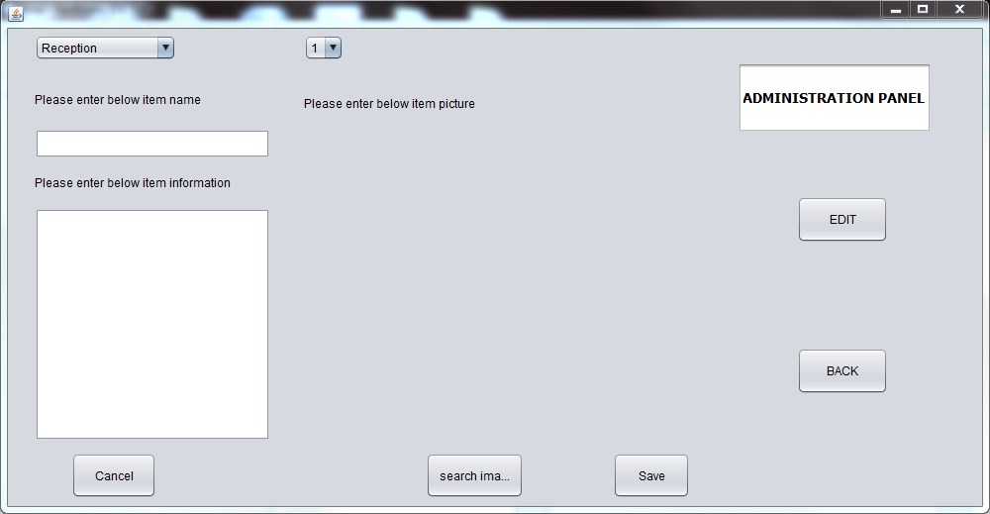

Αφού πληκτρολογήσει το όνομα του καινούριου εκθέματος και τις πληροφορίες πατάει το search image και έχουμε την παρακάτω εικόνα

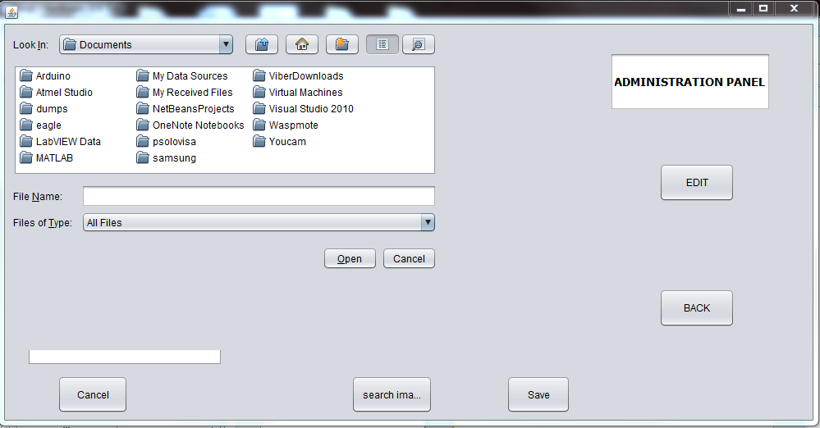

Διαλέγει την εικόνα και έχει την παρακάτω εικόνα

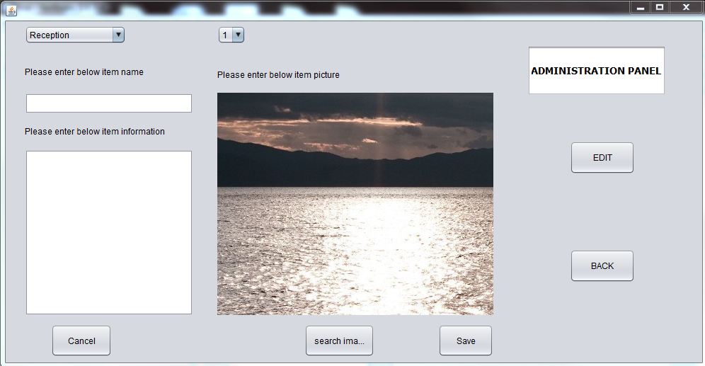

**Ο κώδικας της εφαρμογής:**

package pkgfinal;

import java.awt.image.BufferedImage;

import java.io.File;

import java.io.IOException;

import java.io.InputStream;

import java.sql.*;

import java.sql.DriverManager;

import java.sql.SQLException;

import java.sql.Statement;

import java.sql.ResultSet;

import java.util.logging.Level;

import java.util.logging.Logger;

import javax.imageio.ImageIO;

import javax.swing.JLabel;

//import java.util.logging.Level;

//import java.util.logging.Logger;

import javax.swing.ImageIcon;

import javax.swing.ImageIo;

import javax.swing.JFileChooser;

//import javax.swing.JOptionPane;

public class MainMenu extends javax.swing.JFrame {

Connection con = null;

Statement stmt = null;

ResultSet rs = null;

int curRow = 0;

String Reception;

String room2;

String room3;

String room4;

String room5;

String shop;

String table;

private BufferedImage bufImg;

/**

* Creates new form MainMenu

*/

public MainMenu() {

initComponents();

try{

Class.forName("com.mysql.jdbc.Driver").newInstance();

}catch(Exception e){

//System.out.println("Unable to load Driver");

}

try{

String connectionUrl = "jdbc:mysql://127.0.0.1:3306/maindb";

String connectionUser = "user";

String connectionPassword = "password";

con = DriverManager.getConnection(connectionUrl , connectionUser , connectionPassword);

}catch(SQLException e){

try {

String connectionUrl = "jdbc:mysql://localhost:3306/maindb";

String connectionUser = "user";

String connectionPassword = "password";

con = DriverManager.getConnection(connectionUrl , connectionUser , connectionPassword);

} catch (SQLException ex) {

System.out.println("Unable to connect to database");

}

}

if(con!=null){

try{

stmt=con.createStatement();

}catch(SQLException e){

System.out.println("Unable to create statement");

}

}

jPanel1.setVisible(false);

jPanel2.setVisible(false);

jPanel3.setVisible(false);

jPanel4.setVisible(true);

jPanel5.setVisible(false);

jPaneledit.setVisible(false);

jPaneldelete.setVisible(false);

jPanel6.setVisible(false);

}

/**

* This method is called from within the constructor to initialize the form.

* WARNING: Do NOT modify this code. The content of this method is always

* regenerated by the Form Editor.

*/

@SuppressWarnings("unchecked")

// <editor-fold defaultstate="collapsed" desc="Generated Code">

private void initComponents() {

jFileChooser1 = new javax.swing.JFileChooser();

jPanel6 = new javax.swing.JPanel();

jFileChooser2 = new javax.swing.JFileChooser();

jPaneledit = new javax.swing.JPanel();

jButton8 = new javax.swing.JButton();

jComboBox1 = new javax.swing.JComboBox();

jComboBox2 = new javax.swing.JComboBox();

jButton9 = new javax.swing.JButton();

jScrollPane5 = new javax.swing.JScrollPane();

jTextArea4 = new javax.swing.JTextArea();

jScrollPane2 = new javax.swing.JScrollPane();

jTextPane2 = new javax.swing.JTextPane();

jLabel2 = new javax.swing.JLabel();

jLabel3 = new javax.swing.JLabel();

jLabel4 = new javax.swing.JLabel();

jLabel6 = new javax.swing.JLabel();

jButton6 = new javax.swing.JButton();

mapbt = new javax.swing.JButton();

login = new javax.swing.JButton();

javax.swing.JButton jba1 = new javax.swing.JButton();

jba2 = new javax.swing.JButton();

jbe1 = new javax.swing.JButton();

jbe2 = new javax.swing.JButton();

jbe4 = new javax.swing.JButton();

jbe3 = new javax.swing.JButton();

jbd1 = new javax.swing.JButton();

contact = new javax.swing.JButton();

jbb7 = new javax.swing.JButton();

jbb1 = new javax.swing.JButton();

jbb6 = new javax.swing.JButton();

jbd5 = new javax.swing.JButton();

jbb2 = new javax.swing.JButton();

jbb5 = new javax.swing.JButton();

jbb8 = new javax.swing.JButton();

jbb3 = new javax.swing.JButton();

jbb4 = new javax.swing.JButton();

jbc2 = new javax.swing.JButton();

jbc1 = new javax.swing.JButton();

jbc3 = new javax.swing.JButton();

jbd2 = new javax.swing.JButton();

jbd3 = new javax.swing.JButton();

jbd4 = new javax.swing.JButton();

jbf1 = new javax.swing.JButton();

jbf2 = new javax.swing.JButton();

jPanel4 = new javax.swing.JPanel();

jTextField2 = new javax.swing.JTextField();

jTextField4 = new javax.swing.JTextField();

jLabel5 = new javax.swing.JLabel();

jScrollPane7 = new javax.swing.JScrollPane();

jTextArea2 = new javax.swing.JTextArea();

jPanel1 = new javax.swing.JPanel();

jScrollPane1 = new javax.swing.JScrollPane();

jTextArea1 = new javax.swing.JTextArea();

jLabel1 = new javax.swing.JLabel();

jButton4 = new javax.swing.JButton();

jPanel2 = new javax.swing.JPanel();

jScrollPane3 = new javax.swing.JScrollPane();

jTextPane1 = new javax.swing.JTextPane();

jButton3 = new javax.swing.JButton();

jPanel3 = new javax.swing.JPanel();

jPasswordField1 = new javax.swing.JPasswordField();

jButton1 = new javax.swing.JButton();

jButton2 = new javax.swing.JButton();

jTextField3 = new javax.swing.JTextField();

jPanel5 = new javax.swing.JPanel();

jTextField1 = new javax.swing.JTextField();

jButton5 = new javax.swing.JButton();

jButton7 = new javax.swing.JButton();

jPaneldelete = new javax.swing.JPanel();

jComboBox3 = new javax.swing.JComboBox();

jComboBox4 = new javax.swing.JComboBox();

jButton10 = new javax.swing.JButton();

jButton11 = new javax.swing.JButton();

gmap = new javax.swing.JLabel();

setDefaultCloseOperation(javax.swing.WindowConstants.EXIT_ON_CLOSE);

setAlwaysOnTop(true);

setBackground(new java.awt.Color(255, 5, 5));

setBounds(new java.awt.Rectangle(0, 0, 975, 478));

setFocusTraversalPolicyProvider(true);

setMaximumSize(new java.awt.Dimension(1024, 640));

setMinimumSize(new java.awt.Dimension(975, 520));

setPreferredSize(new java.awt.Dimension(1000, 520));

getContentPane().setLayout(null);

jFileChooser2.addActionListener(new java.awt.event.ActionListener() {

public void actionPerformed(java.awt.event.ActionEvent evt) {

jFileChooser2ActionPerformed(evt);

}

});

javax.swing.GroupLayout jPanel6Layout = new javax.swing.GroupLayout(jPanel6);

jPanel6.setLayout(jPanel6Layout);

jPanel6Layout.setHorizontalGroup(

jPanel6Layout.createParallelGroup(javax.swing.GroupLayout.Alignment.LEADING)

.addComponent(jFileChooser2, javax.swing.GroupLayout.PREFERRED_SIZE, javax.swing.GroupLayout.DEFAULT_SIZE, javax.swing.GroupLayout.PREFERRED_SIZE)

);

jPanel6Layout.setVerticalGroup(

jPanel6Layout.createParallelGroup(javax.swing.GroupLayout.Alignment.LEADING)

.addComponent(jFileChooser2, javax.swing.GroupLayout.PREFERRED_SIZE, javax.swing.GroupLayout.DEFAULT_SIZE, javax.swing.GroupLayout.PREFERRED_SIZE)

);

getContentPane().add(jPanel6);

jPanel6.setBounds(0, 0, 582, 397);

jPaneledit.setMinimumSize(new java.awt.Dimension(690, 480));

jButton8.setText("Save");

jButton8.addActionListener(new java.awt.event.ActionListener() {

public void actionPerformed(java.awt.event.ActionEvent evt) {

jButton8ActionPerformed(evt);

}

});

jComboBox1.setModel(new javax.swing.DefaultComboBoxModel(new String[] { "Reception", "room2", "room3", "room4", "room5", "shop" }));

jComboBox1.addActionListener(new java.awt.event.ActionListener() {

public void actionPerformed(java.awt.event.ActionEvent evt) {

jComboBox1ActionPerformed(evt);

}

});

jComboBox2.setModel(new javax.swing.DefaultComboBoxModel(new String[] { "1", "2", "3", "4", "5", "6", "7", "8" }));

jComboBox2.addActionListener(new java.awt.event.ActionListener() {

public void actionPerformed(java.awt.event.ActionEvent evt) {

jComboBox2ActionPerformed(evt);

}

});

jButton9.setText("Cancel");

jTextArea4.setColumns(20);

jTextArea4.setRows(5);

jScrollPane5.setViewportView(jTextArea4);

jScrollPane2.setViewportView(jTextPane2);

jLabel2.setText("Please enter below item name");

jLabel3.setText("Please enter below item picture");

jLabel4.setText("Please enter below item information");

jButton6.setText("search image");

jButton6.addActionListener(new java.awt.event.ActionListener() {

public void actionPerformed(java.awt.event.ActionEvent evt) {

jButton6ActionPerformed(evt);

}

});

javax.swing.GroupLayout jPaneleditLayout = new javax.swing.GroupLayout(jPaneledit);

jPaneledit.setLayout(jPaneleditLayout);

jPaneleditLayout.setHorizontalGroup(

jPaneleditLayout.createParallelGroup(javax.swing.GroupLayout.Alignment.LEADING)

.addGroup(jPaneleditLayout.createSequentialGroup()

.addGap(27, 27, 27)

.addGroup(jPaneleditLayout.createParallelGroup(javax.swing.GroupLayout.Alignment.LEADING)

.addGroup(jPaneleditLayout.createSequentialGroup()

.addGroup(jPaneleditLayout.createParallelGroup(javax.swing.GroupLayout.Alignment.TRAILING, false)

.addComponent(jScrollPane5, javax.swing.GroupLayout.Alignment.LEADING)

.addComponent(jLabel4, javax.swing.GroupLayout.Alignment.LEADING)

.addComponent(jComboBox1, javax.swing.GroupLayout.Alignment.LEADING, javax.swing.GroupLayout.PREFERRED_SIZE, 143, javax.swing.GroupLayout.PREFERRED_SIZE)

.addComponent(jScrollPane2, javax.swing.GroupLayout.Alignment.LEADING)

.addComponent(jLabel2, javax.swing.GroupLayout.Alignment.LEADING, javax.swing.GroupLayout.DEFAULT_SIZE, 201, Short.MAX_VALUE))

.addGap(34, 34, 34)

.addGroup(jPaneleditLayout.createParallelGroup(javax.swing.GroupLayout.Alignment.LEADING)

.addGroup(jPaneleditLayout.createSequentialGroup()

.addGroup(jPaneleditLayout.createParallelGroup(javax.swing.GroupLayout.Alignment.LEADING)

.addComponent(jLabel3)

.addComponent(jComboBox2, javax.swing.GroupLayout.PREFERRED_SIZE, javax.swing.GroupLayout.DEFAULT_SIZE, javax.swing.GroupLayout.PREFERRED_SIZE))

.addPreferredGap(javax.swing.LayoutStyle.ComponentPlacement.RELATED, javax.swing.GroupLayout.DEFAULT_SIZE, Short.MAX_VALUE))

.addComponent(jLabel6, javax.swing.GroupLayout.PREFERRED_SIZE, 390, javax.swing.GroupLayout.PREFERRED_SIZE)))

.addGroup(javax.swing.GroupLayout.Alignment.TRAILING, jPaneleditLayout.createSequentialGroup()

.addComponent(jButton9, javax.swing.GroupLayout.PREFERRED_SIZE, 86, javax.swing.GroupLayout.PREFERRED_SIZE)

.addGap(272, 272, 272)

.addComponent(jButton6, javax.swing.GroupLayout.PREFERRED_SIZE, 99, javax.swing.GroupLayout.PREFERRED_SIZE)

.addGap(90, 90, 90)

.addComponent(jButton8, javax.swing.GroupLayout.PREFERRED_SIZE, 78, javax.swing.GroupLayout.PREFERRED_SIZE)))

.addGap(38, 38, 38))

);

jPaneleditLayout.setVerticalGroup(

jPaneleditLayout.createParallelGroup(javax.swing.GroupLayout.Alignment.LEADING)

.addGroup(jPaneleditLayout.createSequentialGroup()

.addContainerGap()

.addGroup(jPaneleditLayout.createParallelGroup(javax.swing.GroupLayout.Alignment.BASELINE)

.addComponent(jComboBox1, javax.swing.GroupLayout.PREFERRED_SIZE, javax.swing.GroupLayout.DEFAULT_SIZE, javax.swing.GroupLayout.PREFERRED_SIZE)

.addComponent(jComboBox2, javax.swing.GroupLayout.PREFERRED_SIZE, javax.swing.GroupLayout.DEFAULT_SIZE, javax.swing.GroupLayout.PREFERRED_SIZE))

.addGroup(jPaneleditLayout.createParallelGroup(javax.swing.GroupLayout.Alignment.LEADING)

.addGroup(jPaneleditLayout.createSequentialGroup()

.addGap(35, 35, 35)

.addComponent(jLabel3))

.addGroup(javax.swing.GroupLayout.Alignment.TRAILING, jPaneleditLayout.createSequentialGroup()

.addPreferredGap(javax.swing.LayoutStyle.ComponentPlacement.RELATED)

.addComponent(jLabel2, javax.swing.GroupLayout.PREFERRED_SIZE, 24, javax.swing.GroupLayout.PREFERRED_SIZE)))

.addGap(18, 18, 18)

.addGroup(jPaneleditLayout.createParallelGroup(javax.swing.GroupLayout.Alignment.LEADING)

.addGroup(jPaneleditLayout.createSequentialGroup()

.addComponent(jScrollPane2, javax.swing.GroupLayout.PREFERRED_SIZE, javax.swing.GroupLayout.DEFAULT_SIZE, javax.swing.GroupLayout.PREFERRED_SIZE)

.addPreferredGap(javax.swing.LayoutStyle.ComponentPlacement.RELATED, javax.swing.GroupLayout.DEFAULT_SIZE, Short.MAX_VALUE)

.addComponent(jLabel4)

.addGap(18, 18, 18)

.addComponent(jScrollPane5, javax.swing.GroupLayout.PREFERRED_SIZE, 235, javax.swing.GroupLayout.PREFERRED_SIZE))

.addComponent(jLabel6, javax.swing.GroupLayout.PREFERRED_SIZE, 314, javax.swing.GroupLayout.PREFERRED_SIZE))

.addPreferredGap(javax.swing.LayoutStyle.ComponentPlacement.UNRELATED)

.addGroup(jPaneleditLayout.createParallelGroup(javax.swing.GroupLayout.Alignment.LEADING, false)

.addComponent(jButton6, javax.swing.GroupLayout.DEFAULT_SIZE, 46, Short.MAX_VALUE)

.addComponent(jButton8, javax.swing.GroupLayout.DEFAULT_SIZE, 46, Short.MAX_VALUE)

.addComponent(jButton9, javax.swing.GroupLayout.DEFAULT_SIZE, javax.swing.GroupLayout.DEFAULT_SIZE, Short.MAX_VALUE))

.addContainerGap())

);

getContentPane().add(jPaneledit);

jPaneledit.setBounds(0, 0, 690, 480);

mapbt.setText("MAP");

mapbt.addActionListener(new java.awt.event.ActionListener() {

public void actionPerformed(java.awt.event.ActionEvent evt) {

mapbtActionPerformed(evt);

}

});

getContentPane().add(mapbt);

mapbt.setBounds(690, 450, 95, 30);

login.setText("LOGIN");

login.addActionListener(new java.awt.event.ActionListener() {

public void actionPerformed(java.awt.event.ActionEvent evt) {

loginActionPerformed(evt);

}

});

getContentPane().add(login);

login.setBounds(880, 450, 95, 30);

jba1.setText("jButton2");

jba1.setContentAreaFilled(false);

jba1.setCursor(new java.awt.Cursor(java.awt.Cursor.HAND_CURSOR));

jba1.addActionListener(new java.awt.event.ActionListener() {

public void actionPerformed(java.awt.event.ActionEvent evt) {

jba1ActionPerformed(evt);

}

});

getContentPane().add(jba1);

jba1.setBounds(30, 390, 30, 20);

jba2.setText("jButton2");

jba2.setContentAreaFilled(false);

jba2.setCursor(new java.awt.Cursor(java.awt.Cursor.HAND_CURSOR));

jba2.addActionListener(new java.awt.event.ActionListener() {

public void actionPerformed(java.awt.event.ActionEvent evt) {

jba2ActionPerformed(evt);

}

});

getContentPane().add(jba2);

jba2.setBounds(120, 360, 50, 40);

jbe1.setText("jButton2");

jbe1.setContentAreaFilled(false);

jbe1.setCursor(new java.awt.Cursor(java.awt.Cursor.HAND_CURSOR));

jbe1.addActionListener(new java.awt.event.ActionListener() {

public void actionPerformed(java.awt.event.ActionEvent evt) {

jbe1ActionPerformed(evt);

}

});

getContentPane().add(jbe1);

jbe1.setBounds(500, 280, 50, 40);

jbe2.setText("jButton2");

jbe2.setContentAreaFilled(false);

jbe2.setCursor(new java.awt.Cursor(java.awt.Cursor.HAND_CURSOR));

jbe2.addActionListener(new java.awt.event.ActionListener() {

public void actionPerformed(java.awt.event.ActionEvent evt) {

jbe2ActionPerformed(evt);

}

});

getContentPane().add(jbe2);

jbe2.setBounds(490, 220, 50, 40);

jbe4.setText("jButton2");

jbe4.setContentAreaFilled(false);

jbe4.setCursor(new java.awt.Cursor(java.awt.Cursor.HAND_CURSOR));

jbe4.addActionListener(new java.awt.event.ActionListener() {

public void actionPerformed(java.awt.event.ActionEvent evt) {

jbe4ActionPerformed(evt);

}

});

getContentPane().add(jbe4);

jbe4.setBounds(640, 270, 50, 40);

jbe3.setText("jButton2");

jbe3.setContentAreaFilled(false);

jbe3.setCursor(new java.awt.Cursor(java.awt.Cursor.HAND_CURSOR));

jbe3.addActionListener(new java.awt.event.ActionListener() {

public void actionPerformed(java.awt.event.ActionEvent evt) {

jbe3ActionPerformed(evt);

}

});

getContentPane().add(jbe3);

jbe3.setBounds(630, 220, 50, 40);

jbd1.setText("jButton2");

jbd1.setContentAreaFilled(false);

jbd1.setCursor(new java.awt.Cursor(java.awt.Cursor.HAND_CURSOR));

jbd1.addActionListener(new java.awt.event.ActionListener() {

public void actionPerformed(java.awt.event.ActionEvent evt) {

jbd1ActionPerformed(evt);

}

});

getContentPane().add(jbd1);

jbd1.setBounds(490, 140, 50, 40);

contact.setText("CONTACT");

contact.addActionListener(new java.awt.event.ActionListener() {

public void actionPerformed(java.awt.event.ActionEvent evt) {

contactActionPerformed(evt);

}

});

getContentPane().add(contact);

contact.setBounds(785, 450, 95, 30);

jbb7.setText("jButton2");

jbb7.setContentAreaFilled(false);

jbb7.setCursor(new java.awt.Cursor(java.awt.Cursor.HAND_CURSOR));

jbb7.addActionListener(new java.awt.event.ActionListener() {

public void actionPerformed(java.awt.event.ActionEvent evt) {

jbb7ActionPerformed(evt);

}

});

getContentPane().add(jbb7);

jbb7.setBounds(90, 220, 50, 40);

jbb1.setText("jButton2");

jbb1.setContentAreaFilled(false);

jbb1.setCursor(new java.awt.Cursor(java.awt.Cursor.HAND_CURSOR));

jbb1.addActionListener(new java.awt.event.ActionListener() {

public void actionPerformed(java.awt.event.ActionEvent evt) {

jbb1ActionPerformed(evt);

}

});

getContentPane().add(jbb1);

jbb1.setBounds(30, 280, 30, 20);

jbb6.setText("jButton2");

jbb6.setContentAreaFilled(false);

jbb6.setCursor(new java.awt.Cursor(java.awt.Cursor.HAND_CURSOR));

jbb6.addActionListener(new java.awt.event.ActionListener() {

public void actionPerformed(java.awt.event.ActionEvent evt) {

jbb6ActionPerformed(evt);

}

});

getContentPane().add(jbb6);

jbb6.setBounds(150, 270, 50, 40);

jbd5.setText("jButton2");

jbd5.setContentAreaFilled(false);

jbd5.setCursor(new java.awt.Cursor(java.awt.Cursor.HAND_CURSOR));

jbd5.addActionListener(new java.awt.event.ActionListener() {

public void actionPerformed(java.awt.event.ActionEvent evt) {

jbd5ActionPerformed(evt);

}

});

getContentPane().add(jbd5);

jbd5.setBounds(530, 80, 50, 40);

jbb2.setText("jButton2");

jbb2.setContentAreaFilled(false);

jbb2.setCursor(new java.awt.Cursor(java.awt.Cursor.HAND_CURSOR));

jbb2.addActionListener(new java.awt.event.ActionListener() {

public void actionPerformed(java.awt.event.ActionEvent evt) {

jbb2ActionPerformed(evt);

}

});

getContentPane().add(jbb2);

jbb2.setBounds(40, 180, 40, 30);

jbb5.setText("jButton2");

jbb5.setContentAreaFilled(false);

jbb5.setCursor(new java.awt.Cursor(java.awt.Cursor.HAND_CURSOR));

jbb5.addActionListener(new java.awt.event.ActionListener() {

public void actionPerformed(java.awt.event.ActionEvent evt) {

jbb5ActionPerformed(evt);

}

});

getContentPane().add(jbb5);

jbb5.setBounds(150, 170, 50, 40);

jbb8.setText("jButton2");

jbb8.setContentAreaFilled(false);

jbb8.setCursor(new java.awt.Cursor(java.awt.Cursor.HAND_CURSOR));

jbb8.addActionListener(new java.awt.event.ActionListener() {

public void actionPerformed(java.awt.event.ActionEvent evt) {

jbb8ActionPerformed(evt);

}

});

getContentPane().add(jbb8);

jbb8.setBounds(100, 130, 50, 40);

jbb3.setText("jButton2");

jbb3.setContentAreaFilled(false);

jbb3.setCursor(new java.awt.Cursor(java.awt.Cursor.HAND_CURSOR));

jbb3.addActionListener(new java.awt.event.ActionListener() {

public void actionPerformed(java.awt.event.ActionEvent evt) {

jbb3ActionPerformed(evt);

}

});

getContentPane().add(jbb3);

jbb3.setBounds(50, 80, 40, 30);

jbb4.setText("jButton2");

jbb4.setContentAreaFilled(false);

jbb4.setCursor(new java.awt.Cursor(java.awt.Cursor.HAND_CURSOR));

jbb4.addActionListener(new java.awt.event.ActionListener() {

public void actionPerformed(java.awt.event.ActionEvent evt) {

jbb4ActionPerformed(evt);

}

});

getContentPane().add(jbb4);

jbb4.setBounds(120, 0, 50, 40);

jbc2.setText("jButton2");

jbc2.setContentAreaFilled(false);

jbc2.setCursor(new java.awt.Cursor(java.awt.Cursor.HAND_CURSOR));

jbc2.addActionListener(new java.awt.event.ActionListener() {

public void actionPerformed(java.awt.event.ActionEvent evt) {

jbc2ActionPerformed(evt);

}

});

getContentPane().add(jbc2);

jbc2.setBounds(320, 80, 50, 40);

jbc1.setText("jButton2");

jbc1.setContentAreaFilled(false);

jbc1.setCursor(new java.awt.Cursor(java.awt.Cursor.HAND_CURSOR));

jbc1.addActionListener(new java.awt.event.ActionListener() {

public void actionPerformed(java.awt.event.ActionEvent evt) {

jbc1ActionPerformed(evt);

}

});

getContentPane().add(jbc1);

jbc1.setBounds(310, 170, 50, 40);

jbc3.setText("jButton2");

jbc3.setContentAreaFilled(false);

jbc3.setCursor(new java.awt.Cursor(java.awt.Cursor.HAND_CURSOR));

jbc3.addActionListener(new java.awt.event.ActionListener() {

public void actionPerformed(java.awt.event.ActionEvent evt) {

jbc3ActionPerformed(evt);

}

});

getContentPane().add(jbc3);

jbc3.setBounds(320, 0, 50, 40);

jbd2.setText("jButton2");

jbd2.setContentAreaFilled(false);

jbd2.setCursor(new java.awt.Cursor(java.awt.Cursor.HAND_CURSOR));

jbd2.addActionListener(new java.awt.event.ActionListener() {

public void actionPerformed(java.awt.event.ActionEvent evt) {

jbd2ActionPerformed(evt);

}

});

getContentPane().add(jbd2);

jbd2.setBounds(530, -10, 50, 40);

jbd3.setText("jButton2");

jbd3.setContentAreaFilled(false);

jbd3.setCursor(new java.awt.Cursor(java.awt.Cursor.HAND_CURSOR));

jbd3.addActionListener(new java.awt.event.ActionListener() {

public void actionPerformed(java.awt.event.ActionEvent evt) {

jbd3ActionPerformed(evt);

}

});

getContentPane().add(jbd3);

jbd3.setBounds(590, 50, 50, 40);

jbd4.setText("jButton2");

jbd4.setContentAreaFilled(false);

jbd4.setCursor(new java.awt.Cursor(java.awt.Cursor.HAND_CURSOR));

jbd4.addActionListener(new java.awt.event.ActionListener() {

public void actionPerformed(java.awt.event.ActionEvent evt) {

jbd4ActionPerformed(evt);

}

});

getContentPane().add(jbd4);

jbd4.setBounds(600, 120, 50, 40);

jbf1.setText("jButton2");

jbf1.setContentAreaFilled(false);

jbf1.setCursor(new java.awt.Cursor(java.awt.Cursor.HAND_CURSOR));

jbf1.addActionListener(new java.awt.event.ActionListener() {

public void actionPerformed(java.awt.event.ActionEvent evt) {

jbf1ActionPerformed(evt);

}

});

getContentPane().add(jbf1);

jbf1.setBounds(580, 380, 50, 40);

jbf2.setText("jButton2");

jbf2.setContentAreaFilled(false);

jbf2.setCursor(new java.awt.Cursor(java.awt.Cursor.HAND_CURSOR));

jbf2.addActionListener(new java.awt.event.ActionListener() {

public void actionPerformed(java.awt.event.ActionEvent evt) {

jbf2ActionPerformed(evt);

}

});

getContentPane().add(jbf2);

jbf2.setBounds(340, 290, 50, 40);

jTextField2.setEditable(false);

jTextField2.setHorizontalAlignment(javax.swing.JTextField.CENTER);

jTextField2.setText("WELCOME");

jTextField4.setHorizontalAlignment(javax.swing.JTextField.LEFT);

jLabel5.setHorizontalAlignment(javax.swing.SwingConstants.CENTER);

jTextArea2.setColumns(20);

jTextArea2.setRows(5);

jTextArea2.setMaximumSize(new java.awt.Dimension(270, 126));

jTextArea2.setPreferredSize(new java.awt.Dimension(270, 126));

jScrollPane7.setViewportView(jTextArea2);

javax.swing.GroupLayout jPanel4Layout = new javax.swing.GroupLayout(jPanel4);

jPanel4.setLayout(jPanel4Layout);

jPanel4Layout.setHorizontalGroup(

jPanel4Layout.createParallelGroup(javax.swing.GroupLayout.Alignment.LEADING)

.addComponent(jScrollPane7, javax.swing.GroupLayout.Alignment.TRAILING)

.addGroup(javax.swing.GroupLayout.Alignment.TRAILING, jPanel4Layout.createSequentialGroup()

.addGroup(jPanel4Layout.createParallelGroup(javax.swing.GroupLayout.Alignment.TRAILING)

.addGroup(javax.swing.GroupLayout.Alignment.LEADING, jPanel4Layout.createSequentialGroup()

.addContainerGap()

.addComponent(jLabel5, javax.swing.GroupLayout.DEFAULT_SIZE, javax.swing.GroupLayout.DEFAULT_SIZE, Short.MAX_VALUE))

.addGroup(javax.swing.GroupLayout.Alignment.LEADING, jPanel4Layout.createSequentialGroup()

.addGap(73, 73, 73)

.addComponent(jTextField2, javax.swing.GroupLayout.PREFERRED_SIZE, 126, javax.swing.GroupLayout.PREFERRED_SIZE)

.addGap(0, 67, Short.MAX_VALUE))

.addGroup(javax.swing.GroupLayout.Alignment.LEADING, jPanel4Layout.createSequentialGroup()

.addContainerGap()

.addComponent(jTextField4)))

.addGap(24, 24, 24))

);

jPanel4Layout.setVerticalGroup(

jPanel4Layout.createParallelGroup(javax.swing.GroupLayout.Alignment.LEADING)

.addGroup(jPanel4Layout.createSequentialGroup()

.addContainerGap()

.addComponent(jTextField2, javax.swing.GroupLayout.PREFERRED_SIZE, 61, javax.swing.GroupLayout.PREFERRED_SIZE)

.addPreferredGap(javax.swing.LayoutStyle.ComponentPlacement.UNRELATED)

.addComponent(jTextField4, javax.swing.GroupLayout.PREFERRED_SIZE, javax.swing.GroupLayout.DEFAULT_SIZE, javax.swing.GroupLayout.PREFERRED_SIZE)

.addPreferredGap(javax.swing.LayoutStyle.ComponentPlacement.RELATED)

.addComponent(jLabel5, javax.swing.GroupLayout.PREFERRED_SIZE, 193, javax.swing.GroupLayout.PREFERRED_SIZE)

.addPreferredGap(javax.swing.LayoutStyle.ComponentPlacement.RELATED, 68, Short.MAX_VALUE)

.addComponent(jScrollPane7, javax.swing.GroupLayout.PREFERRED_SIZE, 126, javax.swing.GroupLayout.PREFERRED_SIZE))

);

getContentPane().add(jPanel4);

jPanel4.setBounds(690, 0, 290, 450);

jTextArea1.setEditable(false);

jTextArea1.setColumns(20);

jTextArea1.setRows(5);

jTextArea1.setText("ΛΕΩΦΟΡΕΙΑ \n\n035, 049, 227, 500, 815, \n838, 914, Β18, Γ18 \n\nΤΡΟΛΛΕΫ 21 \n\nΜΕΤΡΟ \n\nγραμμή 3 (σταθμός ΚΕΡΑΜΙΚΟΣ)\n \nΗΛΕΚΤΡΙΚΟΣ ΣΙΔΗΡΟΔΡΟΜΟΣ\n \nσταθμός ΠΕΤΡΑΛΩΝΩΝ");

jScrollPane1.setViewportView(jTextArea1);

jLabel1.setIcon(new javax.swing.ImageIcon(getClass().getResource("/pkgfinal/map.png"))); // NOI18N

jLabel1.setText("jLabel1");

jButton4.setText("BACK");

jButton4.addActionListener(new java.awt.event.ActionListener() {

public void actionPerformed(java.awt.event.ActionEvent evt) {

jButton4ActionPerformed(evt);

}

});

javax.swing.GroupLayout jPanel1Layout = new javax.swing.GroupLayout(jPanel1);

jPanel1.setLayout(jPanel1Layout);

jPanel1Layout.setHorizontalGroup(

jPanel1Layout.createParallelGroup(javax.swing.GroupLayout.Alignment.LEADING)

.addComponent(jScrollPane1)

.addGroup(jPanel1Layout.createSequentialGroup()

.addComponent(jLabel1, javax.swing.GroupLayout.PREFERRED_SIZE, 290, javax.swing.GroupLayout.PREFERRED_SIZE)

.addGap(0, 0, Short.MAX_VALUE))

.addGroup(jPanel1Layout.createSequentialGroup()

.addGap(99, 99, 99)

.addComponent(jButton4, javax.swing.GroupLayout.PREFERRED_SIZE, 92, javax.swing.GroupLayout.PREFERRED_SIZE)

.addContainerGap(javax.swing.GroupLayout.DEFAULT_SIZE, Short.MAX_VALUE))

);

jPanel1Layout.setVerticalGroup(

jPanel1Layout.createParallelGroup(javax.swing.GroupLayout.Alignment.LEADING)

.addGroup(javax.swing.GroupLayout.Alignment.TRAILING, jPanel1Layout.createSequentialGroup()

.addComponent(jLabel1, javax.swing.GroupLayout.PREFERRED_SIZE, 157, javax.swing.GroupLayout.PREFERRED_SIZE)

.addPreferredGap(javax.swing.LayoutStyle.ComponentPlacement.RELATED)

.addComponent(jScrollPane1, javax.swing.GroupLayout.DEFAULT_SIZE, 177, Short.MAX_VALUE)

.addPreferredGap(javax.swing.LayoutStyle.ComponentPlacement.UNRELATED)

.addComponent(jButton4, javax.swing.GroupLayout.PREFERRED_SIZE, 47, javax.swing.GroupLayout.PREFERRED_SIZE)

.addGap(52, 52, 52))

);

getContentPane().add(jPanel1);

jPanel1.setBounds(690, 0, 290, 450);

jTextPane1.setEditable(false);

jTextPane1.setText("Για οποιαδήποτε πρόσθετη πληροφορία ή διευκρίνιση, μπορείτε να επικοινωνείτε μέσω e-mail στη διεύθυνση sales-shop@benaki.gr. ή τηλεφωνικά στο 0030 210 3671000 καθημερινά 09:00-17:00 εκτός Τρίτης. \n\nΩράρια Πωλητηρίων\n\nΠωλητήριο Κουμπάρη 1\nΔευτέρα, Τετάρτη, Παρασκευή: 9.00-17.00, Πέμπτη: 9.00-20.00, Σάββατο: 9.00-20.00, Κυριακή: 9.00-15.00, Τρίτη: Kλειστά \nΤηλ.0030 210 3671000-Fax: 0030 2103671063 ");

jTextPane1.setToolTipText("");

jTextPane1.setEnabled(false);

jScrollPane3.setViewportView(jTextPane1);

jButton3.setText("BACK");

jButton3.addActionListener(new java.awt.event.ActionListener() {

public void actionPerformed(java.awt.event.ActionEvent evt) {

jButton3ActionPerformed(evt);

}

});

javax.swing.GroupLayout jPanel2Layout = new javax.swing.GroupLayout(jPanel2);

jPanel2.setLayout(jPanel2Layout);

jPanel2Layout.setHorizontalGroup(

jPanel2Layout.createParallelGroup(javax.swing.GroupLayout.Alignment.LEADING)

.addComponent(jScrollPane3, javax.swing.GroupLayout.DEFAULT_SIZE, 290, Short.MAX_VALUE)

.addGroup(javax.swing.GroupLayout.Alignment.TRAILING, jPanel2Layout.createSequentialGroup()

.addContainerGap(javax.swing.GroupLayout.DEFAULT_SIZE, Short.MAX_VALUE)

.addComponent(jButton3, javax.swing.GroupLayout.PREFERRED_SIZE, 92, javax.swing.GroupLayout.PREFERRED_SIZE)

.addGap(99, 99, 99))

);

jPanel2Layout.setVerticalGroup(

jPanel2Layout.createParallelGroup(javax.swing.GroupLayout.Alignment.LEADING)

.addGroup(jPanel2Layout.createSequentialGroup()

.addComponent(jScrollPane3, javax.swing.GroupLayout.DEFAULT_SIZE, 344, Short.MAX_VALUE)

.addPreferredGap(javax.swing.LayoutStyle.ComponentPlacement.RELATED)

.addComponent(jButton3, javax.swing.GroupLayout.PREFERRED_SIZE, 47, javax.swing.GroupLayout.PREFERRED_SIZE)

.addGap(53, 53, 53))

);

getContentPane().add(jPanel2);

jPanel2.setBounds(690, 0, 290, 450);

jPasswordField1.addActionListener(new java.awt.event.ActionListener() {

public void actionPerformed(java.awt.event.ActionEvent evt) {

jPasswordField1ActionPerformed(evt);

}

});

jButton1.setText("ΟΚ");

jButton1.addActionListener(new java.awt.event.ActionListener() {

public void actionPerformed(java.awt.event.ActionEvent evt) {

jButton1ActionPerformed(evt);

}

});

jButton2.setText("ΑΚΥΡΟ");

jButton2.addActionListener(new java.awt.event.ActionListener() {

public void actionPerformed(java.awt.event.ActionEvent evt) {

jButton2ActionPerformed(evt);

}

});

jTextField3.setEditable(false);

jTextField3.setHorizontalAlignment(javax.swing.JTextField.CENTER);

jTextField3.setText("PLEASE ENTER THE PASSWORD");

javax.swing.GroupLayout jPanel3Layout = new javax.swing.GroupLayout(jPanel3);

jPanel3.setLayout(jPanel3Layout);

jPanel3Layout.setHorizontalGroup(

jPanel3Layout.createParallelGroup(javax.swing.GroupLayout.Alignment.LEADING)

.addGroup(javax.swing.GroupLayout.Alignment.TRAILING, jPanel3Layout.createSequentialGroup()

.addGap(0, 99, Short.MAX_VALUE)

.addGroup(jPanel3Layout.createParallelGroup(javax.swing.GroupLayout.Alignment.TRAILING)

.addComponent(jButton1, javax.swing.GroupLayout.PREFERRED_SIZE, 92, javax.swing.GroupLayout.PREFERRED_SIZE)

.addComponent(jButton2, javax.swing.GroupLayout.PREFERRED_SIZE, 92, javax.swing.GroupLayout.PREFERRED_SIZE))

.addGap(99, 99, 99))

.addGroup(jPanel3Layout.createSequentialGroup()

.addGap(55, 55, 55)

.addGroup(jPanel3Layout.createParallelGroup(javax.swing.GroupLayout.Alignment.LEADING, false)

.addComponent(jTextField3)

.addComponent(jPasswordField1, javax.swing.GroupLayout.DEFAULT_SIZE, 180, Short.MAX_VALUE))

.addContainerGap(javax.swing.GroupLayout.DEFAULT_SIZE, Short.MAX_VALUE))

);

jPanel3Layout.setVerticalGroup(

jPanel3Layout.createParallelGroup(javax.swing.GroupLayout.Alignment.LEADING)

.addGroup(jPanel3Layout.createSequentialGroup()

.addGap(71, 71, 71)

.addComponent(jTextField3, javax.swing.GroupLayout.PREFERRED_SIZE, 89, javax.swing.GroupLayout.PREFERRED_SIZE)

.addGap(18, 18, 18)

.addComponent(jPasswordField1, javax.swing.GroupLayout.PREFERRED_SIZE, javax.swing.GroupLayout.DEFAULT_SIZE, javax.swing.GroupLayout.PREFERRED_SIZE)

.addPreferredGap(javax.swing.LayoutStyle.ComponentPlacement.RELATED, 88, Short.MAX_VALUE)

.addComponent(jButton1, javax.swing.GroupLayout.PREFERRED_SIZE, 47, javax.swing.GroupLayout.PREFERRED_SIZE)

.addGap(18, 18, 18)

.addComponent(jButton2, javax.swing.GroupLayout.PREFERRED_SIZE, 47, javax.swing.GroupLayout.PREFERRED_SIZE)

.addGap(52, 52, 52))

);

getContentPane().add(jPanel3);

jPanel3.setBounds(690, 0, 290, 450);

jPanel5.setMinimumSize(new java.awt.Dimension(290, 450));

jTextField1.setFont(new java.awt.Font("Tahoma", 1, 14)); // NOI18N

jTextField1.setHorizontalAlignment(javax.swing.JTextField.CENTER);

jTextField1.setText("ADMINISTRATION PANEL");

jButton5.setText("EDIT");

jButton5.addActionListener(new java.awt.event.ActionListener() {

public void actionPerformed(java.awt.event.ActionEvent evt) {

jButton5ActionPerformed(evt);

}

});

jButton7.setText("BACK");

jButton7.addActionListener(new java.awt.event.ActionListener() {

public void actionPerformed(java.awt.event.ActionEvent evt) {

jButton7ActionPerformed(evt);

}

});

javax.swing.GroupLayout jPanel5Layout = new javax.swing.GroupLayout(jPanel5);

jPanel5.setLayout(jPanel5Layout);

jPanel5Layout.setHorizontalGroup(

jPanel5Layout.createParallelGroup(javax.swing.GroupLayout.Alignment.LEADING)

.addGroup(jPanel5Layout.createSequentialGroup()

.addGap(47, 47, 47)

.addComponent(jTextField1, javax.swing.GroupLayout.PREFERRED_SIZE, 196, javax.swing.GroupLayout.PREFERRED_SIZE)

.addContainerGap(47, Short.MAX_VALUE))

.addGroup(javax.swing.GroupLayout.Alignment.TRAILING, jPanel5Layout.createSequentialGroup()

.addGap(0, 0, Short.MAX_VALUE)

.addGroup(jPanel5Layout.createParallelGroup(javax.swing.GroupLayout.Alignment.TRAILING)

.addComponent(jButton7, javax.swing.GroupLayout.PREFERRED_SIZE, 92, javax.swing.GroupLayout.PREFERRED_SIZE)

.addComponent(jButton5, javax.swing.GroupLayout.PREFERRED_SIZE, 92, javax.swing.GroupLayout.PREFERRED_SIZE))

.addGap(91, 91, 91))

);

jPanel5Layout.setVerticalGroup(

jPanel5Layout.createParallelGroup(javax.swing.GroupLayout.Alignment.LEADING)

.addGroup(jPanel5Layout.createSequentialGroup()

.addGap(34, 34, 34)

.addComponent(jTextField1, javax.swing.GroupLayout.PREFERRED_SIZE, 71, javax.swing.GroupLayout.PREFERRED_SIZE)

.addGap(64, 64, 64)

.addComponent(jButton5, javax.swing.GroupLayout.PREFERRED_SIZE, 47, javax.swing.GroupLayout.PREFERRED_SIZE)

.addGap(106, 106, 106)

.addComponent(jButton7, javax.swing.GroupLayout.PREFERRED_SIZE, 47, javax.swing.GroupLayout.PREFERRED_SIZE)

.addContainerGap(81, Short.MAX_VALUE))

);

getContentPane().add(jPanel5);

jPanel5.setBounds(690, 0, 290, 450);

jPaneldelete.setMinimumSize(new java.awt.Dimension(690, 480));

jComboBox3.setModel(new javax.swing.DefaultComboBoxModel(new String[] { "Reception", "room2", "room3", "room4", "room5", "shop" }));

jComboBox3.addActionListener(new java.awt.event.ActionListener() {

public void actionPerformed(java.awt.event.ActionEvent evt) {

jComboBox3ActionPerformed(evt);

}

});

jComboBox4.setModel(new javax.swing.DefaultComboBoxModel(new String[] { "1", "2", "3", "4", "5", "6", "7", "8" }));

jComboBox4.addActionListener(new java.awt.event.ActionListener() {

public void actionPerformed(java.awt.event.ActionEvent evt) {

jComboBox4ActionPerformed(evt);

}

});

jButton10.setText("Delete");

jButton10.addActionListener(new java.awt.event.ActionListener() {

public void actionPerformed(java.awt.event.ActionEvent evt) {

jButton10ActionPerformed(evt);

}

});

jButton11.setText("Cancel");

jButton11.addActionListener(new java.awt.event.ActionListener() {

public void actionPerformed(java.awt.event.ActionEvent evt) {

jButton11ActionPerformed(evt);

}

});

javax.swing.GroupLayout jPaneldeleteLayout = new javax.swing.GroupLayout(jPaneldelete);

jPaneldelete.setLayout(jPaneldeleteLayout);

jPaneldeleteLayout.setHorizontalGroup(

jPaneldeleteLayout.createParallelGroup(javax.swing.GroupLayout.Alignment.LEADING)

.addGroup(jPaneldeleteLayout.createSequentialGroup()

.addGroup(jPaneldeleteLayout.createParallelGroup(javax.swing.GroupLayout.Alignment.LEADING)

.addGroup(jPaneldeleteLayout.createSequentialGroup()

.addGap(38, 38, 38)

.addComponent(jComboBox3, javax.swing.GroupLayout.PREFERRED_SIZE, 143, javax.swing.GroupLayout.PREFERRED_SIZE)

.addGap(112, 112, 112)

.addComponent(jComboBox4, javax.swing.GroupLayout.PREFERRED_SIZE, javax.swing.GroupLayout.DEFAULT_SIZE, javax.swing.GroupLayout.PREFERRED_SIZE))

.addGroup(jPaneldeleteLayout.createSequentialGroup()

.addGap(137, 137, 137)

.addGroup(jPaneldeleteLayout.createParallelGroup(javax.swing.GroupLayout.Alignment.LEADING)

.addComponent(jButton10, javax.swing.GroupLayout.PREFERRED_SIZE, 178, javax.swing.GroupLayout.PREFERRED_SIZE)

.addComponent(jButton11, javax.swing.GroupLayout.PREFERRED_SIZE, 178, javax.swing.GroupLayout.PREFERRED_SIZE))))

.addContainerGap(366, Short.MAX_VALUE))

);

jPaneldeleteLayout.setVerticalGroup(

jPaneldeleteLayout.createParallelGroup(javax.swing.GroupLayout.Alignment.LEADING)

.addGroup(jPaneldeleteLayout.createSequentialGroup()

.addGap(24, 24, 24)

.addGroup(jPaneldeleteLayout.createParallelGroup(javax.swing.GroupLayout.Alignment.BASELINE)

.addComponent(jComboBox3, javax.swing.GroupLayout.PREFERRED_SIZE, javax.swing.GroupLayout.DEFAULT_SIZE, javax.swing.GroupLayout.PREFERRED_SIZE)

.addComponent(jComboBox4, javax.swing.GroupLayout.PREFERRED_SIZE, javax.swing.GroupLayout.DEFAULT_SIZE, javax.swing.GroupLayout.PREFERRED_SIZE))

.addGap(87, 87, 87)

.addComponent(jButton10, javax.swing.GroupLayout.PREFERRED_SIZE, 80, javax.swing.GroupLayout.PREFERRED_SIZE)

.addGap(69, 69, 69)

.addComponent(jButton11, javax.swing.GroupLayout.PREFERRED_SIZE, 80, javax.swing.GroupLayout.PREFERRED_SIZE)

.addContainerGap(120, Short.MAX_VALUE))

);

getContentPane().add(jPaneldelete);

jPaneldelete.setBounds(0, 0, 690, 480);

gmap.setIcon(new javax.swing.ImageIcon(getClass().getResource("/pkgfinal/Untitled picture10.png"))); // NOI18N

gmap.setText("jLabel1");

getContentPane().add(gmap);

gmap.setBounds(0, 0, 690, 480);

pack();

}// </editor-fold>

private void jba1ActionPerformed(java.awt.event.ActionEvent evt) {

// TODO add your handling code here:

if(stmt!=null){

try{

rs=stmt.executeQuery("select * from Reseption where idpic=2;");

}catch(SQLException e){

System.out.println("Unable to select from the databese");

}

}

if(rs!=null){

try{

while(rs.next()){

jTextField4.setText(rs.getString("caption"));

jTextArea2.setText(rs.getNString("info"));

// jLabel5 = (JLabel) rs.getBlob("img");

InputStream in = rs.getBinaryStream("img");

bufImg = ImageIO.read(in);

jLabel5.setIcon(new ImageIcon(bufImg));

}

}catch(SQLException e){

System.out.println("Unable to read from rs.");

} catch (IOException ex) {

Logger.getLogger(MainMenu.class.getName()).log(Level.SEVERE, null, ex);

}

}

}

private void jbd5ActionPerformed(java.awt.event.ActionEvent evt) {

if(stmt!=null){

try{

rs=stmt.executeQuery("select * from room4 where idpic=3;");

}catch(SQLException e){

System.out.println("Unable to select from the databese");

}

}

if(rs!=null){

try{

while(rs.next()){

jTextField4.setText(rs.getString("caption"));

jTextArea2.setText(rs.getNString("info"));

// jLabel5 = (JLabel) rs.getBlob("img");

InputStream in = rs.getBinaryStream("img");

bufImg = ImageIO.read(in);

jLabel5.setIcon(new ImageIcon(bufImg));

}

}catch(SQLException e){

System.out.println("Unable to read from rs.");

} catch (IOException ex) {

Logger.getLogger(MainMenu.class.getName()).log(Level.SEVERE, null, ex);

}

} // TODO add your handling code here: // TODO add your handling code here:

}

private void jba2ActionPerformed(java.awt.event.ActionEvent evt) {

if(stmt!=null){

try{

rs=stmt.executeQuery("select * from Reseption where idpic=1;");

}catch(SQLException e){

System.out.println("Unable to select from the databese");

}

}

if(rs!=null){

try{

while(rs.next()){

jTextField4.setText(rs.getString("caption"));

jTextArea2.setText(rs.getNString("info"));

// jLabel5 = (JLabel) rs.getBlob("img");

InputStream in = rs.getBinaryStream("img");

bufImg = ImageIO.read(in);

jLabel5.setIcon(new ImageIcon(bufImg));

}

}catch(SQLException e){

System.out.println("Unable to read from rs.");

} catch (IOException ex) {

Logger.getLogger(MainMenu.class.getName()).log(Level.SEVERE, null, ex);

}

}

// TODO add your handling code here:

}

private void jbb8ActionPerformed(java.awt.event.ActionEvent evt) {

if(stmt!=null){

try{

rs=stmt.executeQuery("select * from room2 where idpic=6;");

}catch(SQLException e){

System.out.println("Unable to select from the databese");

}

}

if(rs!=null){

try{

while(rs.next()){

jTextField4.setText(rs.getString("caption"));

jTextArea2.setText(rs.getNString("info"));

// jLabel5 = (JLabel) rs.getBlob("img");

InputStream in = rs.getBinaryStream("img");

bufImg = ImageIO.read(in);

jLabel5.setIcon(new ImageIcon(bufImg));

}

}catch(SQLException e){

System.out.println("Unable to read from rs.");

} catch (IOException ex) {

Logger.getLogger(MainMenu.class.getName()).log(Level.SEVERE, null, ex);

}

} // TODO add your handling code here: // TODO add your handling code here:

}

private void jbd2ActionPerformed(java.awt.event.ActionEvent evt) {

if(stmt!=null){

try{

rs=stmt.executeQuery("select * from room4 where idpic=5;");

}catch(SQLException e){

System.out.println("Unable to select from the databese");

}

}

if(rs!=null){

try{

while(rs.next()){

jTextField4.setText(rs.getString("caption"));

jTextArea2.setText(rs.getNString("info"));

// jLabel5 = (JLabel) rs.getBlob("img");

InputStream in = rs.getBinaryStream("img");

bufImg = ImageIO.read(in);

jLabel5.setIcon(new ImageIcon(bufImg));

}

}catch(SQLException e){

System.out.println("Unable to read from rs.");

} catch (IOException ex) {

Logger.getLogger(MainMenu.class.getName()).log(Level.SEVERE, null, ex);

}

} // TODO add your handling code here: // TODO add your handling code here:

}

private void jbd3ActionPerformed(java.awt.event.ActionEvent evt) {

if(stmt!=null){

try{

rs=stmt.executeQuery("select * from room4 where idpic=4;");

}catch(SQLException e){

System.out.println("Unable to select from the databese");

}

}

if(rs!=null){

try{

while(rs.next()){

jTextField4.setText(rs.getString("caption"));

jTextArea2.setText(rs.getNString("info"));

// jLabel5 = (JLabel) rs.getBlob("img");

InputStream in = rs.getBinaryStream("img");

bufImg = ImageIO.read(in);

jLabel5.setIcon(new ImageIcon(bufImg));

}

}catch(SQLException e){

System.out.println("Unable to read from rs.");

} catch (IOException ex) {

Logger.getLogger(MainMenu.class.getName()).log(Level.SEVERE, null, ex);

}

} // TODO add your handling code here: // TODO add your handling code here:

}

private void jbc3ActionPerformed(java.awt.event.ActionEvent evt) {

if(stmt!=null){

try{

rs=stmt.executeQuery("select * from room3 where idpic=1;");

}catch(SQLException e){

System.out.println("Unable to select from the databese");

}

}

if(rs!=null){

try{

while(rs.next()){

jTextField4.setText(rs.getString("caption"));

jTextArea2.setText(rs.getNString("info"));

// jLabel5 = (JLabel) rs.getBlob("img");

InputStream in = rs.getBinaryStream("img");

bufImg = ImageIO.read(in);

jLabel5.setIcon(new ImageIcon(bufImg));

}

}catch(SQLException e){

System.out.println("Unable to read from rs.");

} catch (IOException ex) {

Logger.getLogger(MainMenu.class.getName()).log(Level.SEVERE, null, ex);

}

} // TODO add your handling code here: // TODO add your handling code here:

}

private void jbd4ActionPerformed(java.awt.event.ActionEvent evt) {

if(stmt!=null){

try{

rs=stmt.executeQuery("select * from room4 where idpic=2;");

}catch(SQLException e){

System.out.println("Unable to select from the databese");

}

}

if(rs!=null){

try{

while(rs.next()){

jTextField4.setText(rs.getString("caption"));

jTextArea2.setText(rs.getNString("info"));

// jLabel5 = (JLabel) rs.getBlob("img");

InputStream in = rs.getBinaryStream("img");

bufImg = ImageIO.read(in);

jLabel5.setIcon(new ImageIcon(bufImg));

}

}catch(SQLException e){

System.out.println("Unable to read from rs.");

} catch (IOException ex) {

Logger.getLogger(MainMenu.class.getName()).log(Level.SEVERE, null, ex);

}

} // TODO add your handling code here: // TODO add your handling code here:

}

private void jbf1ActionPerformed(java.awt.event.ActionEvent evt) {

if(stmt!=null){

try{

rs=stmt.executeQuery("select * from shop where idshop=1;");

}catch(SQLException e){

System.out.println("Unable to select from the databese");

}

}

if(rs!=null){

try{

while(rs.next()){

jTextField4.setText(rs.getString("caption"));

jTextArea2.setText(rs.getNString("info"));

// jLabel5 = (JLabel) rs.getBlob("img");

InputStream in = rs.getBinaryStream("img");

bufImg = ImageIO.read(in);

jLabel5.setIcon(new ImageIcon(bufImg));

}

}catch(SQLException e){

System.out.println("Unable to read from rs.");

} catch (IOException ex) {

Logger.getLogger(MainMenu.class.getName()).log(Level.SEVERE, null, ex);

}

} // TODO add your handling code here: // TODO add your handling code here:

}

private void jbd1ActionPerformed(java.awt.event.ActionEvent evt) {

if(stmt!=null){

try{

rs=stmt.executeQuery("select * from room4 where idpic=1;");

}catch(SQLException e){

System.out.println("Unable to select from the databese");

}

}

if(rs!=null){

try{

while(rs.next()){

jTextField4.setText(rs.getString("caption"));

jTextArea2.setText(rs.getNString("info"));

// jLabel5 = (JLabel) rs.getBlob("img");

InputStream in = rs.getBinaryStream("img");

bufImg = ImageIO.read(in);

jLabel5.setIcon(new ImageIcon(bufImg));

}

}catch(SQLException e){

System.out.println("Unable to read from rs.");

} catch (IOException ex) {

Logger.getLogger(MainMenu.class.getName()).log(Level.SEVERE, null, ex);

}

} // TODO add your handling code here: // TODO add your handling code here:

}

private void jbe4ActionPerformed(java.awt.event.ActionEvent evt) {

if(stmt!=null){

try{

rs=stmt.executeQuery("select * from room5 where idpic=4;");

}catch(SQLException e){

System.out.println("Unable to select from the databese");

}

}

if(rs!=null){

try{

while(rs.next()){

jTextField4.setText(rs.getString("capture"));

jTextArea2.setText(rs.getNString("info"));

// jLabel5 = (JLabel) rs.getBlob("img");

InputStream in = rs.getBinaryStream("img");

bufImg = ImageIO.read(in);

jLabel5.setIcon(new ImageIcon(bufImg));

}

}catch(SQLException e){

System.out.println("Unable to read from rs.");

} catch (IOException ex) {

Logger.getLogger(MainMenu.class.getName()).log(Level.SEVERE, null, ex);

}

} // TODO add your handling code here: // TODO add your handling code here:

}

private void jbc2ActionPerformed(java.awt.event.ActionEvent evt) {

if(stmt!=null){

try{

rs=stmt.executeQuery("select * from room3 where idpic=2;");

}catch(SQLException e){

System.out.println("Unable to select from the databese");

}

}

if(rs!=null){

try{

while(rs.next()){

jTextField4.setText(rs.getString("caption"));

jTextArea2.setText(rs.getNString("info"));

// jLabel5 = (JLabel) rs.getBlob("img");

InputStream in = rs.getBinaryStream("img");

bufImg = ImageIO.read(in);

jLabel5.setIcon(new ImageIcon(bufImg));

}

}catch(SQLException e){

System.out.println("Unable to read from rs.");

} catch (IOException ex) {

Logger.getLogger(MainMenu.class.getName()).log(Level.SEVERE, null, ex);

}

} // TODO add your handling code here: // TODO add your handling code here:

}

private void jbc1ActionPerformed(java.awt.event.ActionEvent evt) {

if(stmt!=null){

try{

rs=stmt.executeQuery("select * from room3 where idpic=3;");

}catch(SQLException e){

System.out.println("Unable to select from the databese");

}

}

if(rs!=null){

try{

while(rs.next()){

jTextField4.setText(rs.getString("caption"));

jTextArea2.setText(rs.getNString("info"));

// jLabel5 = (JLabel) rs.getBlob("img");

InputStream in = rs.getBinaryStream("img");

bufImg = ImageIO.read(in);

jLabel5.setIcon(new ImageIcon(bufImg));

}

}catch(SQLException e){

System.out.println("Unable to read from rs.");

} catch (IOException ex) {

Logger.getLogger(MainMenu.class.getName()).log(Level.SEVERE, null, ex);

}

} // TODO add your handling code here: // TODO add your handling code here:

}

private void jbb1ActionPerformed(java.awt.event.ActionEvent evt) {

if(stmt!=null){

try{

rs=stmt.executeQuery("select * from room2 where idpic=1;");

}catch(SQLException e){

System.out.println("Unable to select from the databese");

}

}

if(rs!=null){

try{

while(rs.next()){

jTextField4.setText(rs.getString("caption"));

jTextArea2.setText(rs.getNString("info"));

// jLabel5 = (JLabel) rs.getBlob("img");

InputStream in = rs.getBinaryStream("img");

bufImg = ImageIO.read(in);

jLabel5.setIcon(new ImageIcon(bufImg));

}

}catch(SQLException e){

System.out.println("Unable to read from rs.");

} catch (IOException ex) {

Logger.getLogger(MainMenu.class.getName()).log(Level.SEVERE, null, ex);

}

} // TODO add your handling code here:

}

private void jbb4ActionPerformed(java.awt.event.ActionEvent evt) {

if(stmt!=null){

try{

rs=stmt.executeQuery("select * from room2 where idpic=8;");

}catch(SQLException e){

System.out.println("Unable to select from the databese");

}

}

if(rs!=null){

try{

while(rs.next()){

jTextField4.setText(rs.getString("caption"));

jTextArea2.setText(rs.getNString("info"));

// jLabel5 = (JLabel) rs.getBlob("img");

InputStream in = rs.getBinaryStream("img");

bufImg = ImageIO.read(in);

jLabel5.setIcon(new ImageIcon(bufImg));

}

}catch(SQLException e){

System.out.println("Unable to read from rs.");

} catch (IOException ex) {

Logger.getLogger(MainMenu.class.getName()).log(Level.SEVERE, null, ex);

}

} // TODO add your handling code here: // TODO add your handling code here:

}

private void jbe2ActionPerformed(java.awt.event.ActionEvent evt) {

if(stmt!=null){

try{

rs=stmt.executeQuery("select * from room5 where idpic=1;");

}catch(SQLException e){

System.out.println("Unable to select from the databese");

}

}

if(rs!=null){

try{

while(rs.next()){

jTextField4.setText(rs.getString("capture"));

jTextArea2.setText(rs.getNString("info"));

// jLabel5 = (JLabel) rs.getBlob("img");

InputStream in = rs.getBinaryStream("img");

bufImg = ImageIO.read(in);

jLabel5.setIcon(new ImageIcon(bufImg));

}

}catch(SQLException e){

System.out.println("Unable to read from rs.");

} catch (IOException ex) {

Logger.getLogger(MainMenu.class.getName()).log(Level.SEVERE, null, ex);

}

} // TODO add your handling code here: // TODO add your handling code here:

}

private void jbb3ActionPerformed(java.awt.event.ActionEvent evt) {

if(stmt!=null){

try{

rs=stmt.executeQuery("select * from room2 where idpic=7;");

}catch(SQLException e){

System.out.println("Unable to select from the databese");

}

}

if(rs!=null){

try{

while(rs.next()){

jTextField4.setText(rs.getString("caption"));

jTextArea2.setText(rs.getNString("info"));

// jLabel5 = (JLabel) rs.getBlob("img");

InputStream in = rs.getBinaryStream("img");

bufImg = ImageIO.read(in);

jLabel5.setIcon(new ImageIcon(bufImg));

}

}catch(SQLException e){

System.out.println("Unable to read from rs.");

} catch (IOException ex) {

Logger.getLogger(MainMenu.class.getName()).log(Level.SEVERE, null, ex);

}

} // TODO add your handling code here: // TODO add your handling code here:

}

private void jbf2ActionPerformed(java.awt.event.ActionEvent evt) {

// TODO add your handling code here:

}

private void jbe3ActionPerformed(java.awt.event.ActionEvent evt) {

if(stmt!=null){

try{

rs=stmt.executeQuery("select * from room5 where idpic=2;");

}catch(SQLException e){

System.out.println("Unable to select from the databese");

}

}

if(rs!=null){

try{

while(rs.next()){

jTextField4.setText(rs.getString("capture"));

jTextArea2.setText(rs.getNString("info"));

// jLabel5 = (JLabel) rs.getBlob("img");

InputStream in = rs.getBinaryStream("img");

bufImg = ImageIO.read(in);

jLabel5.setIcon(new ImageIcon(bufImg));

}

}catch(SQLException e){

System.out.println("Unable to read from rs.");

} catch (IOException ex) {

Logger.getLogger(MainMenu.class.getName()).log(Level.SEVERE, null, ex);

}

} // TODO add your handling code here: // TODO add your handling code here:

}

private void jbb2ActionPerformed(java.awt.event.ActionEvent evt) {

if(stmt!=null){

try{

rs=stmt.executeQuery("select * from room2 where idpic=4;");

}catch(SQLException e){

System.out.println("Unable to select from the databese");

}

}

if(rs!=null){

try{

while(rs.next()){

jTextField4.setText(rs.getString("caption"));

jTextArea2.setText(rs.getNString("info"));

// jLabel5 = (JLabel) rs.getBlob("img");

InputStream in = rs.getBinaryStream("img");

bufImg = ImageIO.read(in);

jLabel5.setIcon(new ImageIcon(bufImg));

}

}catch(SQLException e){

System.out.println("Unable to read from rs.");

} catch (IOException ex) {

Logger.getLogger(MainMenu.class.getName()).log(Level.SEVERE, null, ex);

}

} // TODO add your handling code here: // TODO add your handling code here:

}

private void jbb7ActionPerformed(java.awt.event.ActionEvent evt) {

if(stmt!=null){

try{

rs=stmt.executeQuery("select * from room2 where idpic=3;");

}catch(SQLException e){

System.out.println("Unable to select from the databese");

}

}

if(rs!=null){

try{

while(rs.next()){

jTextField4.setText(rs.getString("caption"));

jTextArea2.setText(rs.getNString("info"));

// jLabel5 = (JLabel) rs.getBlob("img");

InputStream in = rs.getBinaryStream("img");

bufImg = ImageIO.read(in);

jLabel5.setIcon(new ImageIcon(bufImg));

}

}catch(SQLException e){

System.out.println("Unable to read from rs.");

} catch (IOException ex) {

Logger.getLogger(MainMenu.class.getName()).log(Level.SEVERE, null, ex);

}

} // TODO add your handling code here: // TODO add your handling code here:

}

private void jbe1ActionPerformed(java.awt.event.ActionEvent evt) {

// TODO add your handling code here:

}

private void jbb6ActionPerformed(java.awt.event.ActionEvent evt) {

if(stmt!=null){

try{

rs=stmt.executeQuery("select * from room5 where idpic=3;");

}catch(SQLException e){

System.out.println("Unable to select from the databese");

}

}

if(rs!=null){

try{

while(rs.next()){

jTextField4.setText(rs.getString("capture"));

jTextArea2.setText(rs.getNString("info"));

// jLabel5 = (JLabel) rs.getBlob("img");

InputStream in = rs.getBinaryStream("img");

bufImg = ImageIO.read(in);

jLabel5.setIcon(new ImageIcon(bufImg));

}

}catch(SQLException e){

System.out.println("Unable to read from rs.");

} catch (IOException ex) {

Logger.getLogger(MainMenu.class.getName()).log(Level.SEVERE, null, ex);

}

} // TODO add your handling code here: // TODO add your handling code here:

}

private void jbb5ActionPerformed(java.awt.event.ActionEvent evt) {

if(stmt!=null){

try{

rs=stmt.executeQuery("select * from room2 where idpic=5;");

}catch(SQLException e){

System.out.println("Unable to select from the databese");

}

}

if(rs!=null){

try{

while(rs.next()){

jTextField4.setText(rs.getString("caption"));

jTextArea2.setText(rs.getNString("info"));

// jLabel5 = (JLabel) rs.getBlob("img");

InputStream in = rs.getBinaryStream("img");

bufImg = ImageIO.read(in);

jLabel5.setIcon(new ImageIcon(bufImg));

}

}catch(SQLException e){

System.out.println("Unable to read from rs.");

} catch (IOException ex) {

Logger.getLogger(MainMenu.class.getName()).log(Level.SEVERE, null, ex);

}

} // TODO add your handling code here: // TODO add your handling code here:

}

private void mapbtActionPerformed(java.awt.event.ActionEvent evt) {

jPanel1.setVisible(true);

jPanel2.setVisible(false);

jPanel3.setVisible(false);

jPanel4.setVisible(false);

jPanel6.setVisible(false);

}

private void contactActionPerformed(java.awt.event.ActionEvent evt) {

jPanel1.setVisible(false);

jPanel2.setVisible(true);

jPanel3.setVisible(false);

jPanel4.setVisible(false);

jPanel6.setVisible(false);

}

private void loginActionPerformed(java.awt.event.ActionEvent evt) {

jPanel1.setVisible(false);

jPanel2.setVisible(false);

jPanel3.setVisible(true);

jPanel4.setVisible(false);

jPanel6.setVisible(false);

}

private void jButton1ActionPerformed(java.awt.event.ActionEvent evt) {

if (String.copyValueOf(jPasswordField1.getPassword()).equals("12")) { //Process the password.

jPanel5.setVisible(true);

jPanel3.setVisible(false);

contact.setVisible(false);

mapbt.setVisible(false);

login.setVisible(false);

jPanel6.setVisible(false);

}

jPasswordField1.setText(null);

}

private void jPasswordField1ActionPerformed(java.awt.event.ActionEvent evt) {

}

private void jButton2ActionPerformed(java.awt.event.ActionEvent evt) {

jPanel3.setVisible(false);

jPanel4.setVisible(true);

jPanel6.setVisible(false);

}

private void jButton3ActionPerformed(java.awt.event.ActionEvent evt) {

jPanel2.setVisible(false);

jPanel4.setVisible(true);

jPanel6.setVisible(false);

}

private void jButton4ActionPerformed(java.awt.event.ActionEvent evt) {

jPanel1.setVisible(false);

jPanel4.setVisible(true);

jPanel6.setVisible(false);

}

private void jButton5ActionPerformed(java.awt.event.ActionEvent evt) {

jPaneledit.setVisible(true);

jPaneldelete.setVisible(false);

jPanel5.setVisible(true);

jPanel1.setVisible(false);

jPanel2.setVisible(false);

jPanel3.setVisible(false);

jPanel4.setVisible(false);

jPanel6.setVisible(false);

}

private void jButton7ActionPerformed(java.awt.event.ActionEvent evt) {

jPanel5.setVisible(false);

jPanel4.setVisible(true);

jPanel1.setVisible(false);

jPanel2.setVisible(false);

jPanel3.setVisible(false);

jPaneledit.setVisible(false);

jPaneldelete.setVisible(false);

contact.setVisible(true);

mapbt.setVisible(true);

login.setVisible(true);

jPanel6.setVisible(false);

}

private void jComboBox2ActionPerformed(java.awt.event.ActionEvent evt) {

}

private void jComboBox1ActionPerformed(java.awt.event.ActionEvent evt) {

}

private void jComboBox3ActionPerformed(java.awt.event.ActionEvent evt) {

// TODO add your handling code here:

}

private void jComboBox4ActionPerformed(java.awt.event.ActionEvent evt) {

// TODO add your handling code here:

}

private void jButton11ActionPerformed(java.awt.event.ActionEvent evt) {

// TODO add your handling code here:

}

private void jButton10ActionPerformed(java.awt.event.ActionEvent evt) {

// TODO add your handling code here:

}

private void jButton8ActionPerformed(java.awt.event.ActionEvent evt) {

String sql;

sql = "update "+jComboBox1.getSelectedItem()+" set caption='"+jTextPane2.getText()+"',info='"+jTextArea4.getText()+"',img='"+String.valueOf(jComboBox2.getSelectedItem())+";";

if(stmt!=null){

try{

stmt.executeUpdate(sql);

}catch(SQLException e){

}

}

}

private void jButton6ActionPerformed(java.awt.event.ActionEvent evt) {

jPanel6.setVisible(true);

}

private void jFileChooser2ActionPerformed(java.awt.event.ActionEvent evt) {

int o=jFileChooser1.showOpenDialog(this);

if(o==JFileChooser.APPROVE_OPTION){

File f=jFileChooser1.getSelectedFile();

jLabel6.setIcon(new ImageIcon(""+f));

jPanel6.setVisible(false);

}

}

/**

* @param args the command line arguments

*/

public static void main(String args[]) {

/* Set the Nimbus look and feel */

//<editor-fold defaultstate="collapsed" desc=" Look and feel setting code (optional) ">

/* If Nimbus (introduced in Java SE 6) is not available, stay with the default look and feel.

* For details see http://download.oracle.com/javase/tutorial/uiswing/lookandfeel/plaf.html

*/

try {

for (javax.swing.UIManager.LookAndFeelInfo info : javax.swing.UIManager.getInstalledLookAndFeels()) {

if ("Nimbus".equals(info.getName())) {

javax.swing.UIManager.setLookAndFeel(info.getClassName());

break;

}

}

} catch (ClassNotFoundException ex) {

java.util.logging.Logger.getLogger(MainMenu.class.getName()).log(java.util.logging.Level.SEVERE, null, ex);

} catch (InstantiationException ex) {

java.util.logging.Logger.getLogger(MainMenu.class.getName()).log(java.util.logging.Level.SEVERE, null, ex);

} catch (IllegalAccessException ex) {

java.util.logging.Logger.getLogger(MainMenu.class.getName()).log(java.util.logging.Level.SEVERE, null, ex);

} catch (javax.swing.UnsupportedLookAndFeelException ex) {

java.util.logging.Logger.getLogger(MainMenu.class.getName()).log(java.util.logging.Level.SEVERE, null, ex);

}

//</editor-fold>

/* Create and display the form */

java.awt.EventQueue.invokeLater(new Runnable() {

@Override

public void run() {

new MainMenu().setVisible(true);

}

});

}

// Variables declaration - do not modify

private javax.swing.JButton contact;

private javax.swing.JLabel gmap;

private javax.swing.JButton jButton1;

private javax.swing.JButton jButton10;

private javax.swing.JButton jButton11;

private javax.swing.JButton jButton2;

private javax.swing.JButton jButton3;

private javax.swing.JButton jButton4;

private javax.swing.JButton jButton5;

private javax.swing.JButton jButton6;

private javax.swing.JButton jButton7;

private javax.swing.JButton jButton8;

private javax.swing.JButton jButton9;

private javax.swing.JComboBox jComboBox1;

private javax.swing.JComboBox jComboBox2;

private javax.swing.JComboBox jComboBox3;

private javax.swing.JComboBox jComboBox4;

private javax.swing.JFileChooser jFileChooser1;

private javax.swing.JFileChooser jFileChooser2;

private javax.swing.JLabel jLabel1;

private javax.swing.JLabel jLabel2;

private javax.swing.JLabel jLabel3;

private javax.swing.JLabel jLabel4;

private javax.swing.JLabel jLabel5;

private javax.swing.JLabel jLabel6;

private javax.swing.JPanel jPanel1;

private javax.swing.JPanel jPanel2;

private javax.swing.JPanel jPanel3;

private javax.swing.JPanel jPanel4;

private javax.swing.JPanel jPanel5;

private javax.swing.JPanel jPanel6;

private javax.swing.JPanel jPaneldelete;

private javax.swing.JPanel jPaneledit;

private javax.swing.JPasswordField jPasswordField1;

private javax.swing.JScrollPane jScrollPane1;

private javax.swing.JScrollPane jScrollPane2;

private javax.swing.JScrollPane jScrollPane3;

private javax.swing.JScrollPane jScrollPane5;

private javax.swing.JScrollPane jScrollPane7;

private javax.swing.JTextArea jTextArea1;

private javax.swing.JTextArea jTextArea2;

private javax.swing.JTextArea jTextArea4;

private javax.swing.JTextField jTextField1;

private javax.swing.JTextField jTextField2;

private javax.swing.JTextField jTextField3;

private javax.swing.JTextField jTextField4;

private javax.swing.JTextPane jTextPane1;

private javax.swing.JTextPane jTextPane2;

private javax.swing.JButton jba2;

private javax.swing.JButton jbb1;

private javax.swing.JButton jbb2;

private javax.swing.JButton jbb3;

private javax.swing.JButton jbb4;

private javax.swing.JButton jbb5;

private javax.swing.JButton jbb6;

private javax.swing.JButton jbb7;

private javax.swing.JButton jbb8;

private javax.swing.JButton jbc1;

private javax.swing.JButton jbc2;

private javax.swing.JButton jbc3;

private javax.swing.JButton jbd1;

private javax.swing.JButton jbd2;

private javax.swing.JButton jbd3;

private javax.swing.JButton jbd4;

private javax.swing.JButton jbd5;

private javax.swing.JButton jbe1;

private javax.swing.JButton jbe2;

private javax.swing.JButton jbe3;

private javax.swing.JButton jbe4;

private javax.swing.JButton jbf1;

private javax.swing.JButton jbf2;

private javax.swing.JButton login;

private javax.swing.JButton mapbt;

// End of variables declaration

}