Supporting Information

Approaching high-performance of ordered structure Sb₂Te₃ film via unique angular intraplanar grain boundaries
Ming Tan, Liyu Hao, Hui Li, Cong Li, Xiaobiao Liu, Dali Yan, Tie Yang, Yuan Deng

Table S1 The sizes of grains in the Sb₂Te₃ films.
Voltage of electric field (V) |  | Grain size (nm)
0  10  20 |  | 27.2  39.5  59.1
30 |  | 80.2
40 |  | 91.0

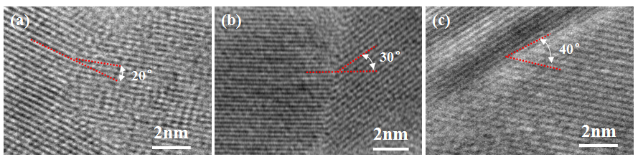
Fig. S1 TEM images of grain boundaries of Sb₂Te₃ films prepared by assisted voltages of (a) 20 V, (b) 30 V, and (c) 40 V, respectively.

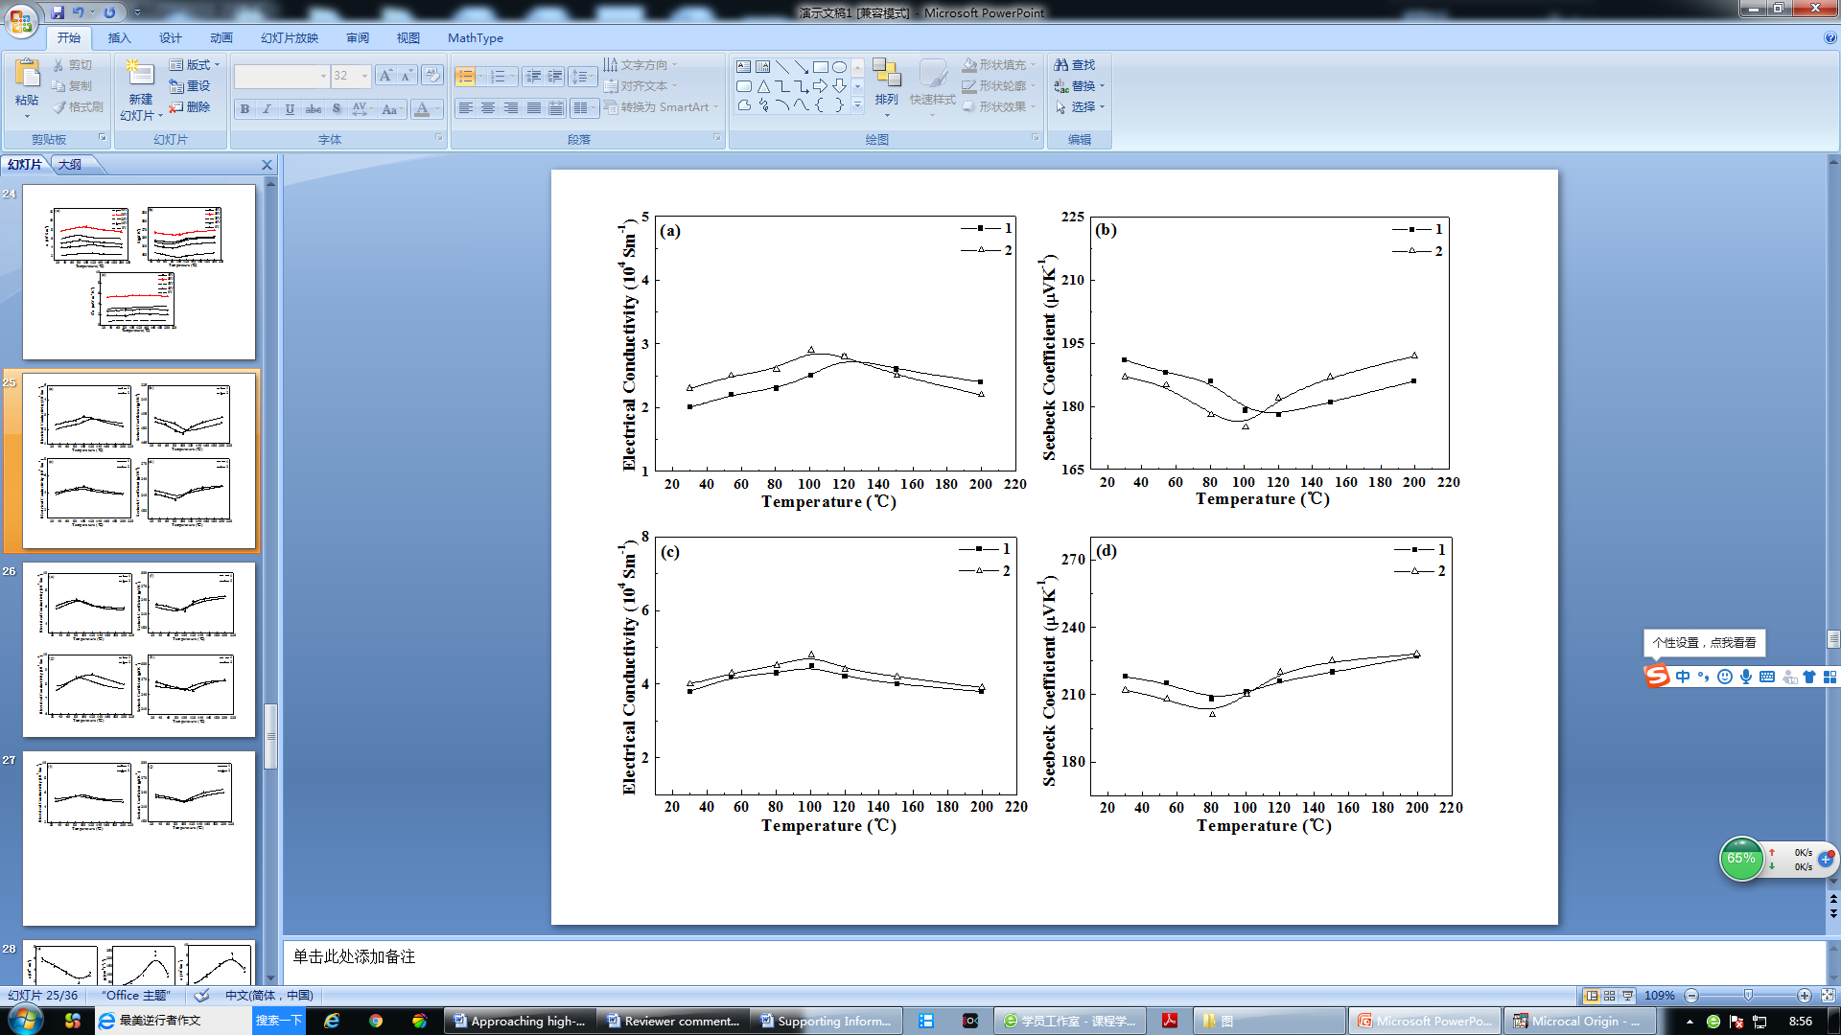
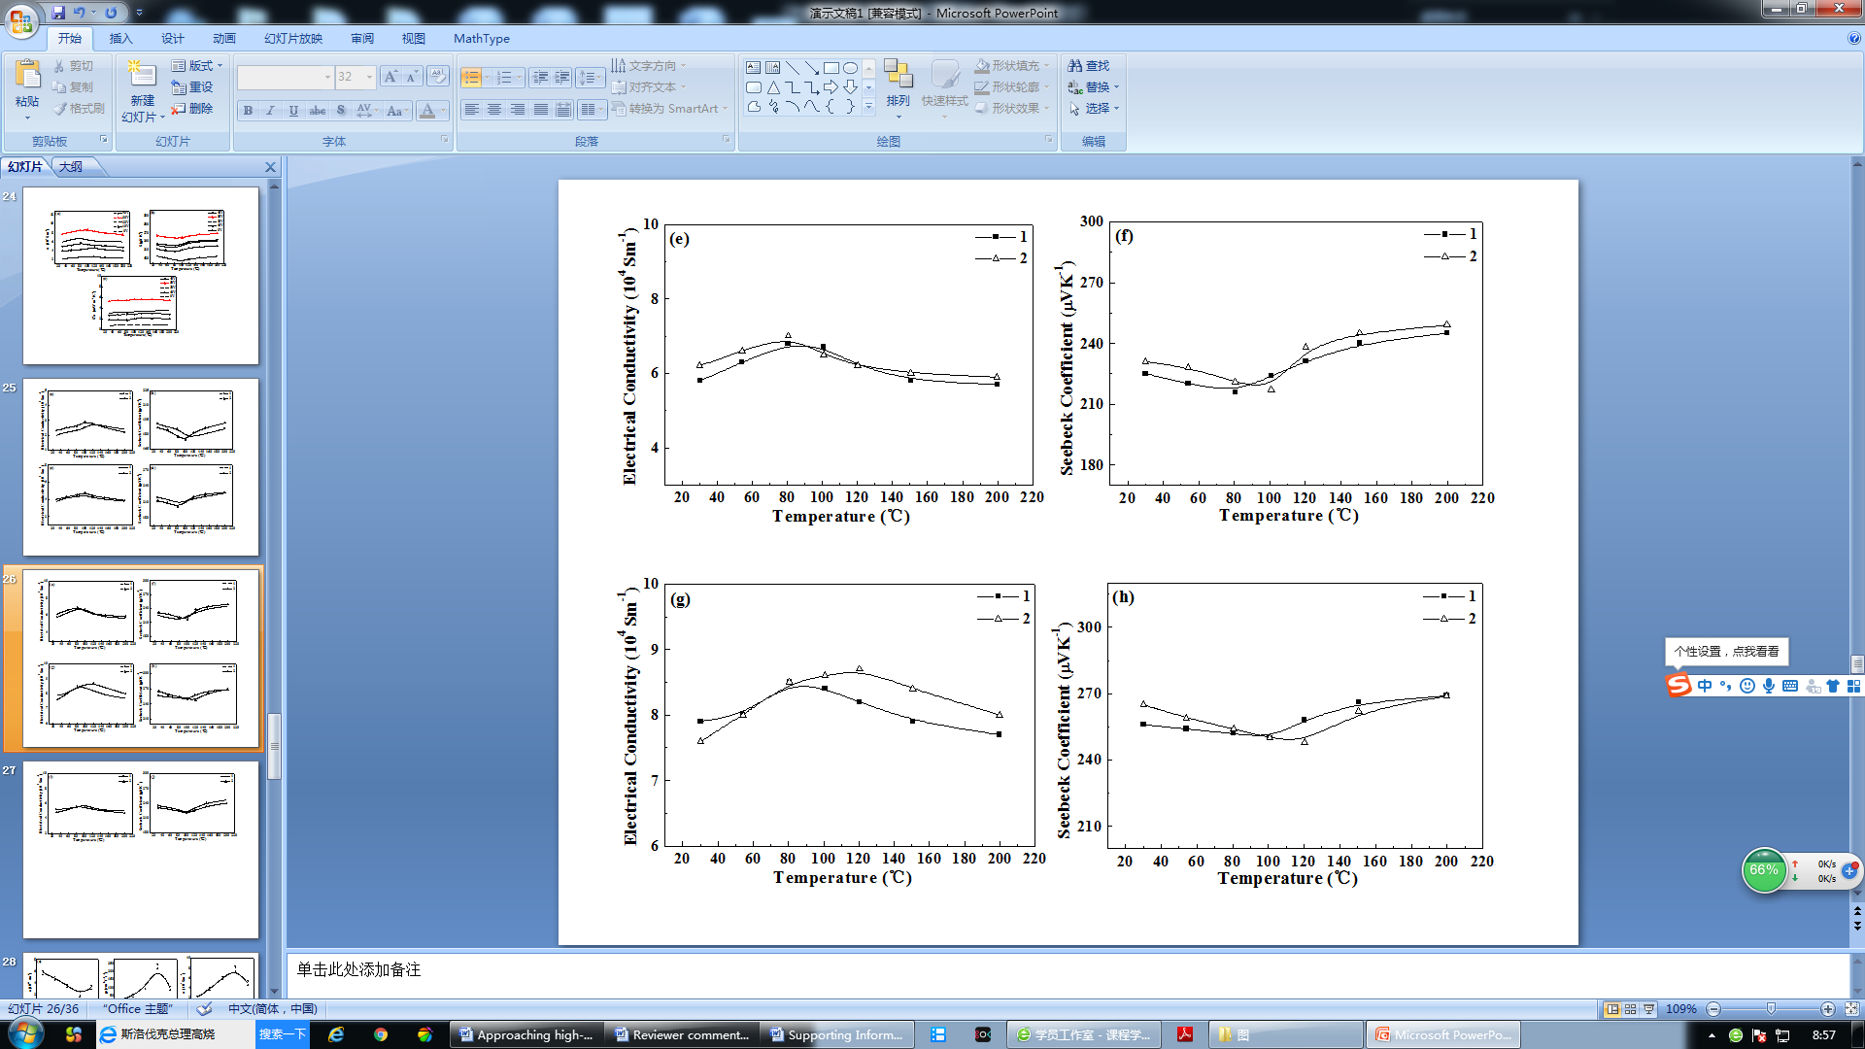
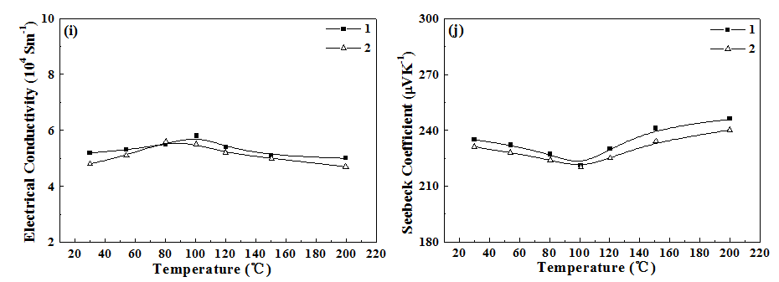
Fig. S2 Thermoelectric performance of Sb₂Te₃ films deposited under 0, 10, 20, 30 and 40 V electric fields, respectively, as a function of temperature: (a,c,e,g,i) σ and (b,d,f,h,j) S. (They are another two repeated measurements’ results of each sample.)

