DEMO 02 · PREDICTIVE MAINTENANCE
See the Failure Before It Bills You

A ten-pump fleet monitor that projects remaining useful life and raises a maintenance advisory only for the asset that actually needs it.
▌ ADVISORY Recommends only — no autonomous writes

AUTHOR Rakovskyi Dmytro · VERSION Full-run demo 02 · DATE 2026 · REPOSITORY github.com/rakovpublic/jneopallium
Unplanned downtime is the expensive failure mode, and the usual defences are both wrong: maintain everything on a fixed calendar and you waste money on healthy machines; wait for things to break and you pay in outage. This demo watches a fleet of ten pumps over a long run, tracks each one's vibration and bearing temperature, and projects remaining useful life — then it stays quiet on the healthy pumps and raises an advisory only for the one that is degrading.

What it is
Demo 02 models predictive maintenance over an MQTT/Sparkplug-style telemetry feed from ten pumps. Its safety ceiling is ADVISORY: it recommends, and a planner decides — there is no autonomous write back to any asset. The network has five layers (sized 5·4·3·2·3), enough to turn raw telemetry into a per-asset health estimate and a targeted recommendation.

How it is wired
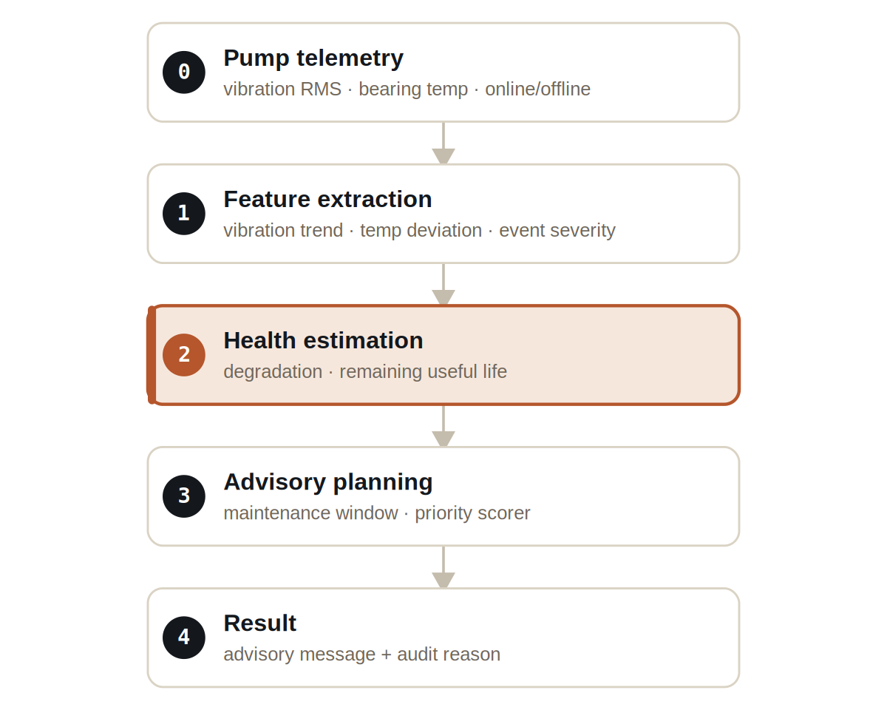
Figure Five layers, from raw telemetry to a targeted advisory with an audit reason.
Signals are typed end to end: VibrationSignal and BearingTempSignal carry the raw telemetry, DeviceEventSignal carries online/offline transitions, DegradationSignal and RemainingUsefulLifeSignal carry the health estimate, and MaintenanceAdvisorySignal carries the recommendation.

What it does
Across the fleet, three patterns appear and the network treats each correctly.
- A degrading pump (pump-03) shows a rising vibration trend; its projected remaining useful life falls sharply and it earns a maintenance advisory.
- A healthy pump (pump-00) holds steady; its remaining useful life stays high and it receives no advisory in the same window.
- A pump that drops offline (pump-07, after tick 8) produces a device-offline advisory rather than being silently ignored.

NOTE
The discipline that matters: the healthy pump gets zero advisories in the same window the degrading pump gets one. The value is not in flagging everything — it is in flagging the right asset.

The evidence
The demo runs deterministically for a thousand ticks, long enough for a slow degradation trend to separate from baseline noise.

VERIFICATION EVIDENCE
Ticks | 1000 / 1000
Degrading pump-03 | remaining useful life 40.0, advisory raised
Healthy pump-00 | remaining useful life 950.0, no advisory
Offline pump-07 | device-offline advisory after t8
Verdict | PASS

How to run it
1 Build
Build the worker and the demo model JAR.
mvn -q -pl worker -am package
2 Run via the framework entry point
Entry loads the model JAR and the demo context through the real local path.
java -cp demo-model.jar \
com.rakovpublic.jneuropallium.worker.application.Entry \
local file:///path/to/demo-model.jar \
com.rakovpublic.jneuropallium.worker.demo.fullrun.runtime.DemoJsonContext \
context.json
3 Inspect
Read the per-tick advisories and audit reasons.
ls target/jneopallium-fullrun-demos/demo-02-pump-maintenance/

Why ADVISORY
Maintenance decisions belong to a planner, not to a model, so the ceiling is advisory by design — the demo never schedules or shuts anything down on its own. To run it on a live fleet you replace the mock telemetry edge with a real MQTT/Sparkplug subscriber while preserving the typed signal contract and the advisory ceiling. The recommendation you verified against a deterministic trace arrives the same way from a live feed, and a human still owns the decision.

