DEMO 03 · DRONE MISSION GUARD
The Co-Pilot That Says No

A mission safety guard that lets a normal flight proceed but vetoes the commands that would breach a geofence — and calls the drone home on a low battery.
▌ SIM-ONLY Bounded simulation — no real actuators

AUTHOR Rakovskyi Dmytro · VERSION Full-run demo 03 · DATE 2026 · REPOSITORY github.com/rakovpublic/jneopallium
An autonomy stack will fly the mission it is given — including, cheerfully, straight through a no-fly boundary or until the battery dies. This demo sits beside the mission as a guard: it watches battery, GPS quality, altitude, and geofence distance, lets ordinary commands through, and refuses the two that would put the aircraft somewhere it must not be. It is the co-pilot whose only job is to say no at the right moment.

What it is
Demo 03 models a MAVLink-style mission guard for a single simulated drone, drone-sim-1. Its safety ceiling is SIM-ONLY: it can veto and recommend, but only inside the simulation — there is no wire to a real flight controller. The network is four layers (sized 5·3·2·2), enough to turn telemetry into a risk assessment and an allow/veto verdict per command.

How it is wired
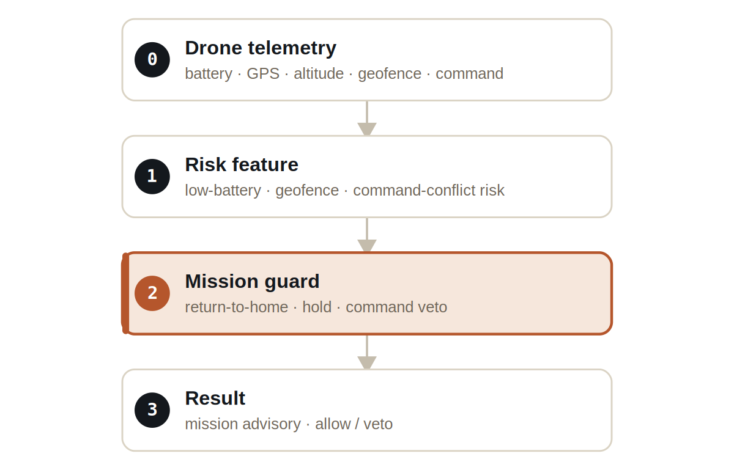
Figure Four layers. The mission-guard layer holds the veto and the return-to-home recommendation.
Signals are typed: BatterySignal, GpsSignal, AltitudeSignal, and GeofenceSignal carry telemetry, MissionCommandSignal carries the command under review, and MissionGuardSignal carries the guard's verdict.

What it does
- A normal mission command is allowed through unchanged — the guard is not a brake on ordinary flight.
- A command that would violate the geofence is vetoed before it can take effect; at tick 6 the violating command becomes a COMMAND_VETO.
- A low battery at tick 12 raises a return-to-home advisory rather than letting the mission continue to exhaustion.

SAFETY
Over the run the guard allows 22 commands and vetoes 2. It is permissive by default and decisive exactly when a command would cross a hard boundary.

The evidence

VERIFICATION EVIDENCE
Ticks | 50 / 50
Allowed commands | 22
Vetoed commands | 2 (geofence @ t6)
Low battery @ t12 | return-to-home advisory
Verdict | PASS

How to run it
1 Build
Build the worker and the demo model JAR.
mvn -q -pl worker -am package
2 Run via the framework entry point
Entry loads the model JAR and the demo context through the real local path.
java -cp demo-model.jar \
com.rakovpublic.jneuropallium.worker.application.Entry \
local file:///path/to/demo-model.jar \
com.rakovpublic.jneuropallium.worker.demo.fullrun.runtime.DemoJsonContext \
context.json
3 Inspect
Read the allow/veto verdicts and advisories.
ls target/jneopallium-fullrun-demos/demo-03-drone-guard/

Why SIM-ONLY
A guard that can veto flight commands must prove itself before it is ever wired to an aircraft, so the ceiling is sim-only and the verdicts affect only the simulation. To move toward a real platform you replace the mock telemetry edge with a MAVLink listener while preserving the typed signal contract and the ceiling. The geofence veto you verified deterministically fires the same way on live telemetry — but until that integration is deliberately certified, nothing leaves the simulation.

