DEMO 04 · CLINICAL DECISION SUPPORT
Decision Support That Stays in Its Lane

A clinical advisory that flags a high-risk patient for clinician review — and never, under any framing, writes a treatment order.
▌ ADVISORY Recommends only — no autonomous writes

AUTHOR Rakovskyi Dmytro · VERSION Full-run demo 04 · DATE 2026 · REPOSITORY github.com/rakovpublic/jneopallium
In medicine the dangerous failure isn't a missed flag — it's a system that quietly acts. A model that can place an order, adjust a dose, or change a record has crossed from decision support into autonomous medical action, and that line is regulatory, not stylistic. This demo reads vitals and medication context, raises an advisory when a patient looks high-risk, and stops there. The clinician decides; the system only points.

What it is
Demo 04 models clinical decision support over a FHIR-style stream of patient observations. Its safety ceiling is ADVISORY, and that ceiling is the whole product: it emits advisories that require clinician review and it never writes treatment orders. The network is four layers (sized 4·3·2·2), enough to turn vitals into a triage priority and a review recommendation.

How it is wired
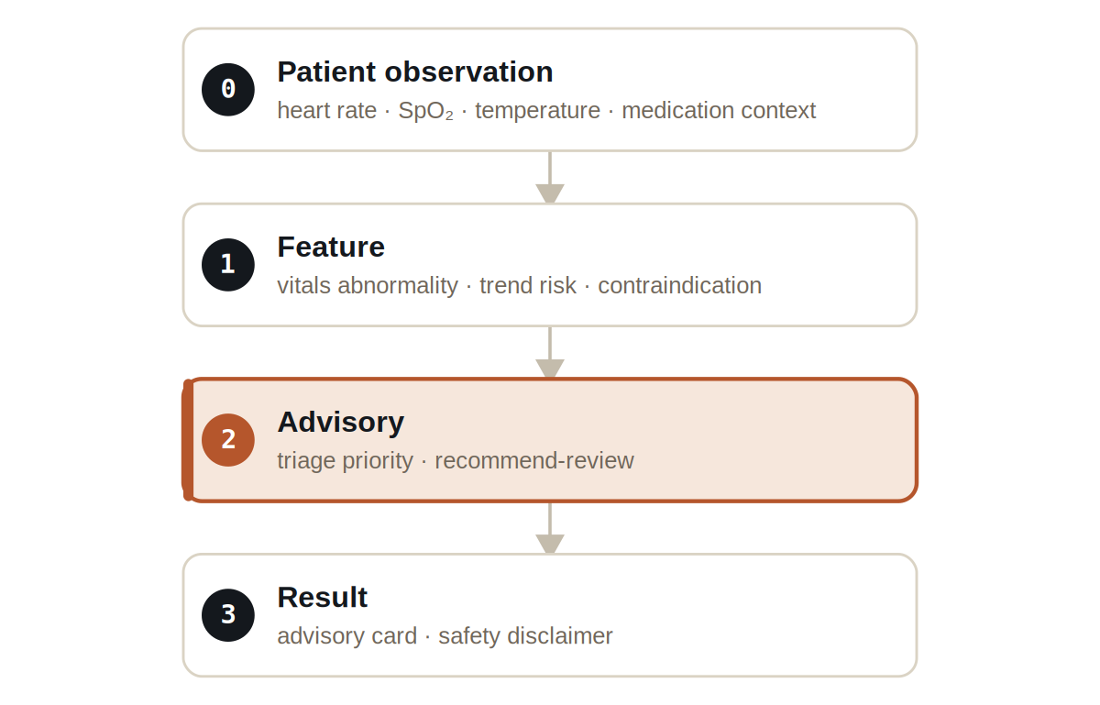
Figure Four layers. The output layer carries an advisory card and a safety disclaimer — never an order.
Signals are typed: VitalSignal carries heart rate, oxygen saturation, and temperature, MedicationContextSignal carries the medication picture, ClinicalRiskSignal carries the computed risk, and ClinicalAdvisorySignal carries the recommendation — a recommendation, never an instruction.

What it does
- A stable patient produces no escalation — the system does not manufacture alarms.
- A high-risk synthetic patient produces a CLINICIAN_REVIEW_ADVISORY with an audit reason.
- Every result is explicitly marked ADVISORY and carries a safety disclaimer; no result is ever an order or a writeback.

SAFETY
The test is adversarial about this: it fails if any result type even looks like an autonomous order or write. “Advisory” is enforced as a property of the output, not a label in the docs.

The evidence

VERIFICATION EVIDENCE
Ticks | 80 / 80
High-risk patient | CLINICIAN_REVIEW_ADVISORY raised
Treatment orders written | zero — enforced
Output mode | ADVISORY
Verdict | PASS

How to run it
1 Build
Build the worker and the demo model JAR.
mvn -q -pl worker -am package
2 Run via the framework entry point
Entry loads the model JAR and the demo context through the real local path.
java -cp demo-model.jar \
com.rakovpublic.jneuropallium.worker.application.Entry \
local file:///path/to/demo-model.jar \
com.rakovpublic.jneuropallium.worker.demo.fullrun.runtime.DemoJsonContext \
context.json
3 Inspect
Read the advisory cards and disclaimers.
ls target/jneopallium-fullrun-demos/demo-04-clinical-advisory/

Why ADVISORY
Clinical action is a clinician's responsibility and, in most jurisdictions, a regulated act; a software system that performs it inherits an entirely different risk and approval burden. The advisory ceiling keeps this demo firmly in decision support. To connect it to a real record system you replace the mock observation edge with a FHIR client while preserving the typed signal contract and the advisory ceiling — and the guarantee that it never writes an order travels with it.

