DEMO 05 · IMAGING CONTEXT
Catch the Bad Study Before the Radiologist Does

A read-only DICOM context interpreter that raises a QC advisory on missing metadata and a routing advisory on a complete study — without ever touching a pixel.
▌ READ-ONLY Reads metadata — no writeback

AUTHOR Rakovskyi Dmytro · VERSION Full-run demo 05 · DATE 2026 · REPOSITORY github.com/rakovpublic/jneopallium
A study with missing metadata wastes a radiologist's time twice: once when it lands in the wrong worklist, and again when it has to be sent back. This demo reads only the metadata around an imaging study — modality, body part, series count, study age — and sorts the good from the incomplete before a human ever opens it. It diagnoses nothing in the image and writes nothing back; it is pure, careful triage of context.

What it is
Demo 05 models a DICOM context bridge. Its safety ceiling is READ-ONLY: it consumes and annotates imaging metadata but performs no pixel diagnosis and no writeback to the imaging system. The network is just three layers (sized 3·2·2) — the smallest stack that turns metadata into a routing or quality-control advisory.

How it is wired
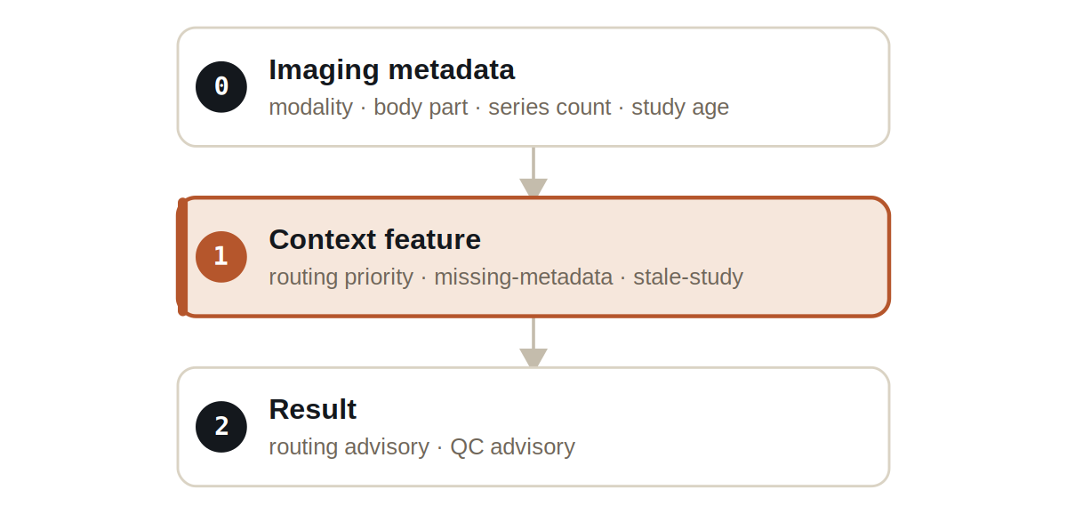
Figure Three layers. The context-feature layer flags missing or stale metadata; the result layer advises routing or QC.
Signals are typed and narrow: DicomMetadataSignal carries the study metadata, ImageQcSignal carries quality-control findings, and RoutingAdvisorySignal carries the routing recommendation. Nothing in the vocabulary can express a diagnosis or a write.

What it does
- A complete study is given a ROUTING_ADVISORY — sent to the right worklist with the right priority.
- A study with missing metadata is given a QC_ADVISORY so it can be corrected before it reaches a radiologist.
- No result reads pixel data, infers a clinical finding, or writes anything back to the source.

NOTE
The boundary is deliberately strict: the demo is a metadata triage assistant, not an image reader. The test proves no command or write result exists at all.

The evidence

VERIFICATION EVIDENCE
Ticks | 60 / 60
Complete study | ROUTING_ADVISORY
Missing metadata | QC_ADVISORY
Writeback / pixel diagnosis | none — enforced
Output mode | READ-ONLY

How to run it
1 Build
Build the worker and the demo model JAR.
mvn -q -pl worker -am package
2 Run via the framework entry point
Entry loads the model JAR and the demo context through the real local path.
java -cp demo-model.jar \
com.rakovpublic.jneuropallium.worker.application.Entry \
local file:///path/to/demo-model.jar \
com.rakovpublic.jneuropallium.worker.demo.fullrun.runtime.DemoJsonContext \
context.json
3 Inspect
Read the routing and QC advisories.
ls target/jneopallium-fullrun-demos/demo-05-dicom-context/

Why READ-ONLY
Pixel-level interpretation is a regulated diagnostic act and writeback to a PACS is an operational risk; this demo deliberately does neither. The read-only ceiling keeps it a context assistant. To connect it to a live archive you replace the mock metadata edge with a real DICOM source while preserving the typed signal contract and the read-only ceiling — and the guarantee that it never writes or diagnoses comes along unchanged.

